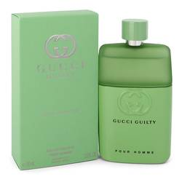GUCCI:

35,000

An Aromatic Fougère, the original Gucci Guilty Pour Homme eau de toilette enters a new chapter, embodying the free spirit of a new generation of scent lovers. Individual, yet fusing together naturally, the men's and women's perfumes embody a declaration of self-expression and fearlessness, conjured up by the statement #ForeverGuilty.