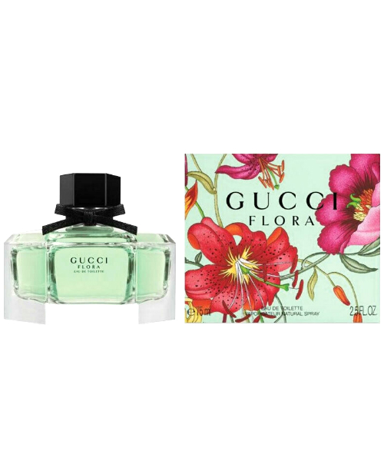FLORA:

12,000

Gucci Flora Gorgeous Jasmine Eau de Parfum bursts with a radiant composition led by Grandiflorum Jasmine. Tender wreaths of noble Jasmine are transformed through extraction into the heart and spirit of Gucci Flora Gorgeous Jasmine, resulting in an enlightened expression of this precious flower. Blended with base notes of Sandalwood and Benzoin, its sensual notes create a skin imprint unique to the wearer. Its energy of inner joy is further lifted with notes of Mandarine Essence and Magnolia Accord, which infuse the scent with a joyful feeling. Reimagined in Alessandro Michele’s vision, the House’s distinctive Flora pattern seals the design with a magical touch, fortifying Gucci Flora Gorgeous Jasmine as an object of inspiration.