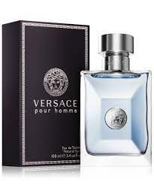POUR HOMME:

2,500

**An intoxicating, powerful blend that starts out fresh and moves onto a spicy leather accord**. The J. Pour Homme arrives in a rush of fresh and spicy leather fragrance. This is a fantasy in a bottle and smells like luxury, fame, and wealth.