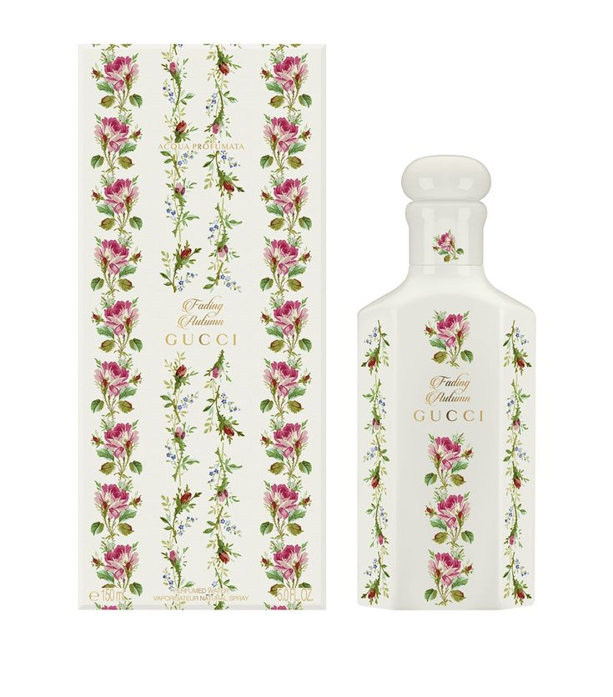FADING AUTUMN:

56,000

Fading Autumn is a **woods acqua profumata**. Its subtle woody caress will reveal the textures of all other ingredients, thanks to its fluid and wrapping intensity. ALCOHOL DENAT., AQUA/WATER/EAU, PARFUM/FRAGRANCE,LINALOOL, COUMARIN, LIMONENE, CITRONELLOL.