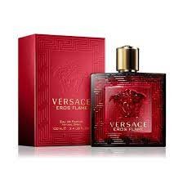EROS FLAME:

23,000

**Eros Flame** by **Versace** is a Woody Spicy fragrance for men. **Eros Flame** was launched in 2018. The nose behind this fragrance is Olivier Pescheux. Top notes are Mandarin Orange, Black Pepper, Chinotto, Lemon and Rosemary; middle notes are Pepper, Geranium and Rose; base notes are Vanilla, Tonka Bean, Sandalwood, Texas Cedar, Patchouli and Oakmoss.