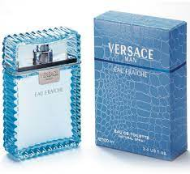EAU FRAICHE:

11,400

Eau Fraiche **contains about 1 to 3% essential oil**, making it the lowest of all available fragrances. The term, eau fraiche translates to fresh water. It doesn't last as long on the skin but is still very popular, especially among those who cannot afford the often-prohibitive cost of true perfume.