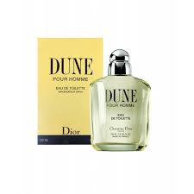DUNE pour homme:

26,000

Dune is indeed **a tenacious, sumptuous fragrance, but with an unusual softness**. It contains all the elements of a voluptuous oriental—creamy layers of vanilla, sandalwood, amber and musk as well as the smoky accents of incense. Nevertheless, Dune is more like a sip of lemonade, rather than a mouthful of hot chocolate.