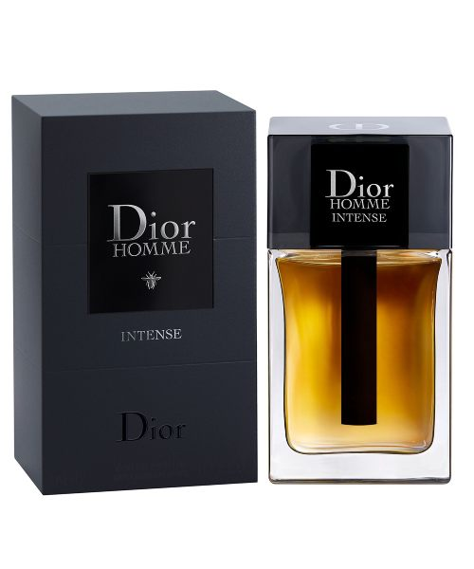  
HOMME by dior:

21,000

Dior Homme Parfum by Dior is **a Leather fragrance for men**. Dior Homme Parfum was launched in 2014. The nose behind this fragrance is Francois Demachy. Top notes are Tuscan Iris and Italian Orange; middle notes are Leather and Rose; base notes are Sandalwood, Ambrette (Musk Mallow), Agarwood (Oud) and Cedar.