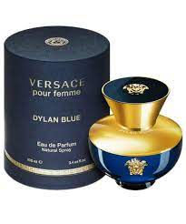DYLAN BLUE WOMEN:

14,999

In the words of Donatella Versace, "Dylan Blue pour femme is **a tribute to femininity**. It is a strong, sensuous, refined fragrance created for a woman who knows the power of her sensuality and mind.” The amphora-shaped bottle evokes Greek mythology, embellished by Medusa emblems.