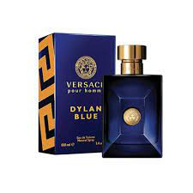DYLAN BLUE MEN:

The fragrance **bold ambrox notes, refreshed with hints of bergamot and grapefruit**. The earthy and citrusy olfactory notes are enveloped with black pepper, papyrus wood and incense, along with mineral musk, tonka beans and saffron.