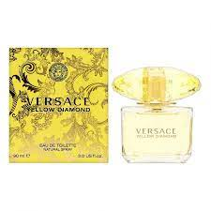YELLOW DIAMOND:

14,500

**A fragrance reminiscent of the magical, warm feeling of the sun on the skin and the intoxicating light of summer sunsets**. Versace Yellow Diamond has a floral aroma with crisp fruity and woody accents for a sensual and feminine, velvety touch.