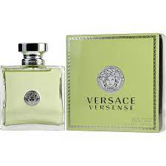VERSENCE women:

12,500

Features. **MEDITERRANEAN NOTES**: This fragrance contains exotic scent notes of sea lily, jasmine petals, cedar musk, olive wood, sandalwood , green mandarin, fig zest, bergamot, accords, rare flowers & more! It is reminiscent of Greece itself.