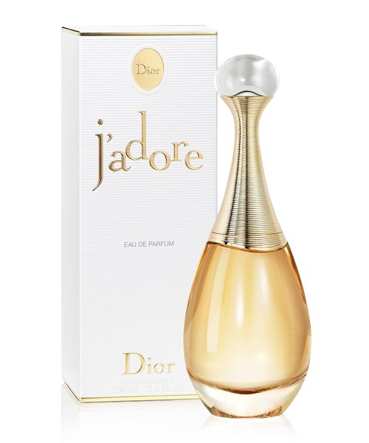J ADORE:

12,000

 An iconic House of Dior perfume for women, J'adore Eau de Parfum is **an irresistibly seductive floral composition**. The fruity-floral notes of ylang-ylang essence combine with the warmth of Damascus rose essence and jasmine for a supremely feminine and mysterious fragrance.