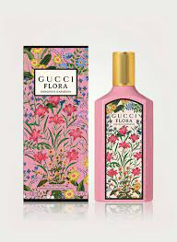GUCCI FLORA:

16,000

**Flora by Gucci Eau de Parfum** by **Gucci** is a Floral fragrance for women. **Flora by Gucci Eau de Parfum** was launched in 2010. Top notes are Peony, Citruses and Mandarin Orange; middle notes are Osmanthus and Rose; base notes are Sandalwood, Patchouli and Pink Pepper.