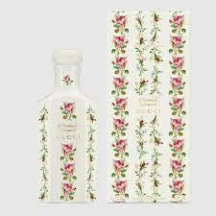MOONLIGHT SERENADE:

56,000

Moonlight Serenade is a **lavender acqua profumata**. Its vintage accord, truly invigorating, will tint the eaux de parfum with bracing aromatic shades. ALCOHOL DENAT., AQUA/WATER/EAU, PARFUM/FRAGRANCE, LINALOOL,COUMARIN, LIMONENE, GERANIOL, EUGENOL, CINNAMYL ALCOHOL.