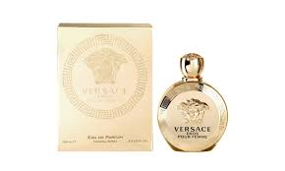EROS pour by Versace:

23,000

Versace Eros is **a fragrance for a strong, passionate man, who is master of himself**. Eros interprets the sublime masculine through a luminous aura with an intense, vibrant, and glowing combination of fresh mint leaves, Italian lemon zest, and green apple.