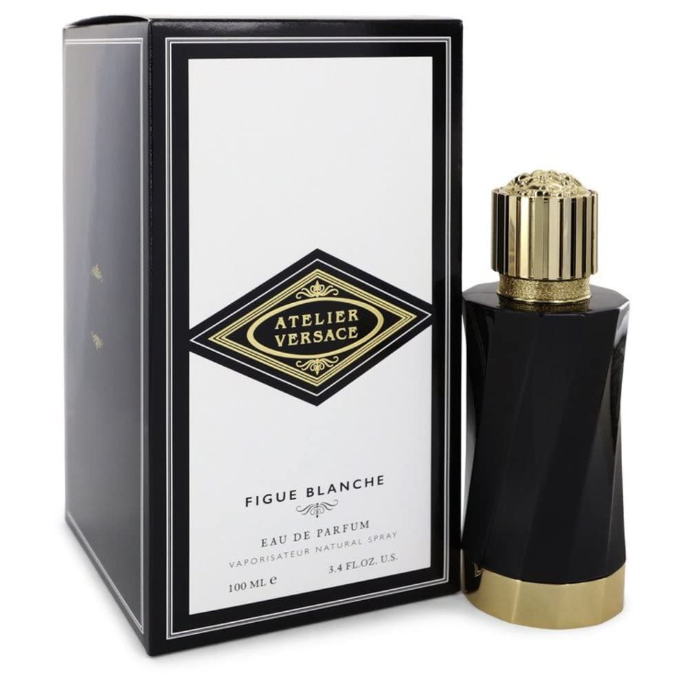FIGUE BLANCHE by versace:

11,400

Evoking the Mediterranean summer, Figue Blanche **encompasses fresh fig notes mixed with the pulp and essential oils of the Italian mandarin**.