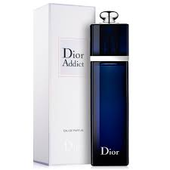DIOR ADDICt:

26,000

Dior Addict is **an instant, immediate statement.** **It is full without being opulent and charming without being too demonstrative**. Grown in southern Italy, Essence of Bergamot is obtained by cold expression of the peel. It brings a distinct, sweet freshness to fragrances and adds a special radiance to citrus notes.

DIOR ADDICT:

Dior Addict is **an instant, immediate statement.** **It is full without being opulent and charming without being too demonstrative**. Grown in southern Italy, Essence of Bergamot is obtained by cold expression of the peel. It brings a distinct, sweet freshness to fragrances and adds a special radiance to citrus notes.