e-Port IP Core
Specifications document

Document History
V0.3 DRAFT

Introduction
The e-port IP core is a macro block designed to interface the User Application Logic residing in a generic Front-End ASICs with the Gigabit Transceiver (GBT) chip set via a communication protocol defined by the GBT called “e-link”. It implements the e-link electrical interface and a serializer/deserializer block which matches the one contained in the GBT.

Features
Electrical interface based on the SLVS electrical protocol (see ref ???).
Synchronous operation at 80, 160 or 320 Mbps.
Deterministic link latency.
Full-duplex bi-directional operation.
GBT interface:
- 3-signal protocol: data input, data output, clock. Clock provided by GBT.
User interface:
- 8-bit data input bus
- 8-bit data output bus
- 40 MHz clock output
- Received clock output
Automatic data synchronization on the serial data input line.
No configuration required. Operation mode obtained by wiring some mode lines at block integration stage.
SEU-robust design.
Low-power design.
Available for ASIC implementation in CMOS 130nm technology.

General Description

Block diagram

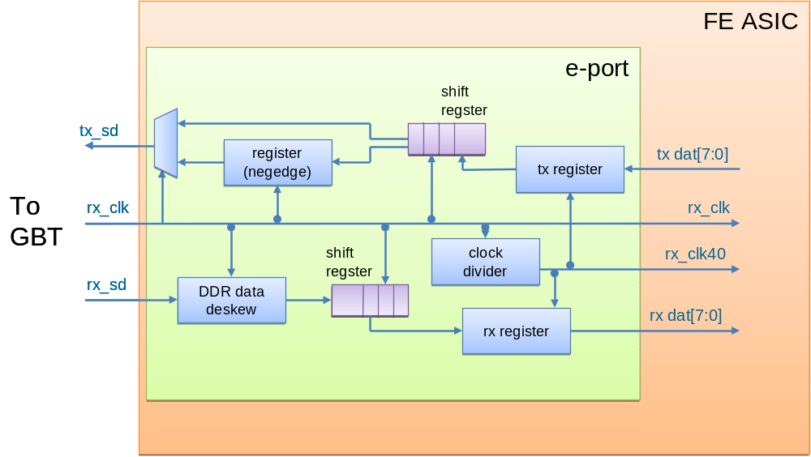
Figure 3-1 Block diagram of the e-port.

Block configuration mode pins
Parameter | Width | Default | Description
DATA_RATE | 2 | 0x0 | Sets the clock divider for the generation of the 40 MHz clock. Set to:  - 0 for 80 Mbps;  - 1 for 160 Mbps;  - 2 for 320 Mbps.  - 3 (reserved)

I/O Signal Description

FE side signals
Port | Width | Direction | Description
rx_clk | 1 | Output | Received clock
rx_clk40 | 1 | Output | 40 MHz received clock
tx_dat | 2 @ 80 Mbps  4 @ 160 Mbps  8 @ 320 Mbps | Input | Data to be transmitted. Depending on DATA_RATE, most-significant bits are ignored.
rx_dat | 2 @ 80 Mbps  4 @ 160 Mbps  8 @ 320 Mbps | Output | Received data. Depending on DATA_RATE, most-significant bits shall be ignored.

SLVS port connections
Port | Width | Direction | Description
rx_sd | 1 | Input | Transmitted serial data
tx_sd | 1 | Output | Received serial data
rx_clk | 1 | Input | Received clock

The e-Port
The e-Port is an IP block implementing serialization/deserialization. A copy of the e-port should be instantiated in the user application ASIC, at the other end of the link. In this case, the data and the clock output are given with a deterministic latency with respect to the off-detector electronics e-link transmit strobe input.
No word or symbol synchronization is provided by the e-Port. No framing is defined at the e-Port level; the user must implement framing if needed.
The e-Port provides serialization/deserialization at double data rate (DDR), therefore the clock frequency is half of the bit rate.

