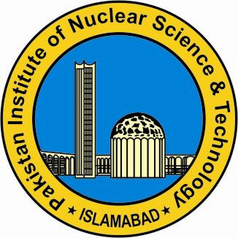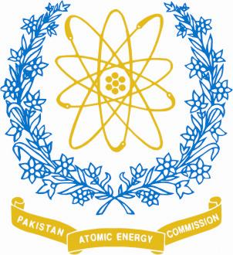

**Workshop on Physics**

**in Perspective of Pakistan' s Collaboration with CERN and SESAME**

**November 14-15, 2016**

***Organized By***

**Physics Division, PINSTECH, Islamabad, Pakistan**

**Registration form**

**Name:** AlishbaKanwal **Father's Name:** Sadaqat Ali

**Date of Birth:** 07-Mar-1992

**E-Mail:** alishba.kanwal@cern.ch **- Cell/Phone number:** 0324-5005573

**Department/University:** Department of Electrical Engineering, School of Electrical Engineering and Computer Science (SEECS), NUST, Islamabad

**CNIC number:** 37406-1499932-2

**Present address:** House#627, street#101, G-9/4, Islamabad

**Permanent address:** House#627, street#101, G-9/4, Islamabad

**Field of Specialization:** Other (Electrical Engineering)

1. Experimental Particle Physics
2. Theoretical Particle Physics
3. Material science/Synchrotron Radiation
4. Other

**Current Status:** MSc student

1. M.Sc/M.Phil Student
2. Ph.D Student
3. Faculty member/researcher

**Accommodation Required** No

1. Yes
2. No

Please send the filled registration form along with CV and recent photograph (including list of publications) before 15 September, 2016, to the following:

**Contact Persons:**

Dr. ZafarYasin (zyasin@cern.ch) Ph: 051 9248824/03468632826

Mr. Safeer Hussain (safeer_senior@yahoo.com)

Dr. Nawab Ali (nawab_71@yahoo.com)