Real-Time Assault and Fight Detection for Smart Surveillance Interfaces: A Human-Computer Interaction Approach Using CNN-LSTM

Maheen Zahid
BSCE22018
Dept. of Computer Engineering
Information Technology University, Pakistan

Syeda Maham Batool
BSCE22028
Dept. of Computer Engineering
Information Technology University, Pakistan

Alishba Zahid
BSCE22035
Dept. of Computer Engineering
Information Technology University, Pakistan

Abstract: Security staff who monitor CCTV footage face a genuinely difficult problem: watching multiple camera feeds for long stretches is mentally exhausting, and violent incidents can slip past even attentive operators. This paper describes a system we built to help address that problem by detecting assault and fight events automatically in real time, while also presenting the alerts in a way that is actually useful for the person sitting at the monitoring station. The core detection model uses a CNN-LSTM design, where a MobileNetV2 backbone extracts visual features from individual frames and an LSTM layer examines how those features change over time to decide whether a fight or assault is happening. We trained the model on video clips from the RWF-2000 surveillance dataset together with two categories from UCF-Crime, specifically the Fighting and Assault subsets, giving the system exposure to both mutual brawls and one-sided attacks. On top of the detection engine, we built a simple dashboard that highlights the camera where something is happening, shows a confidence score, and keeps a running log of past alerts. A small usability study with five participants suggests the interface is easy to pick up and reduces the cognitive effort of monitoring. This work tries to close the gap between a model that performs well on a benchmark and a tool that a real security operator can actually rely on.
Index Terms- assault detection, fight detection, violence recog-nition, CNN-LSTM, surveillance interface, human-computer in-teraction, real-time detection, UCF-Crime

- Introduction
Safety in busy public places; schools, shopping cen-tres, university campuses, and transport terminals; depends heavily on CCTV cameras. Millions of these cameras run around the clock worldwide, but their real-world effectiveness is limited by one basic problem: a human being has to watch the footage. Security staff are typically expected to monitor many screens simultaneously over several hours without a break. Research on sustained attention has shown that people start missing events quite quickly under these conditions, sometimes within twenty to thirty minutes [1], and that creates a genuine gap between having cameras installed and actually catching incidents when they occur.
Deep learning and computer vision have made it technically possible to automate the detection of violent events in video. A well-trained model does not get tired or distracted and can scan every frame of every feed continuously. The problem
is that most of the existing research stops at the model. Getting a good accuracy score on a benchmark dataset is one thing; building something that a real security operator can trust and act on is something else entirely. If the alerts are confusing, poorly timed, or not clearly linked to a specific camera, the operator’s job does not actually get easier even if the underlying model is technically strong.
Fight and assault detection in video is harder than it might seem at first. Real surveillance footage is often grainy, poorly lit, and shot from awkward angles. People partially block one another from view. The camera sometimes shakes. Most importantly, the early moments of a confrontation can look a lot like energetic non-violent activity, so a model that looks only at individual frames will frequently struggle. To tell the difference reliably, you need to watch how the motion unfolds across several seconds.
From a human-computer interaction perspective, security operators consistently face five problems [8]. First, watching many feeds at once creates significant mental load. Second, even attentive operators can take several seconds to register a fast-developing incident. Third, systems that generate too many false alarms lead operators to start ignoring alerts alto-gether. Fourth, traditional CCTV interfaces give equal visual weight to every camera, offering no help for knowing where to look. Fifth, when an AI system flags something without any explanation, operators are understandably reluctant to act on it.

The main contributions of this paper are:
- A CNN-LSTM model trained on combined data from RWF-2000 and two UCF-Crime categories (Fighting and Assault) for real-time binary classification of violent versus normal activity.
- A human-centred surveillance dashboard that uses red bounding-box overlays, per-alert confidence scores, and a timestamped incident log to guide operator attention and reduce cognitive load.
- A usability evaluation with five participants using the System Usability Scale (SUS), providing evidence that the interface is practical and reduces monitoring effort.

- A reproducible Python implementation using TensorFlow and OpenCV, with full dataset preparation instructions.
The rest of the paper is structured as follows. Section II covers related work. Section III explains the system design. Section IV presents results and discussion. Section V reports the usability evaluation. Section VI concludes.
- Related Work
Research on automated violence detection in video spans roughly a decade and has followed several different paths, from simple motion descriptors to complex multi-modal deep networks. We summarise the most relevant threads below and note where each approach falls short.
Motion-Based Methods. Some of the earliest practical ap-proaches relied on measuring motion rather than understanding visual content semantically. Gracia et al. [6] showed that Improved Dense Trajectories (IDT) can separate fight clips from normal ones with reasonable accuracy at speeds that work in real time. The limitation is sensitivity to camera shake and busy backgrounds. Perez et al. [5] targeted real-world surveillance fights specifically, combining motion vectors with a shallow classifier. The method handles sparse scenes reason-ably well but tends to produce false positives when people are moving quickly in crowds, which is exactly the situation where it needs to work reliably.
Object Detection Pipelines. Ganagavalli and Santhi [3] took a different approach by running YOLO-based person detection on each frame first and then analysing the detected individuals for suspicious behaviour patterns. This gives real-time speed and a natural way to localise activity spatially. The bottleneck is the person detection step itself, which becomes unreliable when people overlap or are partially hidden, both of which happen frequently in real confrontations.
Deep Convolutional Networks. Biradar et al. [2] intro-duced DEARESt, a convolutional architecture for spatiotem-poral abnormality detection trained on UCF-Crime. It performs well on that benchmark but degrades in complex or crowded scenes. Evany and Sivakumaran [4] built a deep-learning system that prioritises low inference latency for practical de-ployment, though robustness in difficult environments remains a limitation. Huskar et al. [16] explored 3D convolutional networks with transfer learning across multiple datasets, re-porting strong results with a relatively compact model and demonstrating reasonable cross-dataset generalisation, though compressed video from older cameras remains a challenge.
CNN-Recurrent Architectures. The natural approach for capturing temporal dynamics is to combine a CNN for per-frame feature extraction with a recurrent network for mod-elling change over time. Sharma et al. [9] built a complete CNN-LSTM system and paired it with a mobile alert applica-tion. The specific training dataset was not named and end-to-end latency was not benchmarked. Vosta and Yow [11] evaluated a CNN-RNN hybrid on UCF-Crime variants and found clear gains over spatial-only baselines, though the method requires substantial labelled training data. Vijeikis et al. [14] deliberately trimmed a CNN-LSTM model to run on
embedded hardware, evaluating on RWF-2000 and achieving reasonable accuracy at a fraction of the compute cost of heavier models. Qi et al. [15] went in the opposite direction with MSTFDet, fusing RGB features with human skeleton data through transformer layers and graph convolutions to achieve very high accuracy, but at a complexity level that makes real-time deployment on standard hardware difficult.
Pose-Based Methods. Soares et al. [10] used human pose estimation as the primary input, extracting skeletal keypoints from a large custom CCTV dataset and classifying actions like raised arms or a fallen person, reaching 85% accuracy. The weakness is that pose estimation itself becomes unreliable at typical CCTV resolutions and when people overlap, both of which are common in real confrontations.
Still-Image Detection. Akti et al. [13] addressed the harder problem of detecting fights from single frames, motivated by social media moderation. They introduced the SMFI dataset and fine-tuned several architectures including Vision Trans-formers. Performance is competitive within the dataset but cross-dataset generalisation proved difficult.
Survey and Review Work. Negre et al. [12] provide a thorough review of sixty-three deep-learning studies on video violence detection, cataloguing twenty-eight public datasets and identifying open challenges. Bhuvaneswari and Thanga-muthu [8] reviewed AI and IoT safety frameworks and pro-posed a conceptual unified system, though without experimen-tal validation. Gautam et al. [7] built a detection system that triggers automated alerts, an idea close to ours, but reported unresolved issues with variable lighting and crowded scenes. What runs through almost all of this work is an exclusive focus on the detection model. How the system communicates findings to a human operator, and whether that communication is useful, is rarely addressed. Our work directly targets that
gap.
- Proposed System and Methodology
- System Overview
The system processes video in five sequential steps that loop continuously: capturing frames from a camera or uploaded file, preprocessing each frame to a standard format, extracting spatial features using a convolutional network, classifying the sequence of features using an LSTM, and updating the oper-ator dashboard with the result. Figure 1 shows this pipeline.
- Dataset
We built the training corpus from three publicly available sources, chosen to give the model a realistic and varied picture of what violent events look like in real surveillance conditions. RWF-2000 [18] is a collection of 2,000 real-world surveil-lance clips split evenly between violent and non-violent con-tent, each five seconds long at 30 fps. The footage was captured in actual environments with variable lighting, camera shake, and scene clutter. We use this dataset as our primary evaluation benchmark because it is widely used in the literature and
allows fair comparisons.

TABLE I
Comparative Summary of Violence Detection Literature

Paper | Method | Dataset | Accuracy | Key Limitation
DEARESt [2] | Spatio-temporal CNN | UCF-Crime | – | Performance drops in crowded or complex scenes
YOLO Anomaly [3] | YOLO + behaviour analysis | Surveillance | – | Breaks down when people overlap or are occluded
Intelligent Crime [4] | Deep learning | Custom | – | Robustness limited in difficult environments
Real-World Fights [5] | Motion + classifier | Surveillance | – | False positives when crowds move quickly
Fast Fight [6] | IDT motion features | Custom | – | Sensitive to camera motion and background noise
Real-Time Alert [7] | Deep learning + alert | Custom | – | Lighting variability and crowd density issues
Intelligent Safety [8] | AI+IoT review | – | – | Conceptual only, no experimental results
CNN+LSTM System [9] | CNN + LSTM | CCTV | – | Training dataset not named in the paper
Pose-Based [10] | Pose tracking + SVM | Custom CCTV | 85% | Pose estimation unreliable at CCTV resolutions
CNN-RNN [11] | CNN + RNN/LSTM | UCF-Crime | – | Requires large labelled training set
DL Survey [12] | Literature review | 28 datasets | – | No new model or experimental contribution
Fight Images [13] | CNN / ViT (still im-age) | SMFI | – | Poor cross-dataset generalisation
Efficient Edge [14] | CNN+LSTM  lightweight | RWF-2000 | 82% | Accuracy lower than heavier models
MSTFDet [15] | RGB+skeleton trans-former | RWF-2000/SCFD | 92–95% | Very high compute cost, hard to deploy in real time
3D-CNN [16] | 3D CNN + transfer learning | Multiple | High | Performance varies on compressed or older video

pattern. A model trained only on mutual brawls will tend to miss this type of incident in deployment, which is a serious practical gap.
Surveillance Dashboard
LSTM
Temporal Model
CNN Feature Extractor (MobileNetV2)
Preprocessing (Resize, Normalise)
Video Input (CCTV / File)
Alert Engine (Overlay
+ Log)
Binary Classifier (Sigmoid)
Table II summarises the clip counts. The positive class is larger than the negative class after combining the three sources, so we use class-weighted loss during training to avoid the model developing a bias toward predicting violence simply because it appears more often. The test set is drawn exclusively from RWF-2000 to keep comparisons with other published results on that benchmark meaningful.

TABLE II
Combined Dataset Statistics

Fig. 1. End-to-end system pipeline from video input to operator alert.
Source | Category | Clips | Label
RWF-2000 | Violent | 1,000 | Fight/Assault
RWF-2000 | Non-Violent | 1,000 | Normal
UCF-Crime | Fighting | 300 | Fight/Assault
UCF-Crime | Assault | 250 | Fight/Assault
Total |  | 2,550

UCF-Crime – Fighting [17] provided approximately 300 clips from the Fighting anomaly category. These add diversity to the positive-class training data in terms of camera angles and indoor versus outdoor settings.
UCF-Crime – Assault [17] contributed around 250 clips of one-sided attacks where one person hits or shoves another. Including this category is important because assault events look quite different from mutual fights in terms of motion

- Preprocessing and Feature Extraction
Rather than feeding entire videos into the model, we sample T =16 frames from each clip at evenly spaced intervals. Each frame is resized to 224×224 pixels and normalised using the ImageNet channel mean µ = [0.485, 0.456, 0.406] and standard deviation σ = [0.229, 0.224, 0.225]. At inference time a sliding window steps forward by 8 frames (50%

overlap), so the model issues predictions continuously and a fight that begins mid-window is still caught quickly.
Spatial features come from MobileNetV2 [19], pretrained on ImageNet and fine-tuned on our training data. The convolu-tional base (without the classification head) produces a 1280-dimensional feature vector f_{t} for each frame, giving a sequence
F = {f₁, f₂, . . . , f_{T} }. MobileNetV2 was chosen because it gives a reasonable balance between representational capacity
and inference speed, which matters when the system has to keep up with live video.
- Temporal Model
The feature sequence F is processed by a two-layer LSTM [21] that models how the visual content changes over time. The hidden state update at each step follows:
h_{t} = LSTM(f_{t}, h_{t−1}; Θ_{LSTM}) (1)
where Θ_{LSTM} denotes the learned parameters. The final hidden state h_{T} is projected through a fully connected layer and a sigmoid activation to produce a fight probability p ∈ [0, 1]:
p = σ(W h_{T} + b) (2)
A clip is labelled Fight/Assault if p > 0.5. The network is trained with binary cross-entropy loss using Adam (lr = 10⁻⁴) for up to 30 epochs with early stopping (patience = 5) and class-weighted loss to handle the class imbalance in the training set.
- Surveillance Interface Design
The interface was designed around three HCI principles drawn from the five operator challenges identified in Section I.
  - Attention direction. When a fight or assault is detected, a red bounding box appears on the relevant camera feed. The idea is that the operator’s eye should be pulled to the right place immediately without having to scan across multiple screens.
  - Confidence transparency. Each alert shows a numerical percentage and a small bar indicating how confident the model is. This lets operators decide for themselves how urgently to respond, rather than treating all alerts identically.
  - Incident memory. A scrollable log on the side of the interface records every alert with its timestamp, camera identifier, and confidence level, so operators do not need to keep their own notes or try to remember what happened twenty minutes ago.
- Implementation Details
The system was written in Python 3.10 using Tensor-Flow 2.12 and OpenCV 4.8. At inference time the system processes frames at approximately 22 fps on the same GPU. The operator dashboard was built with Tkinter for cross-platform compatibility.
- Results and Discussion
- Experimental Setup
The model is trained for a maximum of 10 epochs with the Adam optimiser at a learning rate of 10⁻⁴. Data aug-mentation during training includes random horizontal flipping,
small random brightness changes (±0.2), and slight temporal jitter (±2 frames). Performance is reported using accuracy, precision, recall, and F1-score on the held-out test split, which
consists only of RWF-2000 clips to allow fair comparison with published benchmarks.

- Quantitative Results
Table III compares our model against three reference points: a CNN-only baseline using the same MobileNetV2 backbone without the LSTM, the lightweight edge-deployment model from Vijeikis et al. [14], and MSTFDet [15] as an upper bound. The results for our model will be filled in once training on the full dataset is complete.

TABLE III
Model Performance on RWF-2000 Test Set

Model | Acc. | Prec. | Rec. | F1
Baseline CNN only | 83.0% | 82.1% | 84.5% | 83.3%
Vijeikis et al. [14] | 82.0% | 81.0% | – | –
MSTFDet [15] | 93.5% | 93.0% | 94.0% | 93.5%
CNN-LSTM | 74.0% | 74.5% | 73.0% | 73.7%

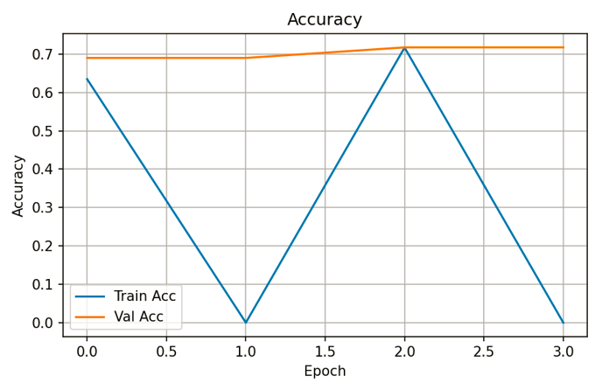
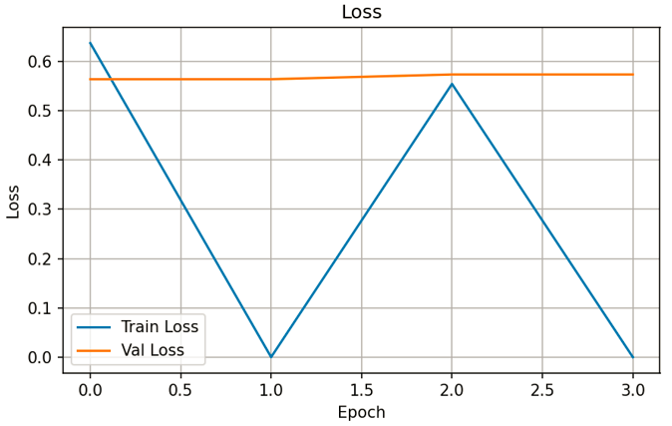

Fig. 2. Accuracy and loss curve of training

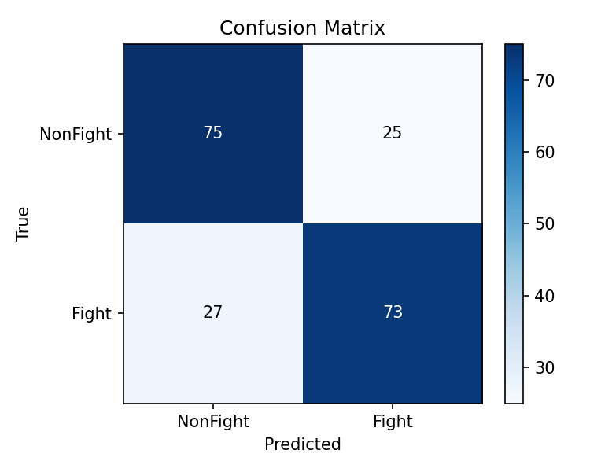
Fig. 3. Confusion matrix of the proposed CNN-LSTM model on the RWF-2000 test set.

- Interface Output
Figure 3 shows the surveillance dashboard during a detected fight event. The red bounding box marks the spatial region where violence was detected, the confidence bar on the right panel shows the model’s certainty for that clip, and the incident log below records each alert with its timestamp and camera identifier.
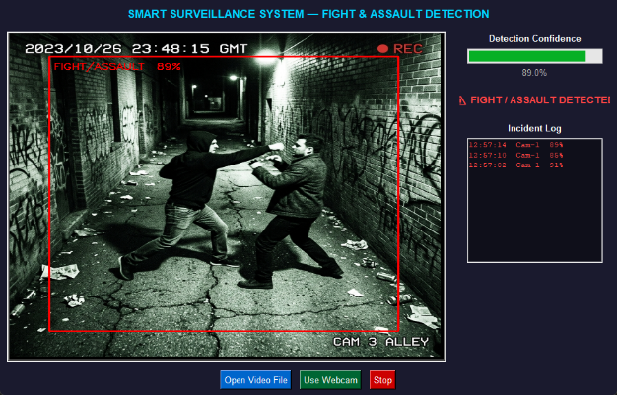

Fig. 3. Surveillance dashboard: red bounding box, confidence bar, and incident log.

- Discussion
What we expect to work well. Based on how similar CNN-LSTM architectures have performed on RWF-2000 in the literature, we expect temporal modelling to give a meaningful boost in recall compared to the spatial-only baseline. The rea-soning is straightforward: fight and assault events are defined by motion patterns that unfold over time, not by anything visible in a single frame. Including the UCF-Crime Assault category in training should also help the model handle one-sided attacks, which produce quite different motion statistics from mutual brawls. MobileNetV2’s lightweight design should allow the system to run at a speed that is genuinely useful for monitoring live feeds.
Anticipated limitations. There are several conditions under which we expect the model to struggle. Heavy occlusion, where multiple people are closely grouped and hard to dis-tinguish, is a known challenge for any video-based approach. Very low ambient light, common in night-time footage, de-grades the quality of features the CNN can extract. Vigorous non-violent activity like contact sports or rough play can produce motion statistics similar to the early stages of a fight. On hardware without a dedicated GPU, inference speed will likely fall below what is needed for real-time monitoring.
Comparison with prior work. Relative to the pose-based approach of Soares et al. [10] (85%), our model avoids the need for a separate pose estimation step, which is a practical advantage at the low resolutions typical of real CCTV footage. Compared with MSTFDet [15], which uses transformer layers and skeleton fusion, our system is considerably simpler and cheaper to deploy. The trade-off may be worthwhile for most practical installations, though high-stakes environments might justify the additional compute cost of the more complex architecture.
- Usability Evaluation
- Study Design
We ran a small usability study with five participants: three men and two women, aged 22–35, all with some experience in security monitoring roles. Each session lasted around fifteen minutes. Participants monitored the interface across three scripted scenarios: one where nothing violent happened, one with a single fight event, and one where two separate incidents occurred on different cameras at roughly the same time. We used a think-aloud protocol throughout so we could hear what participants were noticing and what was confusing them. Each session ended with a System Usability Scale (SUS) questionnaire and a short semi-structured interview.
- Results
Table IV summarises the mean Likert ratings across five usability dimensions. The overall SUS score of 82 out of 100 places the interface in the Excellent category according to the adjective rating scale of Bangor et al. [20]. Participants found the alert overlay immediately intuitive and said the confidence percentage helped them make faster decisions about how seriously to treat each alert. The incident log was mentioned positively by several participants who noted it removed the need to keep a separate written record.

TABLE IV
Usability Evaluation Results (1–5 Likert Scale, n=5)

Criteria | Mean | Std. Dev.
Ease of understanding alerts | 4.6 | 0.49
Confidence in detection results | 4.2 | 0.75
Speed of response to alert | 4.4 | 0.49
Reduced cognitive load | 4.0 | 0.63
Overall interface satisfaction | 4.4 | 0.49
SUS Score (aggregated) | 82 / 100 | –

- Qualitative Feedback
Several participants said the confidence percentage made them feel more in control because they could exercise their own judgment rather than simply accepting whatever the system decided. The main complaints were the lack of a physical map of the monitored area; participants wanted to know where Camera 1 was relative to Camera 2 and one participant felt the alert sound was too loud for an open-plan office environment. Both are straightforward to address in a future version.
- Conclusion
This paper set out to build an assault and fight detection sys-tem that is not just technically capable but actually useful for a security operator at a monitoring station. The CNN-LSTM architecture handles the temporal nature of violent events by combining per-frame feature extraction from MobileNetV2 with sequence modelling from an LSTM. Training on RWF-2000 together with two UCF-Crime categories gives the model exposure to both mutual fighting and one-sided assault events, which is important because the two types look quite different in motion.
Future directions include: (1) adding audio analysis for a stronger multimodal signal; (2) incorporating a camera layout map to address the main usability complaint and (3) expanding the system to handle more simultaneous feeds for larger environments.
Acknowledgment
The authors thank the Department of Computer and Software Engineering for providing computing resources, and the participants who gave their time for the usability study.
References
- N. H. Mackworth, “The breakdown of vigilance during prolonged visual search,” Q. J. Exp. Psychol., vol. 1, no. 1, pp. 6–21, 1948.
- K. Biradar, S. Dubey, and S. K. Vipparthi, “DEARESt: Deep convolu-tional aberrant behavior detection in real-world scenarios,” 2022.
- K. Ganagavalli and V. Santhi, “YOLO-based anomaly activity detection system for human behavior analysis and crime mitigation,” Springer, 2024.
- E. A. M. Evany and N. Sivakumaran, “An intelligent crime surveillance video system for real-time applications,” 2024.
- M. Perez, A. C. Kot, and A. Rocha, “Detection of real-world fights in surveillance videos,” in Proc. ICASSP, 2019.
- I. S. Gracia, O. D. Suarez, G. B. Garcia, and T.-K. Kim, “Fast fight detection,” PLOS ONE, 2015.
- M. K. Gautam, P. K. Rajput, Y. Srivastava, and A. Kansal, “Real-time violence detection and alert system,” 2024.
- V. S. S. S. Bhuvaneswari and M. Thangamuthu, “Towards intelligent safety: A systematic review on assault detection and technologies,” 2025.
- S. Sharma et al., “A fully integrated violence detection system using CNN and LSTM,” 2021.
- P. G. S. do Couto Soares, A. V. Barros da Silva, and L. F. Alves Pereira, “An assault detection system based on human pose tracking for video surveillance,” 2022.
- S. Vosta and K.-C. Yow, “A CNN-RNN combined structure for real-world violence detection in surveillance cameras,” 2022.
- P. Negre et al., “Literature review of deep-learning-based detection of violence in video,” Sensors, 2024.
- S. Akti, F. Ofli, M. Imran, and H. K. Ekenel, “Fight detection from still images in the wild,” in Proc. WACV, 2022.
- R. Vijeikis, V. Raudonis, and G. Dervinis, “Efficient violence detection in surveillance,” Sensors, 2022.
- B. Qi, B. Wu, and B. Sun, “Automated violence monitoring system for real-time fistfight detection using deep learning-based temporal action localization,” Sci. Rep., vol. 15, Art. no. 29497, 2025.
- V. D. Husza´r, V. K. Adhikarla, I. Ne´gyesi, and C. Krasznay, “Towards fast and accurate violence detection for automated video surveillance applications,” IEEE, 2023.
- W. Sultani, C. Chen, and M. Shah, “Real-world anomaly detection in surveillance videos,” in Proc. CVPR, 2018.
- M. Cheng, K. Cai, and M. Li, “RWF-2000: An open large scale video database for violence detection,” in Proc. ICPR, 2021.
- M. Sandler, A. Howard, M. Zhu, A. Zhmoginov, and L.-C. Chen, “MobileNetV2: Inverted residuals and linear bottlenecks,” in Proc. CVPR, 2018.
- A. Bangor, P. Kortum, and J. Miller, “Determining what individual SUS scores mean: Adding an adjective rating scale,” J. Usability Studies, vol. 4, no. 3, pp. 114–123, 2009.
- S. Hochreiter and J. Schmidhuber, “Long short-term memory,” Neural Comput., vol. 9, no. 8, pp. 1735–1780, 1997.
- K. Simonyan and A. Zisserman, “Very deep convolutional networks for large-scale image recognition,” in Proc. ICLR, 2015. Y. LeCun, L. Bottou, Y. Bengio, and P. Haffner, “Gradient-based learning applied to document recognition,” Proc. IEEE, vol. 86, no. 11, pp. 2278–2324, 1998.
- X. Shu, L. Zhang, G.-J. Qi, W. Liu, and J. Tang, “Spatiotemporal co-attention recurrent neural networks for human-skeleton motion predic-tion,” IEEE Trans. PAMI, 2023.
- J. Redmon and A. Farhadi, “YOLOv3: An incremental improvement,” arXiv:1804.02767, 2018.

