Game Design Document

Fill up the following document

1. Write the title of your project.
2. Zombie Land
3. What is the goal of the game?
4. Player has to achieve 300 coins to enter into next level.
5. Write a brief story of your game.
6. There is a man and Zombie in this game.

His aim is to achieve 300 coins to enter into next level.

To achieve 300 coins he has to face many hurdles like Zombie and other tasks.

1. Which are the playing characters of this game?

* Playing characters are the ones who respond to the user based on the input from the user.
* Cars, monkeys, dinos, wizards, etc., are the playing characters in the game.

|  |  |  |
| --- | --- | --- |
| Number | Character Name | What can this character do? |
| 1 | Man | A player who escape from Zombie and collects coins. |
| 2 | Zombies | This character restrict the player to collect the coins |

1. **Which are the Non-Playing Characters of this game?**

* Non-Playing characters are the ones that don't have an action or behavior when the user interacts with the game.
* Hurdles, stones, bananas, coins, etc., are non-playing characters in the game.

|  |  |  |
| --- | --- | --- |
| Number | Character Name | What can this character do? |
| 1 | Coins |  |
| 2 | Diamond |  |
| 3 | Treasure box |  |
| 4 | Bricks |  |

**Draw your imagination of this game. What does this game look like?**

* Draw the game either on your computer or on paper.
* Add images of the game scenes to show each of the playing and non-playing characters at least once.

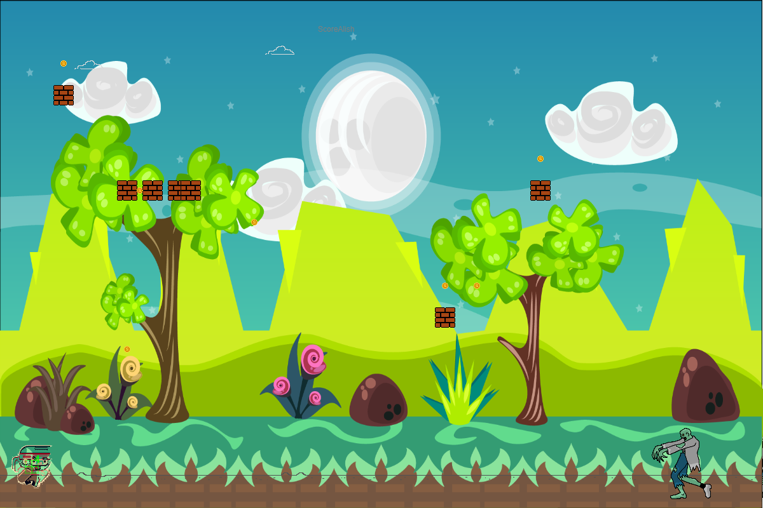

**How do you plan to make your game engaging?**

In my game it is not easy to collects coins.

As you collect coins you will score points

As you score 300 points you will get a diamond.

As you get diamond you will enter into next level.

And It is a challeging.

Player has to fight with Zombie that is a interesting. A player will engaged with this.