|  |  |  |
| --- | --- | --- |
| **ECS782P** | **Introduction to IoT Coursework**  **Ali Shehabi** | **200180517** |
|  | **Autonomous Car Parking Safety Sensor** |  |

**Chapter 1: Introduction**

## Project Overview & Background

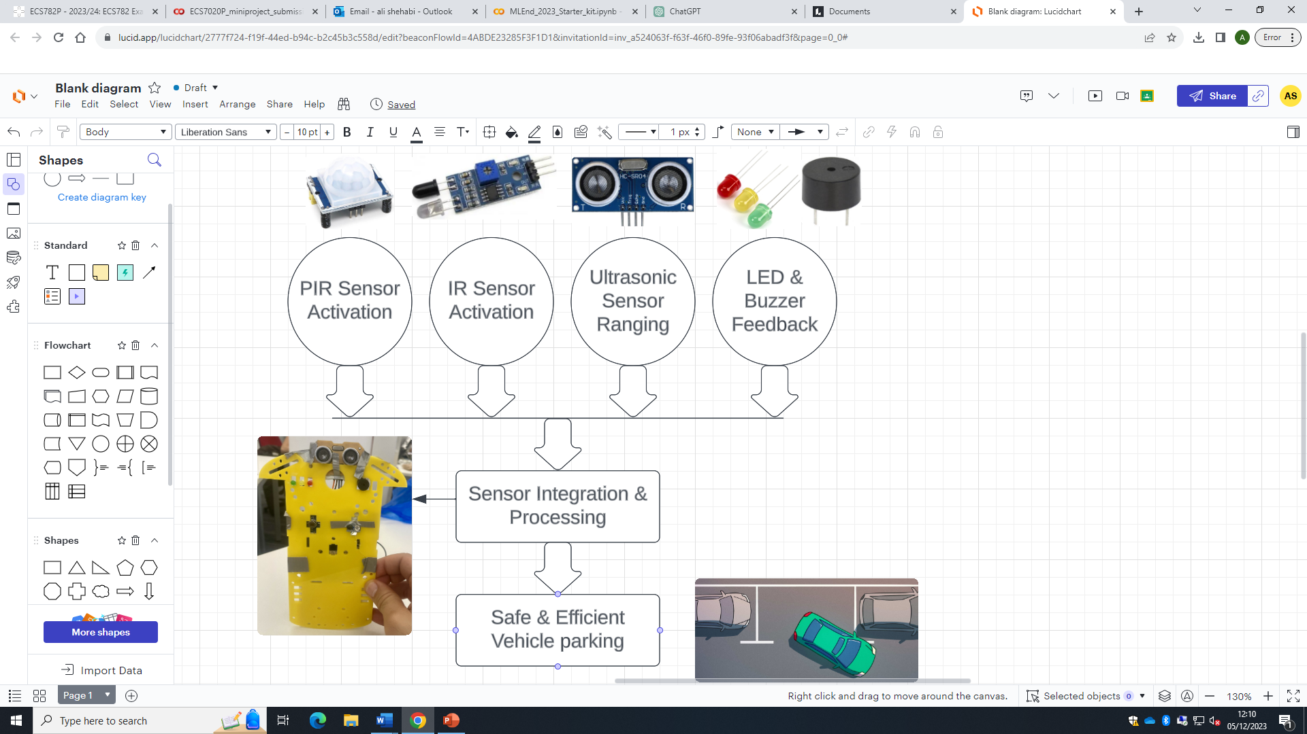

**Figure 1: SSM 2: Problem situation expression**

This project, an autonomous parking sensor system, tackles a common challenge faced in urban mobility – the safety of the vehicle whilst parking as well as the safety of its surroundings. The system produced integrates an array of sensors (PIR, IR and Ultrasonic), which affect the outcome of the systems LEDs and Buzzer, both of which aid the driver whilst parking. This represents a significant leap in making a very common everyday vehicle operation, much safer, more space efficient and at a quicker pace.

As the world’s population is rapidly increasing, and big cities grow, becoming more crowded, parking is becoming an increasingly scarce commodity, whilst also becoming more in demand. Therefore, there is a pressing need for smarter and more efficient parking systems. This system can either be mounted on walls in parking areas, or in the car itself, providing real-time feedback to drivers. This ensures that the parking assistance can be used regardless of the vehicle type or model, making this system universally available. This project therefore improves parking efficiency and contributes to the overall flow of traffic, as well as reducing the potential for parking-related accidents. Therefore, the system will provide real-time feedback whilst the driver performs parking manoeuvres. If implemented in the vehicle, the system can also be used as a general proximity safety sensor on the road, and not only limited to parking. The system not only enhances the safety of both the vehicle and the passengers but also aids the progression towards a fully autonomous vehicle.

## Relevance to IoT Problem Domains

## Making Buildings Smarter (Industry 4.0)

The possibility of integrating this project into buildings reflects the principles of Industry 4.0, which emphasizes automation, machine learning, and real-time data processing, which this project can provide. This system is an example of how IoT can make buildings smarter, more responsive and safer, which aligns with the Industry 4.0 visions.

In terms of **automation** and **interconnectivity**, this project provides a solution to a very common urban challenge – parking. The system can communicate with drivers through both visual and auditory signals autonomously, allowing the building to interact and aid the vehicle users to safety. This interactivity between the 2 entities is one of the key aspects of what makes a building smarter, as the system processes, communicates, and responds to its surroundings, without the need for human interaction **[1]**. Another aspect of Industry 4.0 that this project addresses is **Data-driven decision-making**. The parking sensor collects data through its array of sensors, which is in terms of motion detection and distance of the object/vehicle. Then based on the data obtained, the system performs different actions, allowing it to react to information provided by its environment.

The final aspect that this project addresses is Energy efficiency and sustainability. This is because it facilitates quicker, more efficient and safer parking. It would help reduce traffic congestion in the parking areas, which would reduce emissions released, as the vehicles would take less time to park. It also improves space efficiency, as getting the cars as close to the walls as possible may result in the parking area accommodating a higher capacity. This indirectly would make the building more sustainable, as it would reduce the time the cars have to be operating, further reducing emissions.

The same arguments could be used for addressing a smart object in the home, where this system could be integrated with a garage door, opening it when it detects the vehicle, and ensuring it doesn’t get too close to the opening door.

## Enhancing Vehicle Safety whilst Parking

The autonomous parking sensor is critical for vehicle and passenger safety and efficiency, specifically in urban environments. Although this domain is not explicitly mentioned, it is an increasingly growing and important domain, given the fact that the industry is driving towards more autonomous vehicles, and the communication between the sensors in the vehicle and this system would overall significantly improve the safety of the vehicle.

One of the main benefits of this system is that it would cause a significant reduction in parking-related accidents by more than 30% **[2]**. The system provides real-time alerts. The system helps drivers avoid collisions with walls, other vehicles and even pedestrians, which is a common safety issue in high-capacity parking lots. This provides safety for both the vehicle and the surrounding property, as well as any pedestrians passing the area. The system may also improve safety by reducing the stress of drivers by guiding them safely and securely into the parking space, making the process smoother and quicker, making a collision less likely to occur as a result.

Therefore, this system effectively demonstrates how incorporating IoT technology in transportation solutions, along with using sensor fusion and smart systems, can help with tackling and solving everyday challenges faced in everyday life. Furthermore, this system can be integrated and used in a larger overall network, where parking systems may communicate with other smart infrastructures.

## Objectives & Scope

### Primary Objectives

1. Developing a system that enhances parking assistance, and aids drivers in parking vehicles safely, which in turn would reduce the risk of collision or property damage.
2. To utilise IoT principles and technologies, as well as a variety of sensors for real-time data processing and user interaction.
3. An easily understandable user interface, through both visual and auditory feedback to the driver through different LED colours and a buzzer, as well as displaying updates on the serial monitor for troubleshooting purposes.

### Functional Scope

1. Motion Detection: Both the PIR motion sensor and the IR sensor are used to initially detect if there is any motion, this reduces the energy and storage if an ultrasonic was solely used, as it would have to constantly be feeding data to the MCU unnecessarily, and also would waste energy as otherwise, the LEDs, and buzzers would constantly be on.
2. Distance Measurement: Using an Ultrasonic sensor to accurately measure the distance between the vehicle and a potential obstacle.
3. Feedback Mechanism: Implementing different coloured LEDs and a buzzer to communicate the distance and proximity warnings to the driver.

### Technical Scope

1. Hardware Implementation: Assembling a variety an Arduino UNO with multiple sensors (IR, PIR and Ultrasonic) and output devices (the LED and Buzzer).
2. Software Implementation: Writing and Testing code in the Arduino IDE to change the output based on the sensor data.
3. Design Optimisation and efficiency: ensuring that all the devices used don’t draw a lot of power, and making sure the system is accurate and adaptable to various environments.

### Target Users SSM 3:

Analyzing Different Stakeholder Viewpoints to Solve the Problem

* **Vehicle Driver’s Viewpoint:**  
  The Autonomous Parking Safety Sensor (PROCESS) detects obstacles and measures distances (INPUT) during parking manoeuvres. This data is communicated to the vehicle’s system and the driver (OUTPUT), presenting real-time visual and auditory alerts to assist in safe parking.
* **Heavy Goods Vehicle (HGV) Driver’s Viewpoint:**  
  For HGV drivers, the system (PROCESS) focuses on detecting objects in blind spots and larger distances (INPUT), vital due to the vehicle’s size. The alerts (OUTPUT) are crucial for safe manoeuvring in tight urban spaces, reducing the risk of accidents.
* **Warehouse Operator’s Viewpoint:**  
  For warehouse operators, the system (PROCESS) assists in efficiently managing HGV movement within their premises (INPUT). The data provided (OUTPUT) ensures safer and quicker vehicle parking and docking, critical for operational throughput.
* **Pedestrians and Cyclists’ Viewpoint:**  
  The Autonomous Parking Safety Sensor (PROCESS) plays a critical role in ensuring the safety of pedestrians and cyclists. The system is designed to detect these vulnerable road users (INPUT) when they are near a vehicle. Upon detection, it alerts the driver (OUTPUT) through auditory or visual signals, enabling them to take immediate action to prevent potential accidents. This feature is particularly beneficial in urban areas with high pedestrian and cyclist traffic. The system enhances situational awareness for drivers, contributing to safer urban mobility for all road users.

Mainly the Vehicle Driver’s and the Pedestrians’ Viewpoint is considered for solving the problem in the coursework.

**Chapter 2: System Requirements & Use Cases**

**2.1 Functional Requirements**

### Proximity Sensing and Distance Measure

* The system should detect the distances between the vehicle and an obstacle/wall accurately through the use of the HC-SR04 Ultrasonic sensor.
* The system should use the period of the ultrasonic wave to calculate the distance of the object and use this distance to provide real-time feedback if there is an obstacle in its proximity.

### Visual and Auditory Feedback Mechanism

* The system should use 3 different coloured LED indicators (Red, Yellow, Green), that autonomously change between them depending on the proximity of the vehicle. Red indicates very close proximity, Yellow for moderate proximity and green indicates a safe distance. Thee thresholds are defined explicitly in the code.
* The system should integrate a buzzer that varies in beeping frequency based on the proximity of the obstacle. The closer the object is, the faster the buzzer beeps.

### Motion Detection

* The PIR and IR sensor are both incorporated, to detect vehicle motion near the sensor, activating the whole system automatically if it does.
  + This increases the efficiency of the system, as the system is only activated when motion is detected, and deactivates when no motion is detected, optimising power usage.
  1. **Non-Functional Requirements**
* Reliability and Consistency: The system should perform accurately and consistently, with minimal failures or errors. High-quality components should be used and verified through datasheets and rigorous testing.
* Scalability and Adaptability: The design should accommodate future enhancements or the integration of additional sensors and components.
* User-Friendly Interface: The system should provide clear and intuitive feedback to users. This includes easily discernible LED colours and audible signals.

## User Requirements

* Ease of Use: The system should be straightforward and intuitive, requiring no specialized knowledge or interaction from the user.
* Safety Focus: Prioritize safety by minimizing the risk of parking-related accidents or collisions.
* Clear Communication: Provide unmistakable signals to the user, especially in indicating safe distances and imminent proximity to obstacles.

## Problem Statement

In urban areas, parking, especially in confined spaces, presents significant safety challenges. This is because these spaces are often confined with limited manoeuvrability, which increases the risk of an accident occurring. Drivers often are misguided or struggle with determining the distance between their vehicle and obstacles like the wall, which often leads to inefficient parking, and also often leads to collisions. There is also a serious problem from the pedestrian's viewpoint, as sometimes they would walk in the vehicles’ blind spots, putting them more at risk This project provides an effective solution, to assist drivers by providing accurate and understandable guidance, and ensuring the safety of the vehicle, driver, and pedestrians.

## Use Cases (SSM1)

### Use Case 1- Enhancing Driver/Vehicle Safety in Parking Manoeuvres

1. **Main Stakeholders Involved:** Drivers, Vehicles, and Urban Planners.
2. **What are their different Challenges?**
   * Drivers: Need for safer and more efficient parking, especially in tight spaces.
   * Vehicles: Prevents vehicle damage during parking.
   * Urban Planners: Efficient use of the space, which reduces traffic congestion.
3. **What are the System Boundaries?**
   * Areas where the parking sensors are installed.
   * Sensor range & accuracy.
   * Affects by the environment (e.g. rain, snow etc.).
   * Data processing speed.
4. **What important processes/tasks are taking place?**
   * Detecting the presence of vehicles using sensors.
   * Detecting the distance of vehicles using sensors.
   * Communication distance and safety using RYG LEDs and Buzzer.
   * Adjusting alert intensity based on how close the vehicle is.
5. **How can technology help overcome the problem?**
   * The system provides immediate feedback, which assists drivers in safely parking their vehicles.
   * Visual LEDs and audio signals help guide and alert the driver, which reduces the risk of a collision occurring and improves parking efficiency.
   * The technology is autonomous and doesn’t require human intervention.
   * The technology is compatible with a wide range of vehicles and drivers.

### Use Case 2- Optimising Parking Space Utilisation

1. **Main Stakeholders Involved:** Drivers, Property Owners, Residents, Local Authorities.
2. **What are their different Challenges?**
   * Drivers: Navigating and entering available parking spaces quickly and safely, more specifically in high-density areas.
   * Property Owners: a more efficient use of the available parking spaces, which would enhance the value of the property.
   * Local Authorities: Efficient use of the space, which reduces traffic congestion, and therefore reduces pollution to the environment.
   * Urban residents: access to a higher number of parking areas, allowing safe and convenient parking.
3. **What are the System Boundaries?**
   * Scalability.
   * Integration with other smart city infrastructures.
   * Dependent on constant power supply.
   * Impact of area lighting.
4. **What important processes/tasks are taking place?**
   * Continuous monitoring of parking space availability
   * Improving parking efficiency, which would allow more vehicles to be accommodated in the same space.
   * Real-time monitoring of vacant parking spaces, allowing new vehicles to enter them safely.
   * Interacts with the user, allowing them to know their surroundings.
5. **How can technology help overcome the problem?**
   * Enhancing the parking experience through immediate feedback on space availability and guidance.
   * Utilizing collected data to inform better urban planning and traffic management strategies, leading to more efficient and sustainable urban environments.
   * Leveraging the interconnectivity of smart city infrastructures to create a cohesive and efficiently managed urban ecosystem.

### Use Case 3- Parallel Parking on a busy street.

1. **Main Stakeholders involved:** Drivers, Pedestrians, Parked Vehicles
2. **What are their different Challenges?**

* Drivers: Navigating and parking in tight spaces, especially in between 2 cars
* Pedestrians:Safety concerns due to close-proximity parking
* Parked Vehicles: Ensuring that the vehicle parking wouldn’t hit the parked vehicles, possibly causing property damage.

1. **What are the System Boundaries?**
   * Operational Range: Effectiveness in street settings.
   * Sensor Sensitivity: Accuracy in detecting curb and vehicles in tight spaces.
   * Data Processing: Real-time response requirement.
2. **What important processes/tasks are taking place?**
   * Continuous monitoring of parking space availability
   * Improving parking efficiency, which would allow more vehicles to be accommodated in the same space.
   * Detecting Space Limitations: Sensing the distance to the curb and surrounding vehicles.
   * Alerting the Driver: Providing graded feedback for precise parking.
3. **How can technology help overcome the problem?**
   * Streamlined Parking: Aids in quick and safe parallel parking, minimizing traffic disruption.
   * Enhanced Driver Confidence: Reduces parking anxiety in busy areas, improving overall traffic flow.

### Use Case 3- Parking in Low visibility conditions.

1. **Main Stakeholders Involved:** Drivers, Vehicle Owners, Safety Regulators.
2. **What are their different Challenges?**

* Drivers: Difficulty parking in poor visibility conditions like fog or dim lighting.
* Vehicle Owners: Risk of damage under low-visibility circumstances.
* Safety Regulators: Ensuring parking safety in all conditions.

1. **What are the System Boundaries?**
   * Sensor Effectiveness: Maintaining accuracy in low-visibility scenarios.
   * Feedback Clarity: Providing clear alerts despite visual limitations.
2. **What important processes/tasks are taking place?**
   * + Maintaining Sensor Accuracy: Ensuring reliable measurements regardless of visibility.
     + Effective Alert System: Utilizing LEDs and buzzers for clear distance feedback.
3. **How can technology help overcome the problem?**
   * + - Compensating for Low Visibility: Offers reliable assistance when visual cues are insufficient, enhancing safety.
       - Flexible and Adaptive: Maintains performance, reassuring drivers in challenging conditions.

**Chapter 3: Design**

**3.1 Components Required**

|  |  |  |  |
| --- | --- | --- | --- |
| **Component** | **Description** | **Pros** | **Cons** |
| 46130 | Ultrasonic Distance Sensor HC-SR04 5V Version | RS  **Figure 2: HC-SR04 Ultrasonic Sensor** | * Utilised to gauge an object's distance through SONAR technology. * Transmits high-frequency samples through the trig pin. When the samples come into contact with the object, they rebound and return to the echo pin. * The sensor calculates the distance based on the time taken for this signal to return. * The sensor's maximum detection range is limited to 4 metres. * Suits project objective, which requires the system to determine how close the vehicle is to an obstacle and which LED to light up or how frequently the buzzer should sound based on the proximity of the object detected. | * Accurate Measurement. * Non-contact Sensing. * Wide Range. * Not affected by weather conditions. * Can sense all material types. | * Performance affected by temperature and humidity. * Accuracy depends on the reflectivity of the object's surface. |
| Arduino with PIR Motion Sensor | Random Nerd Tutorials  **Figure 3: HC-SR501 PIR Sensor** | * Detects changes in infrared energy levels within its environment, which occur when an object or person moves into its field of view. * PIR sensors do not emit infrared rays but detect the infrared radiated by objects in the vicinity. * It will serve as the primary trigger for the parking sensor system, ensuring that the system only activates when a vehicle approaches, conserving energy and reducing unnecessary activations **[3]**. | * Detects motion reliably whether day or dark. * Cheap & low power. | * Not as sensitive to very slow objects. * Not as accurate when the room itself is already warm. |
| Infrared (IR) Sensor Module with Arduino – A blog about DIY solar and  arduino projects  **Figure 4: IR Sensor** | * Operate by emitting an infrared signal and then detecting the reflection of an object or person. * They are best suited for outdoor use where they can face the direction of motion without the interference. * In the parking sensor system, the IR sensor will be installed facing the area where a vehicle will approach. * It provides a secondary mechanism of detection, ensuring the system's reliability in different settings, particularly in outdoor parking scenarios where the PIR sensor's performance may be compromised **[3]**. | * Low power consumption * Detects motion reliably whether day or dark. * Cheap * High response time. * Not affected by weather. | * Supports shorter ranges. * Lower data transmission. * Not as accurate when the room itself is already warm. |
| ELECTROPRIME 75 x 3mm Red Green Yellow Assorted Color LED Light Emitting  Diodes : Amazon.in: Electronics  **Figure 5: Red, Yellow, Green LEDs** | * Act as visual indicators that show the distance status. * Provide a visual reference for the driver to understand the vehicle's proximity to obstacles. * The LEDs will light up according to the distance measured by the sensors - green for safe distance, yellow for caution, and red for stop. | * Low power consumption. * Easy to configure. * Easy to understand. | * Easily burnout. * Fragile. |
| 100 PCS RESISTOR 220 OHM 1/4W 0.25W 250MW 5% ORIGINAL OEM PARTS | eBay  **Figure 6: 220Ω Resistor** | * Protect the LEDs by limiting the current flowing through them. * When powered by the 5V from the Arduino, these resistors ensure the current does not exceed the current rating of the LEDs (~20mA), preventing overheating and extending the LEDs' lifespan. |  |  |
| NodeMCU Peizo Buzzer on Arduino IDE | Sriparna's blog on Internet of Things  **Figure 7: Buzzer** | * An electromechanical component that provides auditory signals, alerting the driver through sound. * It emits a beeping sound that increases in rate as the vehicle moves closer to an obstacle, providing an auditory cue to the driver. | * Low Power Usage * Can change intensity and frequency | * Noise Pollution |
| Arduino UNO WiFi REV2 [ABX00021]: Amazon.co.uk: Computers & Accessories  **Figure 8: Arduino UNO Wi-Fi Rev2** | * Serves as the central processing unit for the system. * This model enhances the standard capabilities with integrated Wi-Fi functionality. * It comes with 14 digital I/O pins, crucial for interfacing with sensors and output devices. * Will handle input signals from the sensors and manage outputs to LEDs and a buzzer. * Programming is facilitated through the Arduino IDE, with a focus on leveraging its Wi-Fi capabilities for wireless communication and control. | * Has Wi-Fi Capability * Cost-effective * Energy Efficient * Programmable | * Limited Processing Power * Limited Storage |

**Table 1: Components Used**

**3.2 SSM5: Comparison of Model and Real World**

A comparison of the new model with the real world is made in this section. Most of the Parking Sensors available do not use the combination of IR and PIR Sensors, which makes the system work more efficiently. Implementing the buzzer, to release a sound at a higher rate the closer the detected object gets has not been implemented in other available projects, allowing the system to display the proximity of the detected object both visually and audibly.

|  |  |  |
| --- | --- | --- |
| **Priority** | **Chosen: Arduino UNO Wi-Fi Rev2 MCU** | **Not Chosen: Raspberry Pi Microcomputer** |
| **3 -High** | ++ Easier real-time processing for sensor data | ---More suited for complex computing tasks |
| **2- Medium** | ++ Lower cost, smaller in size | --- Generally higher cost, depending on the Model, and larger due to more on-board components |
| **2- Medium** | ++ Lower Power Consumption | --- Higher Power Consumption |
| **1- Low** | --- Limited to simpler tasks and sensor integration | ++ Capable of multitasking, and handling complex algorithms |

**MCU Chosen:**

**Table 2: MCU Comparison**

**Reason for Selection:** The Arduino was chosen for its simplicity and capability for real-time sensor data processing, which is necessary for the immediate response required by the parking safety sensor system. Its cost-effectiveness also makes it suitable for large-scale production. It also has a lower power consumption, making it work more efficiently. Even though it is only limited to simpler tasks, due to the reasons above, it is more suitable for this project.

**Distance Measurement Sensor chose:**

|  |  |  |
| --- | --- | --- |
| **Priority** | **Chosen: HC-SR04 Ultrasonic Sensor** | **Not Chosen: LiDAR Sensor** |
| **1-Low** | --- Relatively high accuracy | ++ Much more accurate |
| **2- Medium** | ++Cost effective | ---Much more expensive |
| **3- High** | Less complex, easier to integrate | Provides 3D mapping, but is much more complex |
| **3- High** | ++Accurate for long & short distance | ---Overly sophisticated for basic parking needs |

**Table 3: Distance Measurement Sensor Comparison**

**Reason for Selection:** Ultrasonic sensor was chosen for their cost-effectiveness and simplicity, which align well with the system’s goal of providing basic parking assistance without the need for complex 3D mapping. Furthermore, tests show that it is very accurate for both short and long distances

* 1. **Flow Chart of the System**

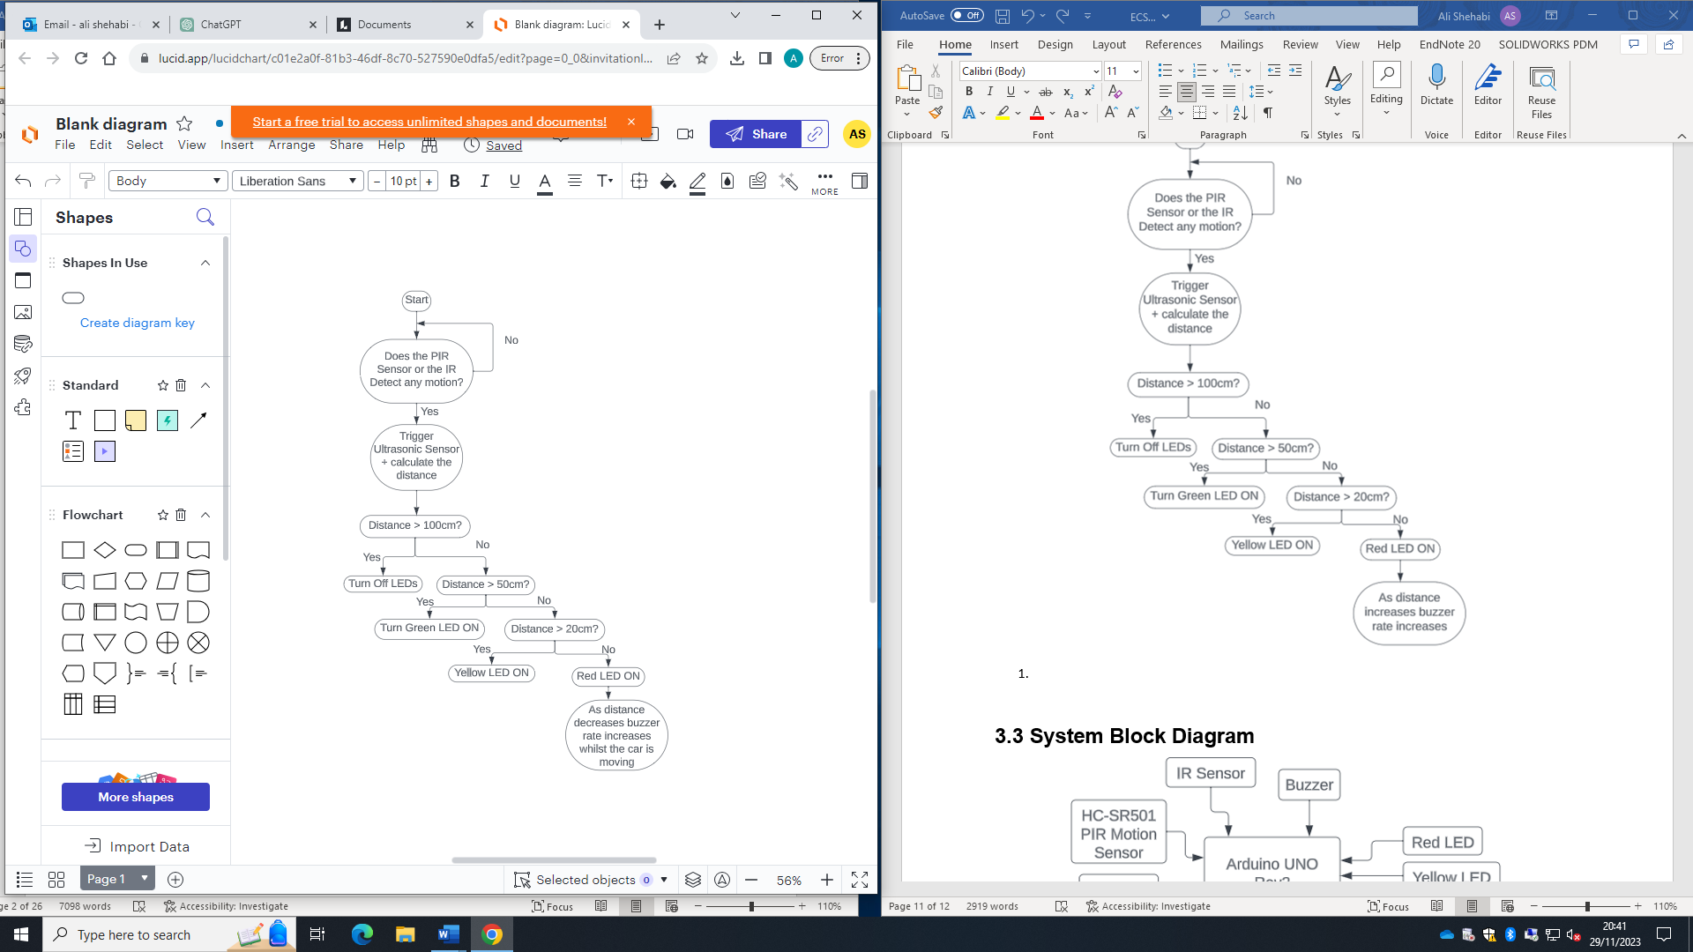

**Figure 9: Flow Chart of the System**

Explaining the flowchart above

1. When the system starts, initially, the PIR sensor and the IR sensor are used to detect motion – using both of these improves the accuracy and efficiency of the sensor because the user interface only activates when either of these sensors detect movement.
2. If there is motion detected the ultrasonic sensor gets triggered, however, if there isn’t, it will keep scanning the area to detect motion.
3. If the distance of the detected vehicle/obstacle is greater than 100cm, none of the LEDs turns on.
4. If the distance of the detected vehicle/obstacle is between 50cm and 100cm, the Green LED will turn on.
5. If the distance of the detected vehicle/obstacle is between 20cm and 50cm, the Green LED will turn on.
6. If the detected vehicle/obstacle is less than 20cm, the Red LED will turn on.
   1. Whilst the Red LED is on, the Buzzer will sound at a quicker rate the closer the vehicle/obstacle gets, eventually becoming a solid continuous beep, and stop buzzing once no motion is detected.
   2. **SSM 4: Conceptual Model of Systems**

Starting from goal 0, the design is developed by following Hierarchical Task Analysis (HTA).

**Goal 0:** User should be able to utilize autonomous parking sensors to safely park their vehicle in urban environments.

* T1 – Select the types of vehicles and parking environments where the system is required.
  + - T1.1 Select vehicle types that will benefit most from using the sensor system.
  + - T1.2 Identify urban parking scenarios (e.g., parallel parking, garage parking).
* T2 – Select the safety parameters that enhance parking.
  + T2.1 Select proximity detection ranges and alert thresholds.
  + T2.2 Identify types of alerts (audio, visual) to be used.
* T3 – Install the Autonomous Parking Safety Sensor (APSS) based on the requirement.
  + T3.1 Choose hardware components (sensors, microcontrollers).
  + T3.2 Make the necessary connections between components.
  + T3.3 Write program logic in Arduino IDE or a similar platform.
  + T3.4 Test the system for functionality.
* T4 – Calibrate sensors to accurately detect obstacles and vulnerable road users.
  + T4.1 Adjust sensor sensitivity and range.
  + T4.2 Test calibration in controlled environments.
* T5 – Using Sensors to Improve System Efficiency
  + T5.1 Configure IR/PIR sensors to serve as the primary detection method for movement near the vehicle.
  + T5.11 Activation of Ultrasonic Sensors
* T6 – Make decisions and take actions based on sensor data.
  + T6.1 If motion is detected from the IR/PIR Sensor, trigger the Ultrasonic Sensor.
  + T6.2 If an obstacle or road user is detected within the set range, Display the corresponding LEDs.
  + T6.3 If an obstacle or road user is detected within the set range, trigger the Buzzer.

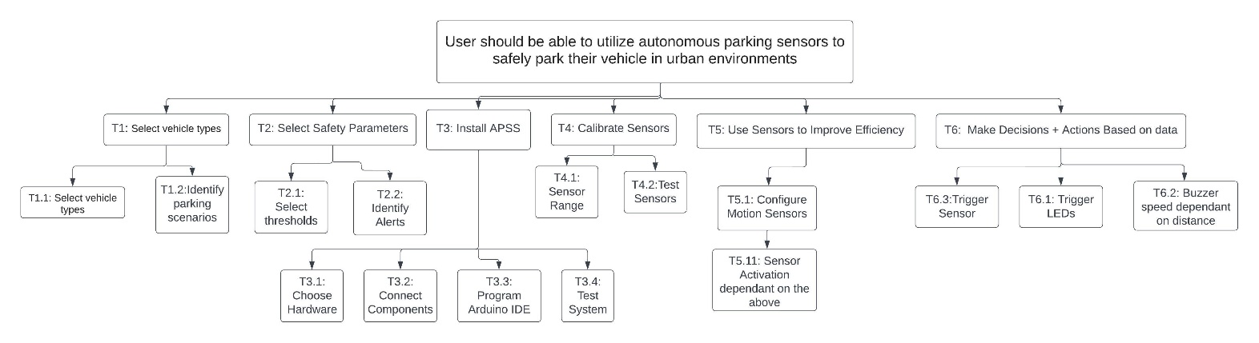

**Figure 10: Conceptual Model (Clearer When Zoomed in)**

* 1. **System Block Diagram**

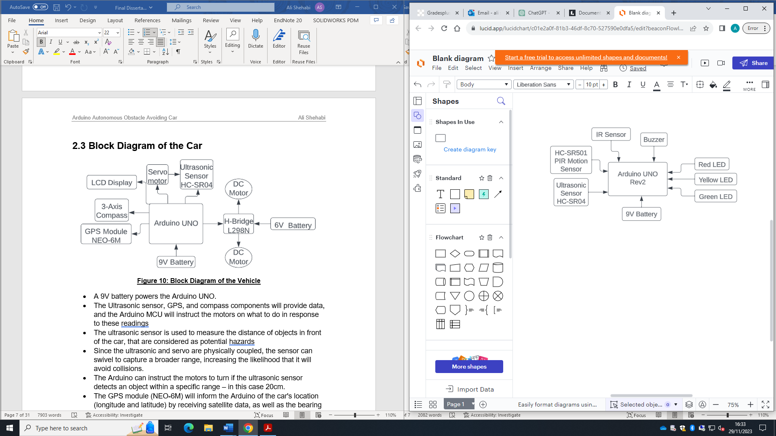

**Figure 11: System Block Diagram**

* A 9V battery powers the Arduino.
* The HC-SR501 PIR Sensor and the IR sensor both provide motion detection and feed this information to the Arduino if there has been motion detected from either one of these sensors.
* The HC-SR04 Ultrasonic sensor measures the distance of moving objects and feeds this information back to the Arduino.
* The Arduino will instruct the LEDs what to do in response to the ultrasonic distance readings, telling which light to turn on.
* The Arduino will also tell the buzzer when to start buzzing, and how frequently based on the same Ultrasonic distance readings.
* The Buzzer will also stop buzzing when there is no motion detected – this is to ensure it doesn’t carry on buzzing needlessly when the car has remained stationary.

**Chapter 4: Implementation**

* 1. **Hardware Implementation**
     1. **Pin Configuration**

|  |  |  |  |
| --- | --- | --- | --- |
| **Component** | **Pin on device** | **Arduino Connection** | **What it does** |
| **Ultrasonic Sensor** | Vcc | +5V | Supplies the sensor with voltage, allowing it to work |
| GND | GND | Connects the sensor to the ground |
| Trig | D5 | Allows a sonic burst to be released from the sensor |
| Echo | D6 | Receives the waves sent out, which calculates the distance of an object |
| **IR Sensor** | OUT | D7 | Sends the detection signal to the Arduino |
| Vcc | +5V | Supplies the sensor with voltage, allowing it to work |
| GND | GND | Connects the sensor to the ground |
| **PIR Sensor** | OUT | D8 | Sends the motion detection signal to the Arduino |
| Vcc | +5V | Supplies the sensor with voltage, allowing it to work |
| GND | GND | Connects the sensor to the ground |
| **Buzzer** | Vcc | A0 | Receives a signal to emit sound |
| GND | GND | Connects the sensor to the ground |
| **Green**  **LED** | Vcc | D4 | Turns on the green light when activated |
| GND | GND | Connects the sensor to the ground through a 220Ω resistor to limit the current |
| **Yellow**  **LED** | Vcc | D3 | Turns on the yellow light when activated |
| GND | GND | Connects the sensor to the ground through a 220Ω resistor to limit the current |
| **Red**  **LED** | Vcc | D2 | Turns on the red light when activated |
| GND | GND | Connects the sensor to the ground through a 220Ω resistor to limit the current |

**Table 4: Pin Configuration**

* + 1. **Circuit Diagram**

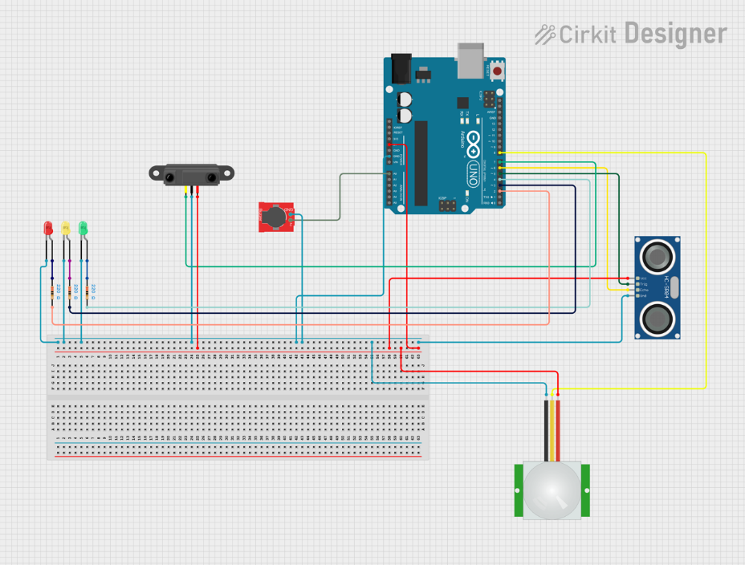

**Figure 12: Circuit Diagram of the System**

* 1. **Software Implementation**
     1. **Pseudo Code of Main Program**

// Define Pin Connections

Set trigPin, echoPin, redLED, yellowLED, greenLED, buzzer, irSensorPin, pirSensorPin as appropriate Input or Output

// Define Distance Thresholds

Set redThreshold, yellowThreshold, greenThreshold

// Main Program Loop

If PIR or IR Sensor detects Motion Then

Print " Motion Detected"

Control LED Indicators based on distance

Control Buzzer based on distance and motion detection

Else

Turn Off All LEDs and Buzzer

// LED Control Functions

Function Control LED Indicators

Function Set LED State

// Buzzer Control Function

Function Control Buzzer

Function Turn Off All LEDs and Buzzer

### triggerUltrasonicSensor()

This function is used to measure distances from the ultrasonic sensor by sending out a trigger ultrasonic pulse, and then waiting for it to come back to the echo pin after it bounces off the nearest object in front of the sensor. The duration of this trip is then returned and assigned to the variable duration. The value assigned to this variable is then used in the calculateDistance() function, where it converts the time taken for the signal to come back into centimetres.

### handleLEDIndicators()

This function controls the LEDs based on their distance.

* All the LEDs turn off if the distance detected is greater than the green threshold of 100cm.
* Green turns on if the detected distance is between 50cm and 100cm.
* Yellow turns on if the detected distance is between 20cm and 50cm.
* Red turns on if the detected distance is less than 20cm.

### handleBuzzer()

This function’s purpose is to control the buzzer based on the measured distance from a sensor, and whether the PIR sensor detects any motion. This is done to ensure that the buzzer doesn’t continuously beep when the car has stopped moving or is stationary as it has successfully parked, which increases the efficiency of the system. If there is motion, and the vehicle is within a proximity i.e., within the red threshold, the function calculates a `beepRate` using the `map` function which varies between 50 to 500, depending on the distance. If the distance is less than the red threshold, suggesting very close proximity, the buzzer emits a continuous tone, alerting to the close presence of an object. The use of the `tone` function in different scenarios allows for varying the buzzer sound based on the proximity of the detected object, providing an audible indicator of distance and motion detection.

### Void loop()

The `void loop()` function, is an infinite loop, that begins by triggering the ultrasonic sensor to get a pulse duration, and then uses this duration to calculate the distance in centimetres. It also checks the state of an IR sensor (indicating an obstacle if the state is LOW) and a PIR sensor (indicating motion if the state is HIGH). If either the IR sensor detects an obstacle or the PIR sensor detects motion, the function acts by outputting a "Motion Detected" message to the serial monitor. It then calls `handleLEDIndicators` with the calculated distance to manage LED indicators accordingly, and `handleBuzzer` with the distance and the PIR sensor state to control the buzzer's behaviour based on the proximity and motion detected. If neither motion nor an obstacle is detected, it turns off all LEDs and the buzzer. This repetitive process allows for continuous monitoring and response to changes in the environment.

**Chapter 5: Testing & Results**

* 1. **Ultrasonic Accuracy Test**

This test was conducted to determine how accurately the ultrasonic sensor can detect distances for both stationary and moving objects. During the test, an object was placed at a known distance from the sensor. Afterwards, the sensor was utilised to compare the real distance of the object with the distance it detects. This was done by examining the measurements displayed on the serial monitor. The test took place in a controlled and well-lit environment, with the sensor's height staying constant. The purpose of this test was to simulate real-life situations where the sensor would interact with both stationary and moving objects or vehicles.

|  |  |  |  |  |  |
| --- | --- | --- | --- | --- | --- |
| **Test** | **Ultrasonic Distance** | **Actual Distance (Static)** | **% Difference** | **Actual Distance (Dynamic)** | **% Difference** |
| **1** | 9.95cm | 10cm | 0.501253% | 10.06 cm | 0.598205% |
| **2** | 20.08 cm | 20cm | 0.399202% | 20.12 cm | 0.598205% |
| **3** | 40.02 cm | 40cm | 0.0499875% | 40.21 cm | 0.523625% |
| **4** | 59.97 cm | 60cm | 0.0500125% | 59.92 cm | 0.133422% |
| **5** | 80.14 cm | 80cm | 0.174847% | 80.15 cm | 0.187324% |
| **6** | 100.10 cm | 100cm | 0.09995% | 100.12 cm | 0.119928% |
| **Average % Difference** | | | **0.213%** |  | **0.360%** |

**Table 5: Ultrasonic Test Results**

The test showed the sensors’ high accuracy as the percentage difference between the results obtained and the actual distances were very low - 0.213% for static and 0.360% for dynamic. This shows that this sensor is suitable for this project.

* 1. **System Robustness in Various Lighting Conditions Test**

The purpose of this test was to assess how accurate and reliable the PIR/IR sensors are in different lighting conditions, both bright and dark. The purpose of doing this was to imitate real-life situations, where the system should work reliably in different lighting conditions, whether it is bright or dark. The test involved observing readings obtained from the sensor on the serial monitor. During this test, we utilised both the PIR sensor and the IR sensor.

|  |  |  |
| --- | --- | --- |
| **Test** | **Condition** | **Does the system Detect Motion?** |
| 1 | Dark | Yes |
| 2 | Dark | Yes |
| 3 | Dark | Yes |
| 4 | Dark | Yes |
| 5 | Light | Yes |
| 6 | Light | Yes |
| 7 | Light | Yes |
| 8 | Light | Yes |

**Table 6: System Robustness Test Results**

The experiment showed that IR and PIR sensors could detect accurately under different lighting conditions. I only tested out complete darkness and complete natural brightness, because if the sensors performed accurately in both of these conditions, then it would perform accurately in all different lighting conditions in between. They performed similarly to optimal lighting conditions. The System Robustness in Various Lighting Circumstances Test showed that the system's sensor components are reliable and efficient in a variety of lighting circumstances. The system's application can be extended to diverse settings and lighting circumstances, allowing for confident real-world deployment.

The sensor technology used in this project is sturdy and precise after extensive testing across numerous factors and circumstances. The Ultrasonic Accuracy Test and System Robustness in Various Lighting Conditions Test show high precision and reliability. The ultrasonic sensor was tested in static and dynamic conditions. The average difference between static and dynamic cases was 0.213% and 0.360%, respectively. Ultrasonic sensors are reliable, as shown by these findings. The system's ability to reliably detect motion in dark and light environments without affecting performance shows its operational resilience. The tests validate the system's real-world performance. These tests are essential for people to trust the technology in different environments. The tests also assess system sensors' appropriateness. System functionality assurance allows smooth integration and deployment in real-world applications where lighting conditions change and precise distance measuring is crucial.

**Chapter 6: Discussions & Conclusions**

**6.1 Achievement & Analysis**

This project has developed a high-accuracy sensor system for distance and movement. Combining ultrasonic, infrared (IR), and passive infrared (PIR) sensor data required careful programming and hardware arrangement. The system's operational accuracy depended on these components' successful coordination to deliver real-time data.

Through thorough testing, the ultrasonic sensor has shown outstanding accuracy in numerous conditions - in static and dynamic circumstances. The sensor did well with consistent readings. Practically, the average percentage difference was negligible. The combination of IR and PIR sensors provides a complete motion detection approach. The IR sensor substantially enhanced obstruction detection, while the PIR sensor was important to motion detection. These additions greatly improved system functionality. Motion detection reliably turned-on LED indicators and sounded the buzzer. The LED indicators also provided clear, distance-related feedback. The graded alert system worked by using red, yellow, and green LEDs to signify distance thresholds. This design choice boosted system-user interaction, making it smart. The technology performed well in controlled circumstances and was accurate in diverse lights. Adjustable sensor calibration shows the system's strength and real-world potential.

The sensor integration and application development project was successful based on project outcomes. The project's design and execution produced a system that processes and responds to environmental inputs accurately. The development process presented several problems, which were learning opportunities. These issues led to a system that accomplishes its aims and provides a solid foundation for future research and improvement.

**6.2 Challenges Faced**

1. Combining and calibrating various sensors (PIR, IR, and Ultrasonic) to work together as a unified system posed significant difficulties, both in terms of setting up the hardware and fine-tuning the software. To make sure that every sensor accurately detected changes in the environment and effectively communicated this data to the Arduino, it was necessary to carefully calibrate and test each sensor. Ensuring accurate sensor readings was crucial for the system's overall performance and dependability.
2. Developing a user interface that effectively displayed sensor data without any disruptions proved to be a significant challenge in the software development process. The objective was to create a system that enabled users to comprehend the visual (LEDs) and auditory (buzzer) feedback, thereby enhancing their interaction with the system. This way, users could effortlessly grasp the system's status and promptly receive alerts.
3. Among the obstacles we faced was the programming of the buzzer to modify its buzz patterns in response to the proximity of objects detected. The urgency of the buzzer's sound increases as the object approaches. To guarantee the efficacy of the notifications and their ability to precisely indicate the distance of the detected object, it was necessary to alter the duration and frequency of the buzzer by the distance.
4. It was critical to implement an effective power management strategy, especially considering that the operation of the system was dependent on a battery. Power consumption needed to be optimised by the system through activation solely when required. For example, in the absence of motion detection, the LEDs, alarm, and ultrasonic sensor would remain inactive.
5. The integration of readings from numerous sensors to dynamically control the system's outputs presented a challenge. Efficiently managing data from the motion sensors and ultrasonic sensor was necessary for the system. It used this information to operate the LEDs and buzzer. Sophisticated software algorithms were necessary for this challenge to ensure that the outputs accurately represented the combined sensor data. These algorithms also had to adapt in real time to any changes in the environment.

All of these challenges were successfully overcome.

**6.3 Conclusions**

In conclusion, the development of this IoT motion detection and distance measurement system has been a challenging yet rewarding journey. Achieving its primary objectives, the project stands out for its integration of multiple sensors (PIR, IR, and Ultrasonic) into a cohesive and efficient unit. This integration, paired with a user-friendly interface and dynamic feedback mechanisms, demonstrates the system's robust functionality.

Unique to this project, compared to similar parking sensor systems, is the implementation of a buzzer that alters its alert patterns based on object proximity—a feature not commonly found in other projects. Additionally, the integration of PIR and IR sensors enhances accuracy and conserves energy, activating the ultrasonic sensor only upon motion detection. This strategic approach is distinct and innovative, setting our system apart in the IoT landscape. Crucial testing phases validated the system's accuracy and reliability, confirming the effectiveness of sensors and feedback mechanisms under various conditions. Our project marks a significant advancement in IoT solutions, particularly with its novel buzzer system and energy-efficient sensor integration.

Achieved within tight budgetary and time constraints, this project demonstrates the feasibility of developing sophisticated yet practical IoT systems. The insights and expertise gained have broad applications, from smart homes to industrial safety, underscoring the potential of such systems to enhance safety, efficiency, and user engagement across diverse domains.

**Chapter 7: Further Work**

**7.1 System Enhancements (SSM 6 & 7)**

Incorporating sophisticated sensors such as LiDAR or advanced vision-based sensors would significantly improve the system’s ability to understand its surroundings. The enhanced precision of the sensors' environmental mapping enables the system to recognise and respond to various environments. LiDAR, for instance, is capable of producing three-dimensional maps and precise distance measurements, whereas vision-based sensors are capable of identifying particular objects or patterns. The integration of these sensors would not only enhance the detection precision of the system but also optimise its operational efficiency.

Creating a more user-friendly interface, such as a mobile application or web platform, would significantly enhance user interaction and contribute to the enhancement of this system. The interface may enable users to customise settings, receive real-time data visualisations, and obtain system status updates, among other capabilities. Users can remotely monitor the system, receive notifications, and make changes to system settings using their mobile devices. An interface like this would not just make it easier for people to use but also allow them to customise it to fit their requirements. Furthermore, this connectivity enables users to remotely control the system by issuing commands such as adjusting sensitivity or turning it on and off.

Using solar panels to produce electricity for the system is a major move towards sustainable energy management. Choosing solar power is an excellent option for producing energy that is both affordable and environmentally friendly. It offers specific benefits in remote or outdoor environments. We can guarantee continuous operation and minimise environmental damage by reducing the reliance on traditional power sources or batteries for the system.

**7.2 Integration with Other Technologies**

1. Integration in Vehicle Systems for Parking Assistance: The parking assistance feature can be integrated into vehicles to assist drivers. The system can use sensors to give drivers real-time information about nearby objects, helping them navigate in tight areas. Furthermore, connecting this system with the vehicle's onboard display or a smartphone app would allow drivers to visually monitor the parking process, enhancing safety and convenience.

2. Smart Parking Lots with Real-Time Space Monitoring: Implementing this system in parking lots could revolutionize parking management. Sensors could be installed in each parking space to detect the presence or absence of vehicles. This data could then be transmitted to a central system and displayed on screens at the entrance or through a mobile app, showing available parking spaces in real-time. Such a setup would streamline the parking experience for users and improve the efficiency of space utilization in busy areas. The different coloured LEDs could also be implemented in the main system to show how full the parking lot is.

3. Smart Homes: Integrating this IoT system with smart home ecosystems can significantly enhance its utility. By connecting with other smart devices and systems within a home, such as smart lights, thermostats, or security systems, the IoT system can contribute to a more cohesive and intelligent home automation experience. For example, the system's motion detection and ultrasonic sensor could trigger security cameras and show different coloured LED lights indoors based on the proximity of the person detected to the door, and maybe a buzzer could be implemented for overnight use, alerting the occupants of any possible intruders, thereby enhancing both security and energy efficiency.

**References**

**[1] Mckinsey & Company, Retrieved from :** [**https://www.mckinsey.com/featured-insights/mckinsey-explainers/what-are-industry-4-0-the-fourth-industrial-revolution-and-4ir**](https://www.mckinsey.com/featured-insights/mckinsey-explainers/what-are-industry-4-0-the-fourth-industrial-revolution-and-4ir)

**[2] “Real World Effects of rear automatice braking and other backing assistance systems” by Jessica B. Cicchino. Retrieved from:** [**https://www.sciencedirect.com/science/article/pii/S0022437518303451**](https://www.sciencedirect.com/science/article/pii/S0022437518303451)

**[3] A & T Doors LTD. Retrieved: https://www.automaticdoorspecialist.co.uk/pir-and-ir-sensors.**

**[4] Exyn Technologies, “Whats the difference between vision-based and LiDAR-based SLAM?” Retrieved from:** [**https://www.exyn.com/news/vision-vs-lidar-based-slam**](https://www.exyn.com/news/vision-vs-lidar-based-slam)**.**