Table of Contents

BookLab — Task 2 Handover Document
Search & Content Discovery (WebGL · Firebase)
Author | Ali Shehroz
For | Adeeb · Phase 1 Technical Assessment — Task 2
Live app | https://adeeb-booklab-task2.web.app
Repository | https://github.com/alishehroz-ideo/webgl-and-firebase-learning
Stack | Unity 6 WebGL · Firebase Realtime Database · REST · TextMeshPro (Amiri)
This document is written for the reviewer. It explains what I built, the decisions behind it, and how it maps to the evaluation criteria — parsing robustness, search performance, code architecture, and scalability.

1. Overview of the implementation
A search page over a content library stored in Firebase Realtime Database. The user types a content name or an author name, presses Search, and the matching items appear as cards showing Name, Author, and Date.
The catch — and the point of the task — is that the data is real-world messy and must be used as-is: the metadata is crammed into a single string field and I am not allowed to clean or restructure it at the source. So the application does all the tidying itself, in code, turning inconsistent strings into clean records — without ever crashing on a bad entry.
It is a Unity WebGL app, follows MVC + event-driven architecture, and reuses the Core built for Task 1 (the Firebase REST client, the event bus, the UI factory).
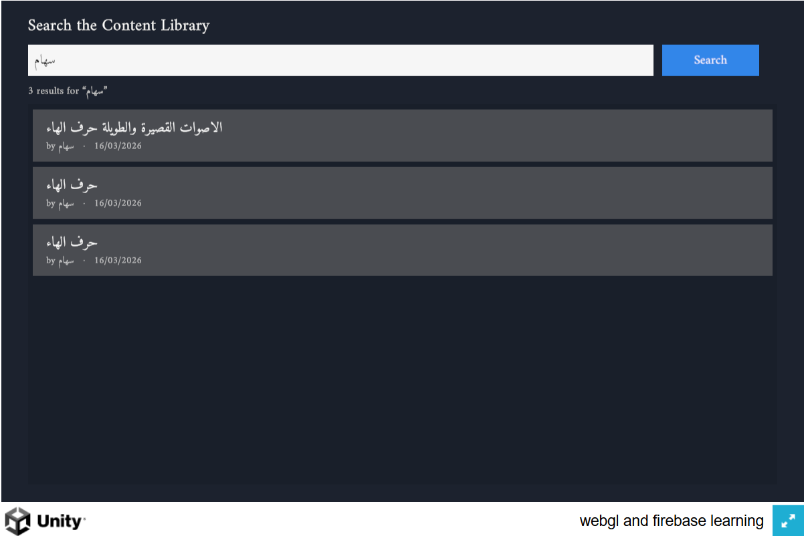
The search screen — searching one author returns three parsed cards (Name · Author · Date).

2. The data challenge
Each item’s metadata lives inside one field whose key ends with CoverInfo (it is prefixed by the item id, e.g. 71726852CoverInfo — so the field name itself is not fixed). The real format, reverse-engineered from the live data, is roughly:
Name _ Author _ Date _ Type _ Subject|Grade|Term _ Tag
…but in practice the data:
- uses mixed separators (_ and |),
- has a variable number of fields,
- can be missing fields (no author, no date),
- carries extra junk (tags, type, grade), and
- mixes RTL Arabic with LTR dates and Latin names.
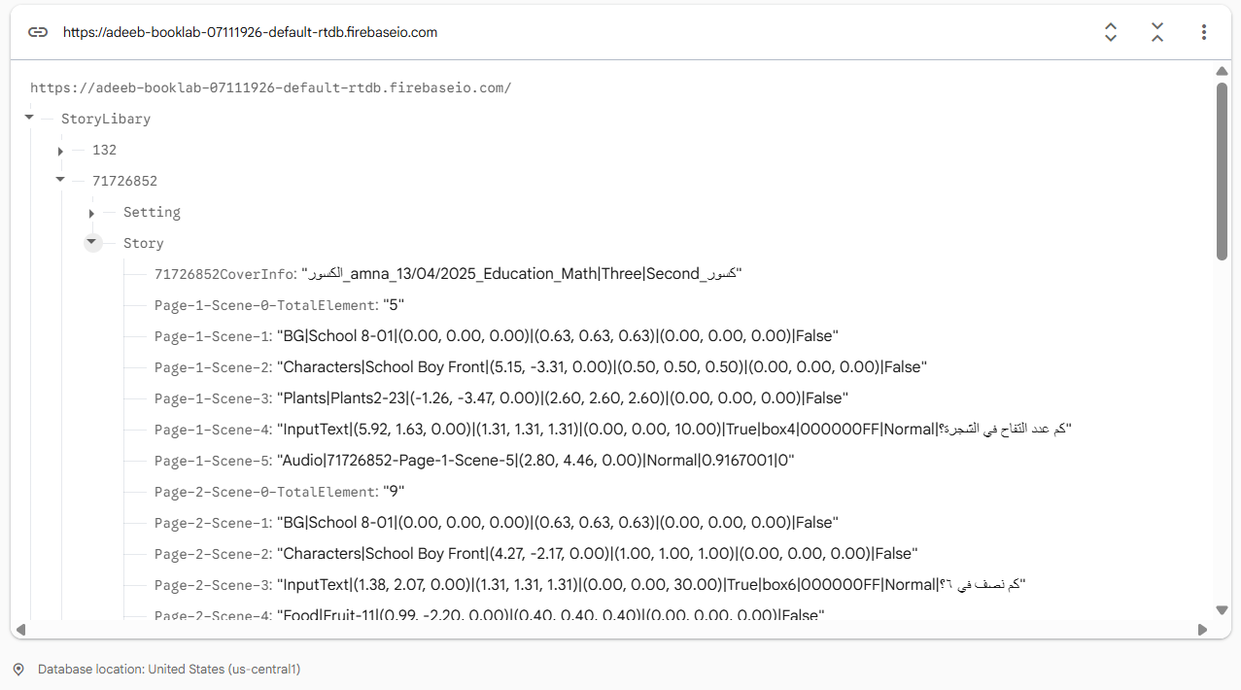
The real CoverInfo in Firebase — one jammed string, mixed separators, Arabic + Latin. The field is …CoverInfo, id-prefixed.
The rule: the source stays untouched. The app reads it as-is and extracts Name / Author / Date programmatically.

3. Parsing approach — the core (data parsing robustness)
Decision: parse by shape, not by position. The naive approach — split on _ and take parts[1] as the author — breaks the instant a field is missing or reordered: on a single-field entry it throws; on a reordered entry it grabs the wrong piece. My parser never assumes a fixed slot.
The algorithm (CoverInfoParser):
- Split the string on _ into top-level tokens.
- Find the date by its shape — a dd/mm/yyyy pattern (also tolerant of d/m/yyyy) — wherever it sits. Digits look the same in RTL or LTR, so this anchor holds even in the Arabic entries.
- The author is the field immediately before the date.
- The name is everything before the author, re-joined with _ (so an underscore inside a name survives).
- Everything after the date (type / subject / tag, even if it contains its own _) is extra and ignored.
- If there is no date, fall back to a best-effort guess, flag it low-confidence, and never crash.
- The original string and a confidence flag are always kept — nothing is lost, and a half-broken entry is marked rather than silently wrong.
The real code:
// dd/mm/yyyy (also tolerates d/m/yyyy). Digits look the same in RTL or LTR,
// so this anchor holds even in the Arabic entries.
static readonly Regex DateRx = new Regex(@"^\s*\d{1,2}/\d{1,2}/\d{4}\s*$", RegexOptions.Compiled);
public static ParsedContent Parse(string raw)
{
var result = new ParsedContent { Raw = raw, Confidence = ParseConfidence.Invalid };
if (string.IsNullOrWhiteSpace(raw)) return result; // empty → safe nulls
var tokens = raw.Split('_'); // top-level fields
// 1) find the date by SHAPE, wherever it sits
int dateIdx = -1;
for (int i = 0; i < tokens.Length; i++)
if (DateRx.IsMatch(tokens[i])) { dateIdx = i; break; }
if (dateIdx >= 0)
{
result.Date = tokens[dateIdx].Trim();
// 2) author = the field right before the date; name = everything before that
if (dateIdx >= 2)
{
result.Author = Clean(tokens[dateIdx - 1]);
result.Name = Clean(string.Join("_", tokens, 0, dateIdx - 1)); // re-join name
}
else if (dateIdx == 1) { result.Name = Clean(tokens[0]); result.Author = null; }
// dateIdx == 0 -> nothing before the date: name & author both missing
result.Confidence = result.HasName ? ParseConfidence.High : ParseConfidence.Low;
}
else
{
// 3) no date anywhere -> best-effort fallback, flagged low-confidence, never a crash
result.Name = tokens.Length > 0 ? Clean(tokens[0]) : null;
result.Author = tokens.Length > 1 ? Clean(tokens[1]) : null;
result.Confidence = result.HasName ? ParseConfidence.Low : ParseConfidence.Invalid;
}
return result;
}
// Trim, and treat an empty/whitespace field as "missing" (null) rather than "".
static string Clean(string s) => string.IsNullOrWhiteSpace(s) ? null : s.Trim();
Proof on real entries (taken straight from the live StoryLibary):
Raw CoverInfo | → Name | → Author | → Date | Why it’s tricky
الكسور_amna_13/04/2025_Education_Math\|Three\|Second_كسور | الكسور | amna | 13/04/2025 | Arabic name + Latin author; all junk after the date dropped
مصنع__09/02/2026_Education_Scinese\|One\|Second_ | مصنع | (null) | 09/02/2026 | Missing author (__) — position parsing would misalign
مركز مصادر التعلم_سامح_06/04/2024_…_#مصادر_الصبيخي | مركز مصادر التعلم | سامح | 06/04/2024 | Trailing tag contains its own _ — still ignored
قصة_No Name_06/01/2025_UserContent_None_… | قصة | No Name | 06/01/2025 | Real oddity — kept as-is
"" / whitespace | (null) | (null) | (null) | Empty → safe nulls, Invalid confidence, no crash
Why this is robust: it is rule-based (deterministic, fast, free — no ML, no network), the rules are shape-based (they look at what each piece is, not where it sits), it has a safe fallback, and it is not hardcoded to any id or entry. The parser design is a small strategy: a ParsedContent model + the shape rules, easily extended (e.g. a second date shape) without touching callers.

4. Explanation of the architecture (code architecture)
MVC + event-driven, reusing Task 1’s Core. The three roles are separate and never call each other — they communicate through two events on the shared EventBus.
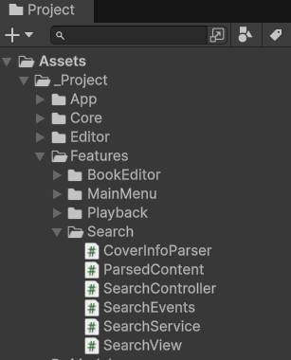
The real Features/Search folder — Model, View, Controller, Events, plus the parser.
Role | Class(es) | Responsibility
Model | SearchService, CoverInfoParser, ParsedContent | loads from Firebase, parses, holds & searches the clean in-memory list
View | SearchView | the input box, Search button, and result cards — renders whatever arrives
Controller | SearchController | turns a search event into results via the service
Events | SearchRequested, SearchResults | the only wiring between View and Controller
The event flow: the View publishes SearchRequested(query) when the user searches; the Controller handles it, asks the service, and publishes SearchResults (the list, plus Loading / Error flags); the View renders. Screens stay decoupled and independently testable.
class SearchRequested { public string Query; }
class SearchResults { public List<ParsedContent> Results; public bool Loading; public bool Error; }

5. Data loading, caching & error states
(The assessment’s video/document points include “asset loading & caching” and “how data is saved & loaded.” This feature is read-only — it saves nothing — so this section covers how data is loaded and cached, and how loading/error are handled.)
- Firebase integration — one GET via the reused FirebaseClient fetches the whole StoryLibary. The CoverInfo is located by the “key ends with CoverInfo” rule (never a hardcoded id).
- Cache — every item is parsed once on load and the clean list is held in memory. Search then never re-fetches or re-parses.
- Loading & error states are first-class:
State | What the user sees
Loading | “Loading…” while the library is fetched
Error | “Couldn’t load the library — check the connection and try again.”
Ready | results as cards; search is instant
The failure detection is defensive: an empty/null/unreachable response returns false, and the whole parse is wrapped in a try/catch, so a malformed entry logs and returns safely — never a crash.
public async Task<bool> LoadAsync()
{
string json = await FirebaseClient.GetJson(FirebaseEndpoints.StoryLibrary());
if (string.IsNullOrEmpty(json) || json == "null") return false; // unreachable/empty → error
try {
var root = JObject.Parse(json);
foreach (var story in root.Properties())
_all.Add(CoverInfoParser.Parse(FindCoverInfo(story)));
return true;
}
catch (Exception e) { Debug.LogError(e.Message); return false; } // malformed → error, no crash
}

6. Search & performance (search performance)
The expensive work — parsing — happens once, at load. After that, a search is a plain in-memory scan of the clean list: the query is lowercased once, then each item’s name or author is matched (case-insensitive substring). No network trip, no re-parsing. This is instant and smooth for the stated 1,000+ items.
foreach (var item in _all) {
bool nameHit = item.Name != null && item.Name.ToLowerInvariant().Contains(q);
bool authorHit = item.Author != null && item.Author.ToLowerInvariant().Contains(q);
if (nameHit || authorHit) results.Add(item); // name OR author
}

7. Scalability discussion (required)
Question: If the dataset grows to 10,000+ items, how would you redesign this system to improve performance?
Why the simple design stops scaling: it downloads all items and parses all of them in the browser, on a single WebGL thread, on every visit. Fine at 1,000; at 10,000+ it becomes a large download plus a visible freeze — repeated for every user.
Redesign — do the heavy work once, off the browser; send each user only what they need:
- Precompute a clean index. A Firebase Cloud Function runs the same parser once (and re-runs only when an item changes), writing clean {name, author, date} records into a separate /searchIndex node. The original messy data is never modified (still honouring “don’t touch the source”), and the browser now reads clean data with zero parsing on load.
- /StoryLibary ← ORIGINAL messy data (never modified)
/searchIndex ← CLEAN, indexed copy the function writes (new)
- Server-side, indexed queries. With an indexed field (.indexOn), the browser sends a targeted, paginated request and Firebase jumps to the matches instead of scanning everything:
- GET /searchIndex.json?orderBy="author"&startAt="wafa"&endAt="wafa"&limitToFirst=20
- The browser only ever downloads the ~20 matches — never the other 9,980+.
- Or a dedicated search service (Algolia / Typesense / Elasticsearch) for instant, typo-tolerant, match-in-the-middle, multi-field search at any scale.
Honest limitation: Firebase’s built-in query is “starts-with, one field at a time.” For match-in-the-middle, typo-tolerance, or name+author together, a dedicated search service is the right tool — but the principle is identical: the browser only ever receives the few matches.
Where AI fits at scale: the offline index-builder (and cleaning the low-confidence stragglers) is a legitimate place for an LLM — run once, offline, never in the live search path.

8. Key decisions & challenges
- Parse in memory, never at the source. The rule forbids cleaning Firebase, so the app builds a clean copy in its own memory on load. The source stays messy and untouched.
- Shape, not position. The single most important call for robustness — it survives reordering, mixed separators, and missing fields where parts[1] would crash.
- Real Arabic in WebGL. The data is Arabic, and WebGL has no OS font fallback, so the built-in font renders blanks. I bundled the Amiri font and render with TextMeshPro, plus letter-shaping + RTL (ArabicSupport.Fix). A subtle bug — cards blanking when the font atlas rebuilt mid-build — was fixed by pre-warming the atlas with every glyph in one pass before creating the cards.
- Loading & error as real states. Empty, unreachable, or malformed data all resolve to a clear on-screen message — never a blank screen or a crash.

9. Use of AI tools
I built this with Claude Code as a pair-programmer. We reasoned through the messy-data edge cases together and landed on the shape-anchored parser; it wrote much of the Search feature alongside me, which I reviewed and adjusted; it was a real help diagnosing the Arabic-in-WebGL font issue; and it helped shape where AI belongs at scale (offline index-building, not the live search path). It sped the build up — the direction, the decisions, and the understanding are mine.

10. Tech stack, running & deploying
Item | Detail
Engine | Unity 6000.4.3f1 (URP), Input System, TextMeshPro, Newtonsoft JSON
Backend | Firebase Realtime Database (node StoryLibary) — read over REST
Text | Amiri font bundled for Arabic (WebGL has no OS fallback)
Run in editor | Open the project, load the task2 scene, press Play
Build | per-task WebGL build; deploy via firebase/deploy-hosting.sh (hosting target task2)
Live | https://adeeb-booklab-task2.web.app
Repository | https://github.com/alishehroz-ideo/webgl-and-firebase-learning
Deliverables: Git repository · live WebGL build · this handover document · video walkthrough.
Content data is real assessment data used as-is. Arabic rendering uses the Amiri font (SIL Open Font License).

