Previous Work — Selected Projects
Ali Shehroz · supplementary to the Adeeb Phase 1 Technical Assessment
A few relevant Unity projects that show my experience across the areas this assessment touches — WebGL + REST and the full Firebase platform — and beyond, into VR, hardware, and machine learning.

GameBull — WebGL Casual-Gaming Platform (company project)
What it is: A browser-based WebGL casual-gaming platform for an Asian market — a portal hosting multiple arcade games, with guest/user profiles, a “Play Lives” energy system, missions and ad-based rewards (Spin, Gacha), global leaderboards, and in-game tournaments.
My role (Unity Developer): I made the games WebGL-ready — building their controls and the WebGL template/build — and integrated the platform’s REST APIs into the games, fetching and pushing live data (scores, leaderboards, Play Lives, tournaments) over HTTP using Newtonsoft JSON in Unity. (The backend APIs were built by the backend team; I consumed them in-engine.)
Why it’s relevant: It is the exact skill set this assessment tests — a Unity → WebGL front-end talking to a backend over REST — but at production scale, with real users and live data.
Link: Live in a dev environment — available on request.
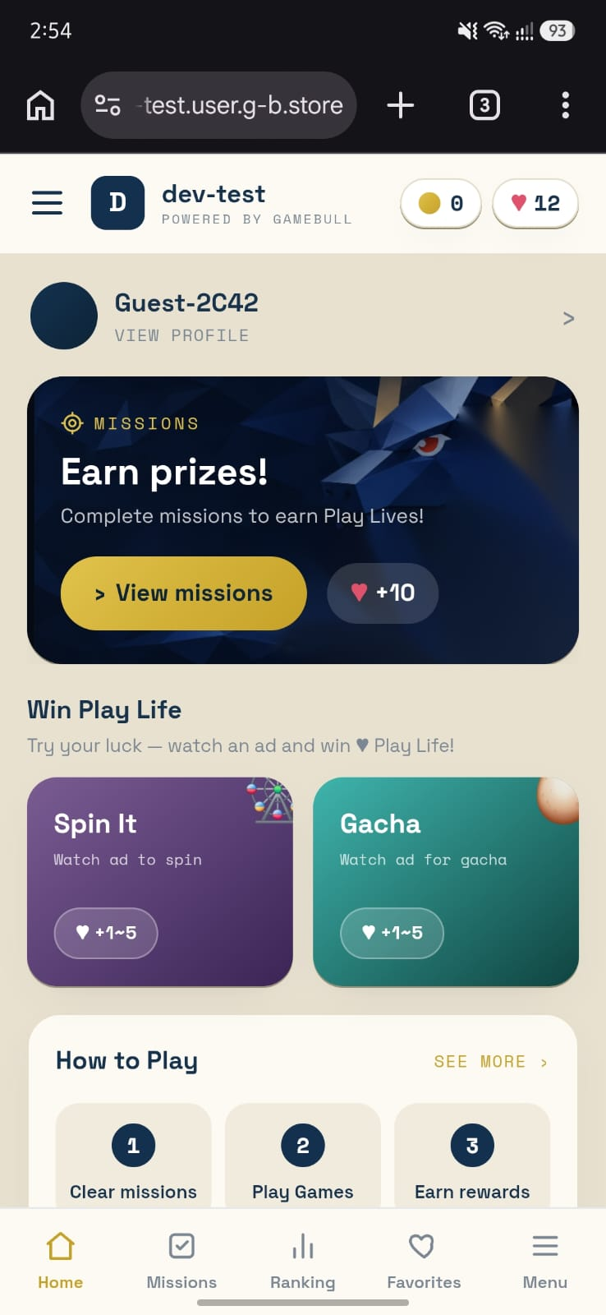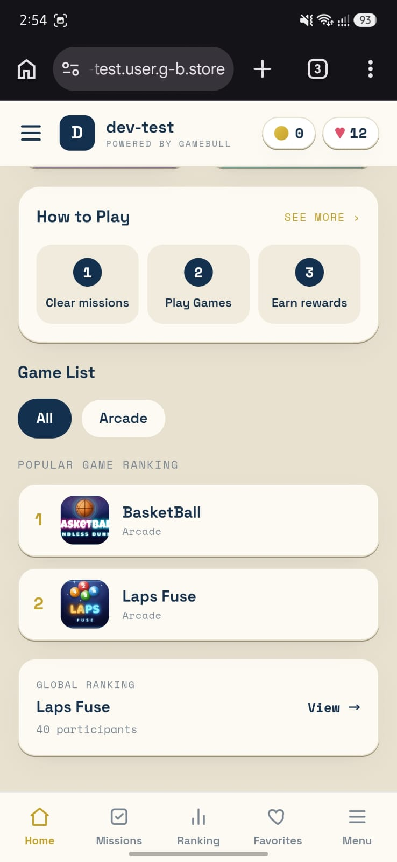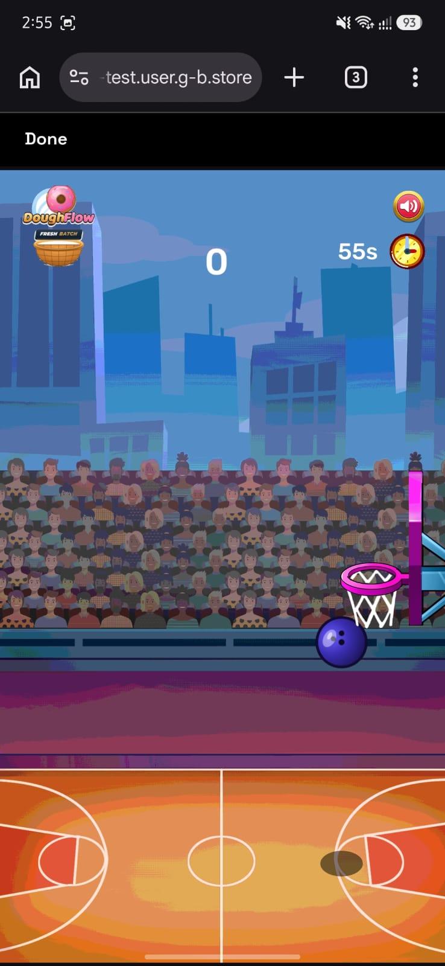
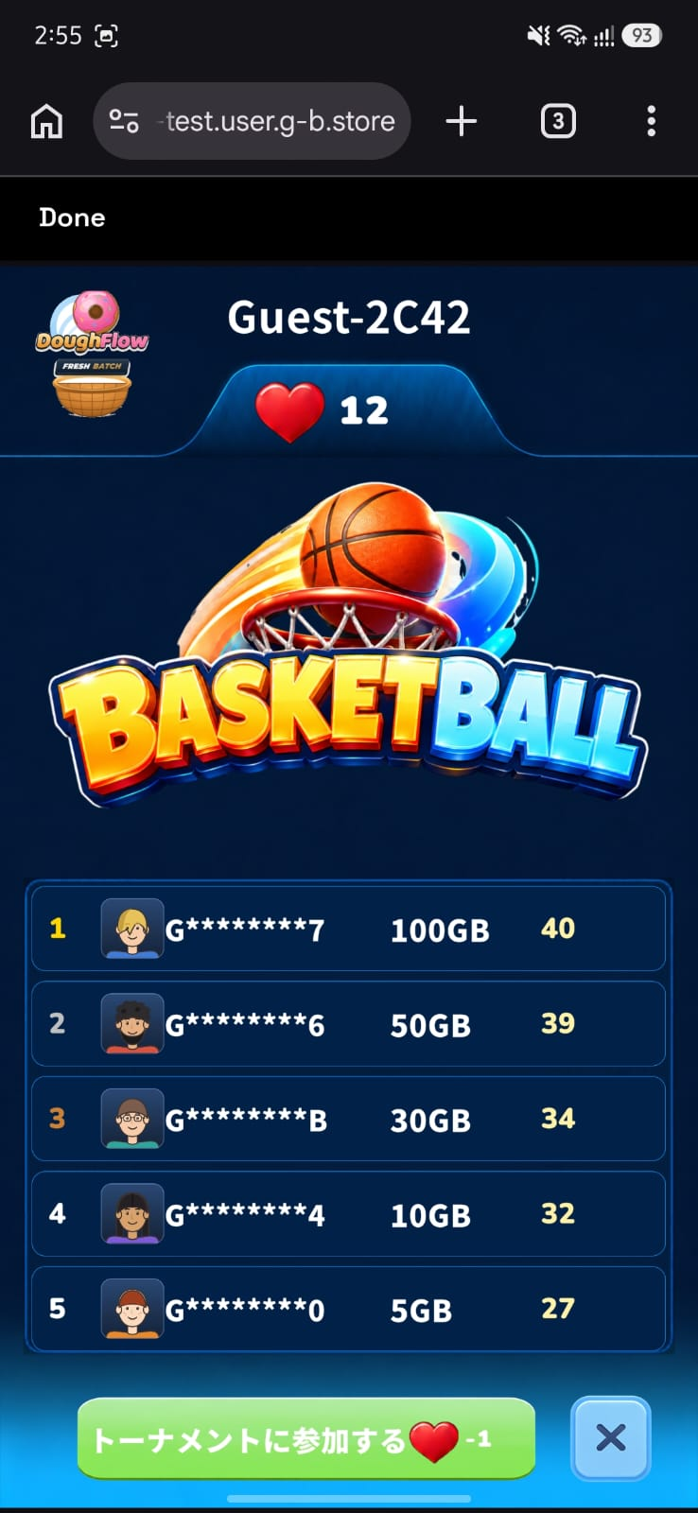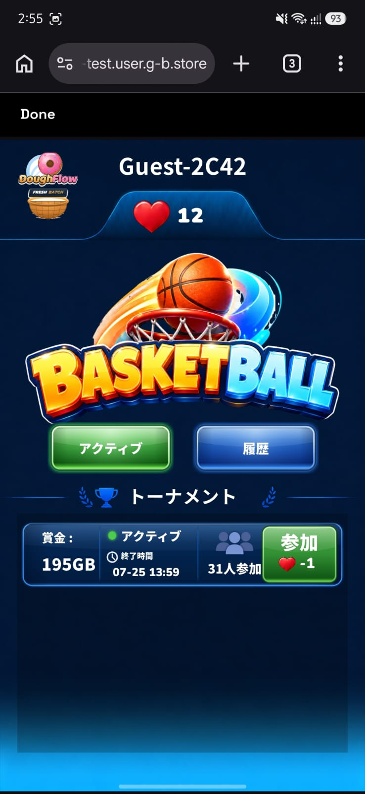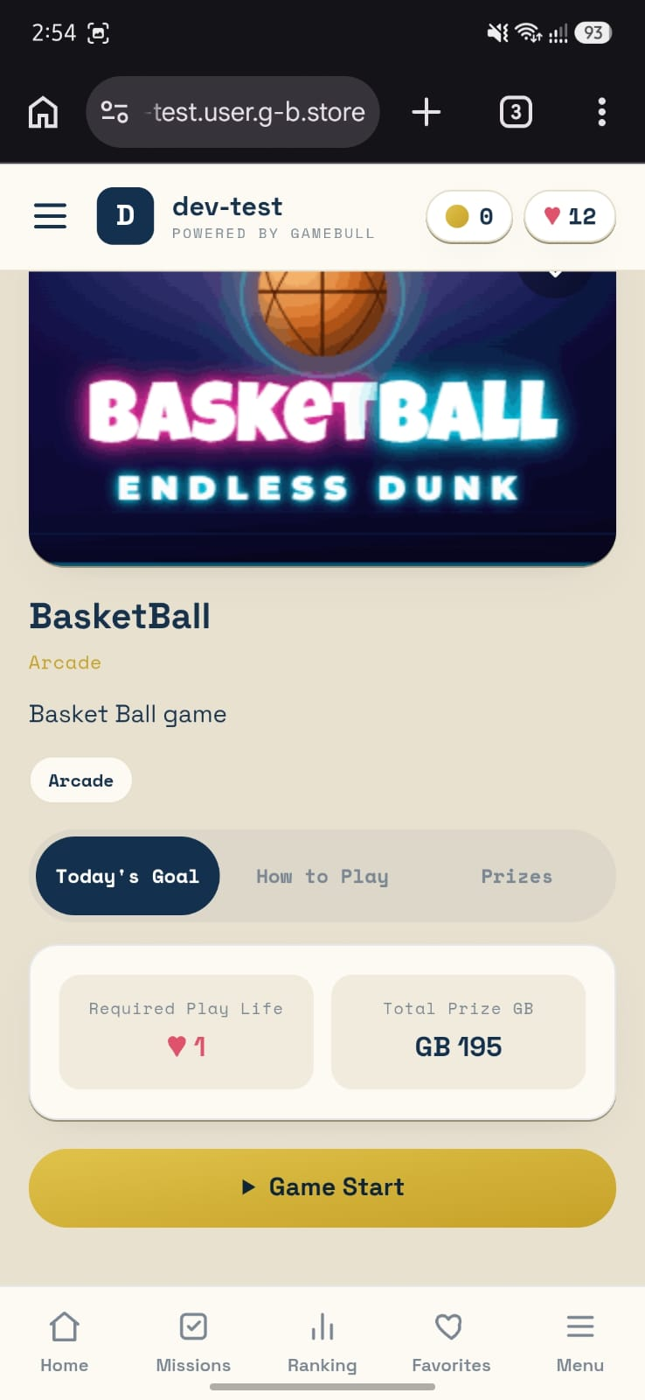
GameBull — main hub · game catalog & rankings · live gameplay · global leaderboard · in-game tournaments · direct play.

EmberBound — Unity Mobile Game on the Firebase Suite (company project)
What it is: A Unity mobile game built on the full Firebase platform — Authentication (sign-in), Realtime Database (game data), Analytics (player telemetry), and Cloud Functions (server-side logic).
My role (Unity Developer): built the game and integrated the Firebase suite end-to-end.
Why it’s the perfect counterpart to this assessment: Task 1 and Task 2 talk to Firebase over REST, because the Firebase SDK does not run in WebGL. EmberBound uses the native Firebase SDK on mobile — so together they show I understand Firebase across platforms, and that I have shipped real Cloud Functions — the exact mechanism I proposed for Task 2’s 10,000-item scalability redesign.
Video walkthrough (narrated): https://drive.google.com/file/d/1VWiBGMu2Bu6xJX0fawogOh4UmXga3r1b/view

Immersive VR Simulation — Unity ML-Agents + Virtuix Omni (a simulation company)
What it is: A full-body VR training simulation built in Unity, combining Unity ML-Agents, the Virtuix Omni omnidirectional treadmill, and VR interaction — the user physically walks and navigates a simulated space while AI agents respond and adapt in real time.
My role (Unity Developer): built the VR control & interaction system, integrated real-time movement and tracking from the Virtuix Omni treadmill, and created the enemy behaviour using Unity ML-Agents — agents trained to react to the player in real time.
Why it’s relevant: breadth well beyond web and mobile — real hardware integration, VR systems, and ML-driven AI in Unity. Applicable to training simulations, experiential learning, and VR prototyping.
Video: https://1drv.ms/v/c/20249f5ad3268347/IQBHgybTWp8kIIAgGQQAAAAAAcdfFea4VXnEElxgxp-gSbY

