Hand Gesture Recognition from a Self-Collected Dataset
Computer Vision — Assignment 1
Classifying three static hand gestures — fist, peace (V-sign) and thumb (thumbs-up) — from images extracted from video I recorded myself.
All code and outputs are in hand_gesture_recognition.ipynb; every figure and number quoted below is produced by that notebook.

1. Dataset

1.1 Collection
I recorded 11 videos on a phone: 1072×1920 portrait, 60 fps, 12–26 seconds each. Rather than shooting one long clip per gesture, I designed the recording session as a small factorial grid over the sources of variation I could control:
factor | levels
gesture | fist, peace, thumb
take (background and hand-pose set) | take 1, take 2
lighting | normal, dark

That is 3 × 2 × 2 = 12 clips. thumb2_dark was not recorded, so 11 exist. The two takes use different backgrounds (a white wall and a grey upholstered headboard) and were shot at different times, so "take" varies background, camera distance and hand orientation together. Within each clip I continuously rotated and translated the hand, so a single recording covers a range of viewpoints rather than one frozen pose.

1.2 From video to images
build_dataset.py converts the clips to an image dataset:
1. drop the first and last 5% of each clip, where the hand is still moving into or out of position;
2. sample frames at a uniform stride across the remainder;
3. centre-crop to a square and resize to 224 × 224.
The hand is roughly centred in every clip, so a centre crop keeps it fully in frame while avoiding the distortion a direct 1072×1920 → square resize would introduce (verified visually across all 11 clips before committing to it).
thumb has one clip fewer, so it is sampled more densely — 80 frames per clip against 60 for the other classes — giving exactly 240 images per class, 720 in total.
class | images | clips | dark / normal
fist | 240 | 4 | 120 / 120
peace | 240 | 4 | 120 / 120
thumb | 240 | 3 | 80 / 160

dataset/metadata.csv stores, for every image, its class, source clip, take, lighting condition, frame index, position within the take, and split assignment. That bookkeeping is what makes the evaluation protocol in §2 possible.

1.3 Diversity, and its limits
Figure 01_samples.png shows two frames from every clip. The variation covered is viewpoint and hand rotation, two backgrounds, two lighting conditions, and hand scale. 02_brightness.png confirms the lighting factor is real: the _dark clips are clearly dimmer, but the brightness distributions overlap across classes, so brightness alone carries no class information. This matters for §2.
What the dataset does not cover: one person, one hand, indoor scenes only, no clutter or occlusion, no other skin tones. Those are real limits on what any result here can claim, and I return to them in §6.
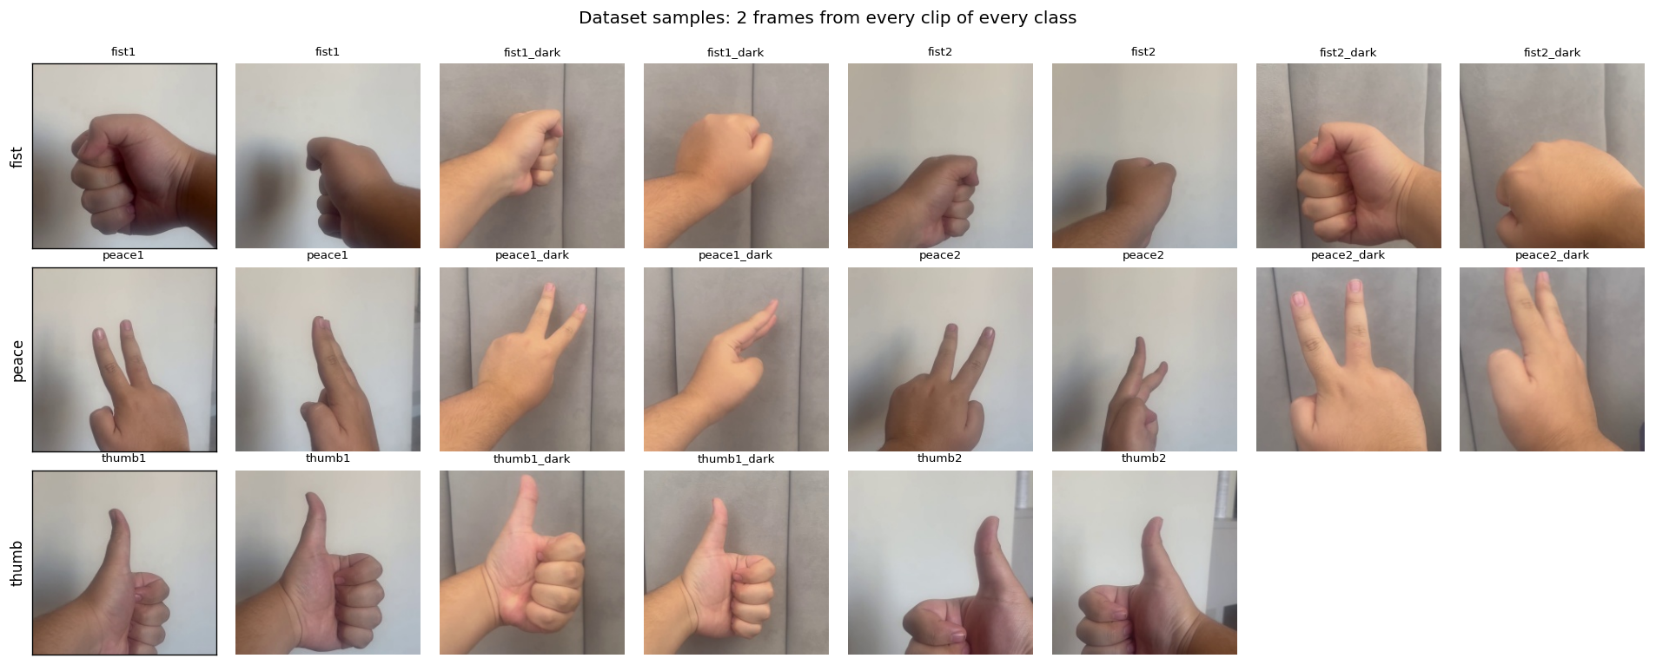
Figure 1. Two frames from every clip of every class.

2. Splitting the data — the decision that matters most
Frames sampled from 60 fps video are near-duplicates of their neighbours. If they are split randomly, almost every test image has a near-identical twin in the training set, and the reported accuracy measures memorisation rather than recognition.
I therefore split by clip (a group split):
- Test — three entire held-out clips, fist2_dark, peace2, thumb2 (200 images). Never seen in training or model selection.
- Validation — the last 20% (in time) of each remaining clip (98 images).
- Train — the first 80% of each remaining clip (422 images).
The test clips deliberately mix lighting (one dark, two normal), and the training set retains both lighting conditions for every class, so neither the model nor the evaluation can be shortcut by brightness.

How much does this choice change the answer?
The same features and the same SVM, trained twice, differing only in the split:
features | random frame split | held-out clip split | overstatement
raw 64×64 pixels | 0.989 | 0.295 | +0.694
HOG | 0.989 | 0.245 | +0.744

A random frame split reports 98.9% accuracy for a model that performs below the 33.3% chance level on a recording it has never seen. This is the single most important result in the project (08_leakage.png), and it is worth stating plainly: any gesture recognition accuracy quoted without specifying the split protocol is unproven.
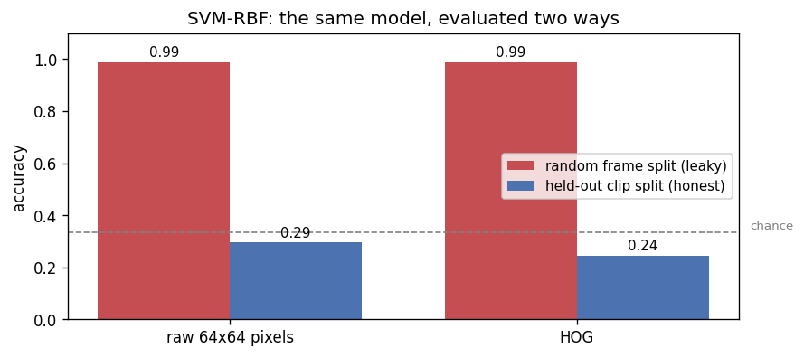
Figure 2. The same SVM evaluated with a random frame split vs. held-out clips.

3. Preprocessing and augmentation
Two pipelines, because the classical models and the CNNs need different inputs.
Classical models — greyscale, resized to 64×64, then either flattened raw pixels (4096 dims) or a HOG descriptor (1764 dims; 9 orientations, 8×8 cells, 2×2 blocks, L2-Hys normalisation). HOG encodes the oriented edge structure of the fingers — the actual signal — and its local contrast normalisation makes it far less sensitive to the brightness shift between lighting conditions than raw pixels.
CNNs — 224×224 RGB (96×96 for the small CNN, to keep CPU training tractable), normalised with ImageNet statistics so the pretrained backbone receives the input distribution it was trained on.
Augmentation is applied to the training split only, and each transform is chosen to mimic a specific way a new recording could differ from the training clips:
transform | what it simulates
RandomResizedCrop(scale 0.7–1.0) | hand nearer/further, off-centre
RandomRotation(±20°) | free wrist rotation
RandomHorizontalFlip | left vs. right hand
ColorJitter (brightness, contrast, saturation, hue) | unseen lighting, white balance, skin tone
RandomErasing(p=0.25) | partial occlusion; discourages reliance on one region

Vertical flips are deliberately excluded: an upside-down thumbs-up is a thumbs-down, a different gesture, so that transform would corrupt the label. 03_augmentation.png shows the pipeline applied to a single frame.

4. Models
Baselines
1. Logistic Regression on raw 64×64 pixels
2. Logistic Regression on HOG
3. SVM (RBF kernel) on raw 64×64 pixels
4. SVM (RBF kernel) on HOG
5. A small CNN trained from scratch — three conv blocks with batch norm, global average pooling, dropout; 288,291 parameters; 30 epochs, AdamW, cosine schedule
Improved model
6. ResNet-18, ImageNet-pretrained (11.2M parameters), fine-tuned in two stages: (i) backbone frozen, new 3-way head trained for 6 epochs at lr 1e-3, so the randomly initialised head cannot destroy the pretrained features; (ii) everything unfrozen for 12 epochs at lr 5e-5. AdamW, cosine schedule, label smoothing 0.05, best-validation weights retained.

Tuning the classical models honestly
Since same-clip validation cannot detect clip memorisation, I tuned the classical models with leave-one-clip-out cross-validation over the 8 development clips instead:
model | best C | LOCO-CV accuracy
LogReg (HOG) | 10 | 0.393 ± 0.386
SVM-RBF (HOG) | 1 | 0.317 ± 0.358

No hyperparameter setting reaches even 0.45, and the fold-to-fold standard deviation is enormous (~0.37) — performance depends almost entirely on which clip is held out. Leave-one-clip-out CV correctly predicted the failure that the same-clip validation split (which reported 0.86–0.93) completely hid.

5. Results
All figures are accuracy on the three held-out clips, 200 images never used for training or model selection. Chance is 0.333.
model | test accuracy | macro F1
ResNet-18 (transfer learning) | 0.945 | 0.947
Small CNN (from scratch) | 0.405 | 0.407
SVM-RBF (raw pixels) | 0.295 | 0.214
SVM-RBF (HOG) | 0.255 | 0.208
LogReg (HOG) | 0.245 | 0.244
LogReg (raw pixels) | 0.125 | 0.132

Per-class performance
ResNet-18 — macro precision 0.948, recall 0.954, F1 0.947:
class | precision | recall | F1
fist | 1.000 | 1.000 | 1.000
peace | 0.845 | 1.000 | 0.916
thumb | 1.000 | 0.863 | 0.926

Small CNN — macro F1 0.407. The aggregate hides a total collapse: fist F1 0.921, peace F1 0.017, thumb F1 0.284.
SVM-RBF (HOG) — macro F1 0.208: fist F1 0.610, peace F1 0.015, thumb F1 0.000.

Confusion structure
06_confusion_matrices.png shows what the baselines actually do: they assign almost everything to one class. The SVM on HOG predicts fist for 83% of the true fists and essentially never predicts thumb correctly. This is not random error — it is a model that learned what the training rooms look like and, presented with an unfamiliar recording, falls back on a near-constant prediction.
Per-clip accuracy makes the same point:
model | fist2_dark | peace2 | thumb2
ResNet-18 | 1.000 | 1.000 | 0.863
Small CNN | 0.967 | 0.017 | 0.275
SVM-RBF (HOG) | 0.833 | 0.017 | 0.000
LogReg (HOG) | 0.667 | 0.150 | 0.000

Because each test clip is one gesture, per-clip accuracy is per-class recall. Every baseline is near-perfect on exactly one clip and near-zero on the others — the signature of a degenerate classifier, not of a model that is merely weak.
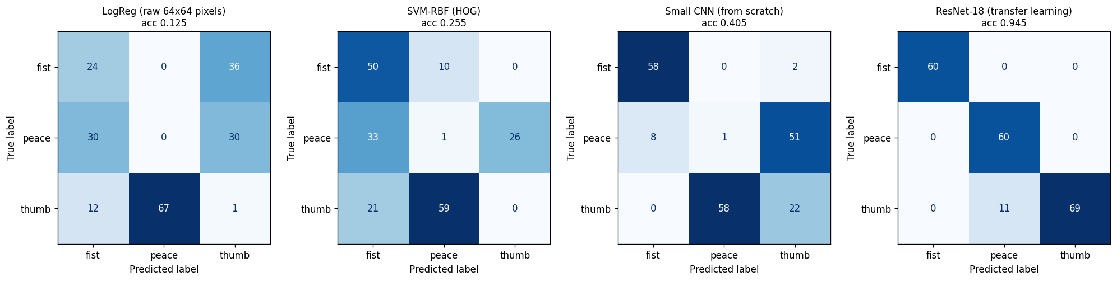
Figure 3. Confusion matrices on the held-out clips.

Robustness to lighting
fist2_dark is the dark test clip. If a model keyed on brightness rather than shape, accuracy there would diverge sharply from the normally-lit clips:
model | dark clip | normal clips
ResNet-18 | 1.000 | 0.921
Small CNN | 0.967 | 0.164
SVM-RBF (HOG) | 0.833 | 0.007

ResNet-18 is essentially flat across lighting conditions — it is reading hand shape. The baselines' apparent success on the dark clip is an artefact of their collapse onto the fist class, which happens to be the dark clip's label.

Training behaviour
04_training_curves.png shows the difference in learning dynamics. The small CNN climbs slowly and plateaus at 0.827 validation accuracy after 30 epochs. ResNet-18 reaches 0.837 with a frozen backbone in 6 epochs, then jumps to 0.908 in a single epoch once unfrozen, peaking at 0.969. Note that validation accuracy (same-clip) overstates test accuracy for every model — by about 2 points for ResNet-18 (0.969 vs 0.945), and by 42 points for the small CNN. The size of that gap is itself a measure of how much a model is memorising clips.
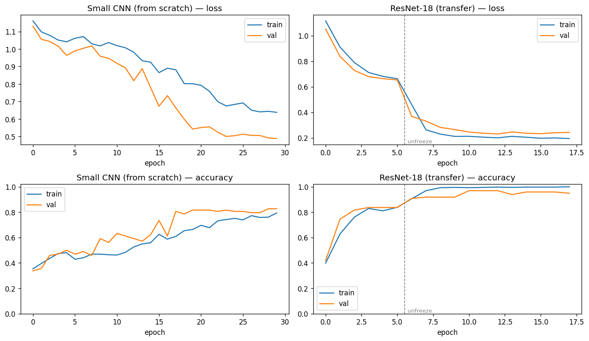
Figure 4. Training curves: small CNN vs. ResNet-18 (dashed line = unfreezing).

Remaining errors
ResNet-18 misclassifies 11 of 200 test images, and all 11 are the same confusion: thumb predicted as peace (07_errors.png). They are all very close-up frames in which the thumb is fully extended and near-vertical while the folded fist is small, out of focus or partly out of frame. What the model sees is an isolated upright digit against a plain wall — geometrically much closer to the extended fingers of a peace sign than to a canonical side-on thumbs-up, where the fist provides most of the evidence.
The confusion is strictly one-directional: no peace frame is ever called thumb. That is consistent with a genuine loss of information at close range — the distinguishing feature (the fist) leaves the frame — rather than with a confused decision boundary. It also points at a concrete fix: the hand-detection-and-crop step proposed in §6 would normalise scale and keep the whole hand in view, which is exactly what these frames lack.

6. Discussion
Transfer learning is not a marginal improvement here — it is the difference between working and not working. 0.945 against 0.405 for the next-best model. With only 422 training images drawn from 8 recordings, learning good low-level filters from scratch is the binding constraint; ImageNet's edge, texture and shape detectors are already general, so fine-tuning only has to adapt the later blocks.
The baselines fail for an interpretable reason. The dataset contains only two backgrounds, and a pixel- or HOG-space classifier has no way to separate "this is a fist" from "this is the white-wall recording". It latches onto whichever is easier, and the easier one is the background. HOG helps against lighting (it is contrast-normalised) but not against background, which is why HOG and raw pixels perform similarly here.
Validation drawn from the same recordings is actively misleading. It reported 0.86–0.93 for models that were below chance on a new clip. Leave-one-clip-out CV caught this; a random split did not. On grouped data, the grouping has to be respected in the split, not just in the modelling.
Limitations
- One person, one hand, two backgrounds, two lighting conditions, indoor only.
- The test set is 200 images but only three independent recordings — the effective sample size for any generalisation claim is 3, not 200. Confidence in the 0.945 figure should be sized accordingly.
- thumb2_dark was never recorded, so thumb has one condition fewer and its held-out clip is normally lit.
- The three gestures were chosen to be visually distinct; harder pairs would be a stricter test.

