Business Template
everest - climbs for a mountaineering club


Contents
1 Business Description 3
1.1 Business background 3
1.2 Problems. Current Situation 3
1.3 The benefits of implementing a database. Project Vision 3
2 Model description 3
2.1 Definitions & Acronyms 3
2.2 Logical Scheme 4
2.3 Objects 5

Business Description
Climbs for a Mountaineering Club manages and tracks climbing activities for club members. The system facilitates guided climbs, monitors member participation, tracks equipment usage, and maintains data on mountains and climbing courses.

Business background
Climbs for a Mountaineering Club manages and tracks climbing activities for club members. The system facilitates guided climbs, monitors member participation, tracks equipment usage, and maintains data on mountains and climbing courses.

Problems. Current Situation
In Climbs for a Mountaineering Club, climb records are currently managed manually, making it difficult to track member participation, climbing history, and equipment inventory. There is also no structured way to store and analyze climb reviews or training data.

the Benefits of implementing a database. Project Vision
Implementing a structured database will streamline record-keeping, improve data accuracy, and enhance operational efficiency. Members will have a detailed history of their climbs, guides can manage training programs, and administrators can track equipment usage effectively.

Model description

Definitions & Acronyms
The EVEREST "Climbs for a Mountaineering Club" data model is designed to effectively manage the climbing activities, track member progress, handle equipment usage, and monitor training programs within the Everest Mountaineering Club.
Key Entities and Their Roles:

- Climbers :
Stores personal details of club members, including name, contact information, and date of birth.
- Climbs:
Represents individual climbs with details such as climb name, difficulty level, location, and planned/completed dates.
- Mountain:
Information about different mountains, including name, country, height, and coordinates.
- Climb Types:
Defines the type of climb (e.g., Alpine, Rock Climbing, Ice Climbing.
- Climber Climbs:
Tracks which climbers participated in which climbs, their roles, and completion status.
- Climb mountains:
Links climbs to specific mountains and allows adding route descriptions.
- Climb equipment:
tores information on the equipment used during climbs, such as name and description.
- Climb equipment usage:
Tracks how much equipment was used in each climb.
- Climb reviews:
Allows climbers to leave reviews and ratings for specific climbs.
- Guides:
Contains data about guides, their license number, and years of experience.
- Climb guides:
Tracks which guides are assigned to each climb.
- Training course:
Information on the training courses offered by the club, including duration and schedule.
- Climber courses:
Tracks which climbers enrolled in which courses and their completion status.

Relationships Between Entities:
- A Climber can participate in multiple climbs through the Climber_Climbs table.
- A Climb can occur on multiple mountains via the Climb_Mountains table.
- A Climb can use multiple pieces of equipment, and the quantity used is tracked in the Climb_Equipment_Usage table.
- A Guide can be assigned to multiple climbs through the Climb_Guides table.
- A Climber can enroll in multiple training courses via the Climber_Courses table.
Please specify a relationship type for each relationship here^^: many-to-many, many-to-one, or one-to-one.
And please reflect all the relationships correctly on the diagram. Many-to-many relationships should be shown as two one-to-many relationships.

Logical Scheme
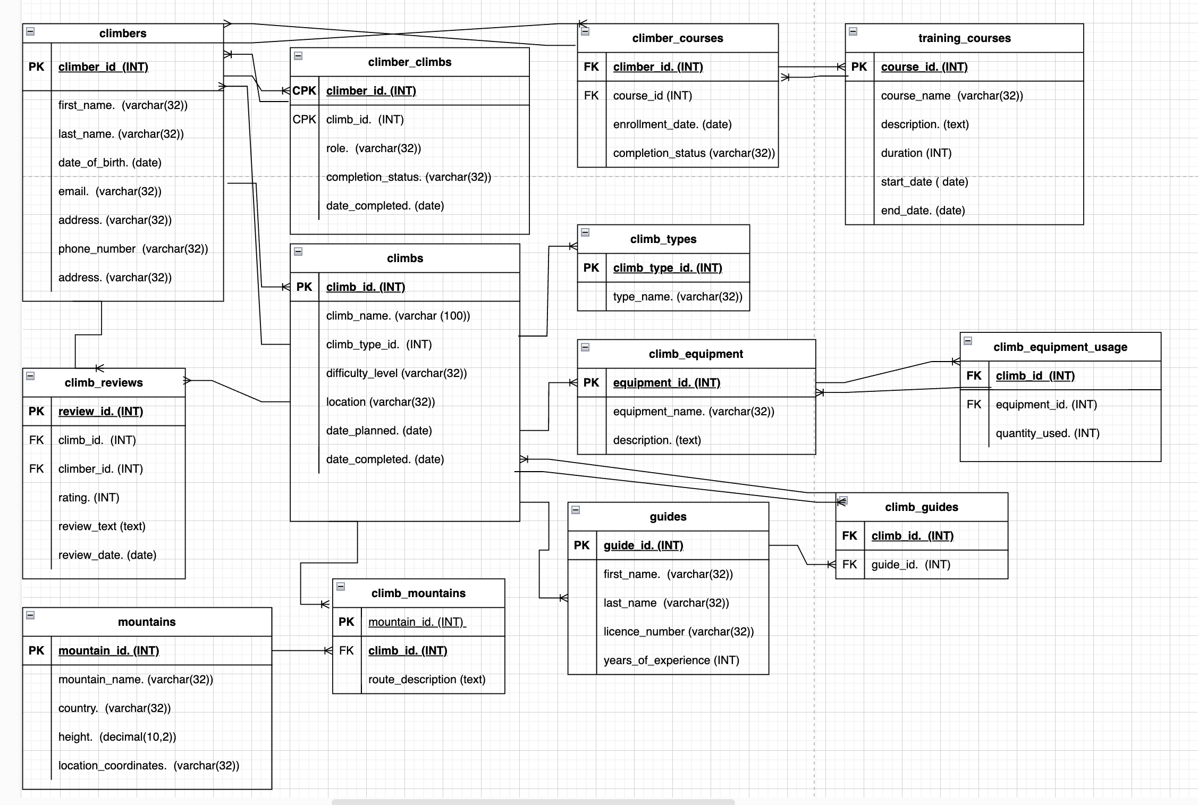

Objects

Table Description
<description>

Table Name | Field name | Field Description | Data Type
climbers  Climber_id is not FK | climber_id | unique identifier of climbers, PK, not null | Int
 | first_name | first name of climbers | varchar32
 | last_name | last name of climbers | varchar32
 | date_of_birth. | birth date | date
 | email | email of climbers, default (‘-’) | varchar32
 | adress | adress of climbers, default (‘-’) | varchar32
 | phone_number | phone.n of climbers | varchar32
climbs | climb_id | unique identifier of climb, PK,not null | int
 | climb_name | name of climb | varchar 32
 | climb_type_id | type of climb | int
 | difficulty_level | the level of difficulty, check (‘A’, ‘B’, ‘C’, ‘D’) | varchar32
 | location | location of climb | varchar32
 | date_planned | date of climb | date
 | date_completed | date of completion | date
mountains | mountain_id. | unique identifier of mount. PK,not null | int
 | mountain_name | name of mountain | varchar32
 | country | located country | varchar32
 | height | height of mountain | decimal(10,2)
 | location_coordinates | coordinations,default (‘-’) | varchar32
climb_mountains  What is a PK? | mountain_id | unique identifier of mountain, PK,not null | int
 | climb_id | unique identifier of climb, FK,not null | int
 | route_description | route description | varchar32
climb_reviews | review_id | unique identifier of climb review, PK,not null | int
 | climb_id | unique identifier of climb FK,not null | int
 | climber_id | unique identifier of climber, FK,not null | int
 | rating | rating of reviews | int
 | review_text | review texts | text
 | review_date | review date | date
climb_types  What is a PK? | climb_type_id | unique identifier of climb type, PK,not null | int
 | type_name | name of type | varchar32
climber_climbs  What is a PK? | climber_id | unique identifier of climber, CPK ,not null | int
 | climb_id | unique identifier of climb, CPK ,not null | int
 | role | role of climbers | varchar32
 | completion_status | the status of climb process,check (‘Completed’, ‘Not started, ‘In progress, ‘Delayed’) | varchar32
 | date_completed | date of completion climb | date
climb_equipment | equipment_id | unique identifier of equipment, PK,not null | int
 | equipment_name | name of equipment | varchar32
 | description | description of equipment | text
training_courses | course_id | unique identifier of course, PK ,not null | int
 | course_name | name of course | varchar32
 | description | description of course | text
 | duration | duration of course | int
 | start_date | start of course | date
 | end_date | end of course | date
climb_guides  What is a PK? | climb_id | unique identifier of climb, CPK,not null | int
 | guide_id | unique identifier of guide, CPK,not null | int
climb_equipment_usage  What is a PK? | climb_id | unique identifier of climb, CPK,not null | int
 | equipment_id | unique identifier of equipment, CPK,not null | int
 | quantity_used | the usage qty of equipment | int
guides | guide_id | unique identifier of guide, PK,not null | int
 | first_name | first name of guide | varchar32
 | last_name | last_name of guide | varchar32
 | licence_number | licence number of guide | varchar32
 | years_of_experience | the year experience of guide | int

Comments on table relationships

Example with data
Please provide example data for all the tables.
climber_id | first_name | last_name | date_of_birth | email | adress | phone_number
1 | John | Smith | 1990-05-15 | john.smith@email.com | 123 Main St, NY | +1-555-1234
2 | Elena | Ivanova | 1985-08-22 | elena.ivanova@email.com | 45 Green Rd, Moscow | +7-901-5678
Table name - climbers

climb_id | climb_name | climb_type_id | difficulty_level | location | date_planned | date_completed
1 | Everest North Ridge | 1 | D | Tibet, China | 2025-06-10 | 2025-06-2
2 | Denali West Buttress | 2 | C | Alaska, USA | 2025-07-15 | 2025-07-30
Table name - climbs

Table name - mountains
mountain_id | mountain_name | country | height(metres) | location_coordinates
1 | Mount Everest | Nepal/China | 8848.86 | 27.9881° N, 86.9250° E
2 | K2 | Pakistan/China | 8611.00 | 35.8808° N, 76.5153° E

Table name - climb_mountains
mountain_id | climb_id | route_description
1 | 1 | North Ridge Route
2 | 5 | Abruzzi Spur

Table name - climb_reviews
review_id | climb_id | climber_id | rating | review_text | review_date
1 | 1 | 2 | 5 | Amazing experience! The North Ridge route was breathtaking. | 2025-06-26
2 | 5 | 3 | 4 | K2 was extremely challenging but rewarding. | 2025-07-22

Table name - climb_types
climb_type_id | type_name
1 | Alpine Climbing
2 | Ice Climbing

Table name - climber_climbs
climber_id | climb_id | role | completion_status | date_completed
1 | 1 | Lead Climber | Completed | 2025-06-25
2 | 1 | Belayer | Completed | 2025-06-25

Table name - climb_equipment
equipment_id | equipment_name | description
1 | Climbing Rope | Durable dynamic rope used for belaying and rappelling.
2 | Helmet | Protective helmet to prevent head injuries from falling rocks.

Table name - training_courses
course_id | course_name | description | duration | start_date | end_date
1 | Basic Mountaineering | Introductory course on mountaineering techniques and safety. | 5 | 2025-06-01 | 2025-06-05
2 | Advanced Climbing Techniques | Advanced techniques for rock and ice climbing, including rescue procedures. | 7 | 2025-07-10 | 2025-07-17

Table name - climb_guides
climb_id | guide_id
1 | 101
2 | 102

Table name - climb_equipment_usage
climb_id | equipment_id | quantity_used
1 | 1 | 5
2 | 2 | 3

Table name - guides
guide_id | first_name | last_name | licence_number | years_of_experience
1 | John | Doe | G12345 | 10
2 | Jane | Smith | G67890 | 15

