**Ques:1**

Write A program to accept Four digit number from user and count zero , odd and even digits from the entered number.

Code:

a=int(input("Enter 4 digit number : "))

count=[0,0,0]

i=a

while(i>0):

r=int(i%10)

if r==0:

count[0]=count[0]+1

elif r%2 == 0:

count[2]=count[2]+1

else:

count[1]=count[1]+1

i=int(i/10)

print("Total number of zeroes = {}, Total even number(s) = {}, Total odd number(s) = {}".format(count[0],count[2],count[1]))

Output:

C:\Users\Shiraz\Documents\Question1Output.PNG

**Ques:2**

Write a program to accept ‘n’ numbers from user , store these numbers into an array. Find out maximum and minimum number from an Array.

Code:

a=int(input("How many number you want to enter : "))

Number=[]

for i in range(a):

Number.append(int(input("Enter Number[{}]".format(i+1))))

print("Maximum number = {}".format(max(Number)))

print("Minimum number = {}".format(min(Number)))

Output:

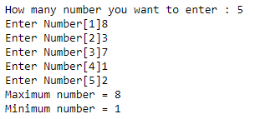

**Ques:3**

Write a menu driven program that shows the working of a library. The menu option should be

--ADD BOOK INFORMATION

--DISPLAY BOOK INFORMATION

--LIST ALL BOOKS OF GIVEN AUTHOR

--LIST THE COUNT OF BOOKS IN THE LIBRARY

--EXIT

Code:

bookdb=[]

class Book:

id=0

Name=""

Authorname=""

while(1):

a=int(input("Enter 1 for ADD BOOK INFORMATION,2 for Book information,3 for to find books of specific author,4 for Number of books in the library,5 for Exit : "))

b=Book()

if a==1:

b.id=int((input("Enter Book id : ")))

b.Name=input("Enter Book Name : ")

b.Authorname=input("Enter Author Name : ")

bookdb.append(b)

elif a==2:

for i in bookdb:

print("Book id : {}, Book name : {}, Authorname : {}.".format(i.id,i.Name,i.Authorname.upper()))

elif a==3:

c=input("Enter Authorname : ")

count=0

for i in bookdb:

if i.Authorname.upper()==c.upper():

print(i.Name)

count+=1

if count==0:

print("Sorry sir, we dont have any book written by {}".format(c))

elif a==4:

print("Total number of books in the library = {}".format(len(bookdb)))

elif a==5:

break

else:

print("Invalid Input")

Output:

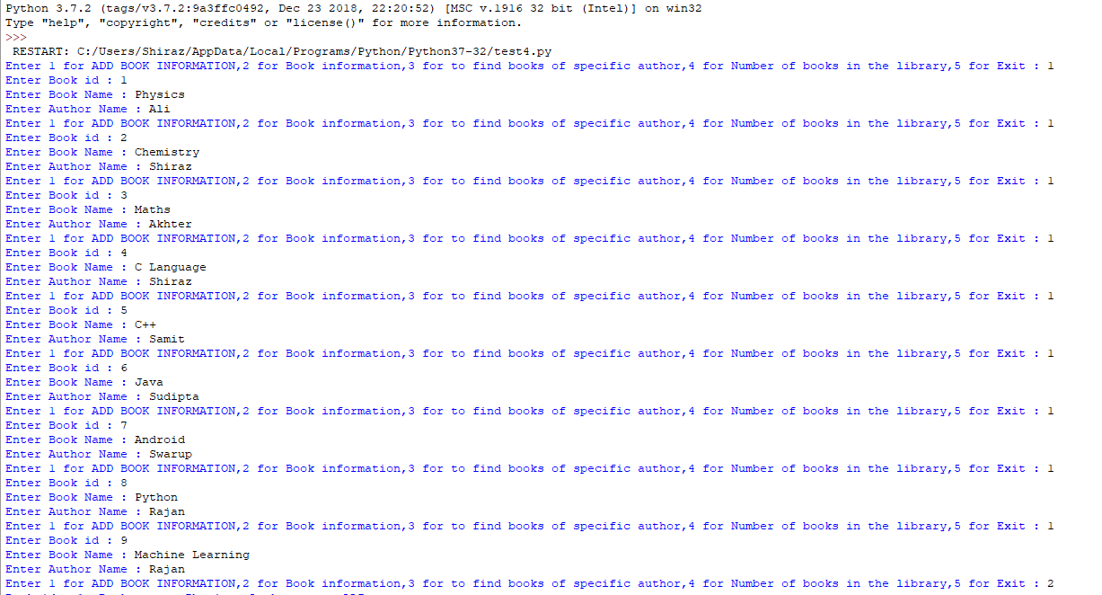

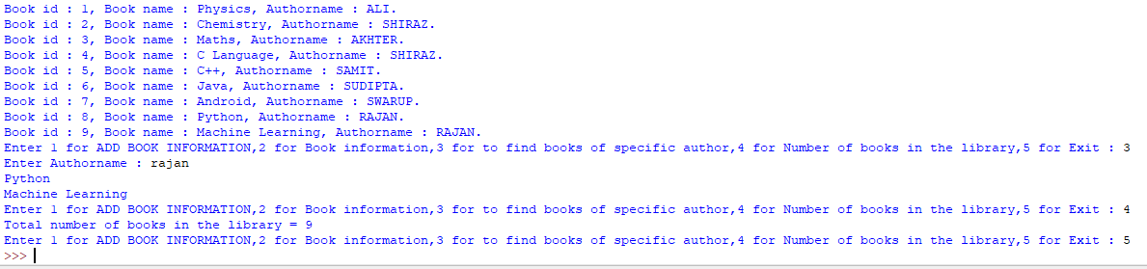

**Ques:4**

Write a program to accept ‘n’ numbers from user , store these numbers into an array and sort the numbers of an array using function.

Code:

a=int(input("How many number you want to enter : "))

Number=[]

for i in range(a):

Number.append(int(input("Enter Number[{}]".format(i+1))))

Number.sort()

print(Number)

Output:

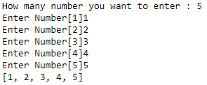

**Ques:6**

Write a program to accept 5 names from user and store these names into an array sort these array element in alphabetical order.

Code:

Names=[]

for i in range(5):

Names.append(input("Enter Name {}".format(i+1)))

Names.sort()

for i in Names:

print(i)

Output:

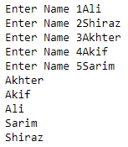

**Ques:7**

Write a program to calculate the sum of digits of a given number.

Code:

a=int(input("Enter Number : "))

sum=0

while(a>0):

r=int(a%10)

sum=sum+r

a=int(a/10)

print("Sum = {}".format(sum))

Output:

C:\Users\Shiraz\Documents\Question7.PNG

**Ques:9**

Write a program to calculate the sum of first digit and last digit of a given number

Code:

a=int(input("Enter Number : "))

first=int(a%10)

a=int(a/10)

while(a>0):

r=int(a%10)

a=int(a/10)

print("Sum of first digit and last digit = {}".format(first+r))

Output:



**Ques:10**

Write a program to accept a string from user , delete all vowels from the string and display the result.

Code:

class Name:

def input(self):

self.a=list(input("Enter a sentance : "))

self.operation()

def operation(self):

for i in self.a:

j=self.a.index(i)

i=i.lower()

if i in "aeiou":

del self.a[j]

self.result()

def result(self):

for i in self.a:

print(i)

name=Name()

name.input()

Output:

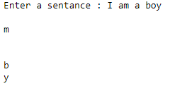

**Ques:11**

Write a program to accept a string value from the user and accept a char value from the user and and find out the total occurrence of char value in the string value.

Code:

class User:

def \_\_init\_\_(self):

self.count=0

def input(self):

self.a=input("Enter the String value : ")

self.b=input("Enter a single character : ")

self.operation()

def operation(self):

for i in self.a:

if self.b==i:

self.count+=1

self.result()

def result(self):

print("Total number of occurance of "+self.b+" in '"+self.a+"' is = {}".format(self.count))

user=User()

user.input()

Output:

C:\Users\Shiraz\Documents\Question11.PNG

**Ques:12**

Write a program to accept a sentence from the user and reverse its each word.

Code:

**class** Reverse:  
 **def** \_\_init\_\_(self):  
 self.list1=[]  
 **def** input(self):  
 self.a=(input(**"Enter a string : "**))  
 self.operation()  
 **def** operation(self):  
 words=self.a.split(**" "**)  
 **for** i **in** words:  
 self.list1.append(i)  
 self.list1.reverse()  
 self.result()  
 **def** result(self):  
 **for** i **in** self.list1:  
 print(i)  
  
reverse=Reverse()  
reverse.input()

Output:

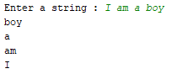

**Ques:14**

Write a program to accept ‘n’ numbers from user and store these numbers into an array and count the number of occurrences of each number.

Code:

**class** User:  
 **def** \_\_init\_\_(self):  
  
 self.b=[]  
 **def** input(self):  
 self.a=int(input(**"Enter, how many numbers you want to insert : "**))  
 **for** i **in** range(self.a):  
 self.b.append(int(input(**"Number[{}]"**.format(i+1))))  
 self.c=set(self.b)  
 self.operation()  
 **def** operation(self):  
  
 **for** i **in** self.c:  
 self.count = 0  
 **for** j **in** self.b:  
 **if** i == j:  
 self.count+=1  
 print(**"Number of occurance of {} : {}"**.format(i,self.count))  
  
user=User()  
user.input()

Output:

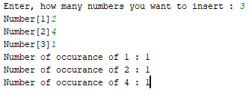

**Ques:15**

Write a program to calculate X(Y+Z) .

Code:

**class** Calculation:  
 **def** input(self):  
 self.a=int(input(**"Enter x = "**))  
 self.b=int(input(**"Enter y = "**))  
 self.c=int(input(**"Enter z= "**))  
 self.operation()  
 **def** operation(self):  
 d=self.b+self.c  
 self.e=self.a\*\*d  
 self.result()  
 **def** result(self):  
 print(self.e)  
calculation=Calculation()  
calculation.input()

Output:

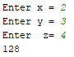

**Ques:16**

Write a Program to Accept character and display its Ascii value and its Next and Previous Character.

Code:

**class** Character:  
 **def** input(self):  
 self.a=input(**"Enter a Character : "**)  
 self.result()  
 **def** result(self):  
 print(**"ASCII value of {} is : "**.format(self.a),ord(self.a))  
 print(**"Previous Character : "**,chr(ord(self.a)-1))  
 print(**"Next Character : "**,chr(ord(self.a)+1))  
character=Character()  
character.input()

Output:

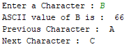

**Ques:17**

Write a Program to accept ‘n’ numbers and store all prime numbers in an array and display the array.

Code:

**import** math  
**class** Prime\_Checking:  
 **def** \_\_init\_\_(self):  
 self.b=[]  
 self.c=[]  
 **def** input(self):  
 self.a=int(input(**"Enter how many number you want to insert : "**))  
 **for** i **in** range(self.a):  
 self.b.append(int(input(**"Number [{}] : "**.format(i+1))))  
 self.calculation()  
 **def** calculation(self):  
 **for** i **in** self.b:  
 count=0  
 **if** i>1:  
 **for** j **in** range(2,int(math.sqrt(i))+1):  
 **if** i%j==0:  
 count=+1  
 **break  
 if** count==0:  
 self.c.append(i)  
 self.result()  
 **def** result(self):  
 **for** i **in** self.c:  
 print(i)  
  
prime\_checking=Prime\_Checking()  
prime\_checking.input()

Output:

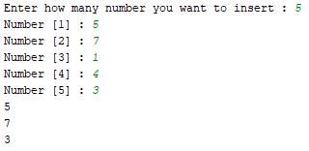

**Ques:18**

Write a program to calculate the x to the power y without using Standard functions.

Code:

**class** Power:  
 **def** input(self):  
 self.a=int(input(**"Enter the value of x : "**))  
 self.b=int(input(**"Enter the value of y : "**))  
 self.result()  
 **def** result(self):  
 print(**"x^y = {}"**.format(self.a\*\*self.b))  
power=Power()  
power.input()

Output:

C:\Users\Shiraz\Documents\Question19.PNG

**Ques:19**

Write a program to accept three sides of a triangle as input and print whether the Trangle is valid or Not.

(The trangle is valid, if sum of each of the two sides is greater then the third side.)

Code:

**class** Triangle:  
 **def** input(self):  
 self.a=int(input(**"enter the first side of a triangle : "**))  
 self.b=int(input(**"enter the second side of the triangle : "**))  
 self.c=int(input(**"enter the third side of the triangle : "**))  
 self.result()  
 **def** result(self):  
 **if** (self.a+self.b>self.c):  
 print(**"triangle is valid"**)  
 **elif** (self.b+self.c>self.a):  
 print(**"triangle is valid"**)  
 **elif** (self.c+self.a>self.b):  
 print(**"triangle is valid"**)  
 **else**:  
 print(**"triangle is not valid"**)  
  
triangle=Triangle()  
triangle.input()

Output:

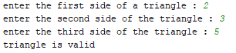

**Ques:20**

Write a program to accept string from the user and replace all occurrences of character ‘a’ by ‘\*’ symbol.

Code:

**class** Replace\_:  
 **def** input(self):  
 a=input(**"Enter String : "**)  
 self.operation(a)  
 **def** operation(self,a):  
 b=a.replace(**"a"**,**"@"**)  
 self.result(b)  
 **def** result(self,b):  
 print(b)  
  
replace\_=Replace\_()  
replace\_.input()

Output:

C:\Users\Shiraz\Documents\Question20.PNG

**Ques:23**

Write a menu driven program to perform the following operations on string using standard library functions

--Calculate length of string

--Reverse a given string

--Concatenation of one string to another

--Copy one String into another

--Compare two string.

Code:

**class** String:  
 **def** length(self,s):  
 print(**"The length of the string is"**,len(s))  
 **def** rev(self,s):  
 print(**"The reverse of the string is"**,s[::-1])  
 **def** con(self,s,s2):  
 print(**"The string after concatenation is"**,s,**" "**,s2)  
 **def** cop(self,s):  
 self.st=s  
 print(**"The string is copied "**,self.st)  
 **def** comp(self,s,s2):  
 **if** s==s2:  
 print(**"The string is equal"**)  
 **else**:  
 print(**"The string is not equal"**)  
string=String()  
n=int(input(**"Enter 1 to fine the length, 2 to reverse, 3 to concatenate, 4 to copy, 5 to compare string : "**))  
**if**(n==1):  
 s7=input(**"Enter a string : "**)  
 string.length(s7)  
**elif** n==2:  
 s1=input(**"Enter a string : "**)  
 string.rev(s1)  
**elif** n==3:  
 s2=input(**"Enter a string : "**)  
 s3=input(**"Enter another string : "**)  
 string.con(s2,s3)  
**elif** n==4:  
 s4=input(**"Enter a string : "**)  
 string.cop(s4)  
**elif** n==5:  
 s5=input(**"Enter a string : "**)  
 s6=input(**"Enter another string to compare : "**)  
 string.comp(s5,s6)

Output:

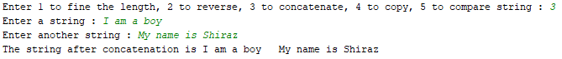C:\Users\Shiraz\Documents\Question23_2.PNGC:\Users\Shiraz\Documents\Question23_1.PNGC:\Users\Shiraz\Documents\Question23_4.PNG

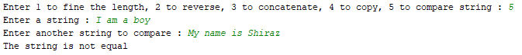

**Ques:24**

Write a program to display the multiplication table of a given number.

Code:

**class** Multiplication\_Table:  
 **def** mult(self,n):  
 self.i=1  
 **while**(self.i<=10):  
 print(n,**"x"**,self.i,**"="**,self.i\*n)  
 self.i+=1  
multiplication\_table=Multiplication\_Table()  
n=int(input(**"Enter a number to print its multiplication table : "**))  
multiplication\_table.mult(n)

Output:

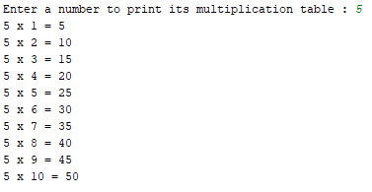

**Ques:25**

Write a program to display whether the input character is a digit or alphabet.

Code:

**class** Number:  
 **def** input(self):  
 self.ch = input(**"Enter a charcater : "**)  
 self.check()  
 **def** check(self):  
 **if** ((self.ch >= **'a' and** self.ch <= **'z'**) **or** (self.ch >= **'A' and** self.ch <= **'Z'**)):  
 print(**"Its an alphabet"**)  
 **elif** (int(self.ch) >= 0 **and** int(self.ch) <= 9):  
 print(**"Its an number"**)  
  
  
number = Number()  
number.input()

Output:

C:\Users\Shiraz\Documents\Question25.PNG

**Ques:26**

Write a program to accept basic salary from user. If basic salary>=5000 then hra=15% and da=150% of basic salary.

If basic salary<5000 then hra=10% and da=110% of basic salary .

Display the Gross salary.

Code:

**class** Basic\_Salary:  
 **def** input(self):  
 self.Bs =float(input(**"Enter Basic Salary\n"**))  
 self.calculation()  
 **def** calculation(self):  
 **if** self.Bs >= 5000:  
 hra = (15 /100 ) \*self.Bs  
 da = (150 /100 ) \*self.Bs  
 **else**:  
 hra = (10 /100 ) \*self.Bs  
 da = (110 /100 ) \*self.Bs  
 gs = hra +da +self.Bs  
 self.result(hra,da,gs)  
 **def** result(self,hra,da,gs):  
 print(**"Basic Salary = "** ,self.Bs)  
 print(**"hra = "** ,hra)  
 print(**"da = "** ,da)  
 print(**"Gs = "** ,gs)  
  
  
basic\_salary=Basic\_Salary()  
basic\_salary.input()

Output:

