Final Project Report
Course: Advanced Databases (NoSQL) Project: Booking System Web Application
Students: Alisher Mendulda, Zharkyn Mukhambetiyar.

Project Overview
The goal of this project was to design and implement a full-stack web application using MongoDB as the main database. The application is a Booking System that allows users to register, authenticate, view available services, and create bookings. The system includes a backend REST API and a basic frontend interface that interacts with the API. The project demonstrates NoSQL data modeling, MongoDB queries and aggregations, backend logic, authentication, and documentation.

System Architecture
The system follows a client-server architecture:
- Frontend: HTML, CSS, and JavaScript pages that send HTTP requests to the backend using the Fetch API.
- Backend: Node.js with Express.js framework that exposes RESTful API endpoints.
- Database: MongoDB used as the primary NoSQL database, accessed through Mongoose ODM.
Data Flow:
- The user interacts with the frontend.
- The frontend sends HTTP requests to the backend API.
- The backend processes the request, performs database operations in MongoDB, and returns JSON responses.
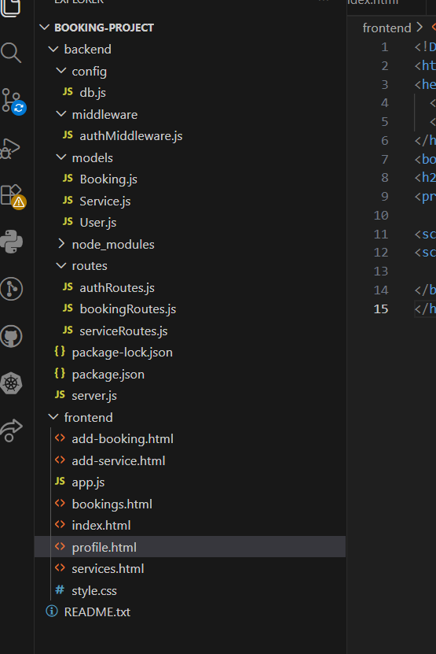

Database Schema and Data Modeling
The database consists of three main collections: Users, Services, and Bookings.

Users Collection
The Users collection stores registered users and their authentication information. Fields:
- name (String)
- email (String, unique)
- password (String, hashed)
- role (String, user or admin)
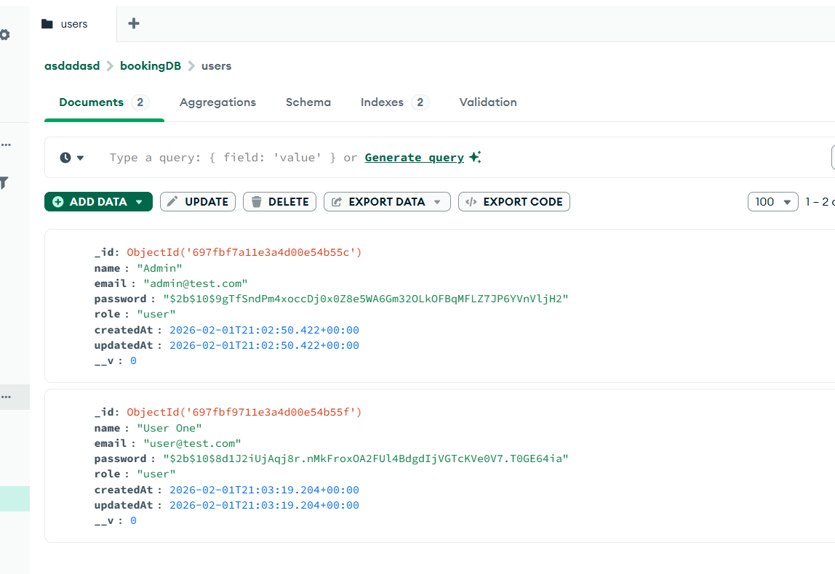

Services Collection
The Services collection stores the list of services that can be booked. Fields:
- name (String)
- price (Number)
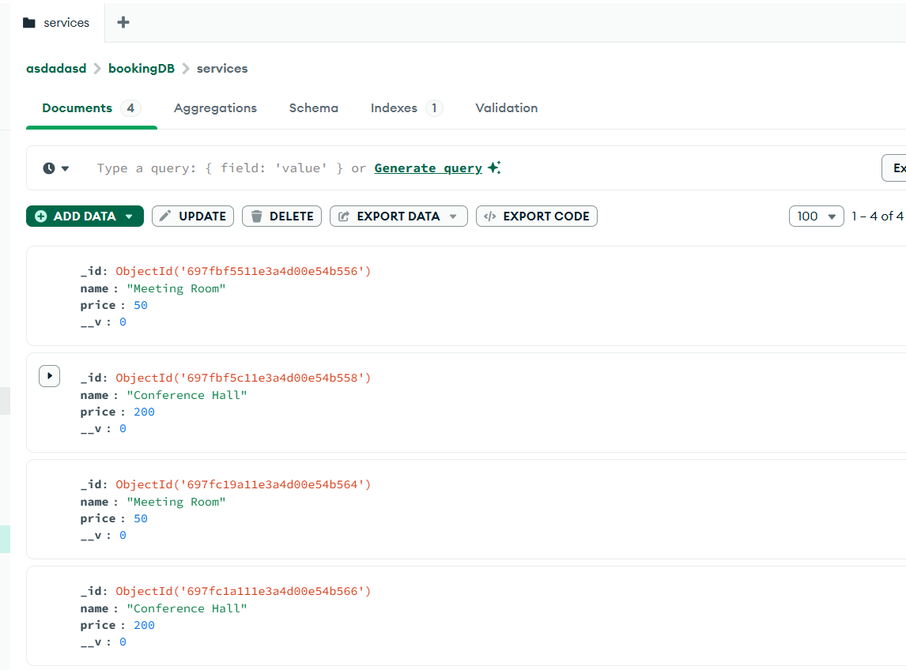

Bookings Collection
The Bookings collection stores booking records made by users. Fields:
- user (ObjectId reference to Users)
- service (ObjectId reference to Services)
- date (Date)
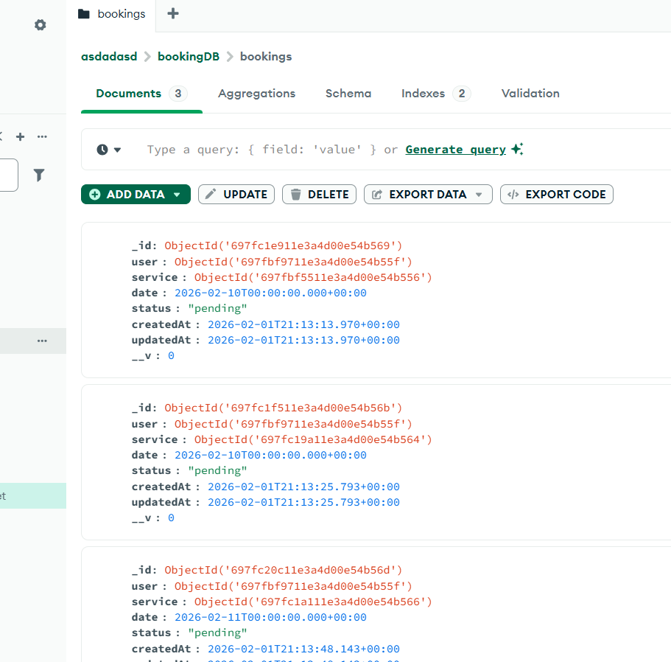
Referenced data modeling is used between Bookings and Users/Services to demonstrate relationships between collections.

REST API Implementation
The backend exposes multiple REST API endpoints following REST principles. The API supports full CRUD operations and authentication.

Authentication Endpoints
- POST /auth/register – registers a new user.
- POST /auth/login – authenticates user and returns a JWT token.
- GET /auth/me – returns information about the authenticated user (requires JWT).
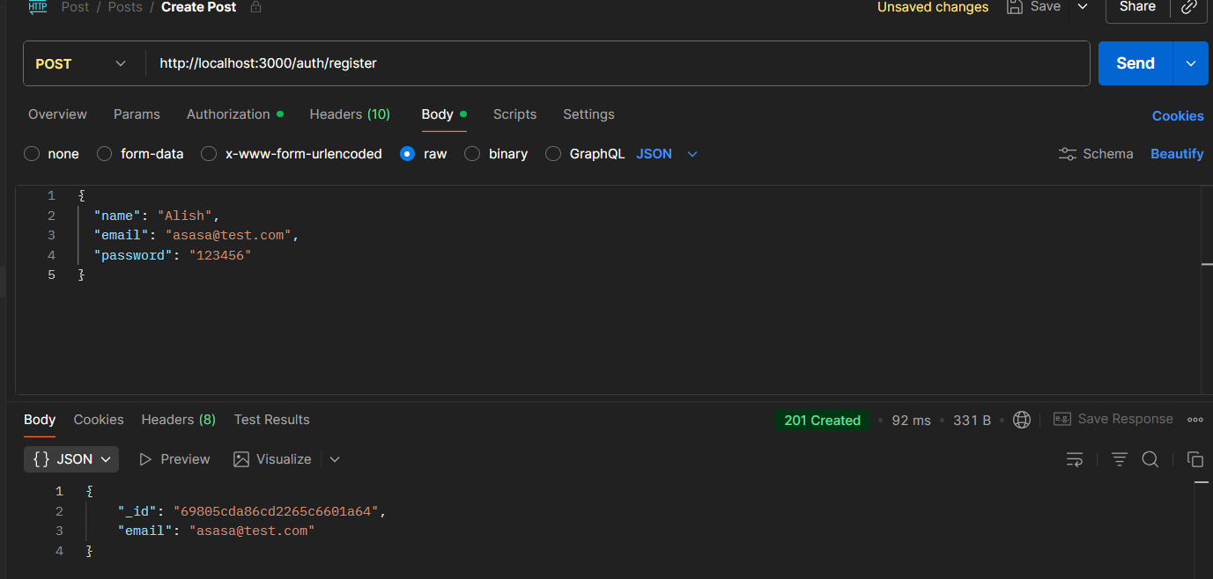
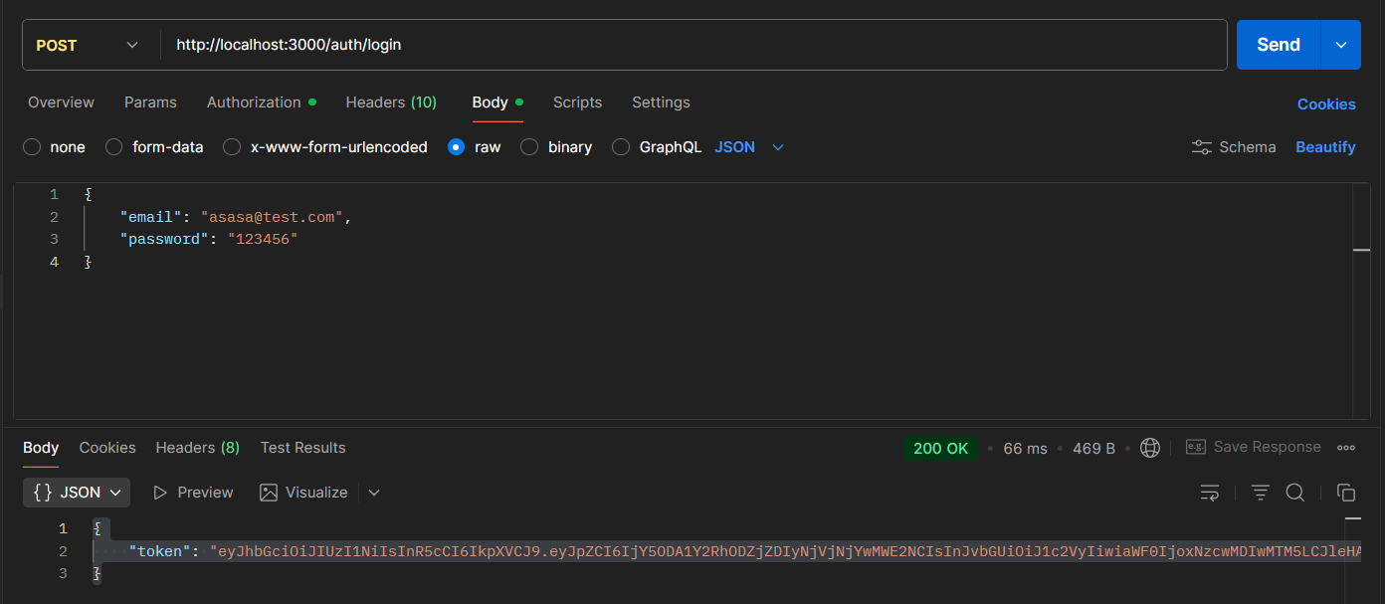

Services Endpoints
- GET /services – returns all services.
- POST /services – creates a new service.
- PUT /services/:id – updates an existing service.
- DELETE /services/:id – deletes a service.
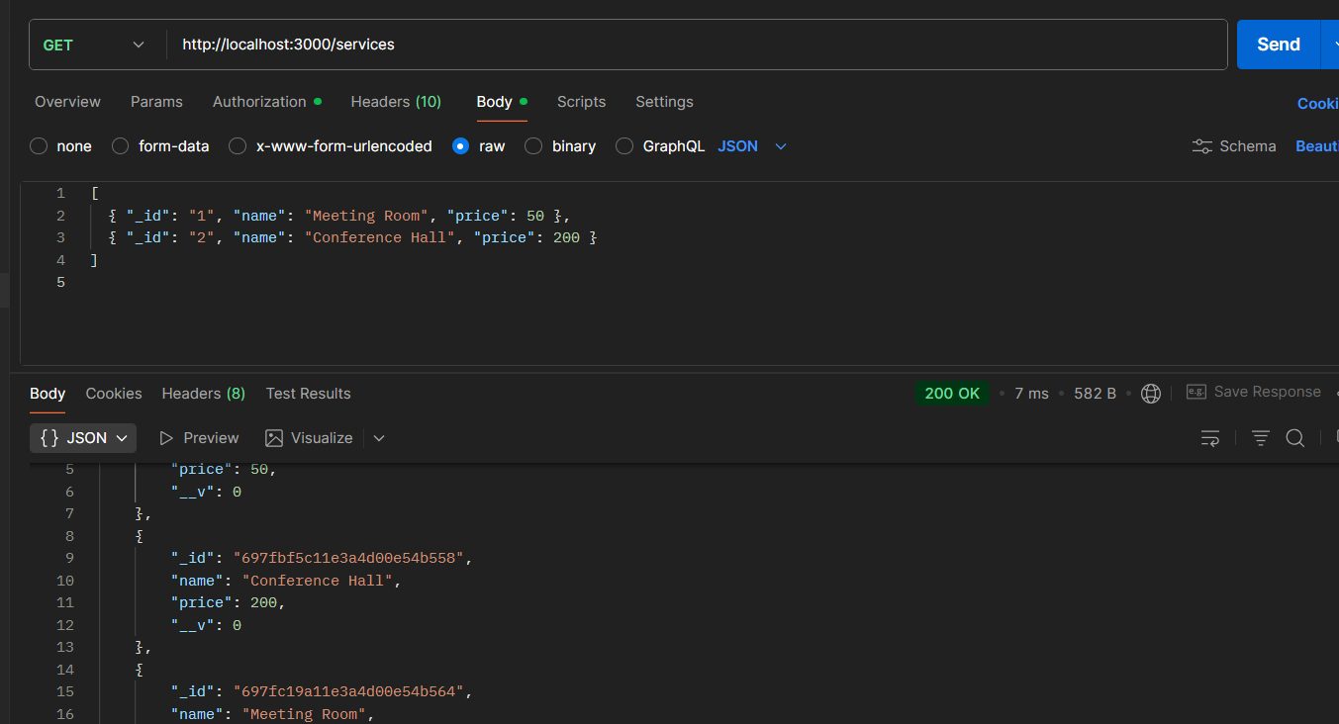
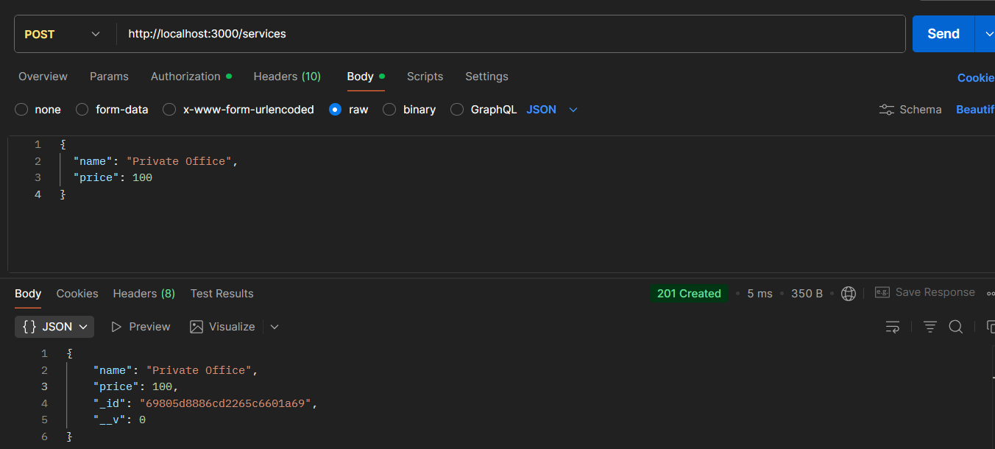
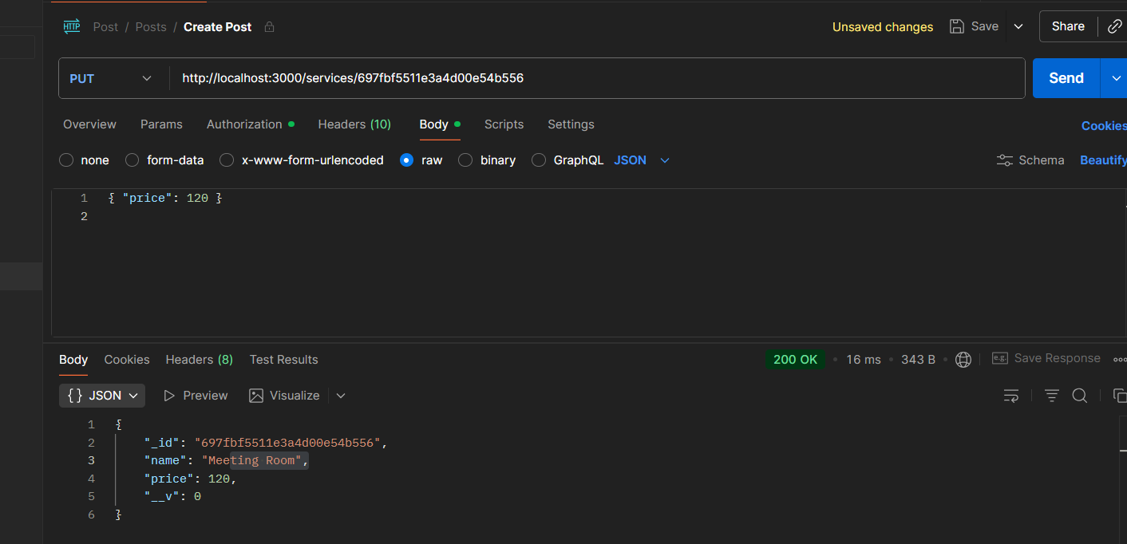

Bookings Endpoints
- GET /bookings – returns all bookings (requires authentication).
- POST /bookings – creates a booking for the authenticated user.
- PUT /bookings/:id – updates booking details.
- DELETE /bookings/:id – deletes a booking.
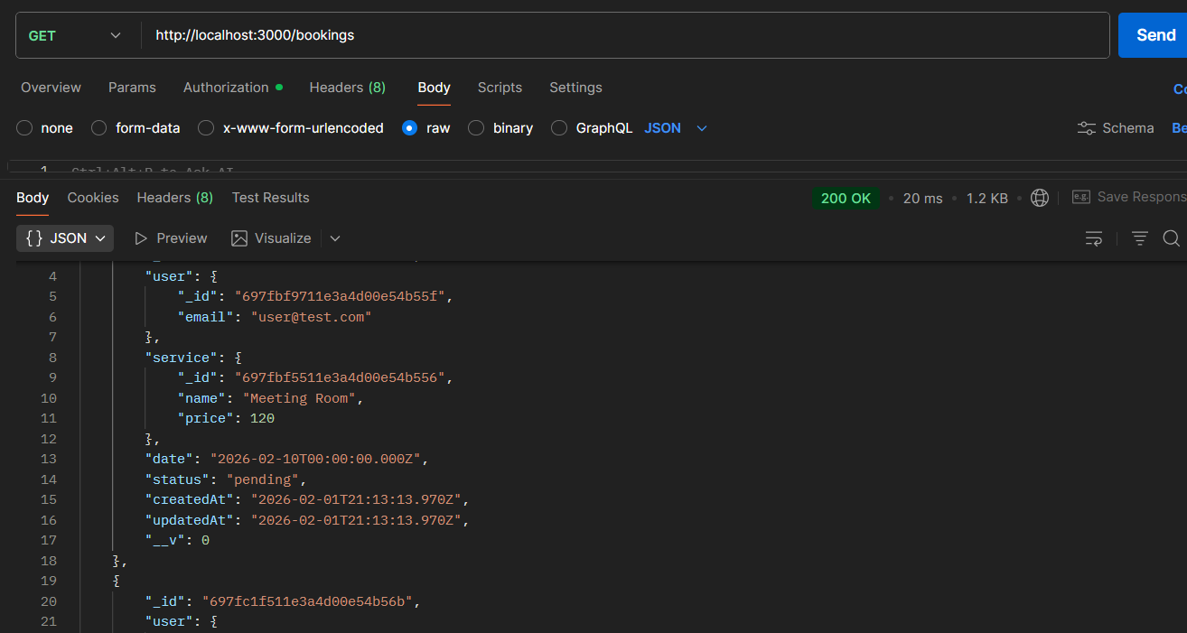

MongoDB Queries and Aggregation
MongoDB CRUD operations are used across all collections. Advanced aggregation pipelines are implemented to analyze booking data.

Aggregation Examples
- Number of bookings per service.
- Total revenue per service calculated as price multiplied by number of bookings.
The aggregation pipeline uses stages such as $lookup, $group, and $project to combine data from multiple collections and compute statistics.

Indexing and Optimization Strategy
Indexes are created on frequently queried fields such as email in the Users collection and service references in the Bookings collection. Compound indexes can be applied to optimize query performance when filtering bookings by user and date.

Backend Logic and Security
The backend implements business logic for creating and managing bookings. Passwords are hashed using bcrypt. JWT tokens are used for authentication and authorization. Protected routes require a valid token in the Authorization header.
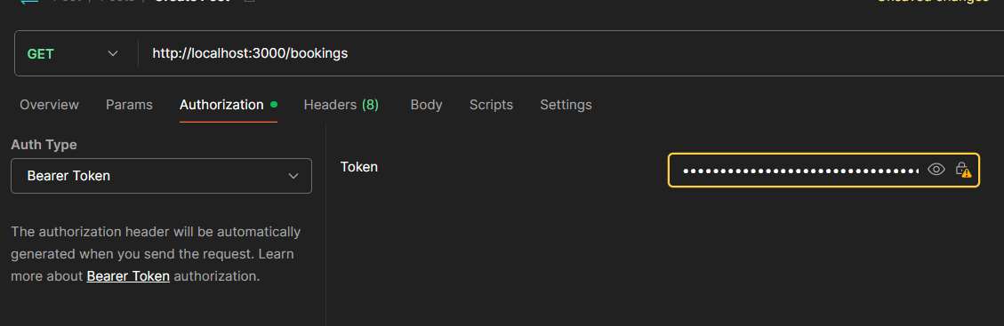
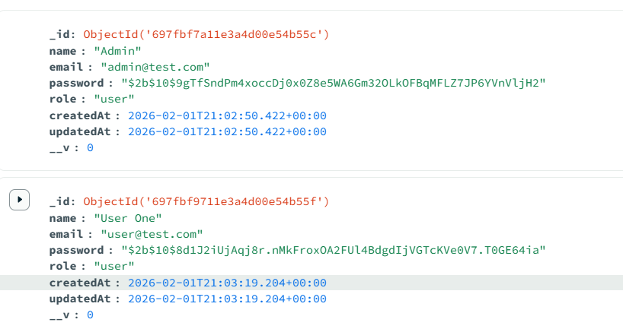
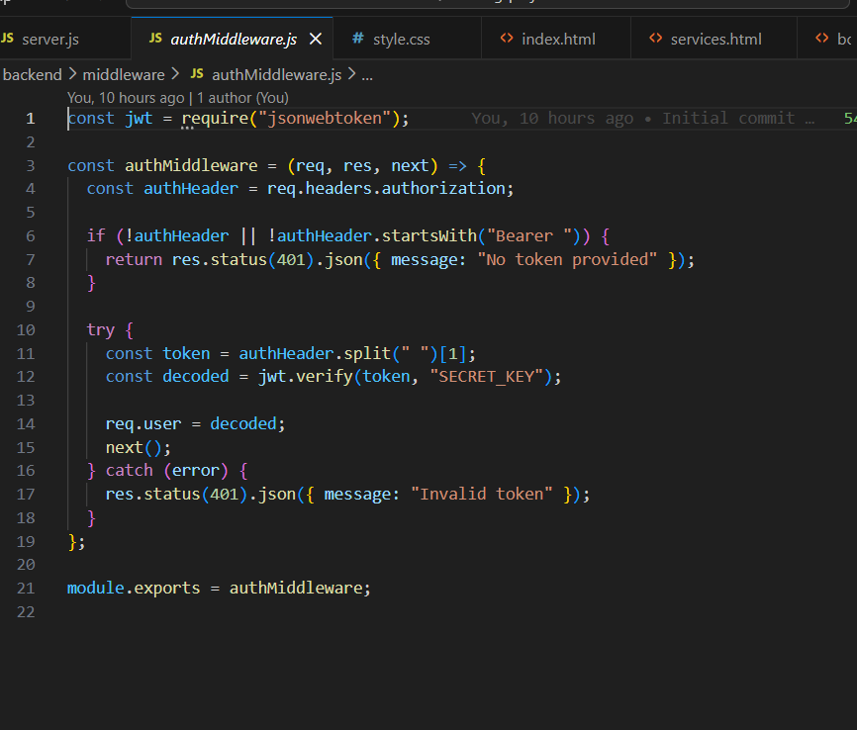

Frontend Implementation
The frontend consists of six pages:
- Login page
- Services list page
- Add service page
- Bookings list page
- Add booking page
- User profile page
The frontend sends HTTP requests to the backend API and displays the returned data. LocalStorage is used to store JWT tokens for authenticated requests.
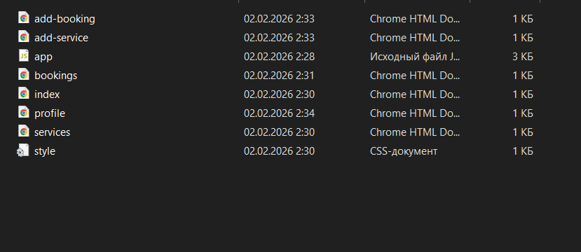
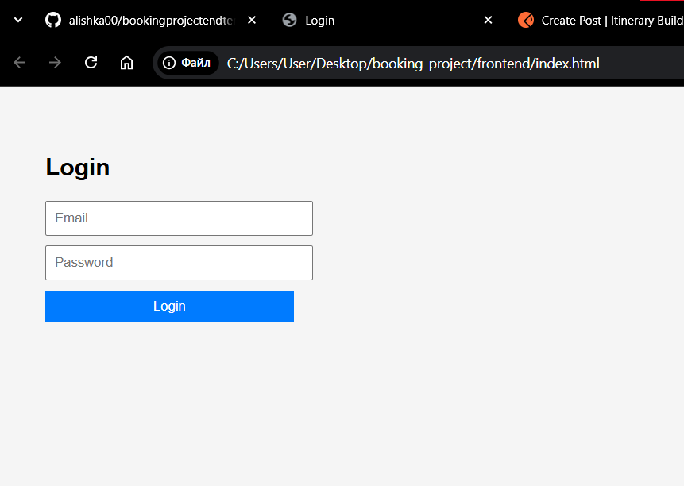

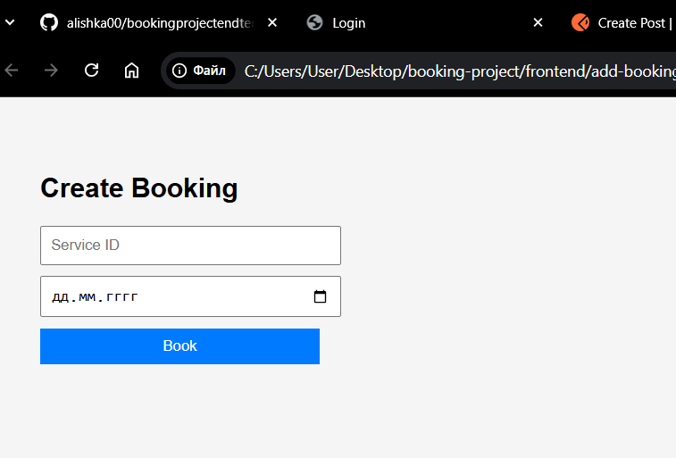

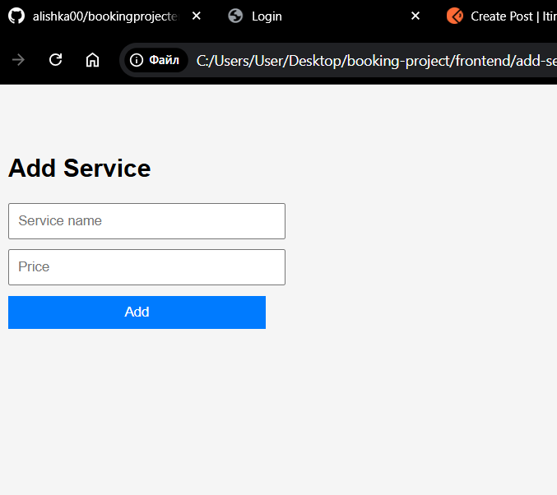

Conclusion
This project demonstrates the use of MongoDB in a real web application with full CRUD functionality, aggregation queries, authentication, and a working frontend. The system satisfies all course requirements for the Advanced Databases (NoSQL) final project.

