Real-Time Data Collection and Stream Processing System
Smart Campus Environmental Sensor Monitoring — Technical Report
Team: Zharkyn Mukhambetiyar, Alisher Mendulda, Nurkeldi Samuratov
Scope: Weeks 1–4 — Introduction to Real-Time Data Analysis with Python; Python Fundamentals for Data Streaming; Data Acquisition and Stream Processing; Real-Time Data Processing with Pandas and NumPy.
Technologies: Python 3, Pandas, NumPy, Matplotlib, SQLite.

1. Introduction and Scenario
This project implements a real-time data collection and stream-processing system for a Smart Campus environmental monitoring scenario. Five IoT sensor nodes installed in classrooms, laboratories and an auditorium report ambient temperature, relative humidity and CO2 concentration. The system acquires the readings incrementally as they arrive, cleans and analyses them with Pandas and NumPy, maintains rolling indicators per sensor, applies rule-based anomaly detection, shows live results in the console, and stores every processed record for later analysis.
A live campus feed was not available, so a reproducible data generator (data_generator.py) produces timestamped records and injects labelled anomalies. This gives the detector real events to find and lets us measure how many injected events it actually catches (Section 7).

1.1 Data source, schema and frequency
The simulated network emits one record every 0.15 s in the reference run (configurable). The reporting node is chosen at random, so each of the five sensors reports on average every 0.75 s (about 1.3 Hz per sensor, 6.7 records/s overall). Every record has a fixed five-field schema:
Field | Type | Meaning
timestamp | ISO-8601 string | UTC time the reading was captured
sensor_id | string | Room / node that produced the reading (ROOM_A101, ROOM_A102, LAB_B201, LAB_B202, AUDITORIUM_C1)
temperature | float, °C | Ambient temperature at the sensor
humidity | float, % | Relative humidity at the sensor
co2 | float, ppm | CO2 concentration, a proxy for air quality and occupancy
Table 1. Schema of an incoming record.
Each sensor has its own baseline (mean and standard deviation) for the three quantities, e.g. 22.0 ± 0.4 °C and 500 ± 40 ppm for ROOM_A101, and a higher CO2 baseline (700 ± 80 ppm) for the auditorium to reflect larger occupancy. Readings are Gaussian noise around these baselines.

2. Team and Contributions
Member | Main responsibilities
Zharkyn Mukhambetiyar | Scenario and schema design; data generator (data_generator.py) with anomaly injection and simulated clock; README.
Alisher Mendulda | Stream processor (stream_processor.py): incremental acquisition, cleaning, rolling indicators, rule-based anomaly detector; unit tests (tests.py).
Nurkeldi Samuratov | Orchestration and live console output (main.py); CSV/SQLite storage; summary table, dashboard visualization; this report.
Table 2. Distribution of work. All members reviewed and tested the complete pipeline.

3. System Architecture
The system consists of three single-responsibility modules and a test file. The processor does not know how data is produced: it only depends on a CSV file that is appended to, so the simulator can be replaced by a REST poller, an MQTT subscriber or a Kafka consumer writing the same five columns, without touching stream_processor.py.
Module | Responsibility
data_generator.py | Simulates the live source. Appends one CSV row per reading and flushes immediately so a concurrent reader sees it. Injects heat, spike, CO2 and frozen-sensor anomalies. Seeded, including a simulated clock, for exact reproducibility.
stream_processor.py | StreamProcessor class: incremental acquisition (poll_new_rows), cleaning (_clean), per-sensor rolling state, indicators, anomaly detector (_detect_anomaly), CSV + SQLite persistence, pandas cross-check.
main.py | Runs the generator in a background thread and the processor in the main thread; live console output and log file; summary table, anomaly list and dashboard.
tests.py | 11 unit tests: incremental reading, partial lines, cleaning, all four rules, rate, pandas agreement, storage, reproducibility.
Table 3. Modules and responsibilities.

4. Incremental Data Acquisition
Re-reading the whole file on every check would reprocess old rows and scale badly. Instead, StreamProcessor.poll_new_rows() keeps a byte-offset cursor into the source file. On each poll it seeks to the last position, reads only the bytes appended since then, and parses just that chunk with pandas.read_csv. Only complete lines (ending in a newline) are consumed; a row that the generator is still writing is left for the next poll, which prevents half-written records from being parsed. The key part of the implementation is shown below.
with open(self.source_csv, "rb") as f:
f.seek(self._bytes_read) # resume where the last poll stopped
raw = f.read() # only the NEW bytes
last_nl = raw.rfind(b"\n")
if last_nl < 0: # no complete line yet
return pd.DataFrame(columns=FIELDNAMES)
self._bytes_read += last_nl + 1 # advance the cursor past complete lines
new_text = raw[:last_nl + 1].decode("utf-8")

main.py demonstrates this live: the generator runs in a background thread while the main loop calls process_available() every 0.2 s until the generator has finished and several consecutive polls return nothing. Each poll typically returns one to two new records at the reference rate, and each record is processed, printed and stored the moment it is acquired. Two unit tests verify the behaviour: a second poll returns no rows when nothing was appended, and a half-written line is only consumed once it is complete.

5. Data Cleaning and Transformation
Each newly acquired chunk is cleaned with Pandas before analysis (StreamProcessor._clean): rows without a sensor_id are dropped; timestamps are parsed to timezone-aware datetimes and unparseable ones discarded; temperature, humidity and CO2 are coerced to numbers, with invalid values becoming NaN and dropped; and a physical-range filter removes impossible readings (temperature outside −20…80 °C, humidity outside 0…100 %, negative CO2). This protects the rolling statistics from corrupt input. A unit test feeds an impossible temperature, an impossible humidity and a non-numeric value and confirms that only the valid row survives.

6. Real-Time Indicators
For every sensor the processor keeps a fixed-size deque holding the 30 most recent readings. On every new reading the indicators in Table 4 are recomputed with NumPy directly from that window, so the cost per record depends on the window size and not on the length of the stream.
Indicator | Computation | Meaning
Rolling average temperature | np.mean over window | Moving average; smooths sensor noise
Rolling std of temperature | np.std over window | Dispersion; rises when a sensor becomes unstable
Rolling min / max CO2 | np.min / np.max | Recent envelope of air-quality readings
Per-sensor report rate (Hz) | (count − 1) / elapsed s | Event rate; 0 for the first reading of a sensor
Global event / anomaly count | running counters | Totals for the whole stream (global_stats())
Table 4. Real-time indicators (five implemented; three required).
Because the indicators are maintained incrementally with NumPy, we also verify them against an independent batch computation: after the run, verify_with_pandas() recomputes the rolling mean and standard deviation with pandas groupby().rolling() over the stored results. The largest absolute difference is 0.0005 for both, which equals the rounding of the stored values to three decimals (Section 9).

7. Rule-Based Anomaly Detection
StreamProcessor._detect_anomaly evaluates each new reading against four independent rules; any match flags the record and stores a human-readable reason.
Rule | Condition | Purpose
High temperature | temperature ≥ 27.0 °C | HVAC failure, overheating
High CO2 | co2 ≥ 1000 ppm | Poor ventilation, overcrowding
Statistical outlier | |z| ≥ 3.0 versus the previous 30 readings of that sensor (≥ 10 readings of history) | Sudden jumps below absolute limits
Stuck sensor | 5 consecutive identical (temperature, humidity, co2) readings from one sensor | Frozen or failed sensor
Table 5. Detection rules.
One design detail matters for the z-score rule. The reference mean and standard deviation are computed from the window before the new reading is added. If the reading were included, a spike would inflate its own standard deviation: with n readings the largest attainable z-score is (n − 1)/√n, so for small windows a real outlier could never reach 3.0. Using the previous window avoids that. The rule is silent for the first ten readings of a sensor.
if row["temperature"] >= TEMP_HIGH_C:
reasons.append(f"high_temperature>{TEMP_HIGH_C}C")
if row["co2"] >= CO2_HIGH_PPM:
reasons.append(f"high_co2>{CO2_HIGH_PPM}ppm")
if ref_n >= MIN_HISTORY and ref_std > 1e-6:
z = (row["temperature"] - ref_mean) / ref_std
if abs(z) >= ZSCORE_THRESHOLD:
reasons.append(f"temp_zscore={z:.2f}")
if len(st.last_values) == FROZEN_REPEAT_COUNT and len(set(st.last_values)) == 1:
reasons.append("sensor_stuck_repeated_values")

7.1 Detection quality on the reference run
Because the generator labels the events it injects, detection can be checked against ground truth. In the reference run (300 records) the generator injected 12 events. All 12 were detected, plus one additional flag that came from natural noise (a z-score of −3.19 on ROOM_A101), which is the expected false-positive rate of a 3-sigma rule.
Injected type | Injected | Detected | Detected by
co2 | 6 | 6 | High CO2 rule
heat | 1 | 1 | High temperature (and z-score)
spike (+2.5…3.5 °C) | 1 | 1 | Z-score rule only (value 24.49 °C is below 27 °C)
frozen (6 repeats) | 4 | 4 | Stuck-sensor rule; fires on the 5th and 6th repeat (8 records)
natural noise | — | 1 extra | Z-score −3.19 on ROOM_A101 (false positive)
Table 6. Injected anomalies versus detections (17 flagged records in total).

8. Live Display and Storage
While the stream runs, main.py prints one line per processed record: the raw reading, its rolling indicators and, when relevant, an ANOMALY flag with the triggering rule(s). Figure 1 shows an excerpt of the real console log of the reference run (output/console_log.txt): the start of the stream, a z-score anomaly, the second stuck-sensor flag, and a heat spike that triggers two rules at once.
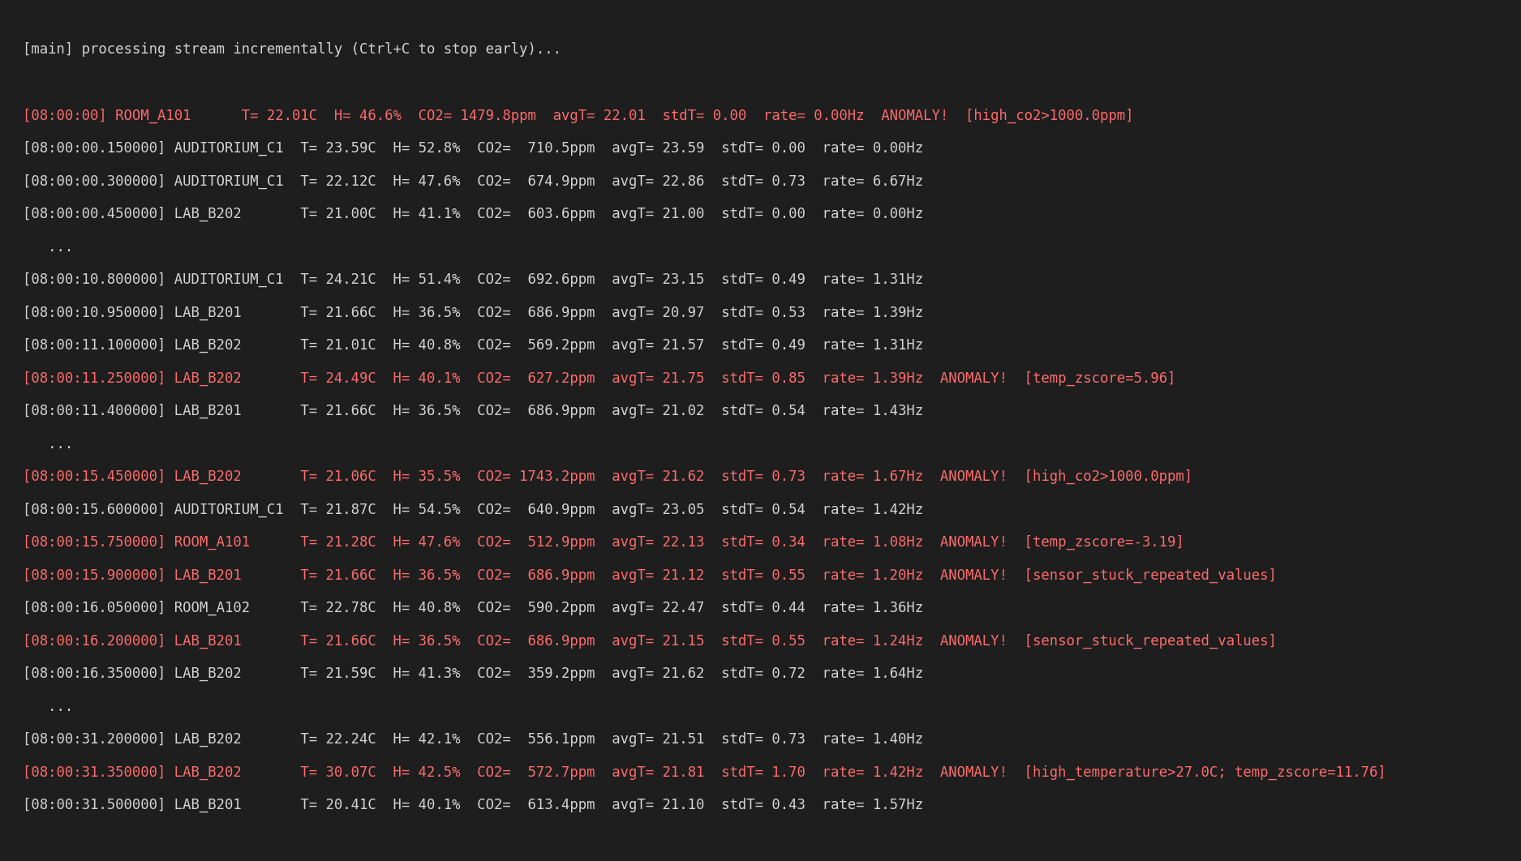
Figure 1. Excerpt of the live console output (anomalies in red).
Every processed record, including raw fields, indicators and the anomaly flag and reason, is appended to output/processed_stream.csv and to the readings table of output/processed_stream.sqlite. The CSV is portable; the SQLite table can be queried with SQL, for example to list anomalies per sensor. Flagged records are additionally exported to output/anomalies.csv, and the per-sensor summary to output/summary_table.csv.

9. Results

9.1 Summary table
The reference run (python main.py --n 300 --interval 0.15 --seed 42) processed 300 records in about 45 s of stream time and flagged 17 of them (5.7 %). Table 7 aggregates the run per sensor (also saved as output/summary_table.csv).
Sensor | Records | Avg T | Max T | Min T | Std T | Avg CO2 | Max CO2 | Anom.
AUDITORIUM_C1 | 62 | 23.00 | 24.21 | 21.84 | 0.52 | 755.74 | 1879.00 | 5
LAB_B201 | 67 | 21.04 | 22.22 | 19.81 | 0.50 | 632.26 | 1382.30 | 5
LAB_B202 | 61 | 21.70 | 30.07 | 20.51 | 1.25 | 619.27 | 1743.20 | 3
ROOM_A101 | 51 | 22.07 | 22.76 | 21.13 | 0.37 | 518.38 | 1479.80 | 2
ROOM_A102 | 59 | 22.50 | 23.62 | 21.53 | 0.41 | 522.04 | 637.90 | 2
Table 7. Per-sensor summary (temperature in °C, CO2 in ppm).
LAB_B202 has the highest temperature standard deviation (1.25 °C versus about 0.4–0.5 °C elsewhere) and a maximum of 30.07 °C. This is entirely due to the single injected heat event, which is also visible as a jump of the rolling standard deviation in Figure 2.

9.2 Detected events
Timestamp (UTC) | Sensor | Temp (°C) | CO2 (ppm) | Rule
08:00:00 | ROOM_A101 | 22.01 | 1479.8 | High CO2
08:00:08.400 | AUDITORIUM_C1 | 23.26 | 1879.0 | High CO2
08:00:11.250 | LAB_B202 | 24.49 | 627.2 | Z-score
08:00:15.450 | LAB_B202 | 21.06 | 1743.2 | High CO2
08:00:15.750 | ROOM_A101 | 21.28 | 512.9 | Z-score
08:00:15.900 | LAB_B201 | 21.66 | 686.9 | Stuck sensor
08:00:16.200 | LAB_B201 | 21.66 | 686.9 | Stuck sensor
08:00:17.250 | AUDITORIUM_C1 | 21.84 | 1284.0 | High CO2
08:00:19.050 | LAB_B201 | 21.1 | 682.7 | Stuck sensor
08:00:19.350 | LAB_B201 | 21.1 | 682.7 | Stuck sensor
08:00:22.350 | LAB_B201 | 21.21 | 1382.3 | High CO2
08:00:28.650 | AUDITORIUM_C1 | 23.35 | 837.9 | Stuck sensor
08:00:29.100 | AUDITORIUM_C1 | 23.35 | 837.9 | Stuck sensor
08:00:31.350 | LAB_B202 | 30.07 | 572.7 | High temp + z-score
08:00:42.900 | ROOM_A102 | 22.48 | 517.2 | Stuck sensor
08:00:43.050 | ROOM_A102 | 22.48 | 517.2 | Stuck sensor
08:00:43.350 | AUDITORIUM_C1 | 22.76 | 1580.6 | High CO2
Table 8. All 17 flagged records (time of day on 2026-09-01).

9.3 Visualization
Figure 2 (output/dashboard.png) has four panels sharing a time axis: temperature per sensor with its rolling average and the 27 °C threshold; CO2 per sensor with the 1000 ppm threshold; the rolling standard deviation of temperature; and the ingestion rate as the number of records per 2-second bucket. Anomalies are marked with red crosses in the first two panels. The ingestion panel shows a steady 13–14 records per bucket, i.e. data arrived continuously for the whole run; the last bucket is shorter because the stream ended.
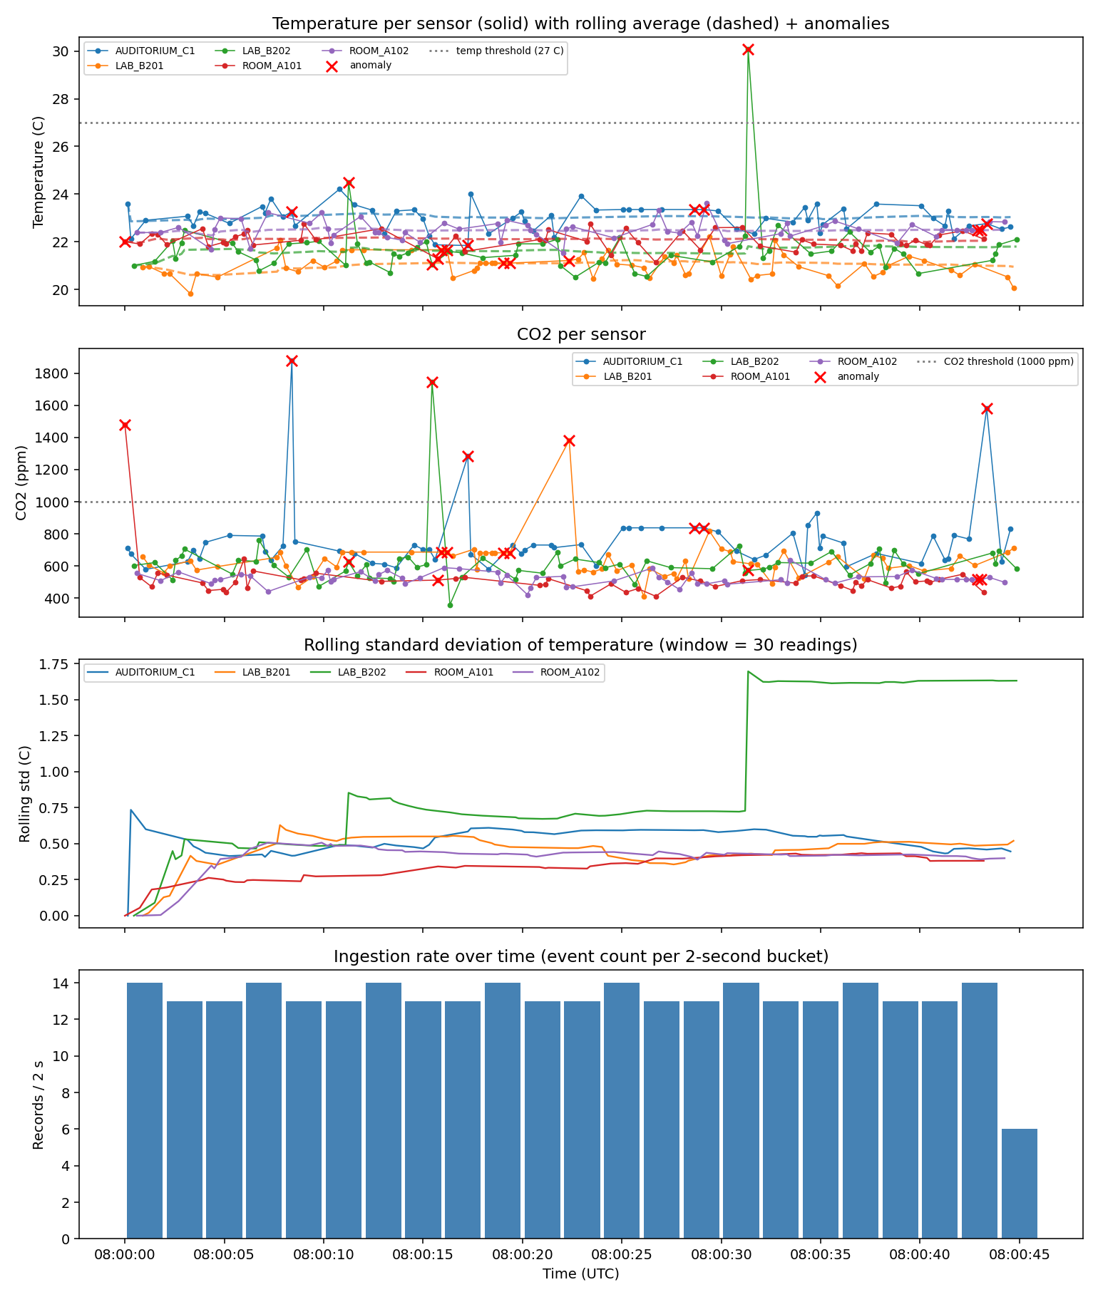
Figure 2. Dashboard of the reference run.

10. Validation and Reproducibility
- Unit tests. python tests.py runs 11 tests (all pass): incremental reading, half-written lines, cleaning, each of the four rules, the rate indicator, agreement with pandas rolling(), storage, and generator reproducibility.
- Indicator cross-check. The incremental NumPy indicators agree with pandas groupby().rolling() within 0.0005 (the rounding of stored values).
- Reproducibility. With a seed, the generator also uses a simulated clock starting at 2026-09-01 08:00:00 UTC. Two runs with the same --n, --interval and --seed produce byte-identical data/stream.csv, output/processed_stream.csv and output/summary_table.csv (verified by comparing MD5 checksums).
- Detection check. All 12 injected events were found (Table 6); one extra z-score flag is a statistical false positive.

11. Limitations and Future Work
The window size (30 readings) and thresholds suit a classroom-scale deployment and would need retuning for other domains; a longer window smooths statistics but delays detection. The z-score rule needs ten readings of history per sensor, so the first readings of a sensor are only covered by the absolute and stuck-sensor rules. The z-score is computed for temperature only and CO2 relies on a fixed threshold. The incremental reader assumes one writer appending to a single CSV; a multi-writer deployment would poll a database cursor, an API "since" parameter or a message-queue offset, but the public interface (poll_new_rows / process_available) would not change. The console display could be replaced by a live-updating chart, and an additional rate-of-change rule would catch slow drifts.

12. Conclusion
The system meets all required tasks. It defines a realistic streaming scenario with a documented schema, generates timestamped and fully reproducible data, acquires records incrementally instead of in batch, uses Pandas and NumPy for cleaning, transformation and analysis, computes five real-time indicators, applies a four-rule anomaly detector that was checked against labelled ground truth, prints continuously updated console output, and persists all results to CSV and SQLite together with a summary table, an event list and a four-panel visualization.

How to reproduce
python3 -m venv venv && source venv/bin/activate
pip install -r requirements.txt
python main.py --n 300 --interval 0.15 --seed 42
python tests.py

