SMART PHARMACY

Senior Project
by
Ali Shreif (82110079),
Ali Moussawi (82110031)

Submitted to the School of Engineering of the
Lebanese International University
Rayak, Lebanon
In partial fulfillment of the requirements for the degree of

BACHELOR OF SCIENCE IN COMMUNICATION ENGINEERING
Spring 2024-2025

Approved by:
Supervisor

Eng. Mohammad Shraif

Committee Member

Dr. Hamsa Hassrouny

DEDICATION

To my loving family, whose unwavering support and encouragement have been my guiding light throughout this journey. Your belief in my abilities has been my greatest motivation to make this achievement possible.
Ali Shreif

I would like to dedicate this project to my family, who supported me from the beginning, and
to my instructors who influenced me through my entire educational journey.
Ali Moussawi
ACKNOWLEDGMENT

First and foremost, we would like to express our deepest gratitude to Allah Almighty, whose blessings and guidance have been the cornerstone of our effort and achievements.

Also, we are profoundly thankful to our supervisor, Eng. Mohammad Shreif, for his expertise, patience, and insightful feedback, has been instrumental in shaping this project and helping us overcome challenges. Without his mentorship, this work would not have been possible.

Furthermore, we would like to extend our sincere appreciation to the committee member, Dr. Hamsa Hassrouny. For his time, constructive criticism and thoughtful suggestions. His feedback has greatly enriched the quality of this project.

Lastly, we are so grateful to my colleagues and peers for their support, collaboration, and stimulating discussions, which have contributed significantly to the success of this project.

ABSTRACT

Medication non-adherence for a diverse range of users, including blind and deaf individuals, is a significant challenge in healthcare, often leading to worsened patient outcomes and increased healthcare costs. To address this issue, presenting the design and implementation of an electronic Smart Pharmacy that leverages ESP32 microcontroller technology and mobile app integration to ensure timely, personalized medication schedules and accurate medication intake. The mobile application allows users to set schedules, receive notifications, and track medication intake. By integrating automations and user-friendly alerts, this project enhances medication adherence, making it especially useful for individuals who require assistance in managing their daily prescriptions.

TABLE OF CONTENTS

CHAPTER 1 INTRODUCTION 1
1.1 Background 1
1.2 Problem Statement 1
1.3 General overview of the project 1
1.4 Thesis Outline 2
CHAPTER 2 Survey of Existing Methods and Similar Systems 3
2.1 Introduction 3
2.2 Method 1 / System 1 3
2.3 Method 2 / System 2 3
2.4 Method 3 / System 3 3
2.5 Methods/Systems Comparison 3
2.6 Conclusion and Motivation 5
CHAPTER 3 System Design 6
3.1 Introduction 6
3.2 Requirements and Specification Analysis 6
3.2.1 Functional Requirements 6
3.2.2 Use Case Diagrams 6
3.3 System Architecture 7
3.4 Class Diagrams 7
3.5 Sequence Diagrams 7
3.6 Activity Diagrams 8
3.7 Entity-Relationship (ER) Diagrams 8
3.8 Non-Technical Aspects 8
3.8.1 Financial Viability 8
3.8.2 Stakeholders 9
3.8.3 Scope 9
3.8.4 Risks 9
3.8.5 Schedule and Milestones 10
3.8.6 Ethical and Social Considerations 10
3.8.7 Environmental and Sustainability Considerations 10
3.8.8 Relevant Standards 11
3.9 Conclusion 11
CHAPTER 4 Implementation/Simulation and Testing 12
4.1 Introduction 12
4.2 Implementation Tools 12
4.3 Implementation Summary 12
1. 12
4.4 Test Cases and Acceptance Criteria 12
4.5 Conclusion 12
CHAPTER 5 Conclusion and Future Work 13
5.1 Conclusion 13
5.2 Future Work 13

LIST OF FIGURES

Figure 1 LiveFine Smart Automatic Pill Dispenser 6
Figure 2 MedaCube Smart Pill Dispenser 7
Figure 3 GMC Pill Dispenser 8
Figure 4 Use Case Diagram 14
Figure 5 System Architecture 17
Figure 6 Class Diagram 18
Figure 7 Sequence Diagram 19
Figure 8 Activity Diagram 20
Figure 9 ER Diagram 21
Figure 10 Cost Benefit Analysis 22
Figure 11 Scheduling Tasks and Milestones 26

LIST OF TABLES

Table 1 Comparison Table Based on Graphical Interfaces 9
Table 2 Comparison Table Based on Content and Functionality 10
Table 3 Comparison Table Based on Features 10
Table 4 Use Case Narrative 14

LIST OF SYMBOLS

MUST LISTED IN ASCENDING ALPHABETICAL ORDER. Examples:
CD: Compact Disk
ISO: International Standardization Organization
LIU: Lebanese International University
WIFI: Wireless Fidelity

INTRODUCTION

Background

Medication adherence is a critical factor in ensuring effective treatment and patient well-being. However, many individuals, especially the elderly and those with chronic illnesses, struggle to take their medications on time due to forgetfulness, cognitive impairments, or complex dosing schedules.

This project seeks to bridge this gap by designing a Smart Pharmacy that incorporates multimodal alerts, audio, visual, and vibration to ensure accessibility for blind and deaf users. This system provides many innovative features like LED indicators, mobile app integration, and personalized medication scheduling to help users manage their medications more effectively.

For blind individuals, the system provides voice-guided instructions and audio announcements to identify the correct drawer and dosage. For deaf users, LED lights and a vibration mechanism are used to signal medication times and drawer locations. This system leverages microcontrollers, such as ESP32, to control LEDs, servo motors that automate drawer opening, and voice records. Furthermore, mobile applications connected via Wi-Fi allow real-time updates and notifications. This system aims to provide a comprehensive solution for medication adherence that is both inclusive and user-friendly. In Lebanon, the percentage of blindness has increased rapidly over the last year because of war, and we all know that. Also, studies have demonstrated that audio-guided systems significantly improve medication adherence among blind patients, while vibration-based alerts are highly effective for deaf individuals [1]. Additionally, the integration of a mobile app for remote monitoring has been shown to enhance patient engagement and caregiver support [2].

Finally, the development of such a system is supported by a growing body of research highlighting the importance of assistive technologies in healthcare.

Problem Statement

Medication non-adherence remains a major challenge in healthcare, leading to severe health consequences, increased hospital admissions, and higher healthcare costs. However, studies show that nearly 50% of patients do not take their medications on time [3]. This late medication causes a lot of health problems.

Despite the availability of traditional reminder systems, such as pillboxes and alarms, they fail to adequately support individuals with cognitive impairments, disabilities, or complex medication schedules. There is a need for an intelligent and automated solution that ensures proper medication intake while providing accessibility features for all patients, including elders and those with visual or hearing impairments.

The proposed solution is a Smart Pharmacy to assist patients in adhering to their medication schedules. The system uses ESP32-based microcontrollers to manage medicine drawers that open automatically via servo motors, ensuring that only the correct medication is accessible at the prescribed time. LED indicators visually represent the number of pills to be taken, while audio alerts notify patients through a pre-recorded voice message, providing an inclusive approach for both sighted and visually disabled users. Also, a mobile application connected via Wi-Fi enables caregivers and patients to set reminders, monitor adherence, and receive notifications if a dose is missed.

Finally, this project addresses the limitations of conventional medication management solutions and offers a comprehensive, accessible, and user-friendly approach to supporting individuals in their daily healthcare routines.

General overview of the project

This project is divided into two parts, hardware and software. Firstly, the software part is a mobile application through which the patient can enter all the information needed about the medication, such as its name, when to take it, in which drawer it is, and the number of pills. To develop this application, we use the Java programming language and the Android Studio app.

Secondly, the hardware part is a Smart Pharmacy consisting of two drawers, for each one we have 2 LEDs, one servo motor, and one button. When the patient presses this button, his voice is recorded. When the time comes, the drawer opens automatically, repeats the voice recorded, and the LEDs turn on to indicate the number of pills. All this is controlled by an ESP32 programmed in the C language.

Finally, we should say that this process is so sensitive that it cannot tolerate errors in the name of medication, the number of pills, or in which drawer it is. So, for more safety, the patient should place the medication in a safe location, press the button, and record their voice. This action reduces the error and makes the process more secure.

Thesis Outline

The first chapter of this report presents the main idea of this project with a general overview of it. Also, it provides a brief introduction about healthcare’s current state and its problems nowadays. Plus, it explains why we need to use new technologies and software implementation in these fields, which is where this project comes in handy.

The second chapter lists to the reader the various similar systems applied in the medical field and compares them in terms of user interface, functionality, and features with the project. Afterwards, a conclusion is drawn, motivating a new online platform to exist, holding some improvements in the cited systems.

As for chapter 3, it explains the functionality of the system designed by screening the UML diagrams on which this project is built, as well as technical and non-technical elements. Some conclusions are drawn after illustrating those requirements and analyzing the system.

Later, the fourth chapter focuses on the implementation tools and presents some screenshots of the Smart Pharmacy for the reader to understand the development of the system.

Finally, the fifth chapter interprets the lifecycle of the project discussed in this report and concludes its benefits to the Smart Pharmacy users. Also, it presents some future upgrades that may be established to enrich the features of this system.

Survey of Existing Methods and Similar Systems

Introduction

Medication management has been a longstanding challenge in healthcare, prompting the development of various solutions aimed at improving adherence and reducing medication errors.

In this section, we will conduct a survey of existing methods and similar systems related to electronic medicine cabinets and medication management technologies. We will explore various approaches and solutions that have been developed to assist patients in adhering to their medication schedules, including smart pill dispensers, internet-based healthcare systems, and mobile app-integrated medication reminders. By analyzing existing methods, we aim to identify gaps and opportunities for improvement, which will inform the design and implementation of our proposed Smart Pharmacy system. The survey will highlight the strengths and limitations of these systems, such as their accuracy, usability, and technological complexity.

LiveFine Smart Automatic Pill Dispenser

The LiveFine dispenser offers automated pill dispensing with scheduled reminders. While it provides basic functionalities, it lacks advanced features such as remote monitoring and integration with mobile applications, limiting real-time adherence tracking and caregiver intervention [4].

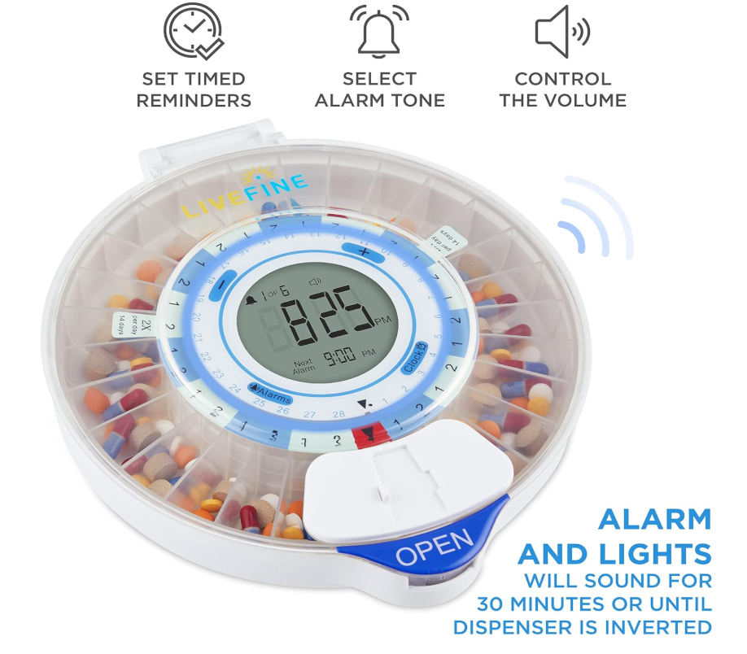
Figure 1 LiveFine Smart Automatic Pill Dispenser

MedaCube Automatic Pill Dispenser

MedaCube is designed to dispense medications accurately and on time. However, its bulkier design and higher cost may not be suitable for all users. Additionally, it requires regular refilling and maintenance, which could be challenging for some patients [5].

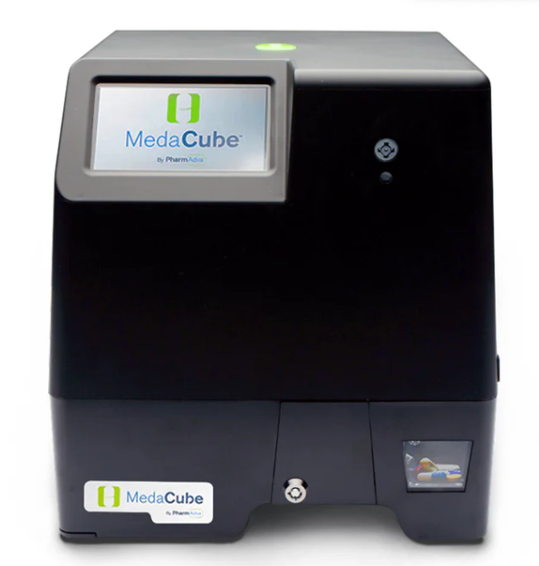
Figure 2 MedaCube Smart Pill Dispenser

GMS Automatic Pill Dispenser

This dispenser provides audible alarms and a locking mechanism to prevent double dosing. Despite these features, it does not support connectivity with other devices or applications, limiting its adaptability to individual patient needs and preferences.

These systems, while functional, may not fully address the complexities of medication management, particularly for patients requiring personalized schedules, remote monitoring, or integration with other health management tools. Recognizing these limitations can inform the development of more efficient solutions that cater to diverse patient needs [6].

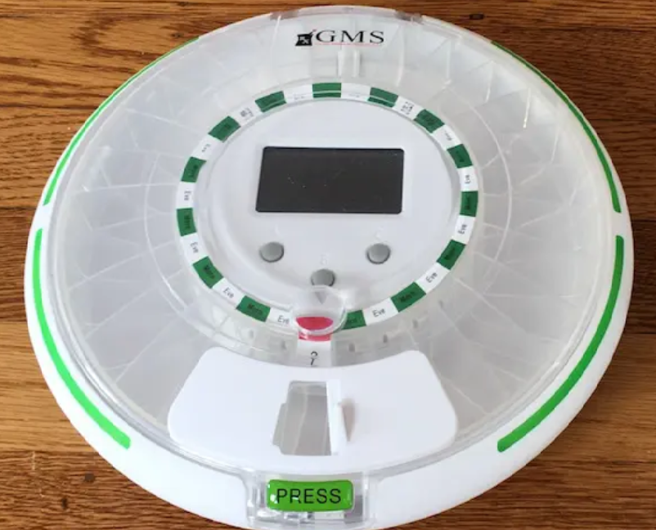
Figure 3 GMS Pill Dispenser

Methods/Systems Comparison

Existing smart medication dispensers, such as LiveFine Smart Automatic Pill Dispenser, MedaCube, and GMS Automatic Pill Dispenser, offer basic functionalities like automated dispensing, audible alarms, and schedule reminders. However, they lack key features that enhance accessibility and monitoring. Unlike my Smart Medicine Cabinet, these systems do not integrate Wi-Fi connectivity for real-time remote tracking, nor do they provide audio alerts with pre-recorded messages to assist visually impaired patients.

Additionally, their designs often require manual interaction, whereas my project utilizes servo motors for automatically opening drawers, ensuring precise medication dispensing at the right time. Moreover, our system incorporates LED indicators to display pill quantity, an improvement over traditional dispensers that rely solely on sound text-based reminders. By addressing the limitations of existing solutions, our Smart Pharmacy offers a more comprehensive, automated, and accessible approach to medication adherence.

Table 1 Comparison Table Based on Graphical Interfaces
Criterion 1 | System 1 | System 2 | System 3
Graphical Interface
Good user interface | ✔ | ✔ | ✘
Easy and effective navigation | ✘ | ✔ | ✘
Simple and professional Design | ✔ | ✘ | ✔
Responsive | ✘ | ✘ | ✘

Table 2 Comparison Table Based on Content and Functionality
Criterion 2 | System 1 | System 2 | System 3
Content and Functionality
Quality content structure | ✘ | ✔ | ✔
Usability | ✔ | ✔ | ✔
Dynamic content | ✘ | ✔ | ✔
Content management system | ✘ | ✔ | ✔

Table 3 Comparison Table Based on Features
Criterion 3 | System 1 | System 2 | System 3
Features
Security measures | ✔ | ✔ | ✔
Third party integration | ✘ | ✔ | ✔
Accessible content and location | ✔ | ✔ | ✔
Registration form | ✔ | ✘ | ✔

Conclusion and Motivation

Based on the comparison of existing methods, it is evident that while systems like LiveFine, MedaCube, and GMS provide some level of medication management, they still have significant limitations in automation, user accessibility, and cost-effectiveness.

These gaps highlight the need for a more efficient, affordable, and user-friendly solution. Our proposed Smart Pharmacy aims to address these shortcomings by incorporating Wi-Fi connectivity, automated drawer control, LED-guided selection, and real time alerts via a mobile application, this system will ensure precise medication adherence, reduce user errors and enhance remote solution will provide a more accessible and effective medication management system that bridges the gaps left by existing methods.

System Design

Introduction

This chapter provides an in-depth exploration of the system design methods employed in the development of the Smart Pharmacy. It encompasses both technical and non-technical aspects, detailing how users will navigate and utilize the system’s services while effectively responding to various use cases. Furthermore, the chapter includes a discussion on the financial ability and scope of the system, considering environmental awareness. Additionally, potential risks associated with the system’s implementation and operation will be addressed. The design of the Smart Pharmacy will be illustrated through various UML diagrams, providing a comprehensive understanding of the system’s structure and functionality.

Requirements and Specification Analysis

The Smart Pharmacy is a system designed to automate and enhance medication management for users. This section outlines the use cases, system requirements, UML diagrams, functional requirements, and system architecture to ensure the project meets the objectives efficiently and to enhance understanding by emphasizing user-friendliness and the commitment to delivering top-notch services.

Functional Requirements

The Smart Pharmacy requires a combination of hardware and software components. Here we mentioned the list of operations, activities, and features offered by this system that make it possible for its users to achieve their recovery:

- Medication Alerts: The system must notify users through audio, LED signals, and buzzers.
- Automated Drawer System: The correct drawer must automatically open when it’s time to take medication.
- Wi-Fi Connectivity: The system must communicate with a mobile application for scheduling, updates, and reminders.
- Pill Counting LED System: LEDs on the drawer must indicate the number of pills that the user should take.
- Reminder Notifications: If medication is not taken, a reminder notification must be sent to the app.
- Mobile App Features:
- Add medicine name, address, time, and dosage.
- View medication schedule.
- Modify medicine timing and dosage.
- Track medicine adherence history.

Use Case Diagram

In this section, we will present the use case diagrams for the system, illustrating the
actors that interact with the system and the fundamental flow of system behavior. The use
case diagrams will cover the following actors: Patient, caregivers, and doctor. We will also outline the actions that each of these actors can perform to provide a comprehensive understanding of their roles within the system.

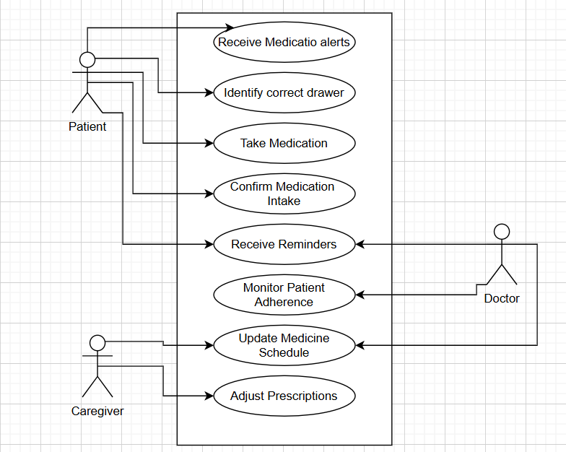
Figure 4 Use Case Diagram

User Type | Use Case | Description
Patient | Receive medication alert | The system notifies the patient through audio alerts, a buzzer, and LED indicators when it’s time to take medicine.
 | Identify the correct drawer. | The system announces the drawer (row and column) and lights up the corresponding drawer’s LED.
 | Take medication | The automated drawer opens, allowing the patient to access the correct pills.
 | Confirm medication intake | The patient confirms intake via the mobile app or a built-in button.
Caregiver | Receive reminders | If the patient forgets to take medicine, the system sends a reminder to the mobile app.
 | Monitor patient adherence | The caregiver can check the patient's medication history via the mobile app.
Doctor | Update the medicine schedule | Caregivers can edit medication schedules in the app.
 | Adjust prescriptions | If integrated with healthcare systems, doctors can update prescriptions remotely.

Table 4 Use Case Narrative

System Architecture

In this section, the system architecture will be explained. It is the “blueprint” of the system, which includes the fundamental technologies used as well as the dataflow, layering, etc. The system architecture diagram will show the route of the data from one level of processing to another in order to handle the user’s requests in the frontend. The structural design of the Smart Pharmacy can be divided into two units: backend and frontend. The backend will handle Wi-Fi-based communication and medicine schedule management, while the frontend will interact with the Wi-Fi-enabled cabinet via the backend API.

We should say that we have many layers in this project:

- Hardware Layer (Embedded System - IoT)
  - Components: ESP32 microcontroller, sensors, buzzers, Wi-Fi module, LED indicators, speaker, and automatic drawer mechanism.
  - Role: Handles physical interactions (alerts, drawer control, LED signals).

- Communication Layer
  - Technology: Wi-Fi (ESP32).
  - Role: Establishes a connection between the Smart Medicine Cabinet and the Mobile Application for real-time updates and monitoring.

- Application Layer
  - Mobile App: Developed using Android (Java).

- User Interface Layer
  - Patients: Receive voice alerts, see LED guidance, open drawers, and confirm medication intake.
  - Caregivers: Monitor medication adherence through the mobile app.
  - Doctors: Adjust medication schedules remotely via the mobile interface.

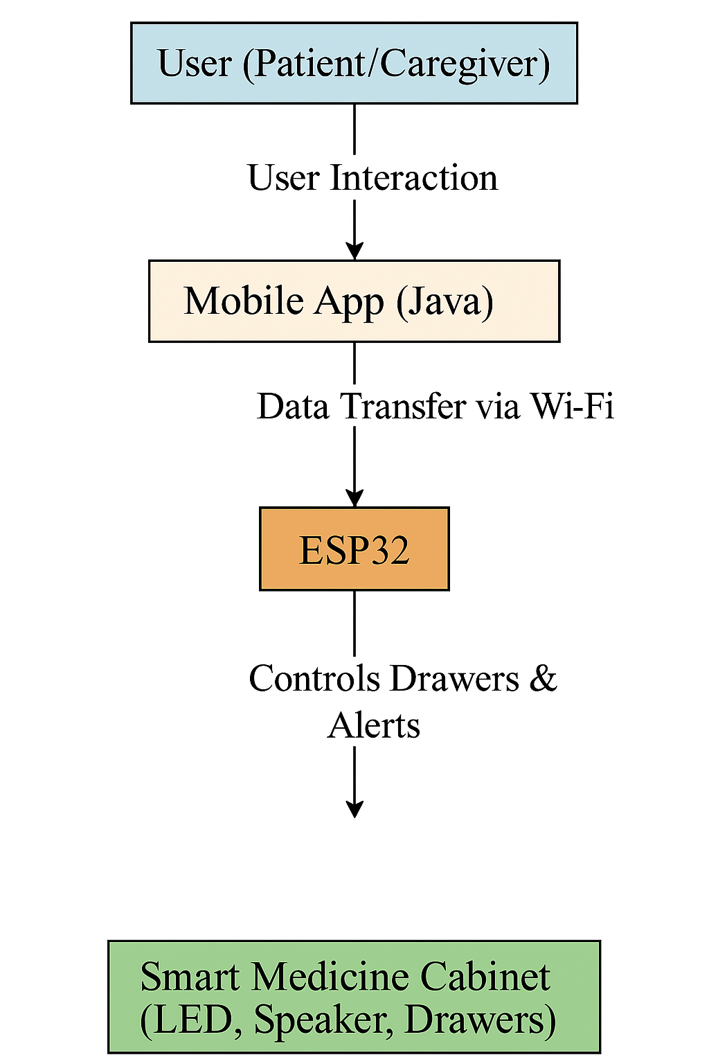
Figure 5 System Architecture

Class Diagrams

In this section, we will present a UML Class Diagram that illustrates the fundamental
structure of the system. The diagram serves as a visual representation of the relationships between the various entities or classes within the application. By depicting these relationships, the diagram highlights how the entities interact and depend on one another. Developing a class diagram is a crucial step in system design, as it provides a blueprint for organizing and implementing the project effectively. It allows for a clear understanding of the system’s hierarchy and aids in creating a well-organized and efficient design before moving on to the implementation phase.

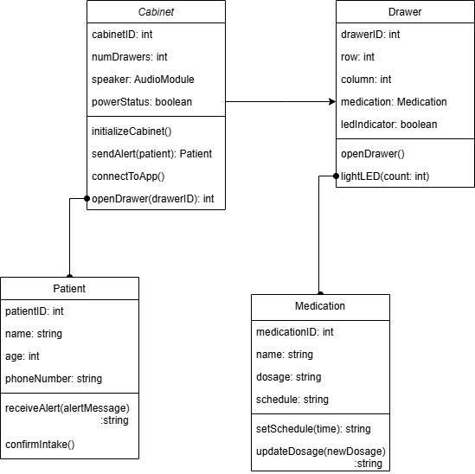
Figure 6 Class Diagram

Sequence Diagrams

Sequence diagrams are a variety of UML diagrams that depict how objects throughout
The system performs multiple operations in order to interact with one another. It may be viewed as a form of collaboration amongst system classes. Also, it demonstrated below represents the sequential flow of events happening in the Smart Pharmacy according to the perspectives of patients, caregivers. These diagrams make it easier for technical and non-technical readers to understand the logic of the system and how its components interact.
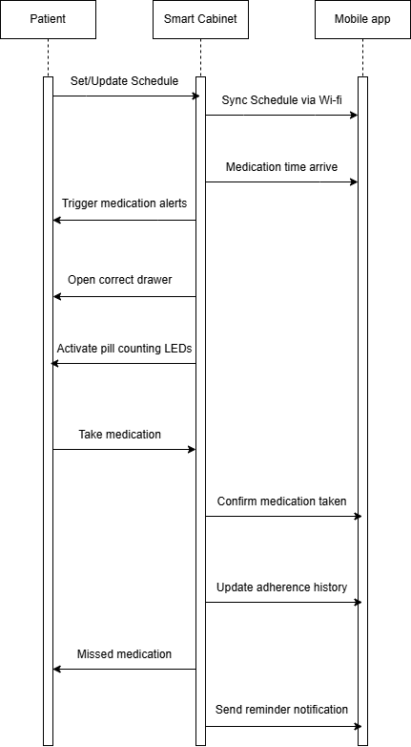
Figure 7 Sequence Diagram

Activity Diagrams

This section will show the activity diagrams that this system is built around. Activity
Diagrams are a visual representation of how activities are arranged to offer a service at various levels of abstraction. They’re utilized to get a high-level comprehension of how the software works. It also enables us to determine the constraints and variables that contribute to certain events. When making complex judgments, a flow chart transforms into an activity diagram.

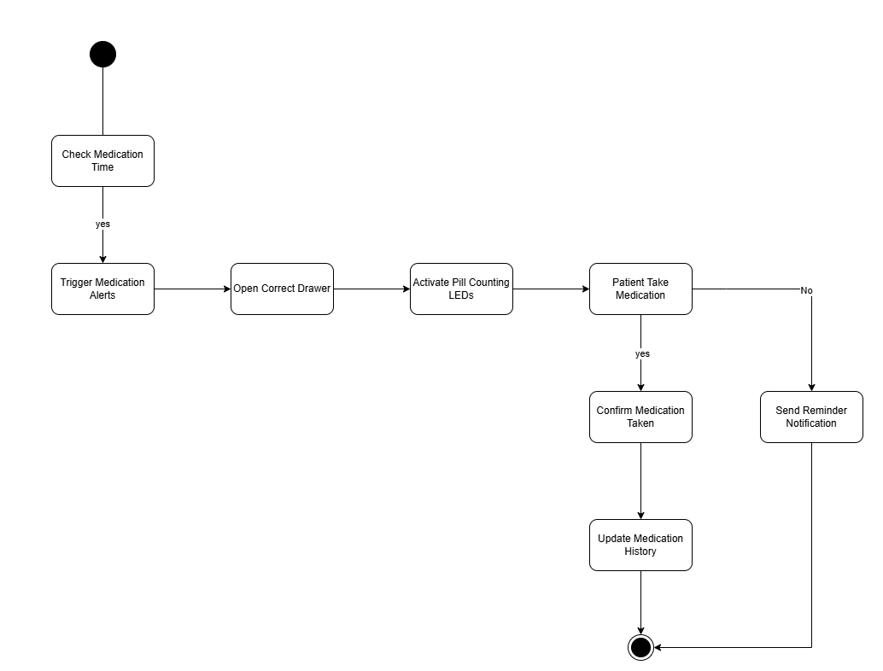
Figure 8 Activity Diagram

Entity-Relationship (ER) Diagrams

No Database.

Non-Technical Aspects

Financial Viability

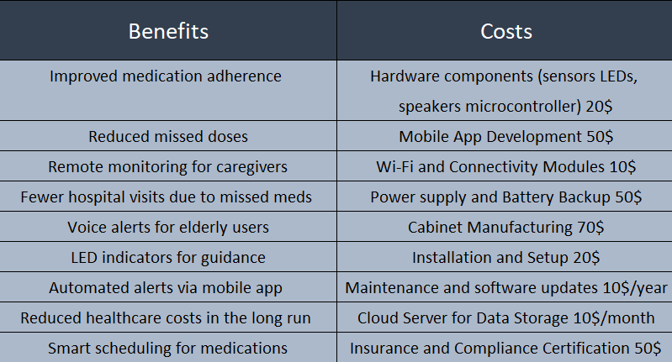
Figure 9 Cost-Benefit Analysis

Stakeholders

There are several stakeholders who will benefit from the Smart Pharmacy project. The primary beneficiaries of it are the patients who require assistance in managing their medication. This includes elderly individuals, visually impaired users, deaf persons, people with chronic illnesses, and those who frequently forget to take their medicine on time. By automating medication reminders and dispensing, the system helps patients stay on track with their prescriptions, ultimately improving health outcomes and reducing the risks associated with missed and incorrect doses.

Caregivers and family members also benefit significantly from this system. Through the mobile application, they can remotely monitor whether their loved ones have taken their medication on time. This reduces the stress and responsibility placed on caregivers while ensuring that patients maintain a consistent medication routine. Additionally, doctors and pharmacists benefit from this technology as it encourages adherence to prescribed medication schedules. Medical professionals often struggle with patient non-compliance, which can lead to worsened health conditions and unnecessary hospital visits. By using this system, healthcare providers can have greater confidence that their patients are following their treatment plans correctly.

While the system offers many benefits, patients can be harmed if the system malfunctions, for instance, if a technical error results in the wrong drawer opening or an alert failing to trigger. Such an issue could lead to missed doses, overdoses, or incorrect medication intake, which may have severe health consequences.

Several stakeholders should be involved in shaping how the Smart Pharmacy is designed, developed, and implemented. Healthcare professionals, including doctors, nurses, and pharmacists, must have input in the project to ensure that the system follows best medical practices. Their expertise is essential in defining how medication schedules are set, what safety measures should be in place, and how patients interact with the device. Patients and caregivers should also play a role in the development of the system. Their feedback is crucial in making the device user-friendly, accessible, and practical for real-world use. The system should be tested with patients to ensure that the audio alerts, drawer mechanisms, and mobile application are intuitive and meet their needs.

Scope

This project involves designing and developing a Smart Pharmacy that helps patients take their medication on time through automated reminders, audio alerts, LED indicators, and automatic drawers. The system will integrate with a mobile application via Wi-Fi, allowing users or caregivers to manage schedules and monitor medication adherence.

The project will focus on hardware and software integration, ensuring a user-friendly experience and reliable medication dispensing. The goal is to improve medication adherence, reduce errors, and provide remote monitoring capabilities for caregivers and healthcare providers.

Risks

Despite careful planning, several risks could hinder the successful completion of the Smart Pharmacy Project. These risks can be categorized into technical, financial, operational, and user-related factors.

- Technical Risks:

- The automatic drawer system may not function reliably due to mechanical failure, incorrect motor calibration, or power supply issues.
- LED indicators or sensors might fail, leading to incorrect pill count displays or inaccurate user feedback.
- The voice alert system may not work as expected, causing unclear or inaudible announcements.
- Wi-Fi connectivity between the cabinet and mobile application may be unstable.

- Financial & Resource Risks

- Substituting components due to availability issues could require redesigning certain parts of the system, increasing costs and time.
- The lack of electronic components in our country slows down the development of the system.

- Operational & Deployment Risks

- Elderly users or non-tech-savvy individuals may find the system too complex to use effectively.
- Caregivers and medical staff may not trust the system fully, leading to lower adoption rates.
- Wear and tear on mechanical parts could lead to frequent breakdowns.

- Compliance & Safety Risks

- If the system opens the wrong drawer or fails to trigger an alert, patients may take incorrect medications, leading to serious health consequences.
- Storing medication schedules in a mobile app could pose privacy risks if the data is not properly encrypted.
- Users may misinterpret the LED indications and take the wrong number of pills.

Schedule and Milestones

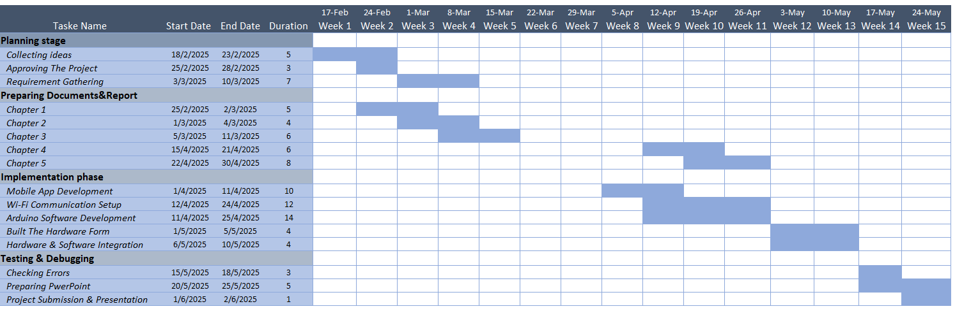
Figure 10 Scheduling Tasks and Milestones

Ethical and Social Considerations

When designing the Smart Pharmacy, it's essential to consider ethical issues that could impact patients, caregivers, healthcare providers, and developers. These ethical concerns revolve around privacy, security, user-anatomy, accessibility, reliability, and safety. Addressing these issues ensures that the system remains trustworthy, safe, and beneficial for the users. When designing the Smart Pharmacy system, it is essential to consider a range of ethical and social factors to ensure the solution is both responsible and inclusive. Accessibility is another key consideration—features like voice guidance for blind users and LED or vibration alerts for deaf users must be reliable and customizable to ensure equal access. The reliability and safety of the system are crucial, as malfunctions could result in missed or incorrect medication doses, which may have serious consequences. Therefore, robust testing, fallback mechanisms, and manual overrides are necessary.

Environmental and Sustainability Considerations

The Smart Pharmacy is primarily an electronic and software-based system, meaning its environmental impact is relatively low. However, there are some environmental factors to consider, particularly in the areas of electronic waste, energy consumption, and material usage. The cabinet contains electronic components such as microcontrollers (ESP32), sensors, motors, LEDs, and speakers. Over time, these components may become obsolete, malfunction, or require replacement, contributing to electronic waste (e-waste). Also, it will be constructed from plastic, which has different environmental implications.

Relevant Standards

- Wi-Fi Standard (IEEE 802.11) – The system includes cloud connectivity for remote access, and it must comply with Wi-Fi networking standards.

- IEC 61010 – International safety standard for electrical equipment used in medical and laboratory environments.

- IEEE 11073 – A standard for medical device communication, ensuring interoperability between health monitoring systems.

- Mobile Application Testing and Verification (IEEE 829) - This standard provides
guidelines for testing and verifying mobile applications, including functional
testing, performance testing, and security testing.

- User Interface Design for Mobile Devices (ISO 9241-110) - This standard provides
guidelines for designing effective and usable user interfaces for mobile devices,
including layout, typography, and navigation.

- ISO 14001 – Standard for environmental management systems, promoting sustainability in product development.

- ISO 14971 – Risk management standard for medical devices, ensuring potential hazards are identified and mitigated.

- ISO/IEC 27001 – International standard for information security management, important for protecting patient medication data.

Conclusion

The Smart Pharmacy is an innovative solution designed to improve medication adherence through automation and connectivity. Utilizing a Wi-Fi-enabled mobile application and a backend server, the system ensures that patients receive timely reminders for their medications. The cabinet features automatic drawers, LED indicators, and voice alerts to guide users in taking the correct medicine at the right time. The mobile app allows caregivers to monitor adherence remotely, while the backend manages schedules and sends notifications.

From a non-technical perspective, the system's scope focuses on medication management but does not include medical diagnosis or dosage adjustments. Risks include Wi-Fi dependency, hardware malfunctions, and user non-compliance. Ethically, data privacy and accessibility for elderly users are key considerations, while environmental impact remains minimal due to low-power electronics.

The overall architecture follows a multi-tier client-server model, ensuring efficiency and scalability. UML diagrams, including use case, class, sequence, and activity diagrams, illustrate the system’s functionality and interactions. This project demonstrates how smart technology can enhance healthcare and improve patient outcomes through automation and real-time monitoring.

Implementation/Simulation and Testing

Introduction

This chapter presents the tools and technologies used to implement the Smart Pharmacy system. It also outlines the step-by-step development process, including both software and hardware integration. The implementation integrates an Android mobile app with an ESP32 microcontroller using Wi-Fi communication, followed by rigorous testing to ensure functionality and reliability. The implementation code is provided in the appendix, and the full source files are included on the accompanying digital media.

Implementation Tools

The implementation of the Smart Pharmacy system relied on a combination of hardware components, programming languages, development tools, and design platforms. These tools were chosen based on their compatibility with embedded systems and mobile development, and developer familiarity.

- Programming Languages:

We used Java, XML, C++ (ESP32), and MySQL to implement the system:

- Java: Used to develop the Android mobile application. Java's maturity and native Android support made it a suitable choice for managing user interactions, Wi-Fi connectivity, and scheduling functionalities.

- XML: Used to design the UI layout of the Android application. XML offers a structured and scalable way to define responsive interfaces across different devices.

- C++ / ESP32 Language: Used for programming the ESP32 microcontroller to manage Bluetooth communication, control servo motors, activate buzzers, and handle LED indicators.

- Hardware Components:

- ESP32 Microcontroller: Core of the hardware system, managing communication and control operations.

- SG90 Servo Motors: Used to automate the opening of medicine drawers

- LEDs: Visual cues to indicate the number of pills or drawer activation.

- Buzzer: Audio alert to notify the user when it’s time to take medication.

- Voice Module ISD 1820: Used to notify the blind user of medication.

- IR Sensor: Integrated into each drawer to detect whether the user has removed the pills.

- Real-Time Clock (RTC): Is used to schedule medications.

- OLED Display (128x64, SSD1306): Used to display real-time clock.

- Power Supply and Breadboard: Used for circuit assembly and testing.

- Development and Simulation Tools:

- Android Studio: For the mobile application.

- Arduino IDE: For the ESP32 and hardware components.

Implementation Summary

The implementation of the Smart Pharmacy involved the development of both software and hardware components. The system is composed of an Android mobile application, a microcontroller-based medicine cabinet with automatic drawers, an OLED display, IR sensors, a voice playback module, and Wi-Fi communication to enable data exchange between the app and the hardware.

- Mobile Application Implementation:

*Allows users to select time, pill count, and drawer number.

*Sends this data to the ESP32 via Wi-Fi when the "Send" button is pressed.

*Custom-designed user interface using Alert Dialogs and styled buttons.

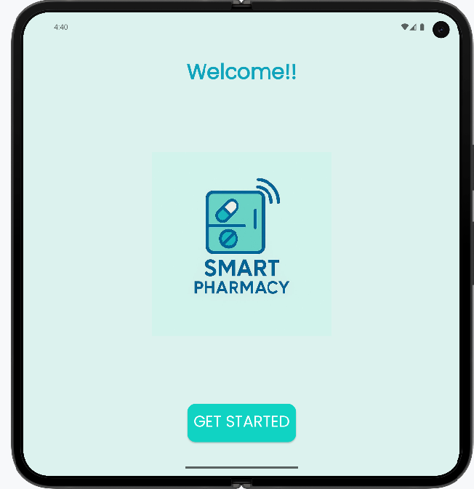
Figure 11 Start Page
This page style is created with the XML language using TextView, Button, and ImageView fields.

When we press the button, the user goes to the next intent to add the medication information using this Java code:

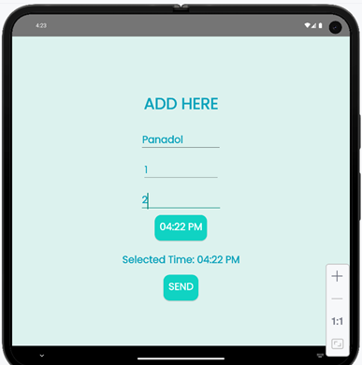
Figure 12 Add Page

For styling, we use two TextViews, three EditTexts, and two buttons.

For the Time Picker button, we use this Java code:

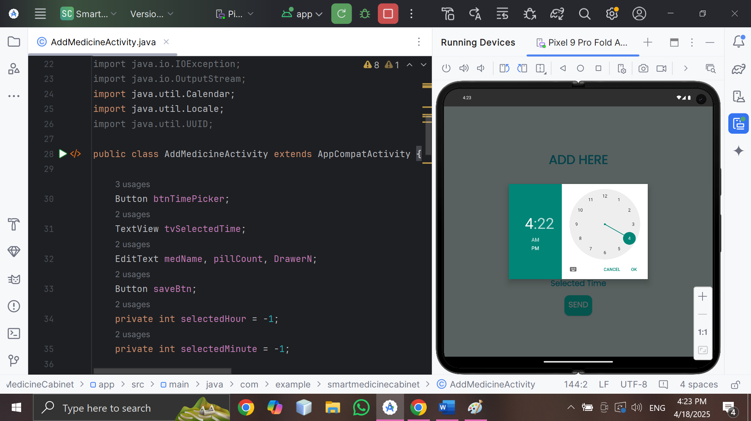
Figure 13 Time Picker Form

Also, an alert dialogue is created to help the user if something is typed incorrectly or fields are forgotten.

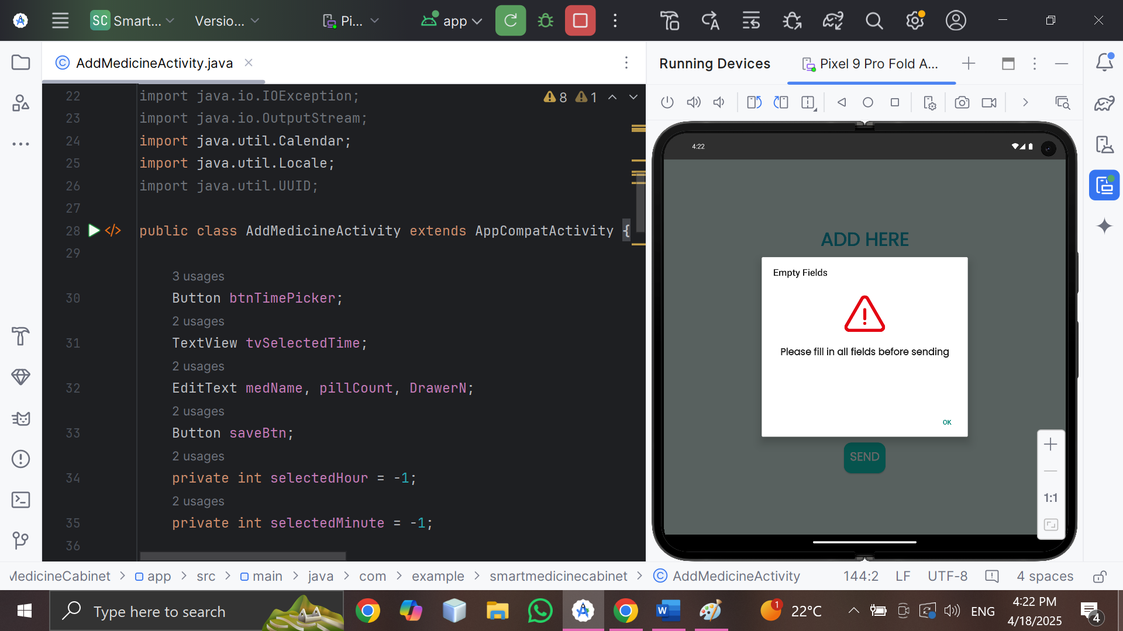
Figure 14 Alert Dialogue Form

For full information, we have another dialogue for confirmation:

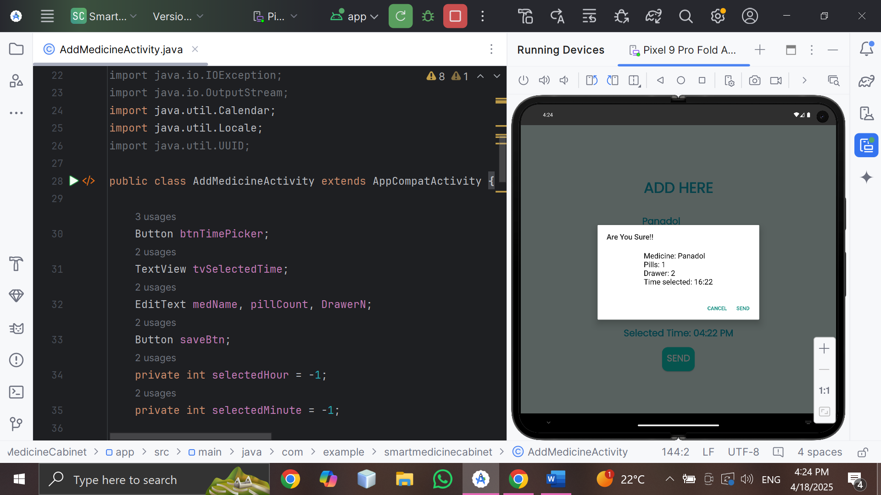
Figure 15 Confirmation Dialogue Form

For the connection in the mobile app, we send the data typed via Wi-Fi, HTTP request, port 80, so we are using the following method.

- ESP32 Implementation Code:

*Firstly, this summary should not contain the void setup for the components used; it just displays the steps needed to read data from the mobile app. U can find the full code in the DVD or in the appendix.

Test Cases and Acceptance Criteria

This section outlines the test cases developed to validate the functionality, performance, and reliability of the Smart Pharmacy. Each test case includes the objective, input, expected output, and actual result, along with whether it meets the predefined acceptance criteria.

- Test Case 1: Wi-Fi Connection with ESP32:

*Objective: Verify that the mobile app can connect to the ESP32 via Wi-Fi.
*Input: Give the mobile app the Wi-Fi SSID and password after powering on the ESP32.
*Expected Output: Wi-Fi connection established; status message updated to (Connected).
*Acceptance Criteria: The app must connect to ESP32 within 5 seconds.
*Result: Pass.

- Test Case 2: Sending Time, Pill, and Drawer Data:

*Objective: Ensure that the app sends properly formatted data to ESP32 via Wi-Fi.
*Input: Select a time (08:30), pill number (2), and drawer (1), then press "Send".
*Expected Output: ESP32 receives and parses the data string (08:30,2,1)
*Acceptance Criteria: The ESP32 should correctly parse the string and extract all
values.
*Result: Pass.

- Test Case 3: RTC Time Matching:

*Objective: Check that the ESP32 matches the scheduled time with the RTC correctly.
*Input: Pre-programmed time set in RTC: 08:30; app sends matching time.
*Expected Output: At 08:30, ESP32 triggers an action (LED, buzzer, servo).
*Acceptance Criteria: Action must occur within ±1 minute of the scheduled time.
*Result: Pass.

- Test Case 4: Drawer Activation:

*Objective: Confirm the correct drawer opens via the servo motor based on input.
*Input: Drawer number sent as “2”.
*Expected Output: Only the corresponding servo motor (drawer 2) activates.
*Acceptance Criteria: 100% accuracy in targeting the correct drawer.
*Result: Pass.

- Test Case 5: IR Sensor Detection:

*Objective: Validate that the IR sensor correctly detects pill removal.
*Input: Hand placed in drawer to simulate pill removal.
*Expected Output: Sensor detects interruption and logs the event.
*Acceptance Criteria: Sensor must respond within 1 second of detection.
*Result: Pass.

- Test Case 6: LED Indication of Pill Quantity:

*Objective: Verify that the LED displays the number of pills visually.
*Input: Send (2) as pill count.
*Expected Output: 2 LEDs should light up at time.
*Acceptance Criteria: LED count matches the pill number.
*Result: Pass.

- Test Case 7: Voice Message Playback:

*Objective: Verify that the system plays the correct voice reminder based on the drawer number.
*Input: Send the command for drawer 2 at the scheduled time.
*Expected Output: Audio message plays: (Time to take your medicine from drawer 2).
*Acceptance Criteria: He corrects the file and must repeat every 500 milliseconds.
*Result: Pass.

- Test Case 8: RTC Time Matching:

*Objective: Ensure the OLED correctly displays the real time.
*Input: The System receives time from the RTC.
*Expected Output: OLED displays.
*Acceptance Criteria: OLED must update every 1 second.
*Result: Pass.

- Test Case 9: Test the functionality of all components together:

*Objective: Verify that the components work together.
*Input: Send (8:30,1,2).
*Expected Output: ESP32 takes the input, opens the drawer needed, turns on the LEDs, repeats the voice, and the process should turn off when the IR sensor detects movement.
*Acceptance Criteria: Work simultaneously.
*Result: Pass.

Conclusion

This chapter has detailed the implementation and testing of the Smart Pharmacy, outlining the tools, technologies, and methodologies used to bring the system to life. Through a combination of Java, XML, and embedded hardware components such as the ESP32, OLED display, LEDs, Servos, IR sensors, and a voice playback module, we successfully developed a smart solution to assist patients with timely and accurate medication intake.

We demonstrated the integration of each component, including the mobile app interface, Wi-Fi communication with the ESP32, real-time time synchronization, and intelligent alerts through both visual (OLED) and audio (voice module) means. IR sensors ensured confirmation of pill removal, and automated drawers enhanced usability and accessibility.

Comprehensive testing confirmed that the system performs reliably under various scenarios, meeting all functional requirements. Each module, from setting a schedule in the app to the physical interaction with the cabinet, was validated using defined test cases and acceptance criteria.

The implementation of the Smart Pharmacy proves not only technically feasible but also practically valuable in promoting patient adherence and improving healthcare management at home. This lays a strong foundation for future expansion, including features like remote monitoring, cloud connectivity, and advanced analytics.

Conclusion and Future Work

Conclusion
The Smart Pharmacy project represents a significant step forward in addressing the critical issue of medication non-adherence, particularly for individuals with visual or hearing impairments, the elderly, and those with chronic illnesses. By integrating hardware and software components, the system provides a comprehensive, user-friendly solution that ensures timely and accurate medication intake. The use of ESP32 microcontrollers, servo motors, LED indicators, voice modules, and a mobile application has resulted in a robust and accessible system that meets the needs of diverse users.

Key achievements of this project include:

- Automated Medication Dispensing: The system reliably opens the correct drawer at the scheduled time, reducing the risk of human error.

- Multimodal Alerts: Audio, visual, and vibration alerts ensure accessibility for blind and deaf users.

- Remote Monitoring: Caregivers and healthcare providers can monitor medication adherence in real-time via the mobile app.

- User-Friendly Design: The intuitive interface and automated features make the system easy to use, even for non-tech-savvy individuals.

Through rigorous testing, the system has demonstrated high reliability and accuracy in meeting its functional requirements. The project not only addresses the limitations of existing medication management solutions but also highlights the potential of assistive technologies in improving healthcare outcomes.

Future Work

While the Smart Pharmacy system is functional and effective, there are several opportunities for future enhancements and expansions:

- Cloud Integration:
  - Implement cloud-based storage for medication schedules and adherence history to enable seamless access across multiple devices.
  - Integrate with healthcare provider systems for real-time updates and remote prescription adjustments.

- Advanced Analytics:
  - Incorporate machine learning algorithms to analyze adherence patterns and provide personalized recommendations.
  - Predict potential medication conflicts or side effects based on user data.

- Expanded Accessibility Features:
  - Add support for multiple languages in voice alerts to cater to a broader user base.
  - Introduce Braille labels or tactile feedback for visually impaired users.

- Enhanced Hardware:
  - Develop a more compact and portable version of the hardware for users who travel frequently.
  - Incorporate biometric authentication (e.g., fingerprint or facial recognition) to ensure medication security.

- IoT and Smart Home Integration:
  - Enable compatibility with smart home systems (e.g., Amazon Alexa, Google Home) for voice-controlled operation.
  - Integrate with wearable devices to monitor vital signs and adjust medication schedules dynamically.

- Scalability:
  - Expand the system to support more drawers for users with complex medication regimens.
  - Develop a commercial-grade version for use in hospitals and nursing homes.

- User Feedback and Iterative Development:
  - Conduct user trials with diverse populations to gather feedback and refine the system.
  - Iterate on the design based on real-world usage to improve reliability and usability.
By pursuing these future directions, the Smart Pharmacy system can evolve into an even more versatile and impactful tool for medication management, ultimately improving health outcomes for a wider range of users.

APPENDIX A:
Implementation Details

The entire code will be available on the accompanying DVD.

APPENDIX B:
USER Manual

- Overview

The Smart Pharmacy system consists of a hardware unit (medicine cabinet) and a mobile application. This manual provides step-by-step instructions for setting up and using the system.

- Hardware Setup
- Unboxing and Assembly:
  - Place the Smart Pharmacy cabinet on a stable, flat surface.
  - Connect the power adapter to the cabinet and plug it into an electrical outlet.
  - Ensure all drawers are closed and LEDs are functioning.
- Initialization:
  - Power on the cabinet. The system will initialize, and the OLED display will show the current time.
  - Wait for the Wi-Fi module to establish a connection (indicated by a steady LED light).

- Mobile Application Setup
- Download and Installation:
  - Download the Smart Pharmacy app from the Google Play Store.
  - Open the app and grant necessary permissions (Wi-Fi, notifications).
- Connecting to the Cabinet:
  - Open the app, and it will connect automatically.
- Using the System
- Adding a Medication Schedule:
  - Open the app and tap "Get Started."
  - Enter the medication name, dosage, and drawer number.
  - Set the time for the medication reminder using the time picker.
  - Tap "Send" to confirm.
- Receiving Alerts:
  - At the scheduled time, the cabinet will:
    - Open the designated drawer.
    - Play a voice reminder (e.g., "Time to take your medication from Drawer 1").
    - Illuminate LEDs to indicate the number of pills to take.
  - Remove the medication from the drawer. The IR sensor will detect the removal and log the event.
- Monitoring Adherence:
  - Open the app to view the medication history and adherence status.
  - Caregivers can check the app remotely to ensure timely medication intake.
- Troubleshooting
- Wi-Fi Connection Issues: Ensure the cabinet and mobile device are on the same network. Restart both devices if necessary.
- Drawer Not Opening: Check the servo motor connection and power supply.
- Voice Alert Not Playing: Verify the voice module is properly connected and the volume is adjusted

APPENDIX C:
deployment and configuration Manual

Hardware Deployment:
  - Place the cabinet in a location with stable Wi-Fi coverage.
  - Ensure the power supply is uninterrupted.
  - Test all components (LEDs, servo motors, voice module) before final placement.

Software Deployment:
  - Install the mobile app on all caregiver and patient devices.
  - Configure the app settings (e.g., notification preferences, user roles).

Wi-Fi Settings:
- Access the ESP32 configuration mode by pressing the reset button for 5 seconds.
  - Use the app or a web interface to update Wi-Fi credentials if the network changes.

Time Synchronization:
  - The Real-Time Clock (RTC) module automatically syncs with the mobile app.
  - Manually adjust the time in the app settings if discrepancies occur.

Voice Module Customization:
  - Record custom voice alerts by pressing the record button on the voice module and speaking into the microphone.
  - Assign each recording to a specific drawer in the app.

Known Issues and Troubleshooting

Issue: Delayed drawer opening.
Solution: Check servo motor calibration and ensure no physical obstructions.

Issue: Incorrect LED count.
Solution: Reconfigure the pill count in the app and reset the hardware.

Issue: App crashes on startup.
Solution: Clear the app cache or reinstall the application.

Maintenance
- Regularly clean the cabinet and drawers to prevent dust buildup.
- Update the mobile app and firmware periodically to ensure optimal performance.
For advanced configuration or unresolved issues, refer to the technical support team.

References

[1] | S. J, "Assistive Technologies for Medication Adherence in Sensory-Impaired Patients," Disability and Rehabilitation: Assistive Technology, Vols. 345-356, p. 15(4), 2020.
[2] | Lee, ""The Impact of Mobile Health Applications on Medication Adherence: A Systematic Review."," Journal of Medical Internet Research, vol. e24567, p. 23(5), 2021.
[3] | D. Yach, Adherence to long-term therapies: evidence for action, 1211 Geneva 27: ©World Health Organization, 2003.
[4] | "Amazone," [Online]. Available: https://www.amazon.com/Automatic-Medication-Monitoring-Adjustable-Prescriptions/dp/B09DMFR85D.
[5] | PharmAdva, "MedaCube™ by PharmAdva," [Online]. Available: https://www.medacube.com/products/medacube-automatic-pill-dispenser?srsltid=AfmBOoraFr72eWznLf73eLW4FOIGqpj9-5wf0rch-V7CuC1xer2OUXZF.
[6] | "Tech-enhanced Life," [Online]. Available: https://www.techenhancedlife.com/reviews/gms-automatic-pill-dispenser.
[7] | W. H. Organization, in Adherence to long-term therapies : evidence for action, World Health Organization., 2003.

