**Section 2**

**The task**: Consider the centered DFT for *dew on roses (noisy).tif* and *tulips irises.tif*, (i) resynthesize the images using the DFT coefficients inside the circular region with radius=30 pixels (based on the original image size), plot the resulted images; (ii) similar to problem (i), however, use the DFT coefficients outside the circular region.

C:\Users\ali_2\Desktop\classes\Image_Processing\Project1\dew on roses (noisy).tif

Figure 2-1

C:\Users\ali_2\Desktop\classes\Image_Processing\Project1\tulips irises.tif

Figure 2-2

**Background**

This section refers to Filtering in Frequency Domain problem. For such purpose given image *dew on roses (noisy).tif* (Figure 2-1) and *tulips irises.tif* (Figure 2-2).

Steps to implement this task:

1. Given an input image *f(x, y)* of size *MxN* obtain the padding parameters *P* and *Q*. Typically, we select *P=2\*M* and *Q=2\*N*. This process is called zero padding. I used two kind of padding (Figure 2-4, 2-5), but still got the same results.

2. Compute the DFT of input image, *f(x,y)*, Eq. (2-1) after zero padding (1024x1024).

(2-1)

3. Translate to center of the frequency rectangle, Eq. (2-2), Figure 2-6:

(2-2)

4. We have two problems: consider obtained DFT coefficients inside the circular region = 30 pixels (based on the original image size, it means that we will use value = 60 pixels, because of zero padding and increasing original image to 1024x1024); consider obtained DFT coefficients outside the same circular region.

5. Use Eq. (2-3) to get circle. Each pixel makes equal to zero when *D(u,v)>=60* for the first problem (Eq. (2-5), Figure 2-8, Figure 2-10) and makes each pixel equal to zero when *D(u,v)<=60* for the second problem (Eq. (2-4), Figure 2-7, Figure 2-9).

(2-3)

(2-4)

(2-5)

6. Compute the IDFT for both problems by using Eq. (2-6).

(2-6)

7. Crop obtained image (512x512).

**Algorithm, Flow chart**

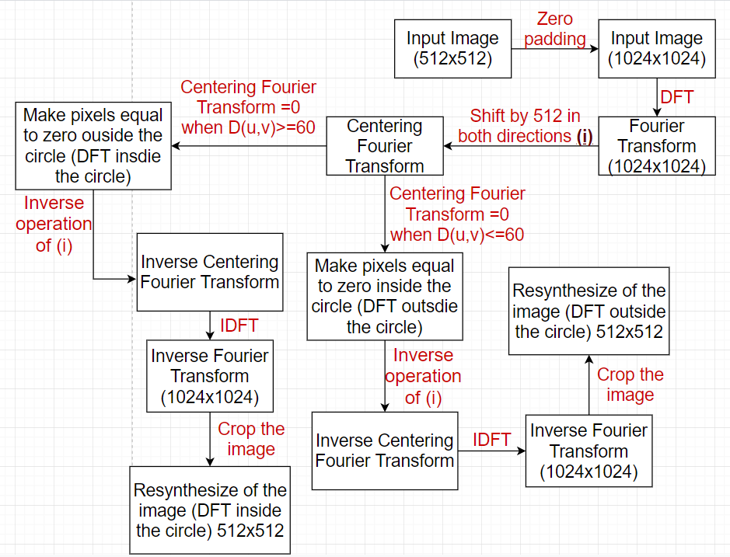

Figure 2-3

**Results**

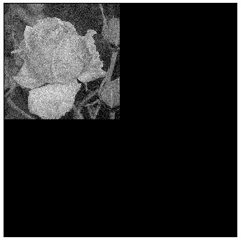

Figure 2-4

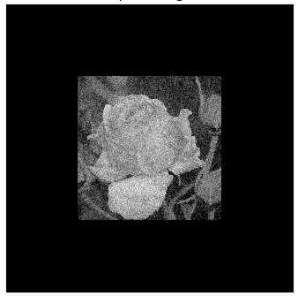

Figure 2-5

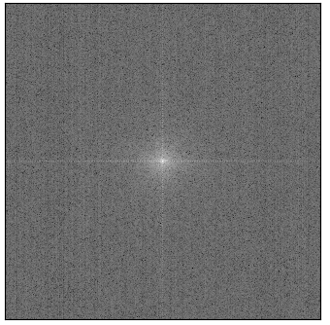

Figure 2-6

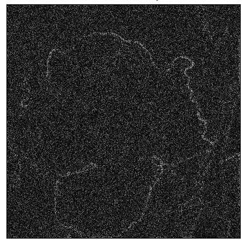

Figure 2-7

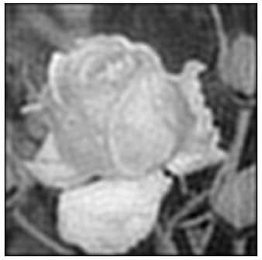

Figure 2-8

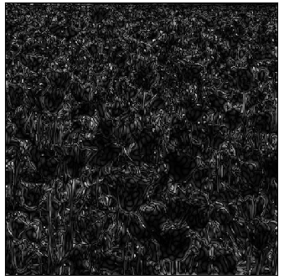

Figure 2-9

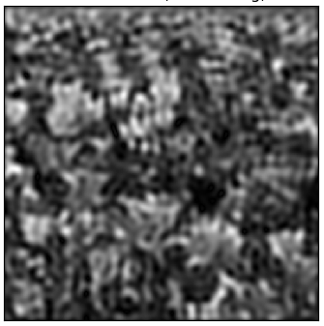

Figure 2-10

**Discussions**

We can notice that in the first problem (using the DFT coefficients inside the circular region) we are dealing with Lowpass filter and in the second problem it is Highpass filter.