

**WEB PROGRAMMING**

PROJECT REPORT ON :- College Website(NMIMS)

DATE OF SUBMISSION :- 29TH MARCH 2019

SUPERVISED BY :- DHIRAJ BHISE

**BRANCH :- B.TECH IT (2ND YEAR)**

**SCHOOL :- MPSTME**

**SUBMITTED BY :-**

**ALI SIDDIQUI(A246)**

**RISHI SHAH (A242)**

**SIDDHANT SHETTY (A258)**

**Acknowledgement :-**

**I would like to express my deepest appreciation to all those who provide me the possibility to complete this report. A special gratitude I give to our web programming faculty Mr. DHIRAJ BHISE whose contribution in stimulating suggestions and encouragement helped me to coordinate my project specially in writing this report. He helped us in every possible ways in which he can especially in PHP.**

**• About project :-**

**We have completed this project using HTML to develop a web page of college(NMIMS) whichis same laike college website.This web page also explores to real webpage of nmims by using anchor tag which make this webpage real and awesome.**

**• Technology/software used:-**

**In this project we have used basic:**

**• HTML**

**• CSS**

**• JAVA SCRIPT**

**• PHP**

•SQL

**• Code :-**

1.Homepage**:-**

**<!DOCTYPE html>**

**<html lang="en">**

**<head>**

**<title>NMIMS</title>**

**<link rel="stylesheet" type="text/css" href="style.css">**

**<script src="javascript/js.js="></script>**

**</head>**

**<body class="body">**

**<header class="mainheader">**

**<img src="logo1.png">**

**<content id="search">**

**<form>**

**<input type="text" name="search" placeholder="Search anything..." onclick="window.location.href='search.html'">**

**</form>**

**</content>**

**<nav>**

**<ul>**

**<li><a href="index.html">Home</a></li>**

**<li><a href="about.html">About</a></li>**

**<li><a href="department.html">Department</a></li>**

**<li><a href="contact.html">Contact Us</a></li>**

**<li><a href="login.html">SAP Login</a></li>**

**</ul>**

**</nav>**

**</header>**

**<br>**

**<div class="slideshow-container">**

**<div class="iambrpslides fade">**

**<div class="numbertext">01 / 04</div>**

**<img src="4.jpg">**

**</div>**

**<div class="iambrpslides fade">**

**<div class="numbertext">02 / 04</div>**

**<img src="2.jpg">**

**</div>**

**<div class="iambrpslides fade">**

**<div class="numbertext">03 / 04</div>**

**<img src="3.jpg">**

**</div>**

**<div class="iambrpslides fade">**

**<div class="numbertext">04 / 04</div>**

**<img src="6.png">**

**</div>**

**</div>**

**<div style="text-align:center">**

**<span class="dot"></span>**

**<span class="dot"></span>**

**<span class="dot"></span>**

**<span class="dot"></span>**

**</div>**

**<script>**

**var slideIndex = 0;**

**showSlides();**

**function showSlides() {**

**var i;**

**var slides = document.getElementsByClassName("iambrpslides");**

**var dots = document.getElementsByClassName("dot");**

**for (i = 0; i < slides.length; i++) {**

**slides[i].style.display = "none";**

**}**

**slideIndex++;**

**if (slideIndex> slides.length) {slideIndex = 1}**

**for (i = 0; i < dots.length; i++) {**

**dots[i].className = dots[i].className.replace(" active", "");**

**}**

**slides[slideIndex-1].style.display = "block";**

**dots[slideIndex-1].className += " active";**

**setTimeout(showSlides, 3000); // This is for Changing image every 2.5 seconds**

**}**

**</script>**

**<br>**

**<script type="text/javascript">**

**document.title="Home";**

**</script>**

**<script src="scripts/slider.js"></script>**

**<div class="mainContent">**

**<div class="Content">**

**<article class="topContent">**

**<header>**

**<h3 style="color:red">WELCOME TO THE MUKESH PATEL SCHOOL OF TECHNOLOGY MANAGEMENT & ENGINEERING, SHIRPUR CAMPUS</h3>**

**</header>**

**<content>**

**<p>Founded in 2007, the Shirpur Campus of NMIMS has wholly materialized the university’s vision—to be a vibrant and innovative centre of education, research, executive training and consultancy in management, technology, pharma, sciences and other emerging areas of higher education. Its mission is singular—to nurture today’s youth to develop into socially responsive managers, technocrats, entrepreneurs and professionals.An enthusiastic, highly competent group of 100-strong faculty and over 200 dedicated staff functioning in an ultra-modern residential campus now impart quality education and training to its entrants. All students enjoy state of art infrastructure and a learning environment that engages innovative pedagogies, rich interactions and global networking. MPSTME extends all these capabilities at Shirpur.**

**</p>**

**</content>**

**</article>**

**<article class="bottomContent">**

**<header>**

**<h3 style="color:red">Infrastructure</h3>**

**</header>**

**<content>**

**<p>Shirpur campus is equipped with world-class classrooms, lounges, laboratories, hostels and playgrounds, and a large library with access to repositories of knowledge across the world. The newest additions are a CNC-equipped workshop, electronics creative labs, numerous SW capabilities and tools, high speed Internet and Wi-Fi, and a BOSCH-Rexroth Automation and Mechatronics Centre of Excellence.**

**</p>**

**</content>**

**</article>**

**<article class="bottom1Content">**

**<header>**

**<h3 style="color:red">PROGRAMS</h3>**

**</header>**

**<content>**

**<b style="color:black">B. TECH. (04 Years) - intake 60 each</b><br>**

**Computer Engineering<br>**

**Information Technology<br>**

**Electronics & Telecommunication Engineering<br>**

**Mechanical Engineering<br>**

**Mechatronics<br>**

**<b style="color:black"> MBA. TECH. (05 Years)</b><br>**

**Computer Engineering (90 Intake)<br>**

**Mechanical (60 Intake)<br>**

**Information Technology (40 Intake)<br>**

**Electronics & Telecommunication Engineering (40 Intake)<br>**

**Civil Engineering (40 Intake)<br>**

**</content>**

**</article>**

**</div>**

**</div>**

**<aside class="top-sidebar">**

**<article>**

**<h3>Join us from very next SEMESTER!</h3>**

**<p>Fill <a href="https://www.npat.in/?utm_source=google&utm_medium=adwords&utm_keyword=keyword&utm_campaign=RLSA-NPAT-Search&gclid=CjwKCAjw1dzkBRBWEiwAROVDLBlyySfzkJcuXuUgnP7XW1Xtjdecn6ScWWa5n-XnvDV4FL1P5F43bRoCH5AQAvD_BwE">NPAT FORM</a> for admissions!!.</p>**

**</article>**

**</aside>**

**<aside class="middle-sidebar">**

**<article>**

**<h3>Your Boardroom Qualification</h3>**

**<p>A Degree to stand out from the crowd…...</p>**

**</article>**

**</aside>**

**<aside class="buttom-sidebar">**

**<article>**

**<h3>Be ahead of your peers</h3>**

**<p>Fast track your education with NMIMS</p>**

**</article>**

**</aside>**

**<footer class="mainFooter">**

**<center>**

**Follow us on <a href="https://www.facebook.com/NMIMS.India/">Facebook</a>!!**

**</center>**

**</footer>**

**</body>**

**</html>**

**//And all Othres pages are same .**

**CSS:-**

**h2{**

**background-color: #FEFFED;**

**padding: 30px 35px;**

**margin: -10px -50px;**

**text-align:center;**

**border-radius: 10px 10px 0 0;**

**}**

**hr{**

**margin: 10px -50px;**

**border: 0;**

**border-top: 1px solid #ccc;**

**margin-bottom: 40px;**

**}**

**div.container{**

**width: 900px;**

**height: 610px;**

**margin:35px auto;**

**font-family: 'Raleway', sans-serif;**

**}**

**div.main{**

**width: 300px;**

**padding: 10px 50px 25px;**

**border: 2px solid gray;**

**border-radius: 10px;**

**font-family: raleway;**

**float:left;**

**margin-top:50px;**

**}**

**input[type=text],input[type=password]{**

**width: 100%;**

**height: 40px;**

**padding: 5px;**

**margin-bottom: 25px;**

**margin-top: 5px;**

**border: 2px solid #ccc;**

**color: #4f4f4f;**

**font-size: 16px;**

**border-radius: 5px;**

**}**

**label{**

**color: #464646;**

**text-shadow: 0 1px 0 #fff;**

**font-size: 14px;**

**font-weight: bold;**

**}**

**center{**

**font-size:32px;**

**}**

**.note{**

**color:red;**

**}**

**.valid{**

**color:green;**

**}**

**.back{**

**text-decoration: none;**

**border: 1px solid rgb(0, 143, 255);**

**background-color: rgb(0, 214, 255);**

**padding: 3px 20px;**

**border-radius: 2px;**

**color: black;**

**}**

**input[type=button]{**

**font-size: 16px;**

**background: linear-gradient(#ffbc00 5%, #ffdd7f 100%);**

**border: 1px solid #e5a900;**

**color: #4E4D4B;**

**font-weight: bold;**

**cursor: pointer;**

**width: 100%;**

**border-radius: 5px;**

**padding: 10px 0;**

**outline:none;**

**}**

**input[type=button]:hover{**

**background: linear-gradient(#ffdd7f 5%, #ffbc00 100%);**

**}**

**.fugo{**

**float:right;**

**margin-top: 100px;**

**}**

**body{**

**background-color: white;**

**color: white;**

**font-size: 87.5%;**

**/*Font Size is 14 */**

**font-family: Arial, "Comic Sans Ms";**

**line-height: 1.5;**

**text-align: left;**

**}**

**div.gallery {**

**margin: 5px;**

**border: 1px solid #ccc;**

**float: left;**

**width: 180px;**

**}**

**OUTPUT:-**

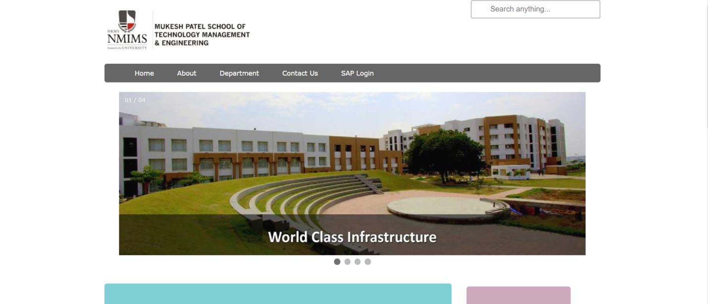

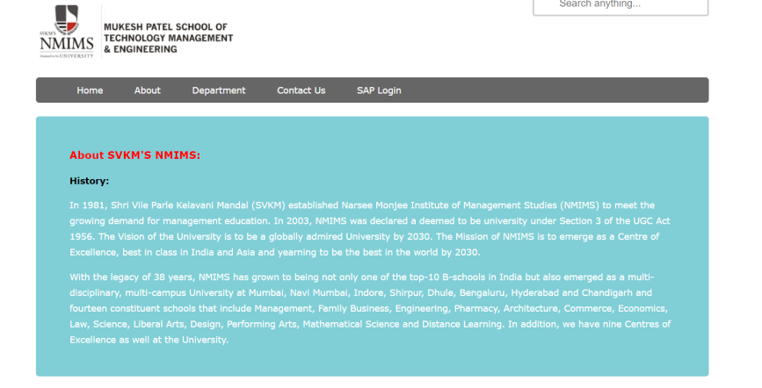

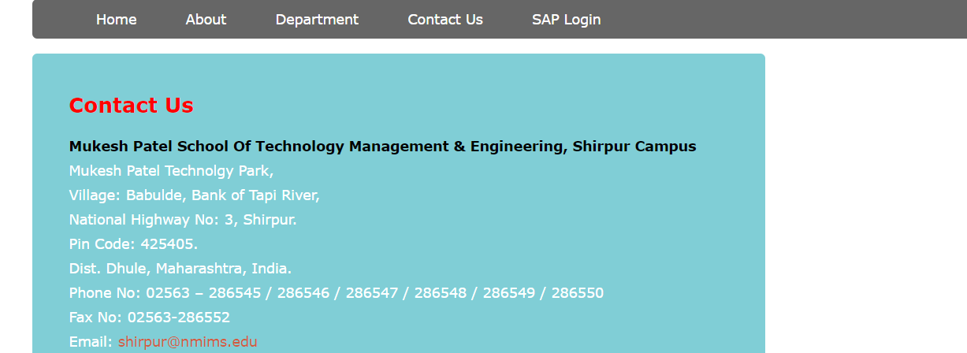

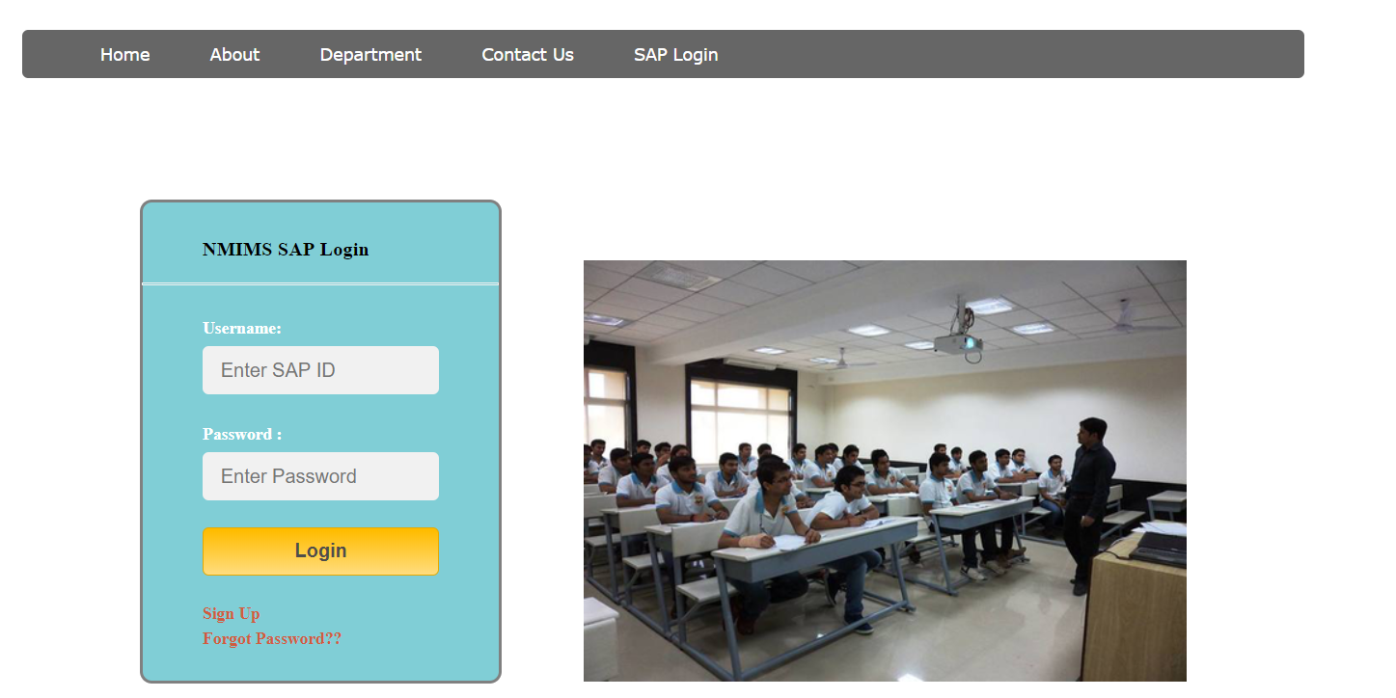

**CONCLUSION:-**

**We thereby conclude that with the completion of this project we are thorough with the use of HTML, CSS, JAVA SCRIPT, PHP.**

**Thus we have completed this project successfully.**

**\*\*\*\*\*\*\*\*\*\*\*\*\*\*\*\*\*\*\*\***