Become a React Developer
- React app run in the browser. You don`t have to wait for a server response to get a new page.
- Keep code managable. We can easily reuse components.
- Render() method allows us to render a JsS function as a component to the real DOM and every react component has to do.
- UI State becomes difficult to handle with Vanilla Js. If you have got more complex web apps where you dynamically add and remove elements, this can quickly can become cubmersome,
- React helps us by making the whole UI state management a non-issue.
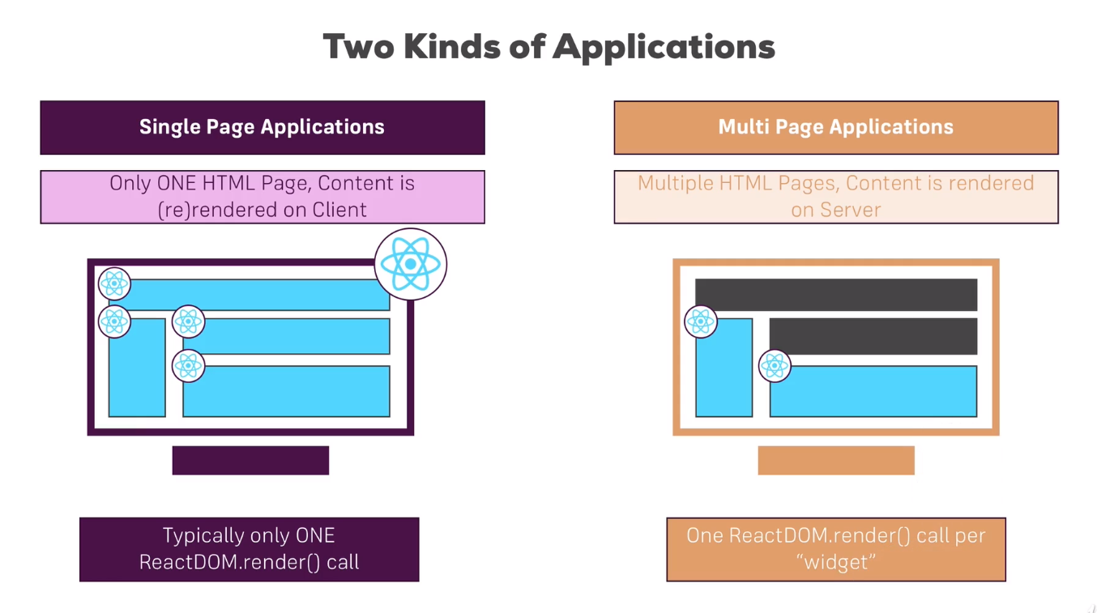
- Huge ecosystem, active community and high performance.
- Jsx is html in javascript
- React component extends from “Component” from the react library.
- “React” is responsible or required for rendering anything to the DOM.
- Jsx expression must have one root element. Wrap everthing into one root element per component.
- State basically allows you to change your component at runtime
- JSX is NOT HTML but it looks a lot like it. Differences can be seen when looking closely though (for example className in JSX vs class in "normal HTML"). JSX is just syntactic sugar for JavaScript, allowing you to write HTMLish code instead of nested React.createElement(...) calls.
- When creating components, you have the choice between two different ways:
1- Functional components (also referred to as "presentational", "dumb" or "stateless" components - more about this later in the course) => const cmp = () => { return <div>some JSX</div> } (using ES6 arrow functions as shown here is recommended but optional)
2- class-based components (also referred to as "containers", "smart" or "stateful" components) => class Cmp extends Component { render () { return <div>some JSX</div> } }
- Components are awesome because you can focus our code in each file and hence make it much more maintainable, not put everything into the app.js file and this component is also resusable and configurable.
- Children refers to any elements and this includes plain text as we have between the opening and closing tag of your component, and you could nest complex html code in between too.
- State is managed from inside a component. State property is only available in components that extend components, so in class-based React components.
- With React 16.8, a new feature was released called React Hooks so you can actually manage state in functional components.
- State can be changed and if it changes, it will lead React to re-render our Dom or to update the Dom.
- props and state are CORE concepts of React. Actually, only changes in props and/ or state trigger React to re-render your components and potentially update the DOM in the browser
- props allow you to pass data from a parent (wrapping) component to a child (embedded) component.
- State whilst props allow you to pass data down the component tree (and hence trigger an UI update), state is used to change the component, well, state from within. Changes to state also trigger an UI update.
- Since React 16.8 there also is a way for us to manage state in functional components with a feature called React Hooks.
- UseState is the that allows us to manage state in functional component. UseState returns an array with exactly two elements and always two elements. The first element we get back will always be our current state, the second element in state array will always be a function that allows us to update this state.
- State doesn`t have to be an object it could also just be a string, a number, an array whatever your app needs and you can have as many useState call as you want.
- Stateless component called as presentational component, statefull component called as smart or container component
- When react renders something to the screen, when it decides that it needs to update the screen, it executes this render method and not just the return expression, everything here. So everything inside the render method gets executed whenever react re-renders this component.
- Radium is popular package for react which allows us to use inline styles with pseudo selectors and media queries. Npm install –save radium add radium package to the project in node_modules directory.
- Radium is just a component wrapping your component adding kind of injecting some extra functionality, some extra syntax.
- Css Module is a CSS file in which all class names and animation name are scoped locally by default.
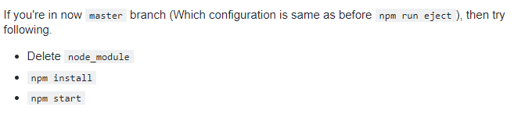
- ComponentDidCatch method which receives potential error and some additional information passed into it automatically by react and it will be executed whenever a component we wrap with error boundary throws and error.
- ErrorBoundary component which simply wraps a component with the goal of handling any errors that component might throw. Wrapped component’s value key have to move to the error boundary because this is now the outer element which we map and the key always has to be outer element.
- Stateless(presentational) component is a functional component that does not manage state. This components by making that split, you keep you app manageable because you have predictable flow of data, you know where your state changes.
- Class-based components that extend that component object we can import from the React package and functional components are simply these functions that take props and return some JSX code.
- Class-based components can access state and they can change it with set state and they also can use these lifecycle hooks. Access state and props via this. Functional components, in past version of React they couldn’t change state but since React Hooks they can with the useState hook. But lifecycle hooks are still not supported. Access state via props.
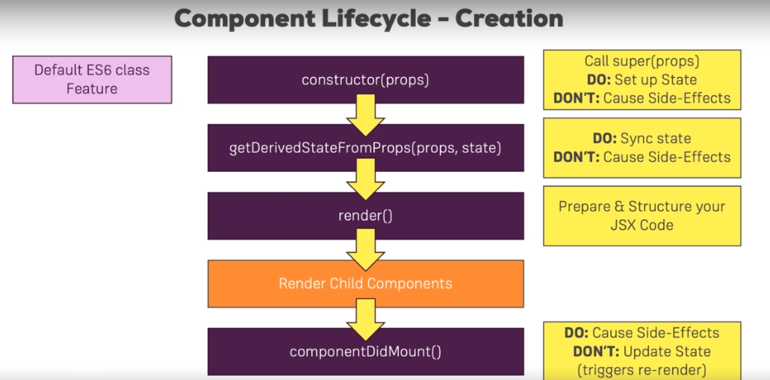
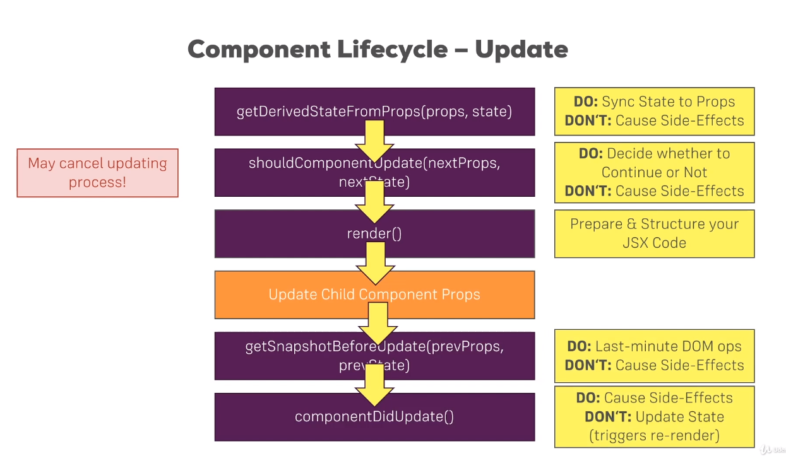
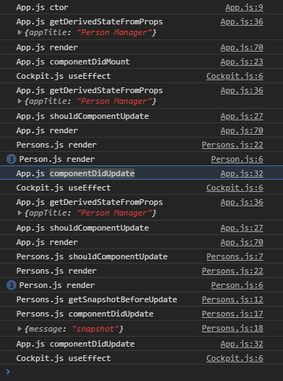

- PureComponent just a normal component that already implements shouldComponentUpdate with a complete props check, so that checks for any changes in any prop of that component.
- The render method being called does not immediately also render this to the real DOM. Of course this also applies to functional components and the JSX returned there, NOT just to class-based components with render().
- Render is more a suggestion of what the HTML should look like in the end.
- Virtual DOM simply is a DOM representation in javascript.
