Thinking like a programmer
- Variables are basically containers for values (such as numbers, or strings of text).
- JavaScript is case sensitive
- Constants are used to store values that you don't want to change, and are created with the keyword const
- Functions are reusable blocks of code that you can write once and run again and again, saving the need to keep repeating code all the time.
- Events are things that happen in the browser — a button being clicked, a page loading, a video playing, etc. — in response to which we can run blocks of code. The constructs that listen out for the event happening are called event listeners, and the blocks of code that run in response to the event firing are called event handlers.
- To get this reference, we used the querySelector() method of the document object. QuerySelector() takes one piece of information — a CSS selector that selects the element you want a reference to.
- Syntax errors: These are spelling errors in your code that actually cause the program not to run at all, or stop working part way through — you will usually be provided with some error messages too. These are usually okay to fix, as long as you are familiar with the right tools and know what the error messages mean!
- Logic errors: These are errors where the syntax is actually correct but the code is not what you intended it to be, meaning that program runs successfully but gives incorrect results. These are often harder to fix than syntax errors, as there usually isn't a resulting error message to direct you to the source of the error.
- Null is a special value that means "nothing", or "no value".
- This error didn't come up as soon as the page was loaded because this error occurred inside a function (inside the checkGuess() { ... } block). As you'll learn in more detail in our later functions article, code inside functions runs in a separate scope than code outside functions. In this case, the code was not run and the error was not thrown until the checkGuess() function was run by line 86.
- Arrays are generally described as "list-like objects"; they are basically single objects that contain multiple values stored in a list.
- console.log() is a really useful debugging function that prints a value to the console.
- When you enter an actual string in your code, enclosed in single or double quotes, it is called a string literal.
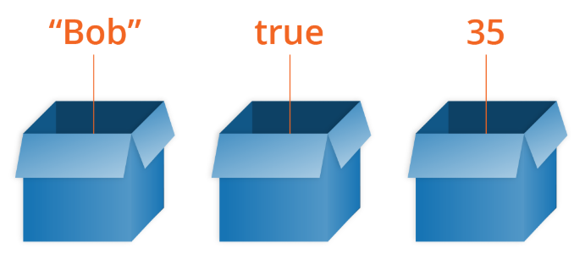
- We say variables contain values. This is an important distinction to make. Variables aren't the values themselves; they are containers for values. You can think of them being like little cardboard boxes that you can store things in.
- In JavaScript, all code instructions should end with a semi-colon (;) — your code may work correctly for single lines, but probably won't when you are writing multiple lines of code together. Try to get into the habit of including it.
- A multiline JavaScript program that declares and initializes a variable, you can actually declare a variable with var after you initialize it and it will still work (var hoisting). Hoisting no longer works with let
- When you use var, you can declare the same variable as many times as you like, but with let you can't. The following would work
- Javascript types are number, string, boolean, array, object - an object is a structure of code that models a real-life object. -, function(net degil degistirilecek)
- JavaScript is a "dynamically typed language", which means that, unlike some other languages, you don't need to specify what data type a variable will contain (numbers, strings, arrays, etc).
- Typeof— this returns the data type of the variable you pass into it.
- 5 ** 5 (returns 3125, which is the same as 5 * 5 * 5 * 5 * 5).
- Such a control that swaps between two states is generally referred to as a toggle. It toggles between one state and another — light on, light off, etc.
- toString() is arguably simpler than join() as it doesn't take a parameter, but more limiting. With join() you can specify different separators.
- The new length of the array is returned when the push() method call completes.
- Any value that is not false, undefined, null, 0, NaN, or an empty string ('') actually returns true
- This is called an anonymous function — it has no name! It also won't do anything on its own. You generally use an anonymous function along with an event handler. You will mainly use anonymous functions to just run a load of code in response to an event firing — like a button being clicked — using an event handler.
- The top level outside all your functions is called the global scope. Values defined in the global scope are accessible from everywhere in the code
- The parentheses in this context are sometimes called the "function invocation operator". You only use them when you want to run the function immediately in the current scope. In the same respect, the code inside the anonymous function is not run immediately, as it is inside the function scope.
- Note that event handlers are sometimes called event listeners — they are pretty much interchangeable for our purposes, although strictly speaking, they work together. The listener listens out for the event happening, and the handler is the code that is run in response to it happening.
- Event handlers is important to note that web events are not part of the core Javascript language – they are defined as part of the Javascript APIs built into the browser.
- Separating your programming logic from your content also makes your site more friendly to search engines.
- Sometimes inside an event handler function, you might see a parameter specified with a name such as event, evt, or simply e. This is called the event object, and it is automatically passed to event handlers to provide extra features and information.
- Note :You can use any name you like for the event object — you just need to choose a name that you can then use to reference it inside the event handler function. e/evt/event are most commonly used by developers because they are short and easy to remember. It's always good to stick to a standard.
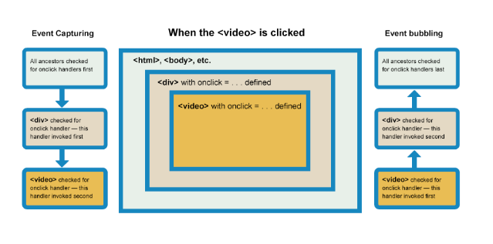
- As mentioned above, by default all event handlers are registered in the bubbling phase, and this makes more sense most of the time. If you really want to register an event in the capturing phase instead, you can do so by registering your handler using addEventListener(), and setting the optional third property to true.
- The first four items are data items, and are referred to as the object's properties. The last two items are functions that allow the object to do something with that data, and are referred to as the object's methods.
- An object like this is referred to as an object literal — we've literally written out the object contents as we've come to create it.
- The this keyword refers to the current object the code is being written inside
- For each webpage loaded, an instance of Document is created, called document, which represents the entire page's structure, content, and other features such as its URL.
- The basic idea of OOP is that we use objects to model real world things that we want to represent inside our programs.
- Abstraction — creating a simple model of a more complex thing, which represents its most important aspects in a way that is easy to work with for our program's purposes.
- The fancy word for the ability of multiple object types to implement the same functionality is polymorphism. Just in case you were wondering.
- A constructor function name usually starts with a capital letter — this convention is used to make constructor functions easier to recognize in code.
- The value of constructor.name can change (due to prototypical inheritance, binding, preprocessors, transpilers, etc.), so for more complex examples you'll want to use the instanceof operator instead.
- The call() function basically allows you to call a function defined somewhere else, but in the current context.
- The Object.keys() method returns an array of a given object's own property names, in the same order as we get with a normal loop.
- JSON is a text-based data format following JavaScript object syntax. Converting a string to a native object is called parsing, while converting a native object to a string so it can be transmitted across the network is called stringification.
- JSON is purely a data format — it contains only properties, no methods. JSON requires double quotes to be used around strings and property names. Single quotes are not valid.
- Client-side JavaScript, in particular, has many APIs available to it — these are not part of the JavaScript language itself
- The key difference between a library and a framework is “Inversion of Control”. When calling a method from a library, the developer is in control. With a framework, the control is inverted: the framework calls the developer's code.
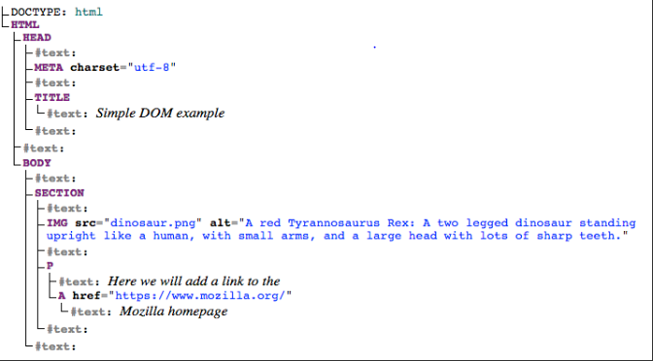
- Each element and bit of text in the document has its own entry in the tree — each one is called a node.
- Document.querySelector() is the recommended modern approach, which is convenient because it allows you to select elements using CSS selectors. querySelector() call will match the first element.
- Document.querySelectorAll(), which matches every element in the document that matches the selector, and stores references to them in an array-like object called a NodeList.
- Document.getElementById(), which selects an element with a given id attribute value, e.g. <p id="myId">My paragraph</p>.
- Document.getElementsByTagName(), which returns an array containing all the elements on the page of a given type.
- A semicolon is not necessary after a statement if it is written on its own line. But if more than one statement on a line is desired, then they must be separated by semicolons.
- Var declares a variable, optionally initializing it to a value. Let declares a block-scoped, local variable, optionally initializing it to a value. Const declares a block-scoped, read-only named constant.
- let (const) does not hoist the variable to the top of the block. Referencing the variable in the block before the variable declaration results in a ReferenceError
- Global variables are in fact properties of the global object. In web pages, the global object is window, so you can set and access global variables using the window.variable syntax.
- Trailing commas can create errors in older browser versions and it is a best practice to remove them.
- String interpolation var name = “sinan” “hello ${name} how are you”

