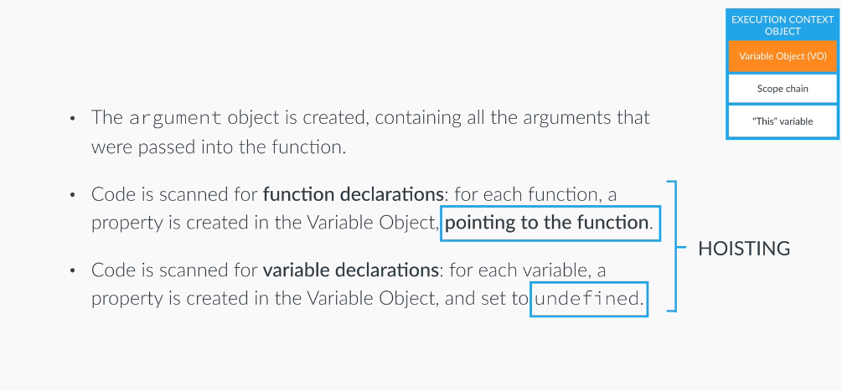

- Each new function create a new scope
- Lexical scope a function that is lexically with another function get access to the scope of the another function.
- Regular function call, the this keyword point at the global object (window)
- Method call, the this variable points to the object that is calling the method.
- The this keyword os not assigned a value until a function where it is defined is actually called.
- Primitives are number, string, boolean, undefined and null. All of other are object.
- Class in javascript constructor or prototype.
- Every JS object has a prototype property, which makes inheritance possible in JS
- The prototype property of an object is where we put methods and properties that we want other objects to inherit.
- The Constructor`s prototype property is not the prototype of the Constructor itself, it is the prototype all instance that are created through it.
- When a cetain method is called the search start in the object itself and if it cannot be found, the search moves on to the object`s prototype. This contunie until the method is found prototype chain.
- A function is an instance if the Object type, behaves like any other object, we can store functions in a variable, we can pass a function as an argument to another function
- Closures: An inner function has always access to the variables and parameters of its outer function, even after the outer function has returned.

