Shopping Cart System
Architecture Overview
Take-home assignment — Full Stack Engineer position, אגף התקשוב ומערכות המידע, משרד הביטחון

1. Overview
shopping-cart-system is a monorepo of three independently deployable services implementing a two-screen shopping flow: client (a React single-page app), server-catalog (a .NET 10 API backing the product catalog, screen 1), and server-orders (a NestJS API backing order submission and history, screen 2). All three share one git repository and one root docker-compose.yml/.env pair for local orchestration.
Each service goes a bit beyond the bare assignment — a rate limiter and structured logging in server-catalog, an Elasticsearch mapping wired directly into the running service in server-orders, cart persistence and a styles/component split in client, among other additions covered in this document. None of it is required by the brief; it reflects what a system meant to run past a demo would actually need, and every addition below is also explained in that service's own README.

Technology stack
Layer | Technology
client | React 19, Redux Toolkit + RTK Query, Vite, TypeScript, MUI, react-router, i18next (en/he, RTL/LTR)
server-catalog (screen 1) | .NET 10, ASP.NET Core, EF Core, SQL Server
server-orders (screen 2) | NestJS, Elasticsearch
Infrastructure | Docker Compose — SQL Server + Elasticsearch always on; all three services under an optional "full" profile

2. System Architecture
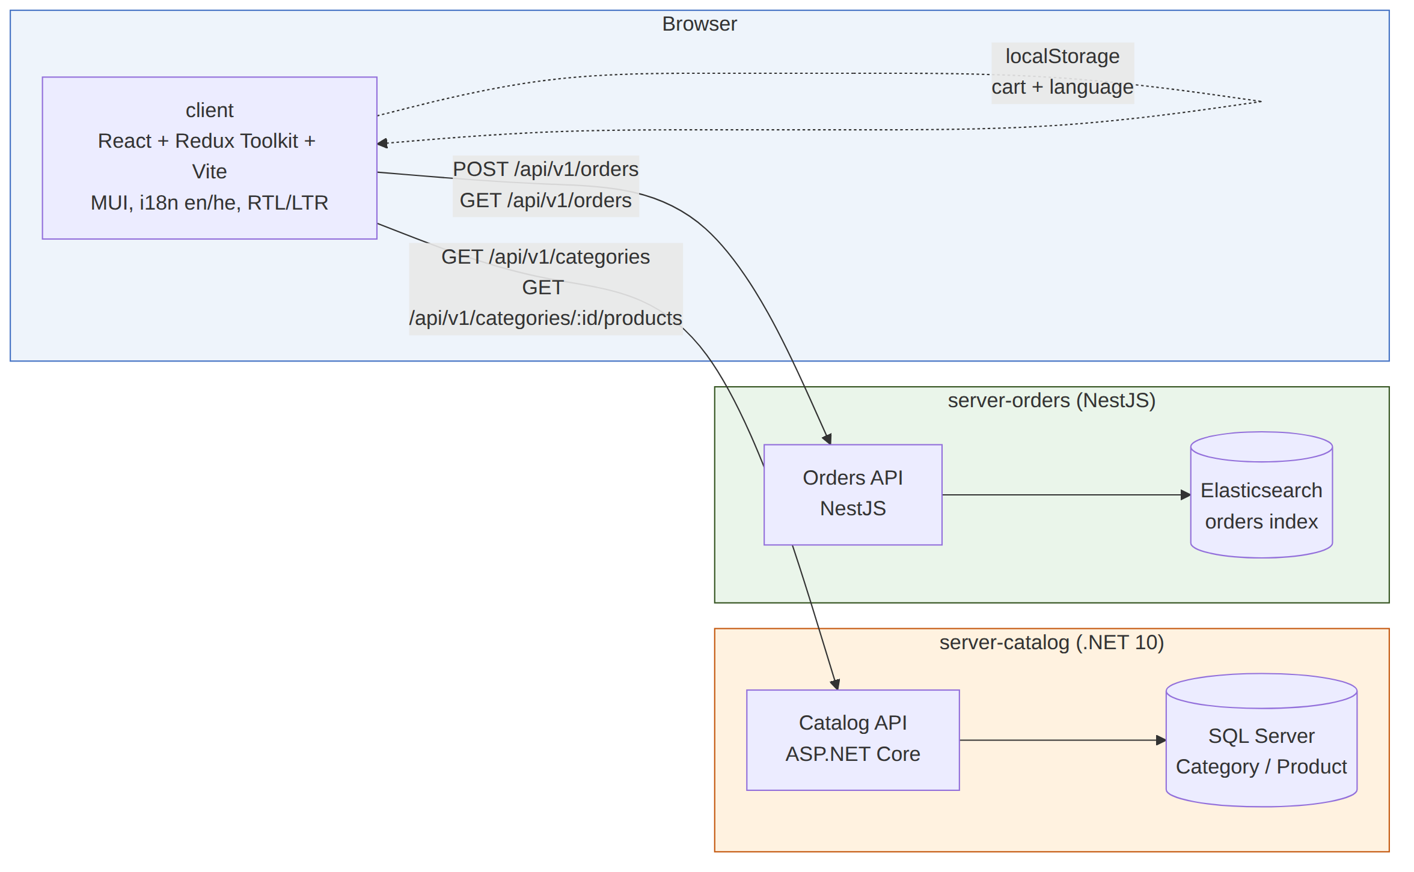
Figure 1. Components and the requests between them.
The two backend services are fully independent — server-orders never queries server-catalog's database. An order stores a denormalized snapshot of the product name, category and unit price the shopper saw at the time of purchase, rather than a live reference into the catalog, since the two services do not share a datastore. client talks to both APIs directly over HTTP and keeps the shopping cart and the language preference in the browser's localStorage, so a page reload loses neither.

3. Request Flows
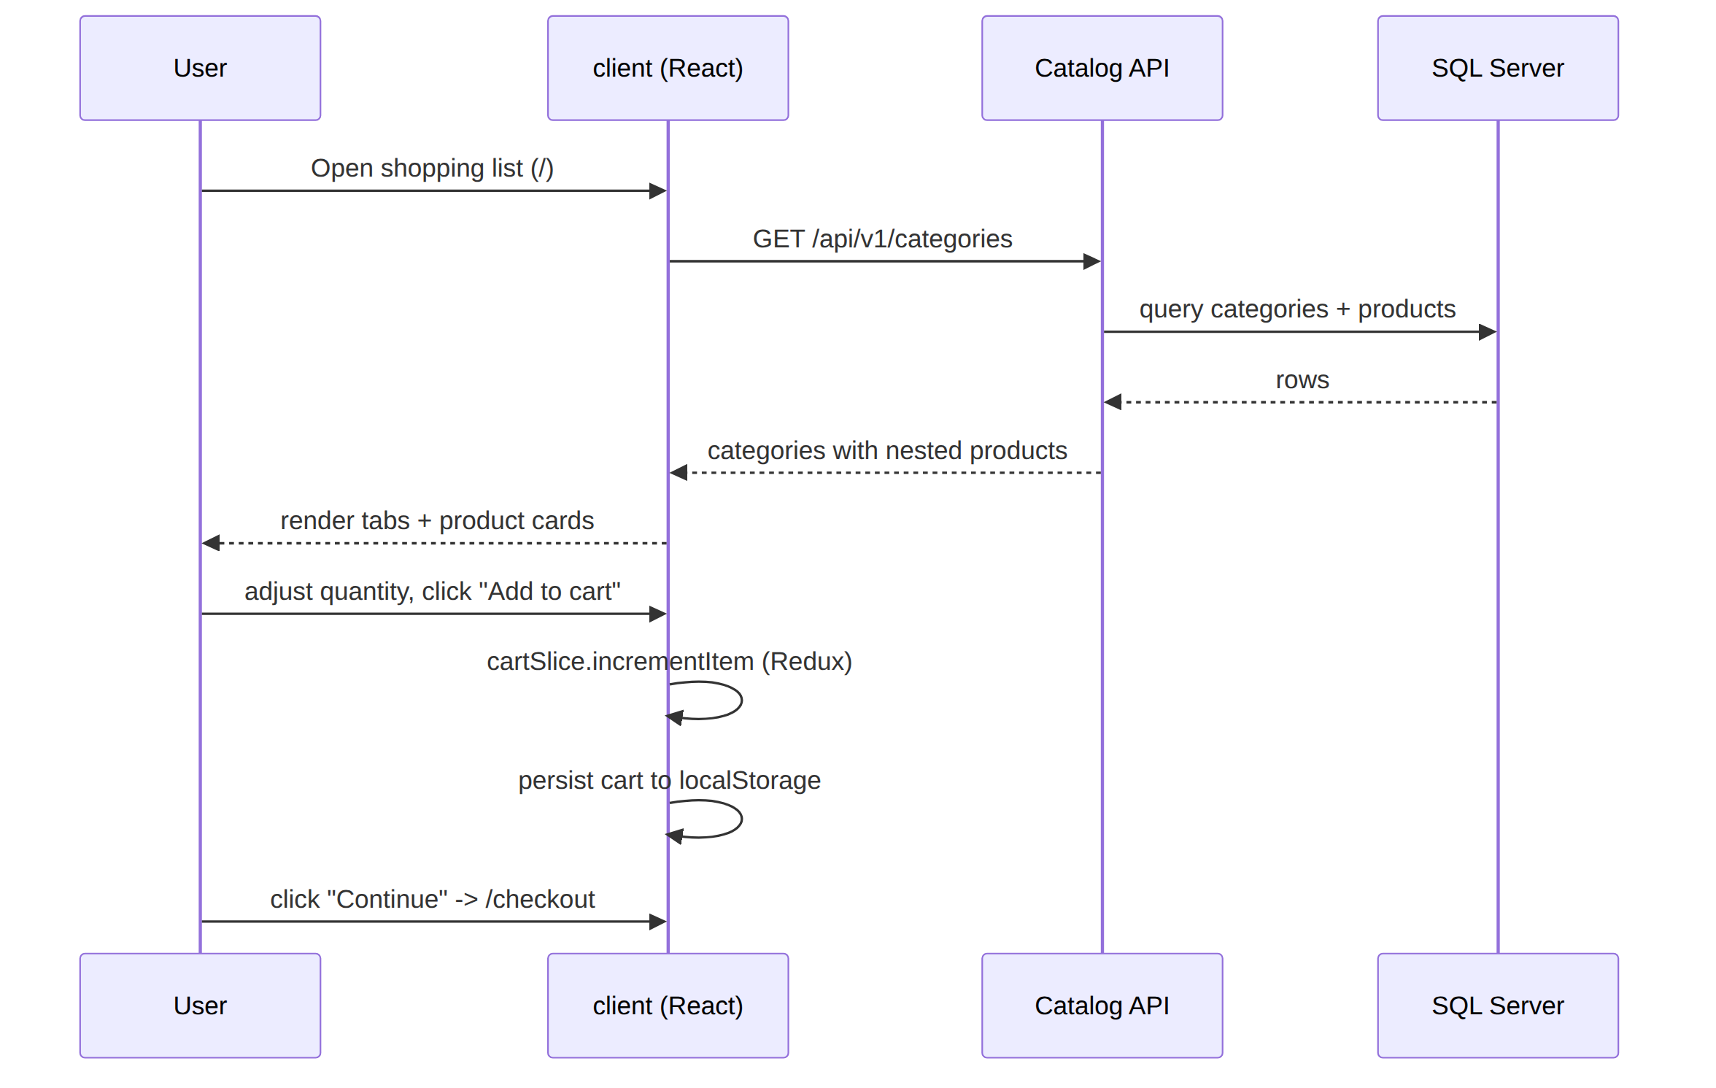
Figure 2. Screen 1 — shopping list (/).
Categories and their products load in a single request; the per-card quantity stepper doubles as the "add to cart" action, updating Redux state and persisting it to localStorage on every change.
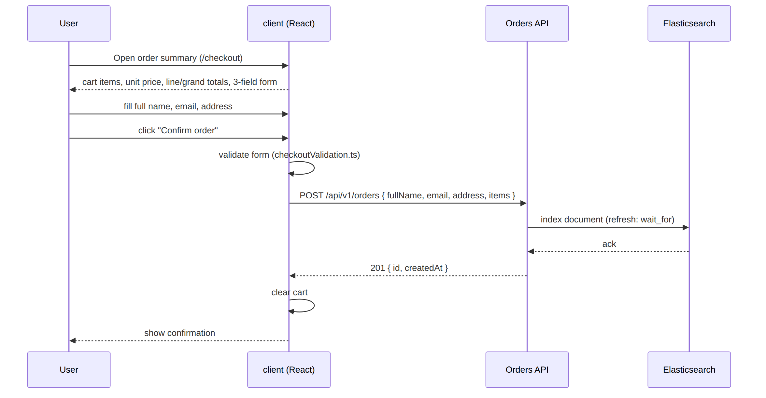
Figure 3. Screen 2 — order summary (/checkout).
The cart snapshot (unit price and unit, captured when each item was added) drives the per-line and grand totals shown here; the 3-field form (full name, email, address) is validated client-side before the order is posted. server-orders indexes the order with refresh: 'wait_for' so it is immediately visible in the order history, and the client clears its cart only after a successful 201 response.

4. Data Model

Catalog (SQL Server, via EF Core)
Entity | Fields
Category | Id (PK), NameEn, NameHe
Product | Id (PK), NameEn, NameHe, CategoryId (FK), ImageUrl (external source link), ImagePath (local, served path), UnitPrice (decimal), Unit (Kilogram | Piece | Liter)
One category has many products. Demo data — 3 categories, 18 products — is seeded from an embedded JSON resource shared by both the SQL-backed and in-memory repository implementations.

Orders (Elasticsearch mapping)
Field | Type
id | keyword
fullName | text + keyword sub-field
email | keyword
address | text + keyword sub-field
createdAt | date
items | nested — productId (integer), productName (text + keyword), categoryName (keyword), quantity (integer)
The mapping the assignment explicitly asks for lives in server-orders/mapping.json and is what the service loads to create the index on first start — not a copy that can drift. items is mapped nested rather than object so per-item queries stay correct; the mapping root sets dynamic: "strict" (rejects unmapped fields, matching the DTO's own validation) and a single shard with zero replicas, matched to the single-node deployment used for this assignment.

5. API Contracts
Method & path | Service | Description
GET /api/v1/categories | Catalog | Full catalog (all categories + products), unpaginated
GET /api/v1/categories/{id}/products?cursor&limit | Catalog | Cursor-paginated products with meta: { limit, total }
GET /health | Catalog | DB connectivity health check
POST /api/v1/orders | Orders | Create an order from a denormalized item snapshot
GET /api/v1/orders?cursor&limit | Orders | search_after-paginated order history with meta
GET /health | Orders | Elasticsearch connectivity health check
Both services share one error envelope — { status, message, errors[] } — and a common X-Correlation-Id convention through both services' request logs, so a request that crosses both APIs can be traced by the same header.

6. Key Design Decisions
Decision | Rationale
NestJS over Express | A layered architecture symmetric with the .NET side (modules, DI) rather than a minimally-assembled Express app.
Elasticsearch over MongoDB | Matches the assignment's stated preference, and exercises mapping/nested-type ownership — the mapping.json file the assignment explicitly asks for.
Denormalized order line items | The two services don't share a database; an order is a snapshot of what the shopper saw and agreed to, not a live link into the catalog.
fullName instead of first/last name | The brief specifies exactly three checkout fields; splitting the name would make four.
Cursor (keyset) pagination, both APIs | Page cost doesn't grow with depth and results don't shift under concurrent inserts, unlike offset-based paging.
In-process caching (IMemoryCache / RTK Query) | Sufficient for a read-mostly catalog at this scale; a shared cache (Redis) is deliberately deferred — see Future Improvements — until more than one instance needs to share state.
Rate limiting + a concurrency limiter, both APIs | A per-client sliding window plus a global in-flight cap, built entirely on each framework's own primitives rather than a new dependency.
Both services and datastores kept stateless | No server-side session; horizontal scaling needs no sticky routing today, at the cost of pushing shared caching to Future Improvements.
Composition-root DI in .NET; per-module DI in NestJS | Dependency wiring is visible in the file tree (a dedicated Catalog.DependencyInjection project) rather than buried in Program.cs / app.module.ts.
Cross-platform tooling throughout | No OS-specific scripts anywhere; setup helpers are single cross-platform Node scripts instead of parallel .ps1/.sh pairs.

7. Testing & Verification
Service | Framework | Coverage
server-catalog | xUnit.v3 + Moq | Category-to-DTO mapping logic, DI wiring across all three layers, in-memory repository data integrity and cursor pagination, cache-decorator behavior.
server-orders | Jest + Supertest | 10 unit tests (service logic, cursor encode/decode) plus an 11-test e2e suite that boots the real Nest application against a mocked Elasticsearch client — no live cluster needed to run it.
client | Vitest + React Testing Library | 33 tests — cart reducer logic and localStorage persistence, checkout form validation, checkout price/total calculations, and one interactive component test.
Tests target logic that can actually regress. Thin pass-through layers — a repository that is little more than an ORM query, or a controller that just delegates — are deliberately left untested, since a test there would mostly be re-testing the underlying framework rather than this project's own code.

8. Future Improvements
Framed as what would come next to take this from a take-home demo to something production-ready, not as gaps left unspoken.

System-wide
- Authentication/authorization. Add OAuth2/OIDC via an SSO provider in front of both APIs — today neither has an auth boundary, and order history carries PII (name, email, address).
- Shared state in Redis. Once running more than one instance of either service, move the in-process cache and rate-limit counters to a shared store so replicas don't diverge or under/over-count.
- A message queue (Kafka or RabbitMQ). Move work that needn't block the response — confirmation emails, cache invalidation, search reindexing — off the request path.
- A reverse proxy (NGINX). In front of both services once running multiple replicas, for load balancing and TLS termination.
- A CI pipeline. Build and test all three services on every push, plus Dependabot/Renovate for dependency freshness — server-orders' e2e suite is already CI-ready today.
- Paginate the catalog listing itself. GET /api/v1/categories returns everything at once; fine at 3 categories, not once the catalog actually grows.
- Responsive images. srcset/sizes on top of the lazy loading already implemented, once product images move to blob storage behind a CDN.

server-catalog
- Real content management. Replace the static JSON seed with an admin UI or product-management API.
- Blob storage + CDN for product images. Local files under wwwroot/images don't survive horizontal scaling.
- Distributed tracing and metrics (OpenTelemetry). Structured logs cover one instance; not a request that crosses services, or latency/error-rate over time.

server-orders
- Filtering/search on order history. By customer, date range, or status — cursor pagination covers walking the list, not finding one order.
- A real multi-node Elasticsearch cluster. With replica shards and TLS/auth, instead of the single-node demo instance.
- Move off refresh: 'wait_for'. Right for a demo's immediate read-after-write; won't scale under real write load.
- A second integration suite against a real, disposable Elasticsearch container. Layered on top of the existing mocked-client e2e suite, to validate Elasticsearch's actual query semantics.

client
- Generate API clients from OpenAPI. Instead of hand-written types, once the contracts stabilize.
- End-to-end tests (Playwright). Against real running instances of both APIs, covering the complete checkout lifecycle.

