quarto_test

## About Alison

|  |
| --- |
| Alison Obright MA |

Alison Obright is a first year Ph.D student at the University of Minnesota. She is interested in rhetoric of science and technology and the ways that language mediates our relationship to science and technology. Currently, her interest has her examining narratives of decision making, computational methods in rhetoric, and the ways that technology, belief, and conspiracy interact.

The diagram below is a summary of my academic timeline. I arrived at the UMN RSTC program with a background in rhetoric/writing and biology. During my Master’s experience I explored how scientists communicate on TikTok which sharpened my interest in how technology is a mediator for communication that fundamentally changes the shape and influence of our words.

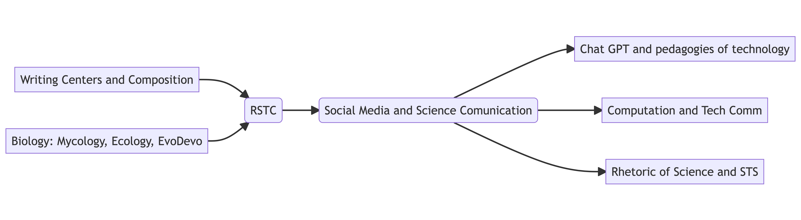

Alison’s academic interest timeline.

## Some of Alison’s work

Breuch, L.-A., Ghimire, A., Bolander, K., Deets, S., Obright, A., & Remcheck, J. (n.d.). Reconsidering Writing Pedagogy in the Era of ChatGPT: Results of a Usability Study of ChatGPT in Academic Writing, forthcoming

Deets, S., Baulch, C., Obright, A., & Card, D. J. (n.d.). Content Analysis, Construct Validity, and Artificial Intelligence: Implications for TPC and Graduate Programming. Journal of Business and Technical Communication, forthcoming

## Technology and Paranormal Investigation

One area of interest for me is how technology interacts with people and how we use technology to navigate the visible and invisible phenomena that shape our world. One rich, albeit more unconventional, space for this is paranormal investigation. I am interested in how communities of paranormal investigators shape methods with technology, relate to technology, and invoke science as part of their understanding of unseen things. There are interesting provocations/challenges this community provides when we think about processes of science and wider understandings of technology (especially AI and scientific laboratory devices). I always feel the need to add a caveat here - I think the question of “are ghosts real” is one of the least interesting. For me, the more important questions include

* How or why do we believe in ghosts? How does technology factor into that?
* How or why do we feel the need to prove our beliefs? How do we communicate and interpret our beliefs to others? How or why do some become conspiracy theories?
* How or why does science show up in this space? Science is invoked here, what do those rhetorics mean about science, people, technology, method?

## ChatGPT

In the spring of 2023 a group of my peers and instructor responded to a need for more information about student perspectives on ChatGPT. We performed a usability test with 32 undergraduate students which asked them to evaluate five texts produced by ChatGPT. This study provided both qualitative and quantitative data that can help inform policy and pedagogical decisions made by higher education institutions and instructors.

## Narratives of decision making

This project examines narratives of decisions making found in three Reddit forums: r/NIPT, r/BabyBumps, and r/Pregnant. Our study examined 20 threads from each of these subreddits to examine the shape of online conversations supporting pregnant people through two key questions 1) Should I get prenatal genetic tests and 2) When results come back abnormal, what should I do? This work is in conversation with scholarship about counter narratives since we are interested in how these stories differ from more dominant narratives of testing and termination in the U.S.

## Computational rhetoric

This project focused on a few forms of computational rhetoric and the use of computational methods in rhetorical scholarship. Our team surveyed how computational methods were used and characterized in a variety of publications and used computational methods to examine social media data related to online climate change conversations.