Welcome

## About Alison

|  |
| --- |
| Alison Obright MA |

Alison Obright is a first year Ph.D student at the University of Minnesota. She is interested in rhetoric of science and technology and the ways that language mediates our relationship to science and technology. Currently, her interest has her examining narratives of decision making, computational methods in rhetoric, and the ways that technology, belief, and conspiracy interact.

The diagram below is a summary of my academic timeline. I arrived at the UMN RSTC program with a background in rhetoric/writing and biology. During my Master’s experience I explored how scientists communicate on TikTok which sharpened my interest in how technology is a mediator for communication that fundamentally changes the shape and influence of our words.

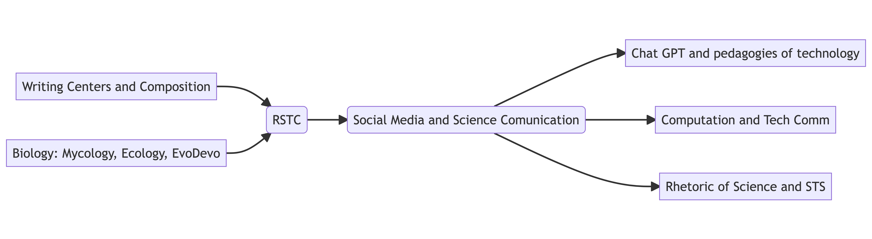

Alison’s academic interest timeline.

## Some of Alison’s work

Breuch, L.-A., Ghimire, A., Bolander, K., Deets, S., Obright, A., & Remcheck, J. (n.d.). Reconsidering Writing Pedagogy in the Era of ChatGPT: Results of a Usability Study of ChatGPT in Academic Writing, forthcoming

Deets, S., Baulch, C., Obright, A., & Card, D. J. (n.d.). Content Analysis, Construct Validity, and Artificial Intelligence: Implications for TPC and Graduate Programming. Journal of Business and Technical Communication, forthcoming