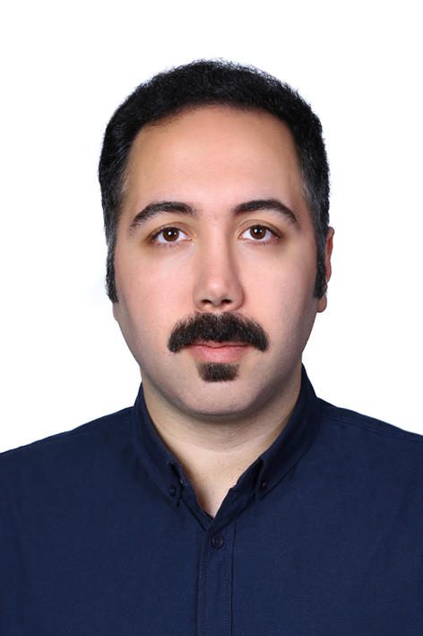
Ali Soleimani
Project Management and Digital Workflows
Cologne, Germany | alisoleimani71@gmail.com
alisoleimani.de/fresenius-kabi/
linkedin.com/in/alisoleimani-de/

Profile
International Management master's student with a Project Management focus and 10+ years of experience in industrial project coordination and procurement. Experienced in milestone and action tracking, management reporting and communication across technical and commercial teams. Advanced Excel user, Strategic Sourcing lecturer and contributor to an academic-industry project on AI-enabled workflows. Seeking the Project Management internship in Fresenius Kabi's Global Information and Digital Technology team.

Relevant capabilities
• Project coordination: milestone and action tracking, cross-functional follow-up, stakeholder communication and structured project documentation.
• Reporting and analysis: advanced Excel, management reports, presentations and decision-support materials; experience teaching Excel to engineering students.
• Digital process improvement: documentation, validation and evaluation of AI-enabled workflows; approximately 50% improvement in procurement efficiency and reporting transparency.

Professional experience
Lecturer in Strategic Sourcing
Hochschule Fresenius, Cologne | Oct 2026 - Present
• Teach Strategic Sourcing using practical industry cases and structured learning materials, explaining commercial and analytical concepts to an international student audience.
Working Student in Operations
Studentwerk, Cologne | Apr 2026 - Present
• Support daily operational and logistics activities in a multicultural team, with a focus on accuracy and efficient execution.
Procurement Manager and Executive Coordinator
Petro Sanat Lidoma, Tehran | Dec 2017 - Feb 2026
• Coordinated procurement and delivery activities across eight national-scale EPC and industrial projects and worked with 30+ suppliers in Europe and Asia.
• Prepared management reports, tracked milestones and open actions, and followed up on priorities across technical and commercial departments.
• Improved digital documentation and reporting transparency; managed RFQs, commercial evaluations, contract negotiations and supplier follow-up.

Earlier professional experience
Procurement Specialist
Petro Sanat Lidoma, Tehran | Jun 2016 - Nov 2017
• Coordinated procurement across concurrent EPC projects, including technical and commercial evaluations of capital equipment and engineering services.
• Negotiated with international suppliers and followed up on delivery schedules and specification requirements.
Research Assistant
Iran University of Science and Technology, Tehran | Jan 2016 - May 2016
• Conducted technical research and economic evaluation of energy systems; delivered Microsoft Excel training to engineering students.
Process Engineering Intern
EIED, OIEC Group, Tehran | Jun 2015 - Aug 2015
• Supported technical and economic analyses, process simulations and data validation during the FEED phase of oil and gas projects.

Selected project
Project Coordinator in Digital Workflow and AI Integration
Hochschule Fresenius and KUKUK Ingenieure, Cologne | Sep 2026 - Dec 2026
• Contribute to an academic-industry collaboration evaluating AI-enabled workflows and digital process integration; support validation, documentation, deliverable tracking and stakeholder communication.

Education
M.A. International Management with Project Management focus
Hochschule Fresenius, Cologne | Mar 2026 - 2028
Current GPA: 1.2. Relevant areas: supply chain management, data analysis for decision making, strategic management and international business.
M.Sc. Chemical Engineering
Iran University of Science and Technology | 2015 - 2018
Specialisation: Simulation, Modeling and Control; research in economic evaluation and energy efficiency.
B.Sc. Chemical Engineering
Iran University of Science and Technology | 2011 - 2015
Ranked third among Chemical Engineering undergraduates; GPA 3.8/4.0.

Tools and languages
Tools: Microsoft Excel (advanced), PowerPoint, Outlook, MS Project, Visio, R and RStudio; HTML and website design; GitHub.
Languages: English C1 (TOEFL iBT 101/120); German A2, improving; Persian and Tati native; Turkish A2; Arabic A1.

Selected training and engagement
Procurement & Import of Goods, 2019 | EPC Contracts, Tax & Social Security, 2024 | MS Project, 2018 | Stepping into Leadership, 2026 | AI Study Buddy, 2026.
Course Representative, International Student Mentor and Student Digital Ambassador at Hochschule Fresenius, 2026 - Present.

