## Purpose

## Scope

This Essex-based online booking system provides reservation system to manage the travel for winter sports. The final deliverable of this project is a Web-based system with 3 different user interfaces including, customer user interface, tele-sale user interface and administrator user interface. Furthermore, the final document will be provided by group as a report. Stakeholders of our system include:

1. Customers in Essex
2. Hotels in Niegania
3. Travel Airlines
4. National Rails
5. Essex-based company.

To understand the responsibilities of our booking system, the following diagram is provided. Also it helps to define their concrete scope and relationships to other, surrounding systems.

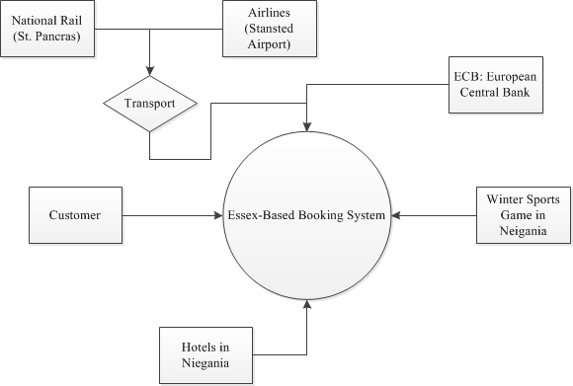

The most important risks may be deals with them are

1. Server Crash
2. Database Crash
3. Internet Connection and Bandwidth
4. Check Currency Interruption

Many booking systems operate in 24/7 mode. Availability is therefore crucial for supporting the business case for this system. Minimum availability of 99.999% - maximum downtime of just over five minutes per year - is required.

Internet Cancelation is the feature will not implemented in this project. Nevertheless, many business rules for discount must be considered.