# Section?

## USE-CASE DIAGRAM

In this part, The usecase diagram of whole system is appeared. The title of each usecases are selected as the "goal the use case is trying to satisfy" [1] and also “an active-verb goal phrase that names the goal of the primary actor” [2] rules. Some of these usecases have more than one primary actor. In this document, the fully dressed scenario will be appeared for the most important usecases in this system. Please be informed that this scenrio is high level scenario without any technical word.

The whole system is shown in figure ?. Essex-Based Booking System has seven usecases which will be introduced in this section.

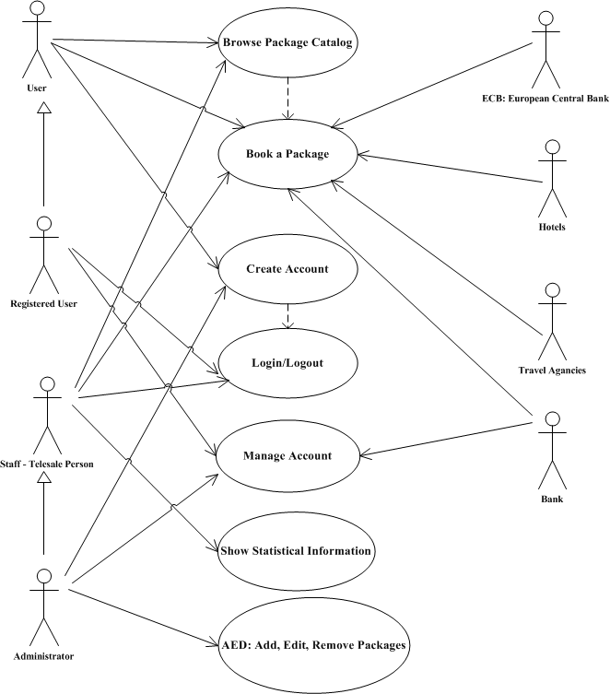

Figure ‎1‑1 - Use-Case Diagram

### Browse Package Catalog

Use-Case Name:

UC1: Browse Package Catalog

Scope:

Every users of our system including, customer and staff can browse in the catalog of the available package.

Level:

User-Goal Level

Primary Actor:

Users including, Un-registered User, Registered User, Staff and Administrator

Stakeholders:

All of the Users

Pre-Condition:

Any travel option including, hotels and transport facilities is available.

Post-Condition (Success Guarantee):

One of the items in the catalog is selected.

Main Scenario:

1- User (Customer or Staff) starts the system.

2- System shows the available packages.

3- User starts to search through the available packages.

4- User selects one of the items.

Extensions:

*a. At any time, packages might be unavailable because of updating operation:

1- User tries again (later).

2- Package is unavailable.

2-1 User cancels the operation.

2-2 User chooses another option.

2- There is no available package right now.

1. User does not select any of available options.

### Book a package

Use-Case Name:

UC2: Book a package

Scope:

System must operate final check for the availability and authentication, and then save new records.

Level:

Sub-functional Level

Primary Actor:

Users

Stakeholders:

ECB: European Central Bank, Hotels, Travel Agencies (Airlines and National Rail), Stansted Airport, London Liverpool Street Station, Bank (Credit Card Check), Users

Pre-Condition:

One of the items in the catalog is selected.

Post-Condition (Success Guarantee):

New record is saved. Hotel and transport facilities such as air traveling or train are booked. Payment authorization approvals are recorded.

Main Scenario:

1. System checks the final availability of the selected package.
2. System shows a brief description of the selected package and rules and conditions.
3. User accepts the description.
4. System checks the status of the user.
5. System asks user about payment methods.
6. User selects his payment method and fills the payment form.
7. System checks the payment process.
8. System generates a booking reference number.
9. System shows the success message.

Extensions:

*a. At any time, system fails:

1- User tries again (later).

1. There is no available package right now.

1a. System shows error message regarding the unavailable package.

1a. 1- System asks user to choose a new package.

1a. 1a. User chooses a new package.

1a. 1a. 1- System returns to 1st step in main scenario.

1a. 1b. User cancels the operation.

1a. 1b. 1- System returns to home page.

1. User does not accept the terms and conditions.

3a. System shows error message regarding the unchecked item.

3a 1- System asks user to confirm the terms and conditions.

3a. 1a. User accepts terms and conditions.

3a. 1a. 1- System continues to 4th step in main scenario.

3a. 1b. User does not accept terms and conditions.

3a. 1b. 1- System returns to home page.

4- User is a member of our system.

4a. User is eligible for any discount.

4a. 1- System calculate new price for the package.

4b. User is not eligible for any discount.

4b. 1- System do not change the price.

7- The information is not acceptable.

7a. System shows error message regarding the wrong information.

7a. 1- System asks user to enter correct information.

7a. 2- User enters information again.

7a. 3- System returns to 7th step in main scenario.

7b. The connection between bank and system is not established.

7b. 1- System tries again.

7b. 1a. System is connected to the bank.

7b. 1a. 1- Returns to 7th step in main scenario.

7b. 1b. The connection times out.

7b. 1b. 1- System shows the error message.

7b. 1b. 2- User tries again later.

### Create Account

Use-Case Name:

UC3: Create Account

Scope:

Un-registered user can create account to be a member of our system. This facility may effects on the cost of the packages (Royalty Discount)

Level:

User-Goal Level

Primary Actor:

Users

Stakeholders:

Users

Pre-Condition:

–

Post-Condition (Success Guarantee):

System saves the user information.

Main Scenario:

1. User requests to create a new account.
2. System shows a form.
3. User fills out the form.
4. System checks the information.
5. User approved the information.
6. System creates new record of user.
7. System shows the success message.

Extensions:

*a. At any time, system fails:

1- User tries again (later).

1- System checks the status of the user whether he is a customer or administrator.

1a. User is a new customer.

1a. 1- System goes to 2nd step.

1b. User is an administrator.

1b. 1- Administrator can create new staff user.

4- The information is not correct.

4a. User already has an account.

4a. 1- System shows message that you already has an account.

4b. The format of information is not correct.

4b. 1- System asks user to correct the incorrect field(s).

4b. 2- System returns to 4th step in main scenario.

5- The information is not accepted by user. 5a. The user is not correct. 5a. 1- User select edit button. 5a. 2- System goes to the beginning of 3th step.

### Login/Logout

Use-Case Name:

UC4: Login/Logout

Scope:

Members of our system (Customer, Staff) can login to their account and logout from their account.

Level:

User-Goal Level

Primary Actor:

Users

Stakeholders:

Users

Pre-Condition (Login):

Your account is not logged in.

Post-Condition (Success Guarantee):

Your account is logged in as a customer or staff.

Main Scenario:

1. User requests to login to system.
2. System shows a form.
3. User fills out the form.
4. System checks the information.
5. System checks the privilege class.
6. System shows the success message.

Extensions:

*a. At any time, system fails:

1- User tries again (later).

4- The information is not correct.

4a. The username is incorrect.

4a. 1- System shows the troubleshooting the problem.

4a. 1a. User tries again.

4a. 1b. User doesn’t have any account.

4a. 1b. 1- System goes to ‘create account’ use-case.

4b. The password is incorrect.

4b. 1- User tries again.

4b. 2- User forgets his password.

4b. 2a. User press forget password button.

4b. 2a. 1- System requests security question.

4a. 2a. 2- User answers the security question.

4a. 2a. 3- System generate new password.

Pre-Condition (Logout):

Your account is already logged in.

Post-Condition (Success Guarantee):

Your account is logged out.

Main Scenario:

1. User request to logout.
2. System logout the user.
3. System shows the success message.

Extensions:

*a. At any time, system fails:

1- User tries again (later).

### Manage Account

Use-Case Name:

UC5: Manage Account.

Scope:

User can change their information. Furthermore they can check their previous purchased item(s).

Level:

User-Goal Level

Primary Actor:

Users

Stakeholders:

Users

Pre-Condition:

User is signed in.

Post-Condition (Success Guarantee):

System saves the new user information.

Main Scenario:

1. User requests to manage his account.
2. System shows a table of information.
3. User select item(s) to edit.
4. System opens a new form.
5. User enters new information.
6. System checks the information.
7. User approved the change.
8. System saves new information of user.
9. System shows the success message.

Extensions:

*a. At any time, system fails:

1- User tries again (later).

6- The information is not correct.

6a. 1- System shows an error message. 6a. 2- User enters correct information. 6a. 3- System goes to the 7th step.

7- The information is not accepted by user. 7a. The information is not correct. 7a. 1- User select edit button. 7a. 2- System goes to the beginning of 5th step.

### Show Statistical Information

Use-Case Name:

UC6: Show Statistical Information

Scope:

Staff can check any statistical information.

Level:

User-Goal Level

Primary Actor:

Staff

Stakeholders:

Staff

Pre-Condition:

User is signed in with staff privilege.

Post-Condition (Success Guarantee):

–

Main Scenario:

1. Staff requests to show the statistical information.
2. System shows the information.

Extensions:

*a. At any time, system fails:

1- User tries again (later).

2- The information is not available.

6a. 1- System shows an error message. 6a. 2- staff must enter valid request.

### AED: Add, Edit, Remove Package

Use-Case Name:

UC7: Add, Edit, Remove Package

Scope:

Administrator can add new package or modifies any existing package.

Level:

Sub-functional Level

Primary Actor:

Administrator

Stakeholders:

ECB: European Central Bank, Hotels, Travel Agencies (Airlines and National Rail), Stansted Airport, London Liverpool Street Station, Bank (Credit Card Check), Users

Pre-Condition:

Administrator is signed in.

Post-Condition (Success Guarantee):

It changes the catalog.

Main Scenario:

1. Administrator request to change the catalog.
2. System shows the table.
3. Administrator select add new item.
4. System shows the form.
5. Administrator enters the information.
6. System checks the information.
7. Administrator approved the information.
8. System shows the success message.
9. System changes the catalog.

Extensions:

*a. At any time, system fails:

1- User tries again (later).

3- Administrator select modify existing item(s).

3a. Administrator wants to edit existing item(s). 3a. 1- Administrator select edit existing item(s). 3a. 2- System goes to 4th step. 3b. Administrator select remove of existing item. 3b. 1- Administrator select remove existing item(s). 3b. 2- System goes to 6th step.

6- The information is not correct.

6a. 1- System shows an error message. 6a. 2- User enters correct information. 6a. 3- System goes to the beginning of 7th step.

7- The information is not accepted by administrator. 7a. The information is not correct. 7a. 1- Administrator select edit button. 7a. 2- System goes to the beginning of 5th step.

# Table of Figure

Figure ‎1‑1 - Use-Case Diagram 1

# References

|  |  |
| --- | --- |
| [1] | M. Fowler, UML Distilled, Addison-Wesley, 2004. |
| [2] | A. Cockburn, Writing Effective Use Cases, 2001: Addison-Wesley. |