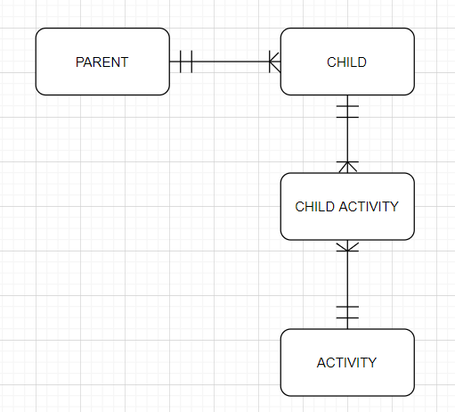

Parent (ParentID, FullName, EmailAdress, PhoneNumber )

Child (ChildID, ParentID*, FullName, Birthday, Gender, Allergy, AddionalInfo )

ChildActivity (ChildID*, ActivityID*)

Activity (ActivityID, ActivityName, Date, StartTime, Duration, Site)

Parent:

|  |  |  |  |  |  |
| --- | --- | --- | --- | --- | --- |
| Name | Date Type | Required | Max Length | Integration | Default Value |
| ParentID | INT | Yes | - | Primary key | Auto Increment |
| FullName | VARCHAR | Yes | 100 | - | - |
| EmailAdress | VARCHAR | Yes | - | Unique | - |
| PhoneNumber | VARCHAR | No | 25 | - | Null |

Child:

|  |  |  |  |  |  |
| --- | --- | --- | --- | --- | --- |
| Name | Date Type | Required | Max Length | Integration | Default Value |
| ChildID | INT | Yes | - | Primary key | Auto Increment |
| FullName | VARCHAR | Yes | 100 | - | - |
| ParentID | INT | Yes | - | Foreign key | - |
| Birthday | DATE | Yes | - | Not null | - |
| Gender | VARCHAR | Yes | 10 | Not null | - |
| Allergy | VARCHAR | No | 100 | - | - |
| AdditionInfo | VARCHAR | No | 200 | - | - |

ChildActivity:

|  |  |  |  |  |  |
| --- | --- | --- | --- | --- | --- |
| Name | Date Type | Required | Max Length | Integration | Default Value |
| ChildID | INT | Yes | - | Primary key, Foreign key | - |
| ParentID | INT | Yes | - | Primary key, Foreign key | - |

Activity:

|  |  |  |  |  |  |
| --- | --- | --- | --- | --- | --- |
| Name | Date Type | Required | Max Length | Integration | Default Value |
| ActivityID | INT | Yes | - | Primary key | Auto Increment |
| ActivityName | VARCHAR | Yes | 100 | - | - |
| Date | DATE | Yes | - | - | - |
| StartTimer | VARCHAR | Yes | 20 | - | - |
| Duration | VARCHAR | Yes | 20 | - | - |
| Site | VARCHAR | Yes | 200 | - | - |