**Question 1: Which stocks are best performing in their respective sectors?** (Sourav)

**Answer:** AMD- Automobile

COOP- Finance

LLY- Healthcare

NOW- Technology

**Performance By Sector**

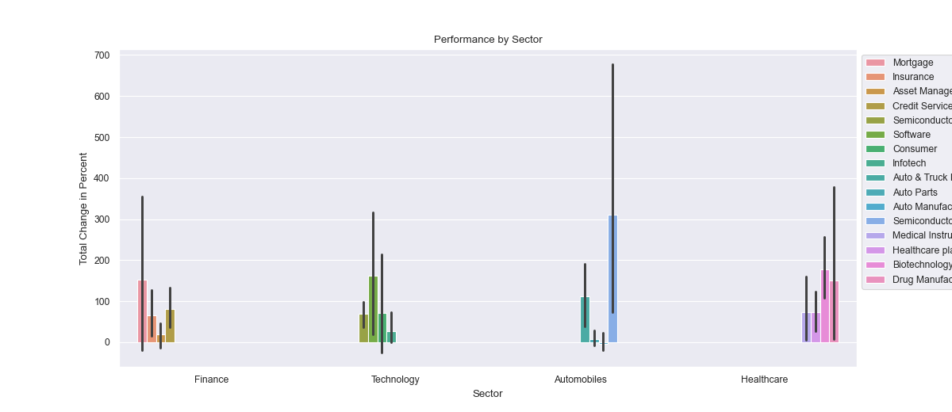

**Performance of Top Performers Per Sector**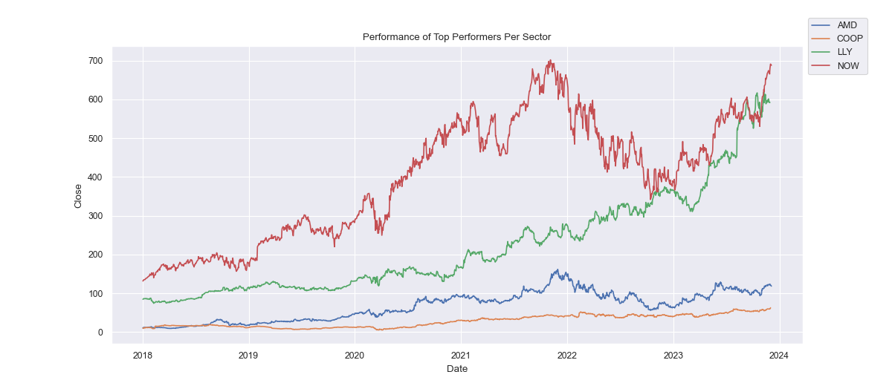

**Question 2: Which ticker performed the worst/best by year?** (Sourav)

**Answer:**

|  |  |  |
| --- | --- | --- |
| **Year** | **Best** | **Worst** |
| **2018** | AMD | ALV |
| **2019** | AMD | LPL |
| **2020** | MRNA | AAPL |
| **2021** | MRNA | LDI |
| **2022** | MRK | TSLA |
| **2023** | NVDA | MRNA |

**Performance of Sectors by Year**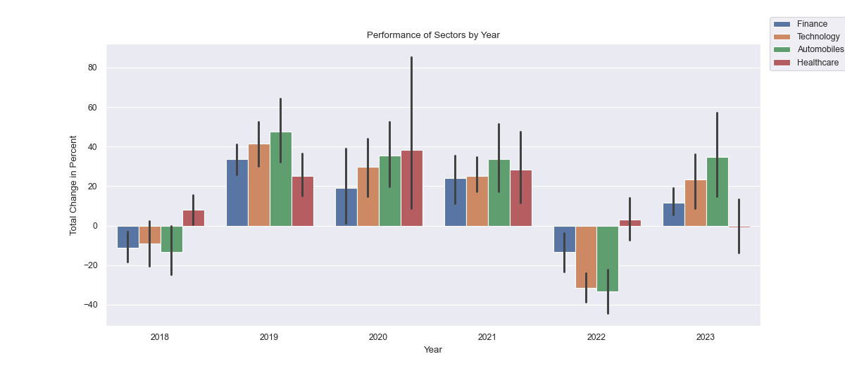

**Best Performer Per Year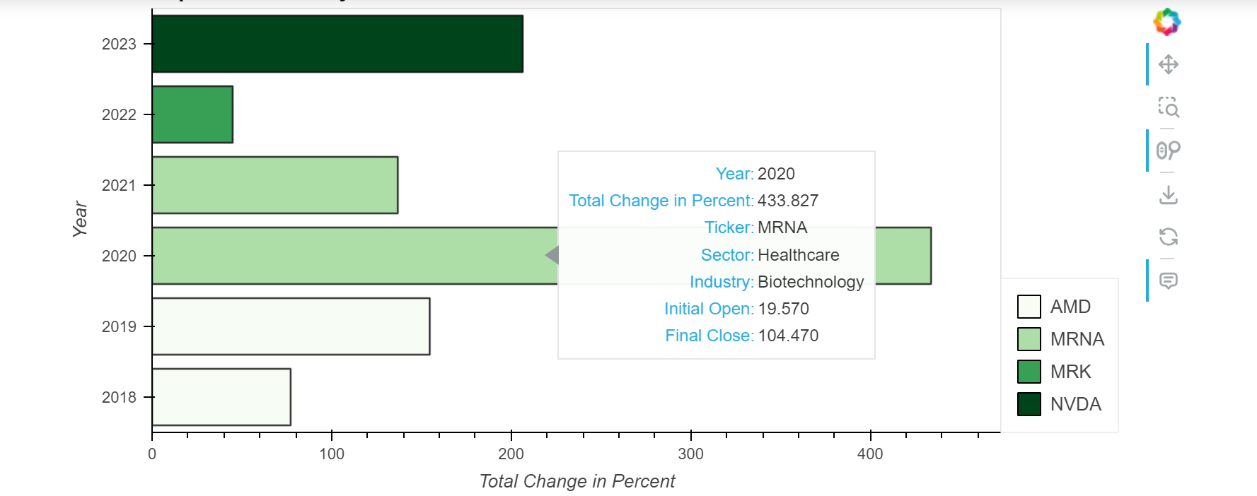Worst Performer Per Year**