**Project1- Stock Data Analysis- Presentation**

**This project talks about**

1. Stock price analysis within various sectors as well as industries and visualize the data.
2. Furthermore, it gives volume of stock traded in each sector and each industry.
3. And find any correlation within sectors to check if one stock was affected by another stock within the sector.
4. As well as calculates moving average in each sector and find the most traded stock in each year.

Our analysis is based on these following Sectors with listed Industries, for each Industry we have 5 Stocks.

|  |  |  |  |
| --- | --- | --- | --- |
| **Automobile** | **Healthcare** | **Finances** | **Technology** |
| Semiconductors | Medical Instruments and Supplies | Credit Services | Semiconductors |
| Auto & Truck Dealerships | Healthcare Plan | Asset Management | Software |
| Auto Parts | Biotechnology | Insurance | Consumer Tech |
| Auto Manufacturers | Drug Manufacturers | Mortgage | Info Tech |

## Datasets used:

* [AlphaVantage package](https://www.alphavantage.co/documentation/)
* Yahoo Finance Module

**Question 1: Which stocks are best performing in their respective sectors?**

**Answer:** AMD- Automobile

COOP- Finance

LLY- Healthcare

NOW- Technology

**Performance By Sector**

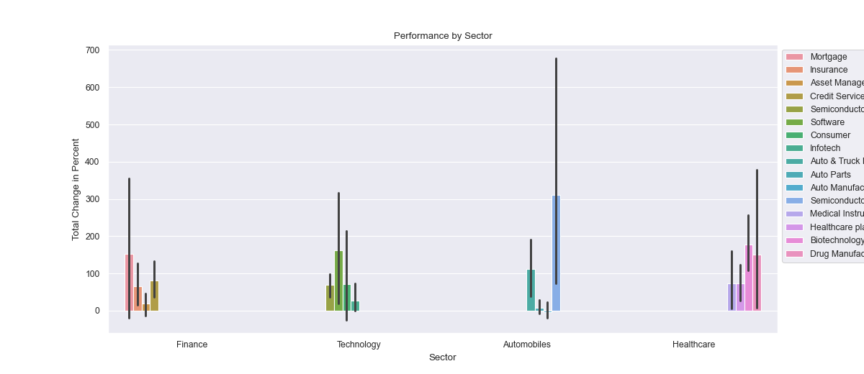

**Performance of Top Performers Per Sector**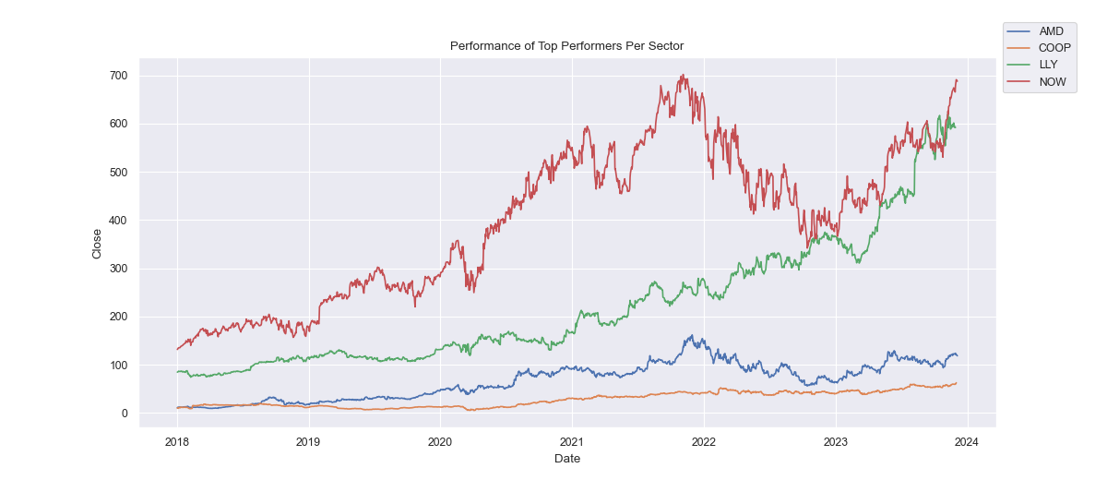

**Question 2: Which ticker performed the worst/best by year?**

**Answer:**

|  |  |  |
| --- | --- | --- |
| **Year** | **Best** | **Worst** |
| **2018** | AMD | ALV |
| **2019** | AMD | LPL |
| **2020** | MRNA | AAPL |
| **2021** | MRNA | LDI |
| **2022** | MRK | TSLA |
| **2023** | NVDA | MRNA |

**Best Performer Per Year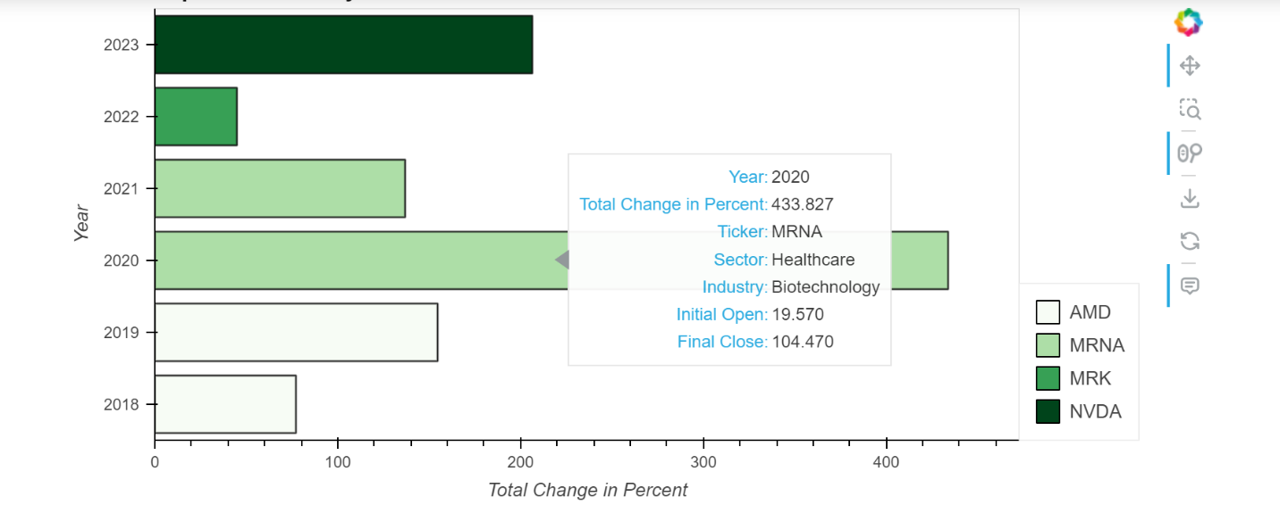Worst Performer Per Year**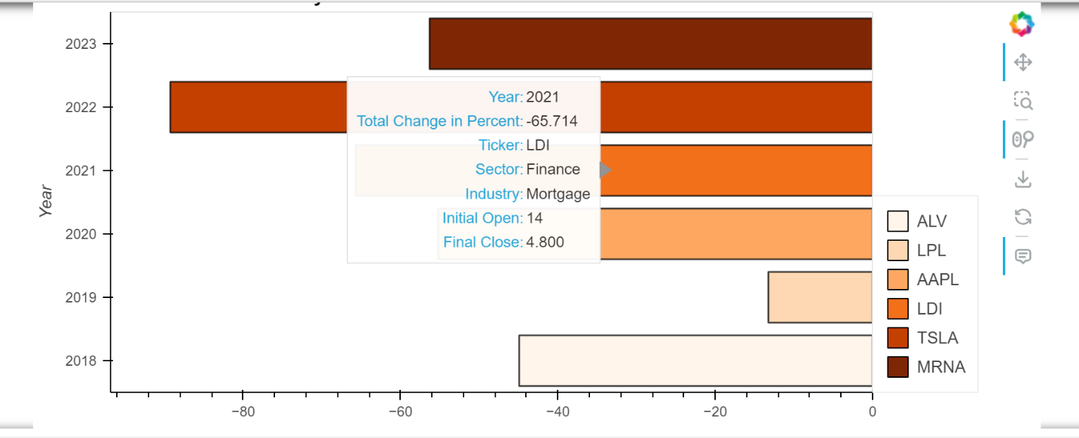

**Question3: How did each sector perform for each year regarding average volume?**

**Answer:**

**Question4: Find a correlation between industries within each sector.**

**Correlation within the Automobile sector**

**Correlation within the Finance sector**

**Correlation within the Healthcare sector**

**Correlation within the Tech sector**

# **Question5: What does the moving average look like for each industry? (Alison)**

**Answer:**

**Moving Average for each Sector (Close Price)**

|  |  |
| --- | --- |
|  |  |
|  |  |

# 

# **Question 6: Which stock was most traded in each year? (Alison)**

**Answer:**

**Highest Volume Traded per Year for Each Sector**

|  |  |
| --- | --- |
|  |  |
|  |  |

# 

# **Question7: What is the allocation of portfolio for each Sector? (Sakina)**

**Answer:**

**Grand Portfolio Allocation by Sector based on Volume**

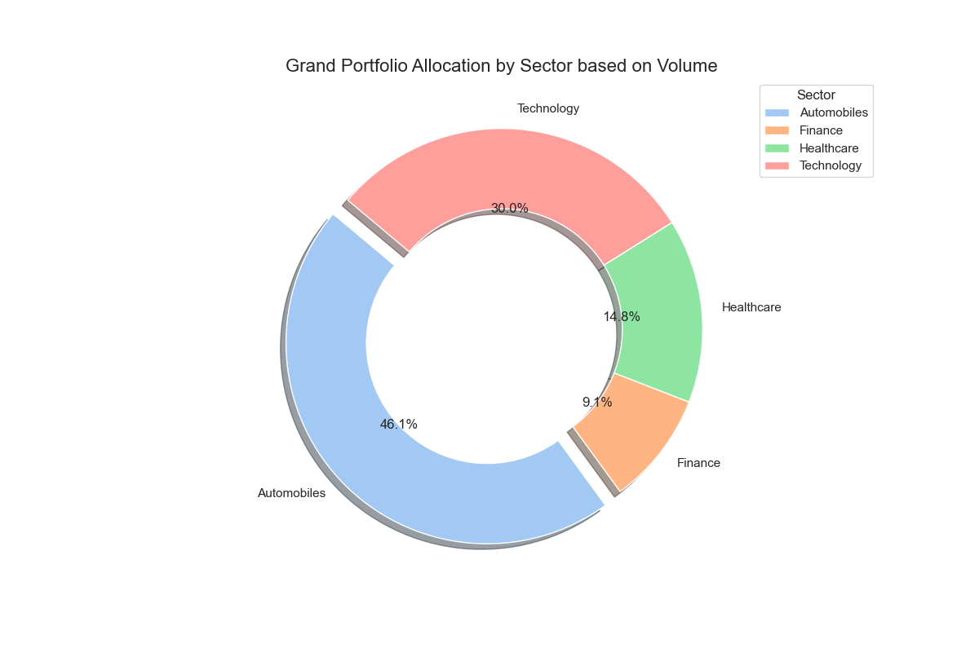

**Question8: What is the allocation of portfolio for each Industry?**

**Answer:**

**Portfolio Allocation by Industry based on Total Volume (Tech)**

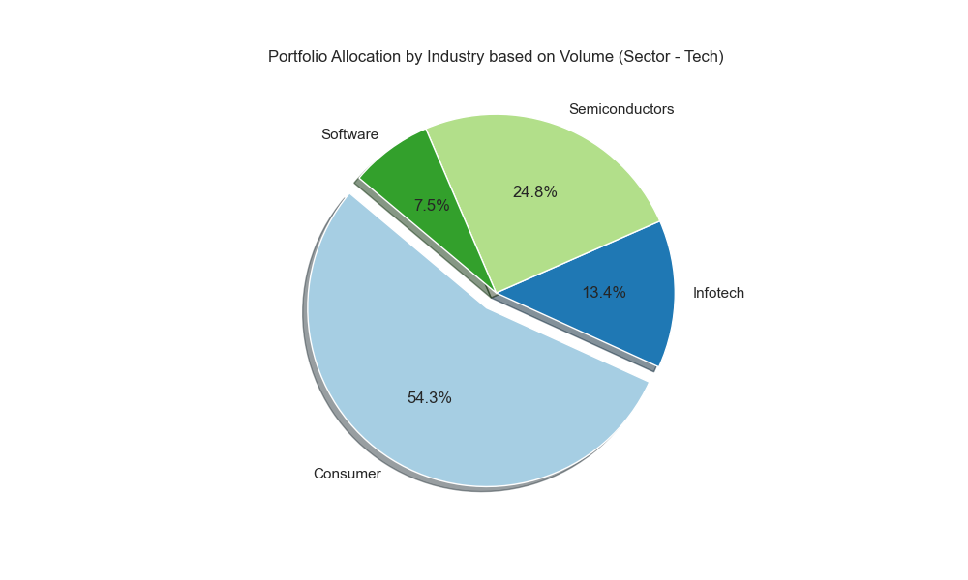

**Portfolio Allocation by Industry based on Total Volume (Healthcare)**

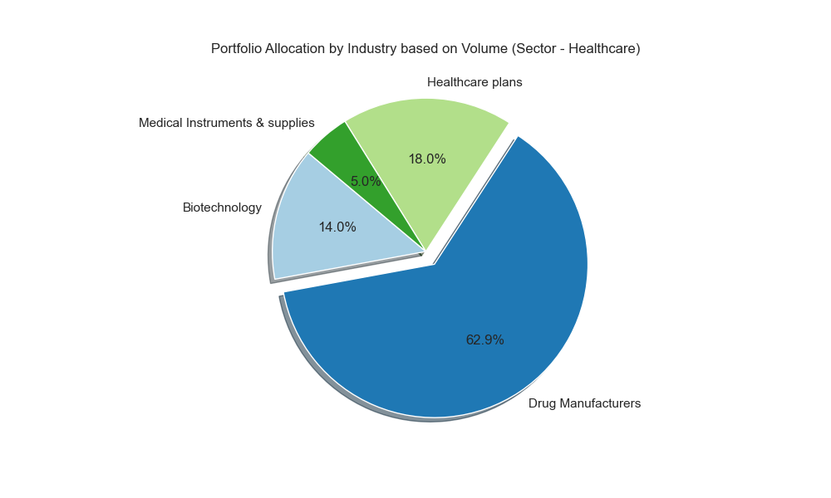

**Portfolio Allocation by Industry based on Total Volume (Finance)**

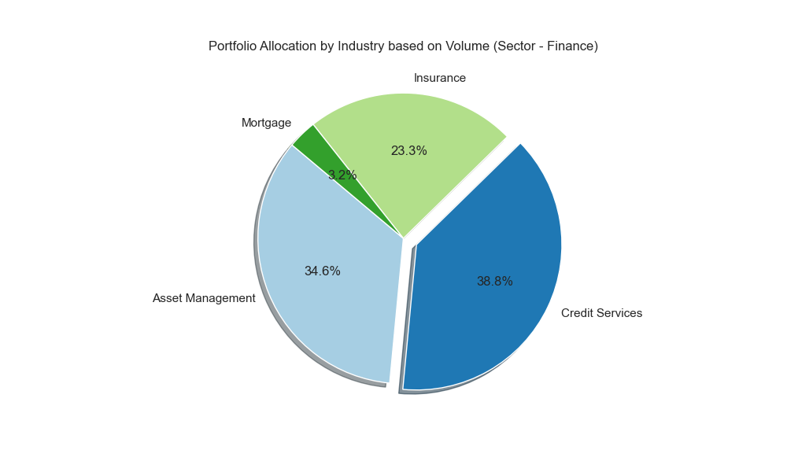

**Portfolio Allocation by Industry based on Total Volume (Semiconductors)**

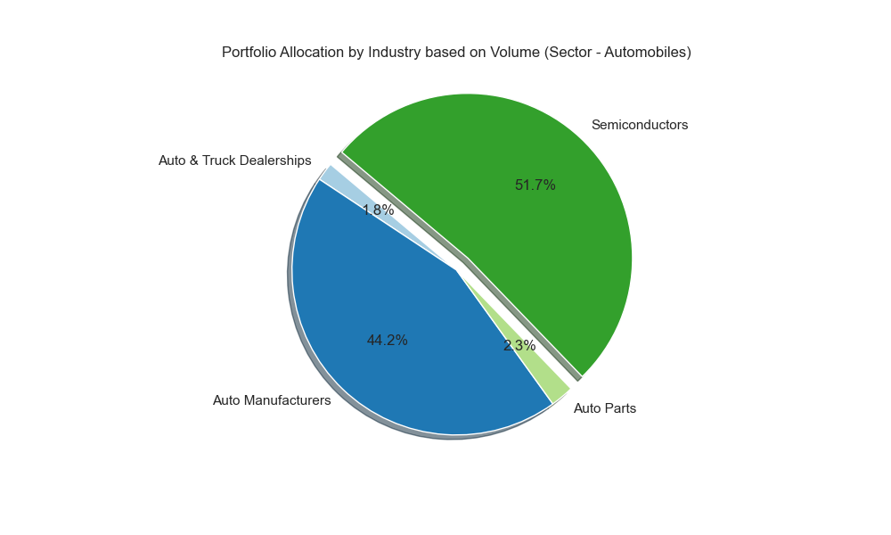

**Limitations**

While our analysis provides valuable insights, it is essential to acknowledge certain limitations. The data used in the analysis represents a small fraction of the entire stock market, and should be acknowledged as a limitation, as this is not fully representative of the entire market.

Factors such as market sentiment, geopolitical events (i.e. The war in Ukraine, 2022), and unforeseen circumstances may also not be fully captured in our methodology.