**Project1- Stock Data Analysis**

**Team members- Alison Andrade, Sakina Jaffri, Kunal Khirwar & Sourav Kumar.**

**Question 1: Which stocks are best performing in their respective sectors?** (Sourav)

**Answer:** AMD- Automobile

COOP- Finance

LLY- Healthcare

NOW- Technology

**Performance By Sector**

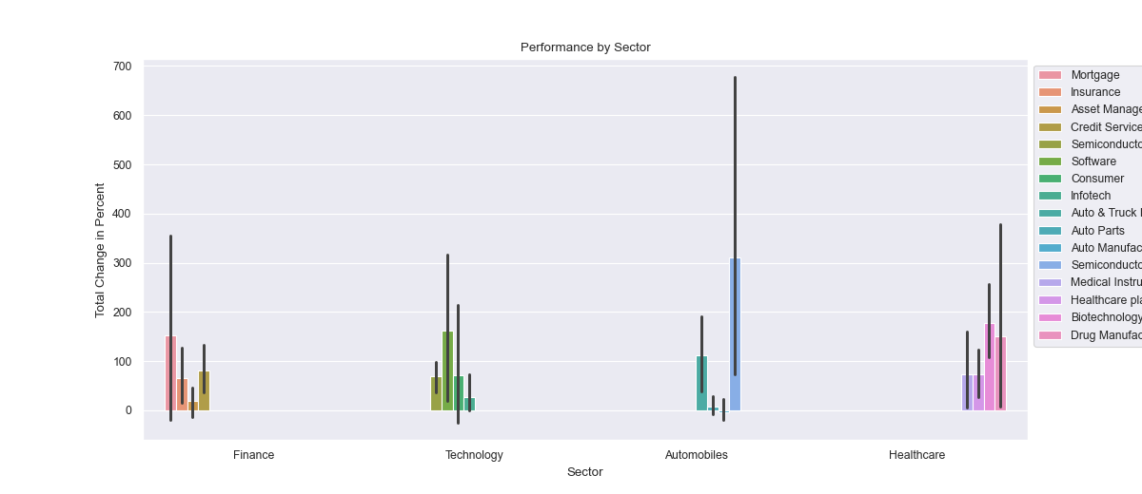

First all the stock data was processed and overall percent change was calculated for each stock in available data. Then, each Sector was plotted with the average change occurred in each industry using grouped bar graph. Where height of bar represents average of total change in percent for each industry in each sector and line in between the bar represent the amount of change occurred. In Finance Sector, Mortgage has the most change while in Technology, Software has most change and going further, Semiconductors in Automobiles and Drug Manufacturers in Healthcare has most change occurred in prices.

**Performance of Top Performers Per Sector**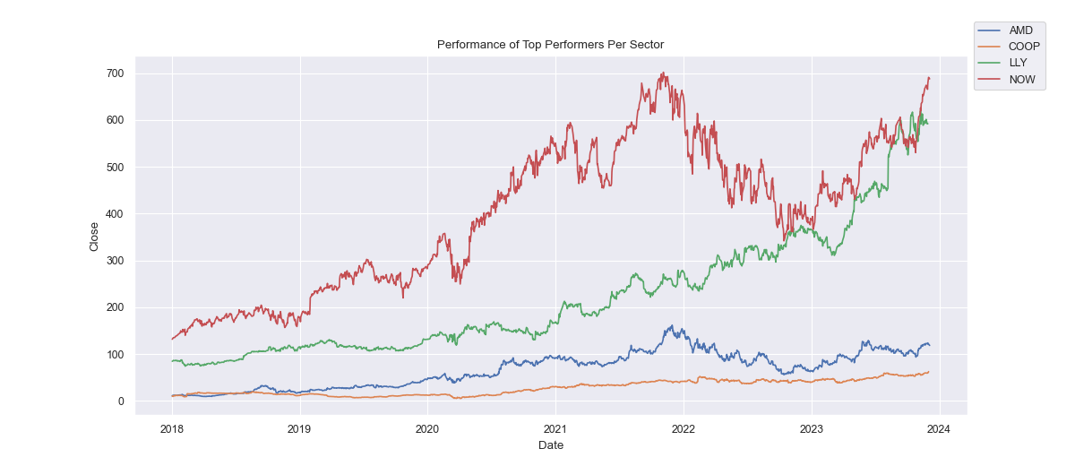

As per the previous bar graph. We have the industry with most change in price for each sector. Then we found the best performing stocks in those industries and plotted the line graph for closing price of those stocks over the years available in dataset. 1037% of growth was seen in AMD where price went from 10.42 to 118.570000, while LLY had 600%, COOP had 507% and NOW had 424% increase in close price.

**Question 6: Which ticker performed the worst/best by year?** (Sourav)

**Answer:**

|  |  |  |
| --- | --- | --- |
| **Year** | **Best** | **Worst** |
| **2018** | AMD | ALV |
| **2019** | AMD | LPL |
| **2020** | MRNA | AAPL |
| **2021** | MRNA | LDI |
| **2022** | MRK | TSLA |
| **2023** | NVDA | MRNA |

**Performance of Sectors by Year**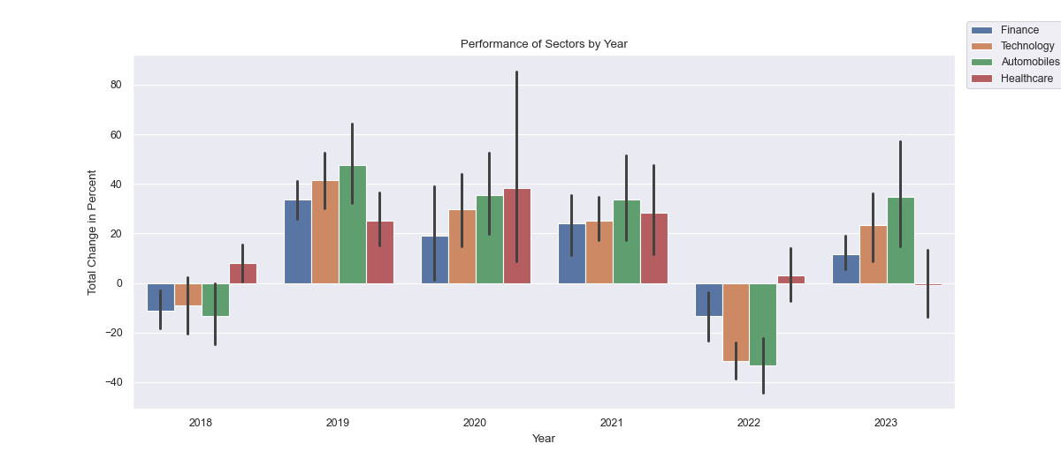

This grouped bar graph shows the performance of each sector during different years. Based on the data we have, Only healthcare performed well in 2018 and 2022 while other Sectors were going down. Whereas, Automobiles was best performing sector in 2019, 2021 and 2023. While for 2020, Healthcare was the best performing sector with astonishing change in close price which could be due to covid-19.

**Best Performer Per Year**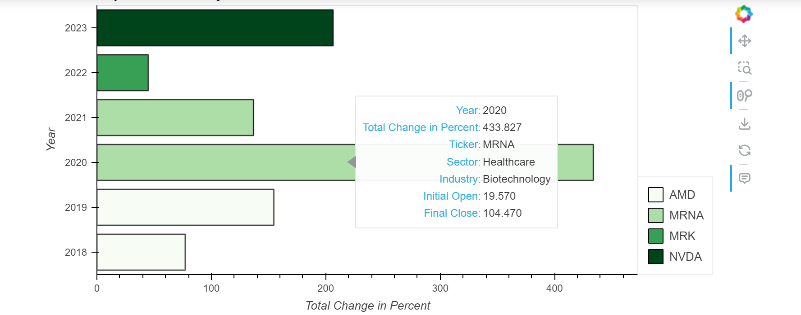

Plotting the Best performing stock per Year based on the available data, for 2018 and 2019 AMD was best stock while checking 2020 MRNA was not only the top performer of that year but also the growth was radical as compared to other stocks performances in other years. It could be the effect of Covid-19 and Moderna was one of the major vaccines producing organization. MRNA was also top performer in 2021 but growth in price was lesser than previous years. Then MRK shows an increase of 44% and NVDA shows increase of more than 200% in 2022 and 2023 respectively.

**Worst Performer Per Year**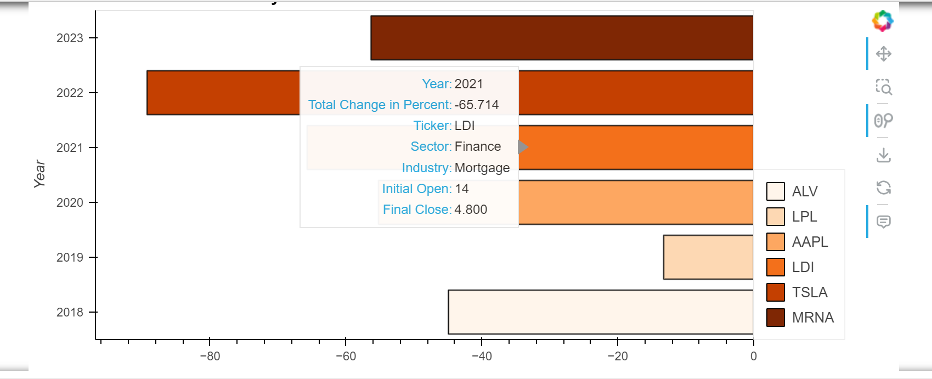

Plotting Worst performers by years, Worst performer for 2018 was ALV that decreased around 44%. for 2019, it was LPL but with just 13% decrease which is least of them all. In 2020, AAPL whose prices drop almost by half making it worst performer. Moving forward, LPL and TSLA were worst performer in 2021 and 2022 respectively. With TSLA being the stock with greatest decrease. In 2023, MRNA's price had a major drop compared to the previous horizontal bar chart where MRNA was Best performer for two consecutive years.

Checking both of these graphs, MRNA was common in both as MRNA's price increase maybe influenced by Covid-19 and as the vaccines were administered during 2022, MRNA experienced a subtle decrease in 2023 making it the worst performer for 2023.