### Q4: What does the moving average look like for each industry

## Moving Average Analysis

### Technology

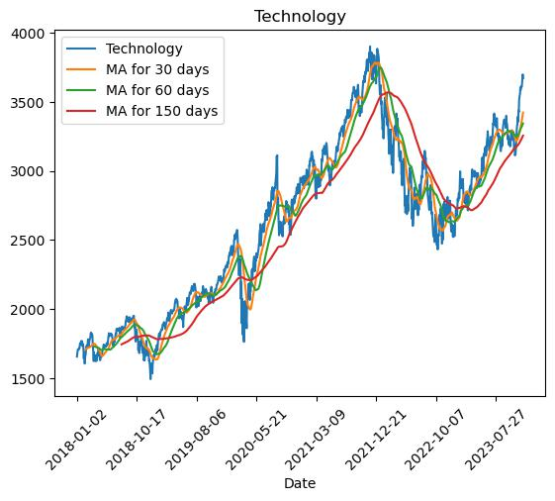

The moving average for the technology sector, particularly over 150 days, reveals a robust recovery post-COVID and during the 2022 market decline. Notably, Apple exhibited a strong increase in volumes post-pandemic, while Micron Tech's volumes surpassed Apple's before the pandemic.

### Finance

Similar to the technology sector, finance experienced a strong recovery post-pandemic and in the 2022 market decline. Morgan Stanley and Visa emerged as the most traded stocks, with volumes increasing during the pandemic and returning to normalcy thereafter.

### Automotives

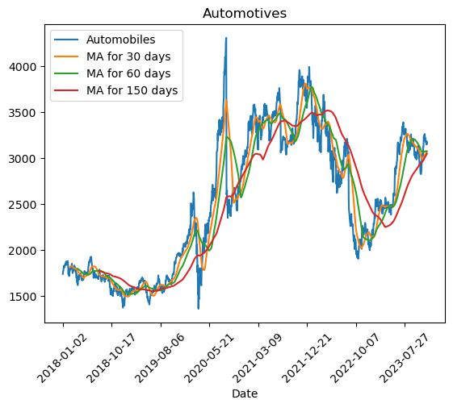

The automotive sector exhibited higher volatility than finance and tech, with a significant upward trend post-pandemic and a steep decline during the 2022 market downturn. Notably, Ford, AMD, and Tesla were the highest traded stocks, with Tesla's volumes reaching new heights in 2023.

### Healthcare

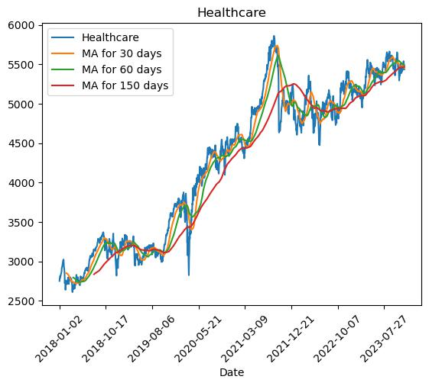

Healthcare, resilient post-pandemic, faced a decline during the 2022 market downturn but recovered similarly to tech and finance. Pfizer and Moderna stood out as the two most traded healthcare stocks, with Moderna experiencing a steep increase in production during and after the pandemic.

### Q5: Which ticker was most traded in each year?

## Highest Volume Traded Analysis

### Tech

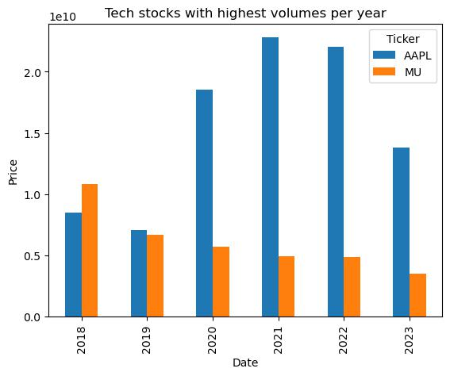

Apple witnessed a significant increase in volumes post-COVID, while Micron Tech had higher volumes than Apple before the pandemic.

### Finance

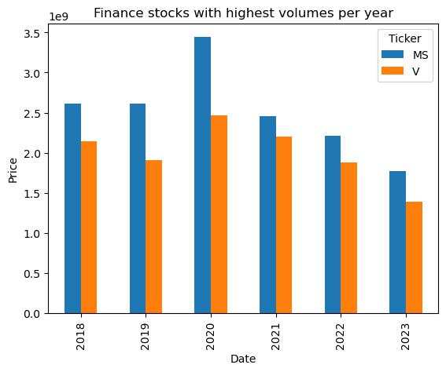

Morgan Stanley and Visa were the most traded stocks, with volumes increasing during the pandemic and reverting to pre-pandemic levels afterward.

### Automobiles

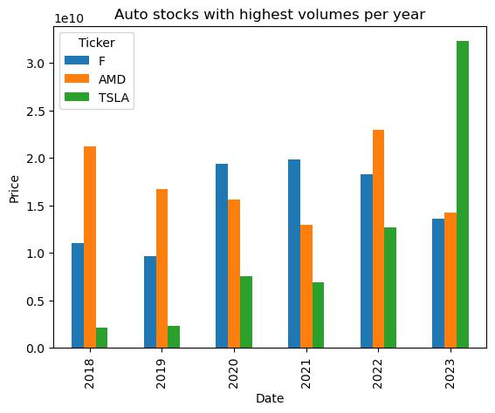

Ford, AMD, and Tesla dominated trading volumes, with Tesla experiencing a substantial increase in production and volumes in 2023.

### Healthcare

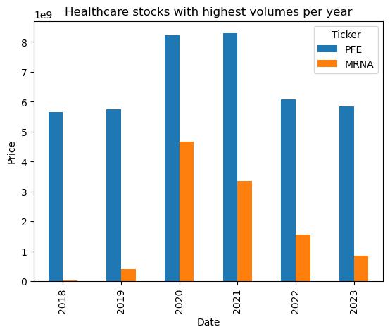

Pfizer and Moderna emerged as the highest traded healthcare stocks, with Moderna experiencing a notable increase in production during the pandemic.

### Limitations

While our analysis provides valuable insights, it is essential to acknowledge certain limitations. The data used in the analysis represents a small fraction of the the entire stock market, and should be acknowledged as a limitation, as this is not fully representative of the entire market.

Factors such as market sentiment, geopolitical events, and unforeseen circumstances may also not be fully captured in our methodology.