#### **Question 4: What does the moving average look like for each industry**

**Moving Average Analysis**

This method of moving averages is used to assess the overall sector performance during market declines, with a focus on understanding the impact of the pandemic and identifying sectors resilient to market factors. Utilizing Plotly and Matplotlib for visualizations, the period spanned the years Jan 1, 2012 to Dec 4, 2023. Moving averages were computed over 30, 60, and 150 days using the pandas.rolling() function, providing an overview of trends for each sector based on the cumulative closing prices.

**Technology**

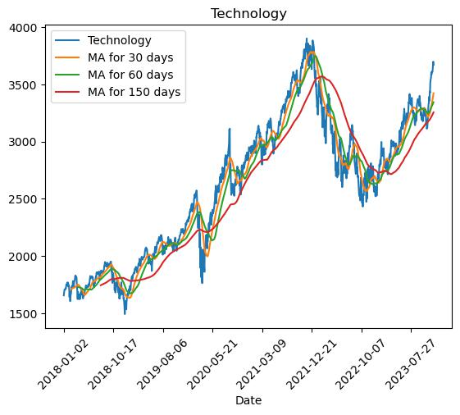

Looking at the moving average for 150 days, it had a strong recovery after the covid decline during the pandemic and in the 2022 market decline.

**Finance**

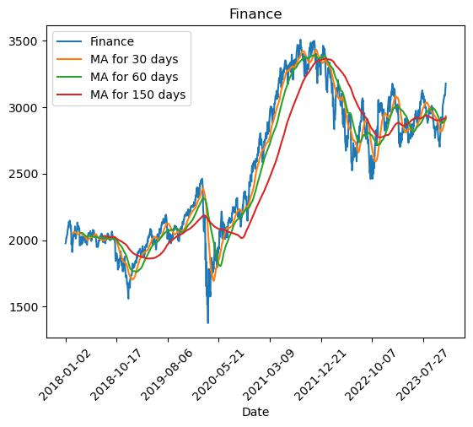

Similar to the technology sector, finance experienced a strong recovery post-pandemic and in the 2022 market decline.

**Automotives**

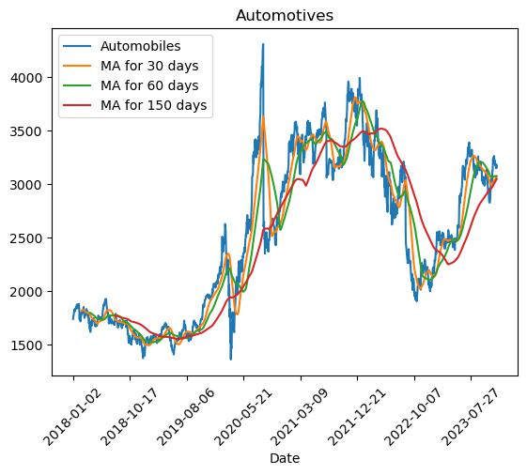

The automotive sector exhibited higher volatility than finance and tech, with a significant upward trend post-pandemic and a steep decline during the 2022 market downturn.

**Healthcare**

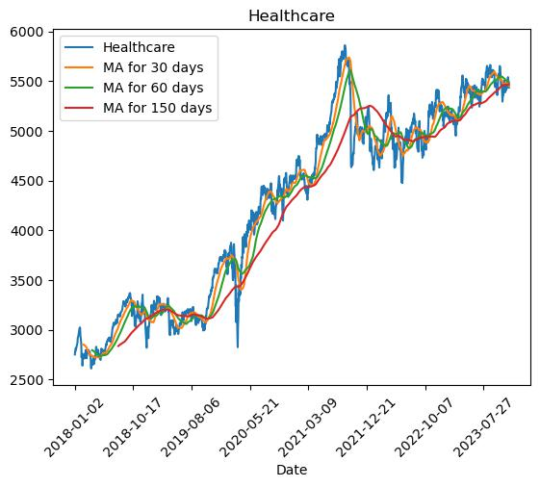

Healthcare, resilient post-pandemic, faced a decline during the 2022 market downturn but recovered similarly to tech and finance.

In general, the finance and technology sectors recovered the best after market declines, followed by healthcare and automotives, which were the most volatile.

#### **Question 5: Which stock was most traded in each year?**

**Highest Volume Traded Analysis**

This analysis focuses on identifying the most traded ticker in each year within different sectors, aiming to determine the impact of the pandemic on trading volumes. Using code, each sector is individually examined to determine the tickers with the highest annual trading volumes. This process involves grouping data by year, and summing the volume for each ticker over the entire year.

**Tech**

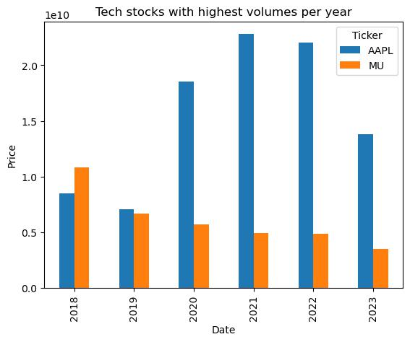

Apple witnessed a significant increase in volumes post-COVID, while Micron Tech had higher volumes than Apple before the pandemic.

**Finance**

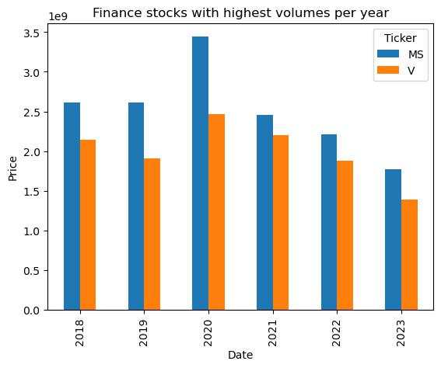

Morgan Stanley and Visa were the most traded stocks, with volumes increasing during the pandemic and reverting to lower than pre-pandemic levels afterward.

**Automobiles**

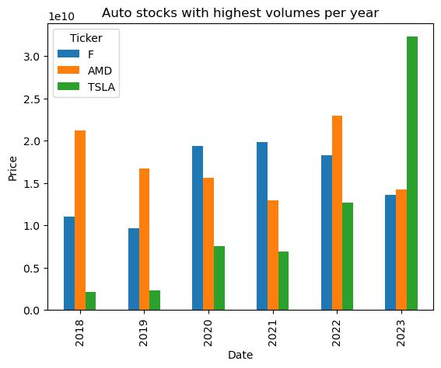

Ford, AMD, and Tesla dominated trading volumes, with Tesla experiencing a substantial increase in production and volumes in 2023.

**Healthcare**

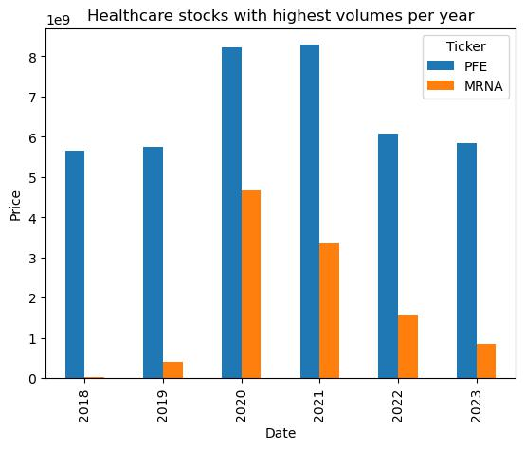

Pfizer and Moderna emerged as the highest traded healthcare stocks, with Moderna experiencing a notable increase in production during the pandemic.

**Limitations**

While our analysis provides valuable insights, it is essential to acknowledge certain limitations. The data used in the analysis represents a small fraction of the entire stock market, and should be acknowledged as a limitation, as this is not fully representative of the entire market.

Factors such as market sentiment, geopolitical events(i.e. The war in Ukraine, 2022), and unforeseen circumstances may also not be fully captured in our methodology.