Final Project – PROG2370

Alisa Vynohradova

**Overview**

My project is called “Rapunzel’s Light”. On the first screen the menu is displayed with such options: “Start”, “Help”, “High Score”, “Credit” and “Quit”. On the main playing screen Rapunzel castle in the background and a boat with Rapunzel and Eugene (Flynn Ryder) are shown. Chinese lanterns are falling to the water and user has to move the boat to the right or to the left so as to catch the lights, so they don’t pollute the river.

LightManager class generates lights randomly (on random positions), lights flash(animation) while they are falling. So as to make the flashing look as real as possible, I use two textures and change the opacity of the one with the shining randomly. If the light is caught by the boat (intersects with it), the user gets 10 points, but it falls to the water, the score is decreased by 5 points. Once 30 seconds pass, the number of received points is shown to the user and recorded to the file with top 10 high scores in the game.

**Class Diagram**

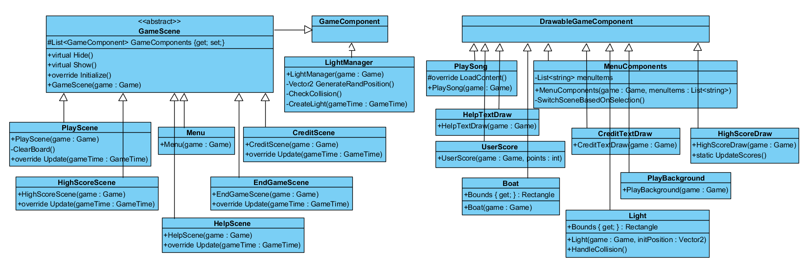

**Recourses**

1. “help.png” – <https://disney.fandom.com/wiki/Rapunzel/Gallery?file=Rapunzel_-_KH3.png#Kingdom_Hearts_III>
2. “boat.png” – <https://www.uihere.com/free-cliparts/rapunzel-flynn-rider-light-art-lantern-tangled-1575674>
3. “main.jpg” – <https://wallpapercave.com/disney-tangled-wallpaper>
4. “background.jpg” – <https://www.deviantart.com/tella-in-sa/art/Portrait-of-a-Kingdom-Corona-288384395>
5. “light.png” – <https://weheartit.com/entry/18377266>
6. “textura.jpeg” – <https://www.fabricgateway.com/topic/tangled+sun>
7. “song.mp3” – <https://www.youtube.com/watch?v=cJyJCz8uIFU>
8. “s1.mp3” – <https://zvukipro.com/audio/918-zvuki-lucha-sveta.html>
9. “credit.jpg” – <http://www.rabstol.net/oboi/rapunzel/2180-rapuncel-flinn-i-maksimus.html>
10. “highscore.png” – <https://estudiante812.files.wordpress.com/2016/02/tangled.png>