1. The probability of winning $80 within 1000 sequential bets is very close to 100% in 1. As we could see from the Monte Carlo simulation, at the 1000th time, the mean and median of episode earnings are both 80, with standard deviation also being 80. This suggests that all the players have won the game at some point earlier in their respective betting processes.
2. According to my simulation result (and Law of Large Number), the sample mean converges to $80, so the expected value is $80.
3. Standard deviation converges. Probability that a player would win within 1000th trial is very close to 1. Thus, by the 1000th trial, every data is expected to be the same at $80 so that the standard deviation converges to 0.
4. According to simulation, the probability is around 66%.
5. According to simulation and Law of Large Number, the expected value is around -34.
6. The standard deviation diverges according to the graphs.

Graphs:

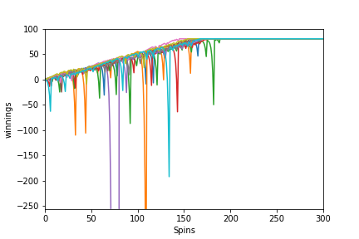

**Figure 1**

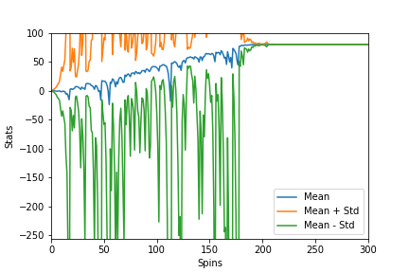

**Figure 2**

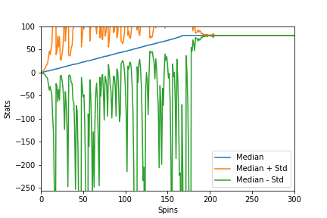

**Figure 3**

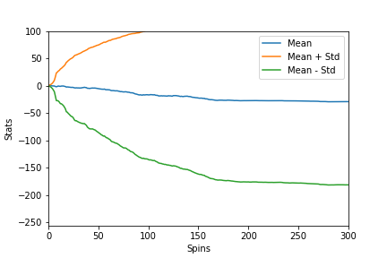

**Figure 4**

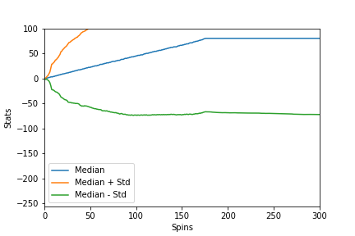

**Figure 5**